State of Kansas
WorkCenter Query: WAR AXD
Statewide Human Resource and Payroll System

Date Created | 8/1/2022
Version | 1.0
Security | - SHARP  KS_HR_WORKCENTER_USER  KS_PAYROLL_WORKCENTER_USER  KS_TL_WORKCENTER_USER
Purpose | This query is to be ran after the final pay period for the year has been ran. This will show you all employees that are enrolled in the KPERS plan AXD. These employees all need to be moved plan AC, effective the first pay period of the new year.
1.  3 Digit DeptID  Pay Period End Date for the last pay day in the calendar year  View Results | 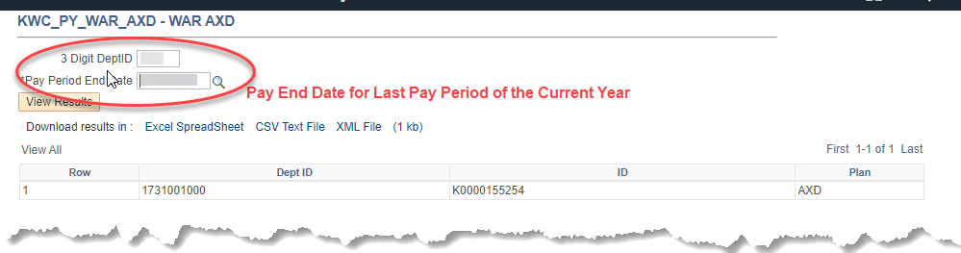
2. | If there are employees who show on the query results, the employee needs to be moved to Plan AC, effective the beginning of the next calendar year.

