State of Kansas
WorkCenter Query: WAR AC
Statewide Human Resource and Payroll System

Date Created |  | 8/1/2022
Version |  | 1.0
Security |  | - SHARP  KS_HR_WORKCENTER_USER  KS_PAYROLL_WORKCENTER_USER  KS_TL_WORKCENTER_USER
Purpose |  | This query is to be ran every pay period. The query will only show results if you have an employee that is enrolled in the KPERS plan AC and has hit $25,000 in earnings. At this point, they will need to be moved to the AXD code.
1.  Balance for Year  3 Digit DeptID  View Results | 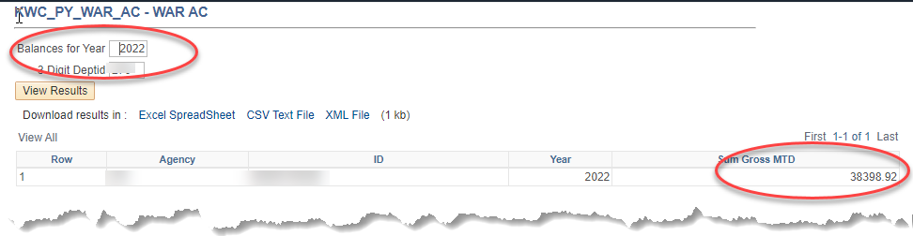  *In the screenshot above, for agency XXX, there was 1 employee who had over $25,000.00 in wages for paychecks to date in 2022.
2. | If there are employees who show on the query results, the employee needs to be moved to Plan AXD until the beginning of the next calendar year.

