State of Kansas
WorkCenter: Reject by Payroll (Payable Time)
Statewide Human Resource and Payroll System

Date Created |  | 4/29/2022
Date Updated |  | 8/18/2023
Information |  | This job aid replaces the RP instruction part of the PAY011 Payroll Error Messages job aid.
Security |  | - SHARP  KS_HR_WORKCENTER_USER  KS_PAYROLL_WORKCENTER_USER  KS_TL_WORKCENTER_USER
Monday, Day 9 throughTuesday, Day 3: Resolving RP (Rejected by Payroll) Errors
1. | Time and Labor Homepage  Time and Labor WorkCenter | 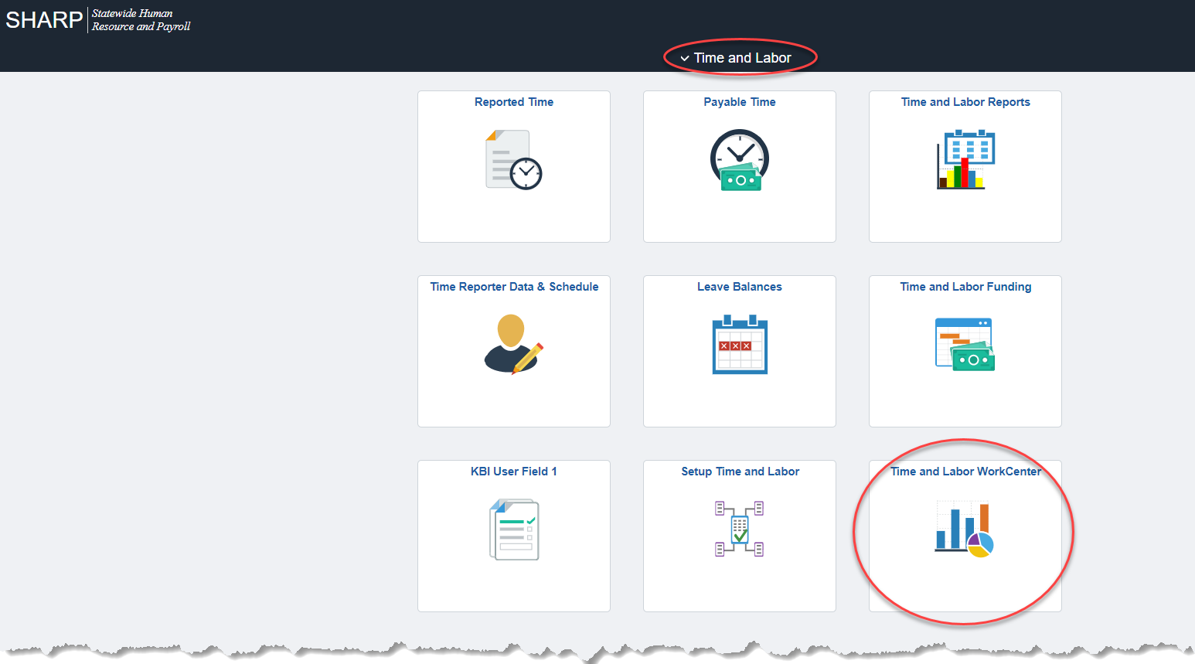
2. | Reject by Payroll (Payable Time)  Enter your agency number in the 3 Digit Dept ID field  View Results | 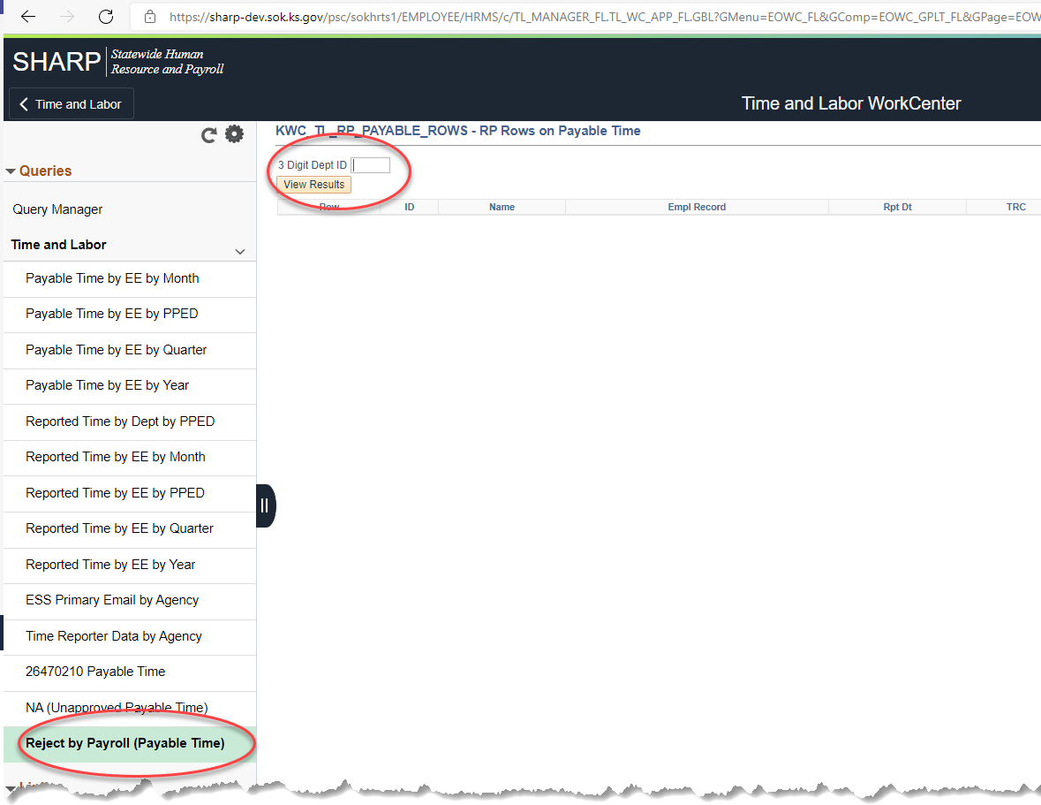
3. | This report is ‘real-time’ meaning all errors displayed are showing as being in error at the time the report is run.  Click on Excel SpreadSheet to download errors to Excel.  Sort the spreadsheet by Rpt Dt to sort by date  Add a Filter  Using the filter on the ID field, select the first employee in your list  Make note that this employee’s errors are for Pay Period 8/22/2021 through 9/4/2021. *Be careful to pay attention that some employees may have multiple periods in errors. | 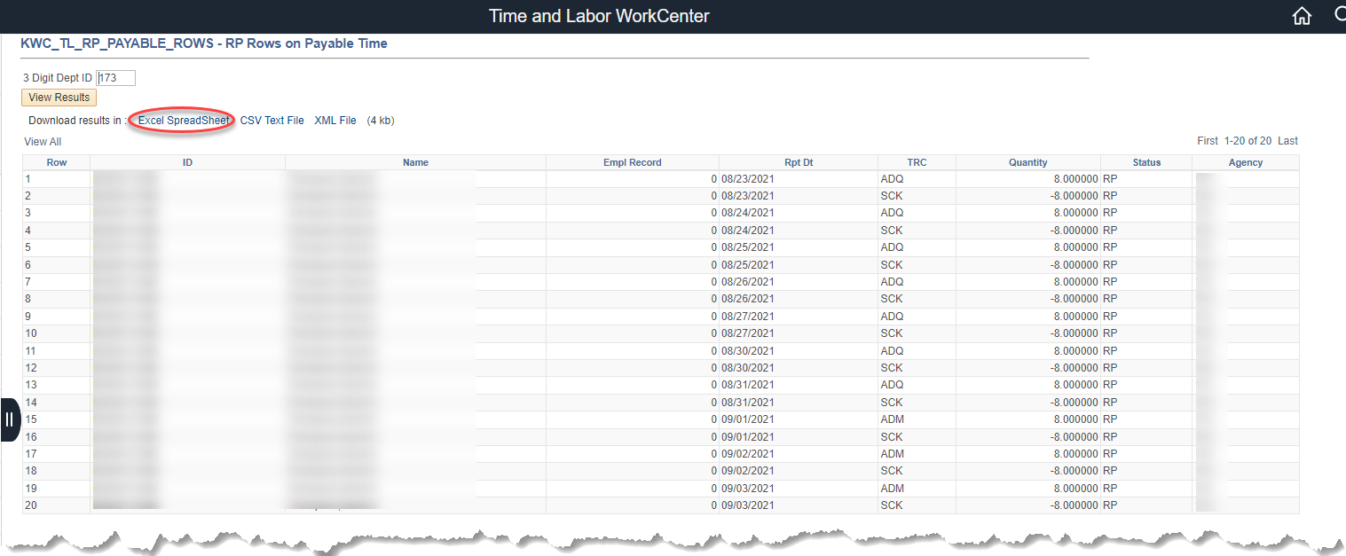  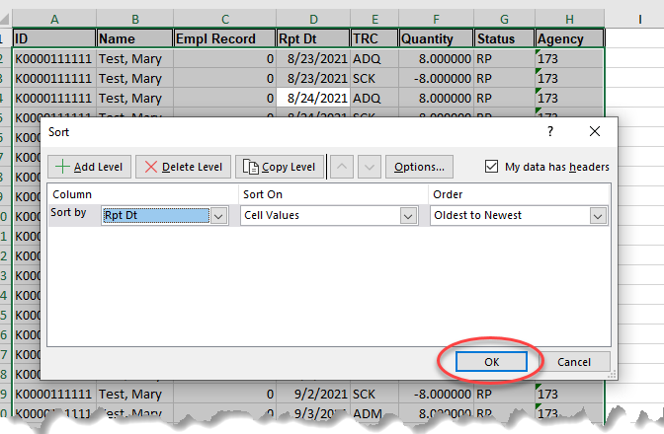  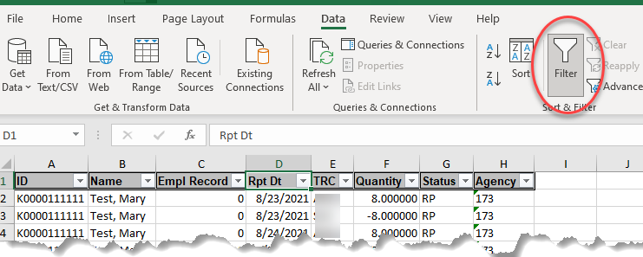  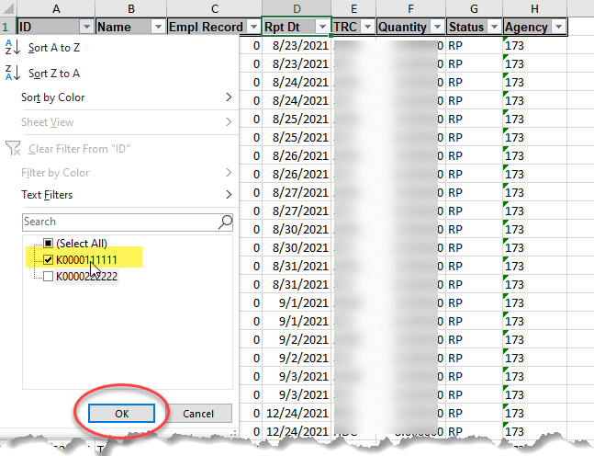  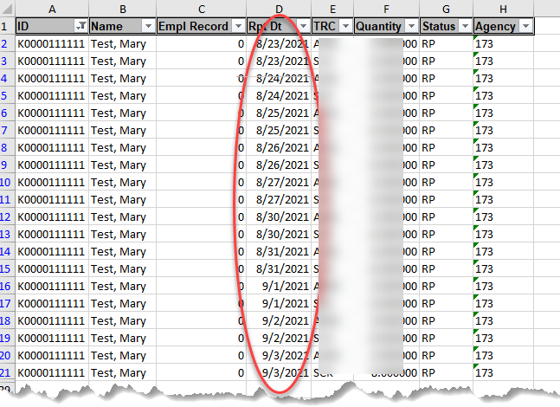
PLEASE NOTE THAT YOU ONLY NEED TO PAY ATTENTION TO THE DATES. THE TRC’S, HOURS, ETC. ARE IRRELEVANT AT THIS POINT. YOU ONLY NEED THE PAY PERIOD TO USE IN YOUR COMPARISON. THIS IS CRITICAL. OTHERWISE, YOU WILL NOT GET VALID RESULTS IN YOUR COMPARISON.
Navigation |  | SHARP > Payroll Homepage > Payroll Processing > Timesheet Review/Approval-Timesheet
4. | SHARP opens to the employee timesheet page.  Enter the Employee ID.  Select the Include Inactive Employees  Get Employees | 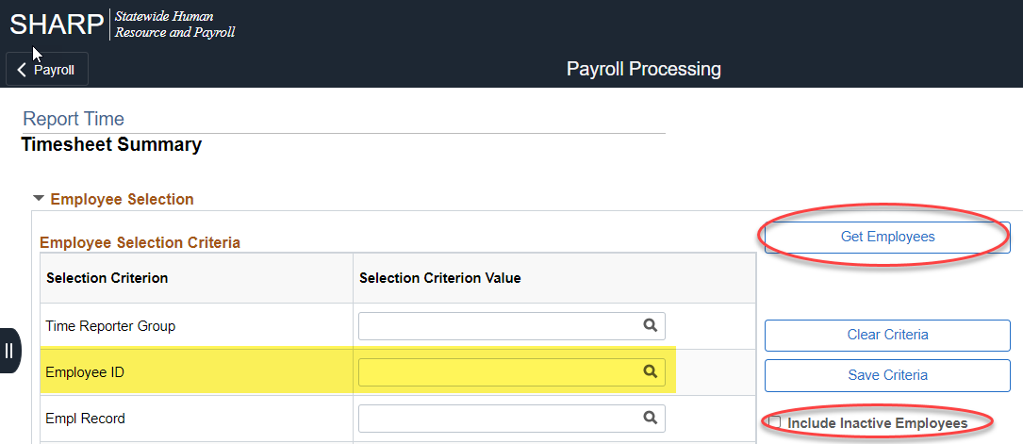
5. | Change the date to the Pay Period End date of the pay period causing the error. (The date(s) you noted in Step 3).  Refresh the Timesheet.  Click on the Last Name hyperlink.  Timesheet displays for the pay period that needs to be researched.  Note all of the Time Reporting Codes that were reported and the hours reported to those codes.  56 PLV  4 SCK  20.25 WCH | 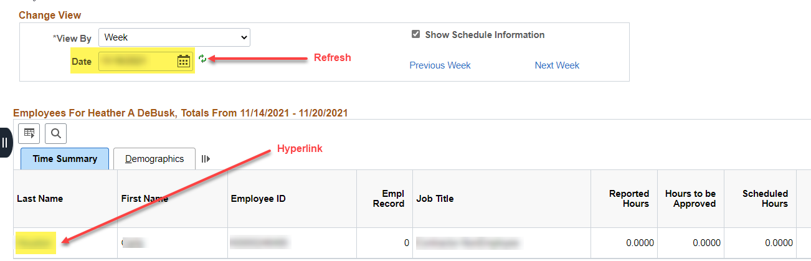  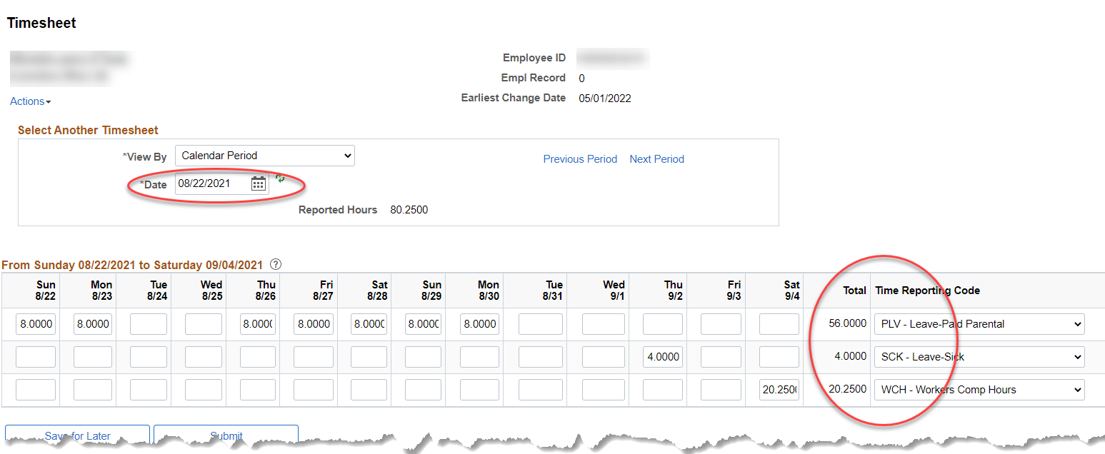
6. | Open New Window. | 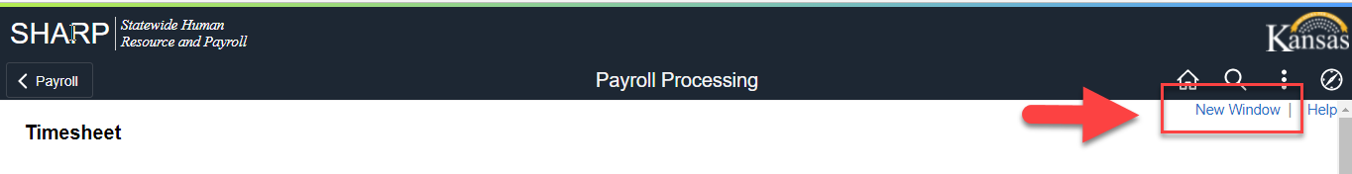
Navigation |  | SHARP > Payroll Homepage > U.S. Payroll WorkCenter > Payroll Queries > Paycheck Detail by Employee
7. | Empl ID  Earnings Begin Date = Pay Period Begin Date  Earnings End Date = Pay Period End Date  View Results  Download results to an Excel Spreadsheet  (The Off Cycle column will contain ‘Y’ if an off-cycle has been requested for this employee for this pay period) | 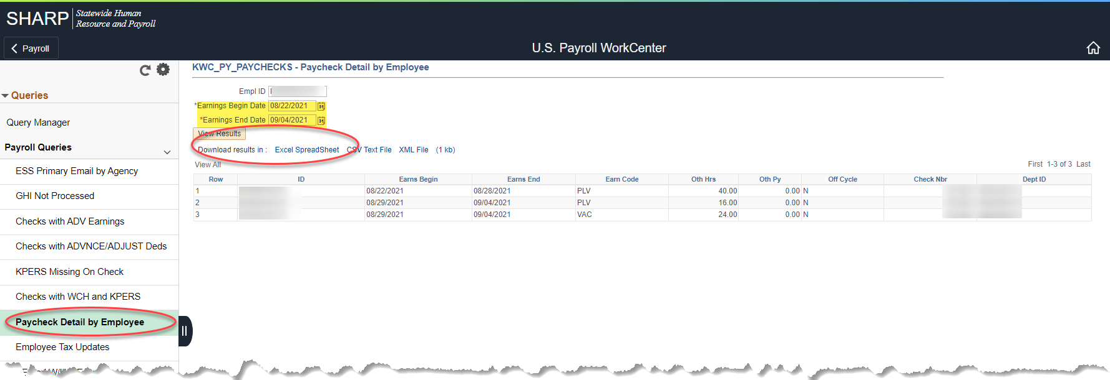  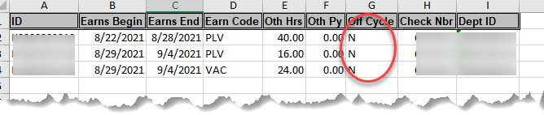
8. | If there are any values in the Check Nbr column of 0, delete those rows. | In the example, in step 7:  TOTAL Other Hours (Oth Hrs), by Earn Code:  PLV 56  VAC 24
9. | Compare the hours on the timesheet, Step 5, to the total Earnings on the paycheck, Step 7.  Timesheet: 56 PLV  4 SCK  20.25 WCH  Paycheck: 56 PLV  24 VAC  The Timesheet and the Paycheck do not match, this is the reason there is an error.
Do the timesheet and paycheck match? |  | If the timesheet and paycheck match, email DOA_Payroll@ks.gov with the employee ID and the pay period end date. Payroll Processing will remove the error. This would happen if the error was corrected through a DA-180.  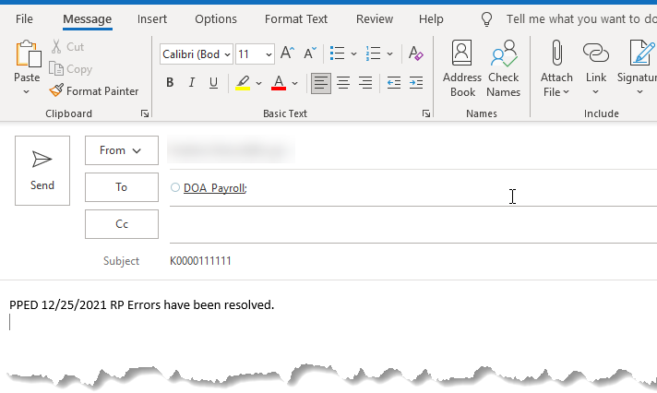
Notes | If the following earnings codes (TRC) are entered on the timesheet, you will need to multiply those hours by 1.5 to get the Earn Code value. 8 XXX TRC = 12 XXX on the paycheck.  - CME  - HCP
Notes | If the following earnings codes (TRC) are entered on the timesheet, you will need to multiply those hours by 0.5 to get the Earn Code value. 8 XXX TRC = 4 XXX on the paycheck.  - HCV
Questions to research for the pay period in question and link to the job aids.  Payable Time Procedures  DA-180 Procedures  ADJ-ALL Procedures |  | 