State of Kansas
Telework Time Reporter Data Setup
Statewide Human Resource and Payroll System

Date Created |  | 2/23/2022
Version |  | 1.0
Security
Description |  | Tracking employee hours worked by the state where the hours were worked.
1. | Payroll Homepage  Employee Payroll/Benefits Data  Job Data | 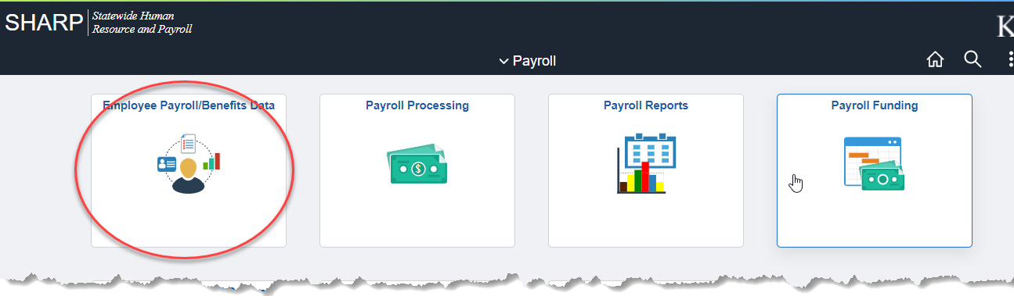  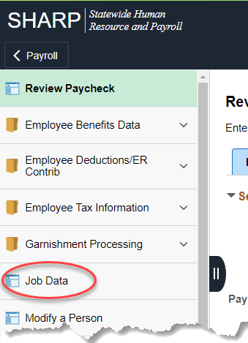
2. | Empl ID  Search | 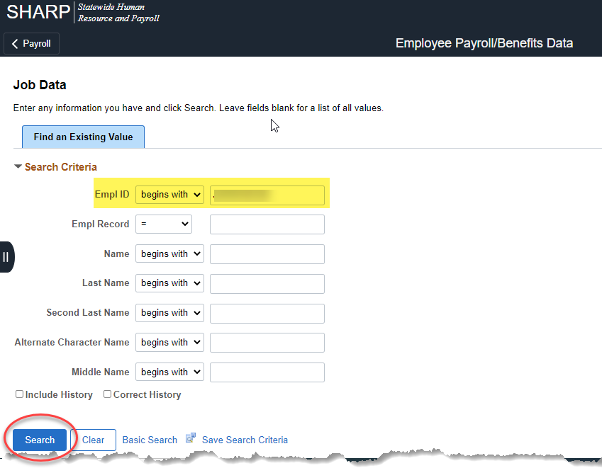
3. | Select the Employment Data Link | 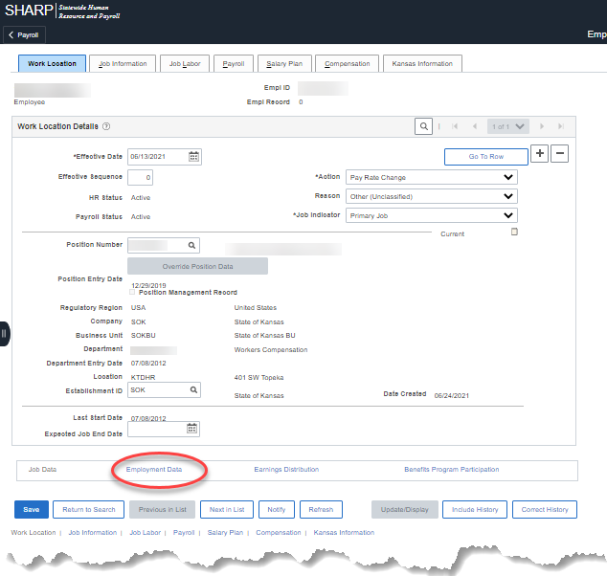
4. | Select Time Reporter Data | 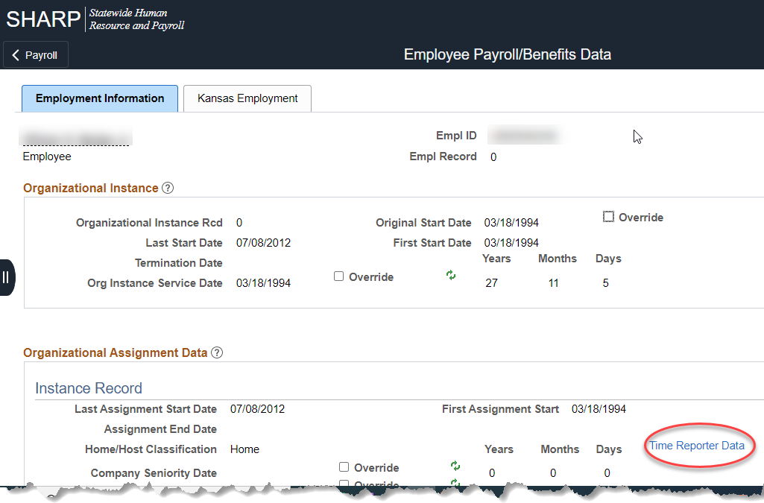
5. | Add a new effective dated row (+)  Effective Date: Pay Period Begin Date for the change (Must be current or future period.)  Time Reporter Type: Elapsed Time Reporter  Elapsed Time Template: DOAUSEONLY  Workgroup and Taskgroup: Use the values that were on the previous row.  OK | 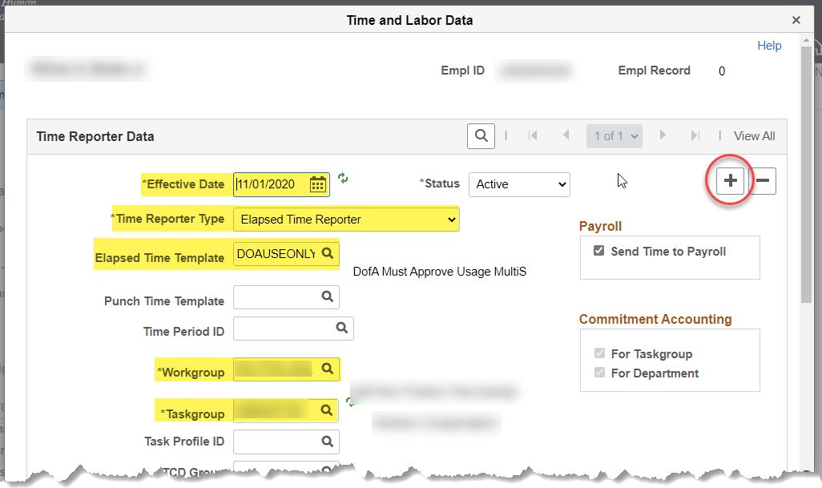  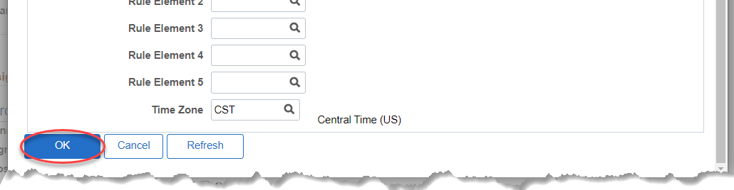
6. | Save | 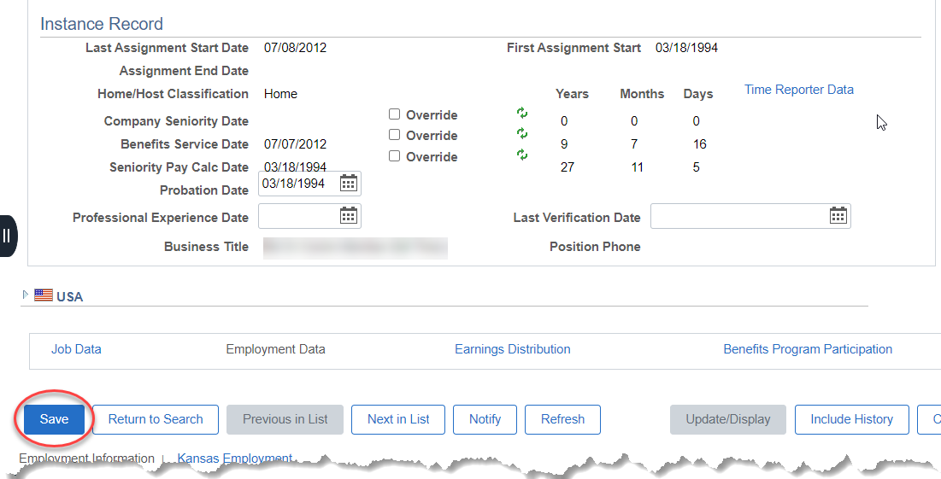
EXAMPLE TIMESHEET
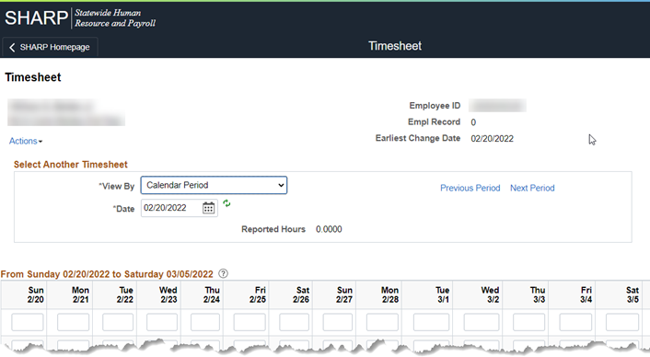

Taskgroup: Agency Default Value
Country: USA
State: Populated by the Employee based on the state the hours were worked in.
Task Profile ID: Blank unless the agency uses Task Profiles.
Add a new row for each new state that needs to be added.
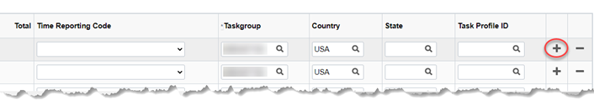

END OF PROCESS

