State of Kansas
Taskgroup Errors on Timesheet
Statewide Human Resource and Payroll System

Date Created |  | 12/30/2021
Version |  | 1.0
Security |  | - SHARP  Role: Agency Time and Labor Timekeeper  -OR-  Role: Agency Time and Labor HR
Description |  | Agency has either:  *Ran the Reported Time Exceptions report  *Been notified by Central Payroll  Employee timesheet has High Severity Exception on the Timesheet:  “The reported Taskgroup is not associated with the reported Task Profile as of this date: SOKLVFUND.”  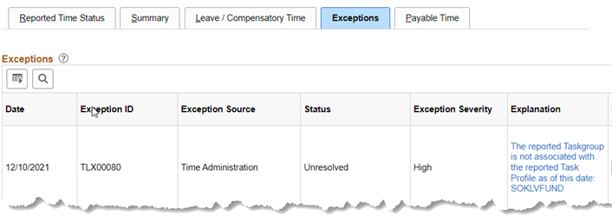
Navigation  *Lesson 2: Reported Time |  | SHARP > Time and Labor Homepage > Reported Time
1. | Timesheet Summary page will open.  *Enter the Employee ID  *Check the Include Inactive Employees Box  *Select Get Employees | 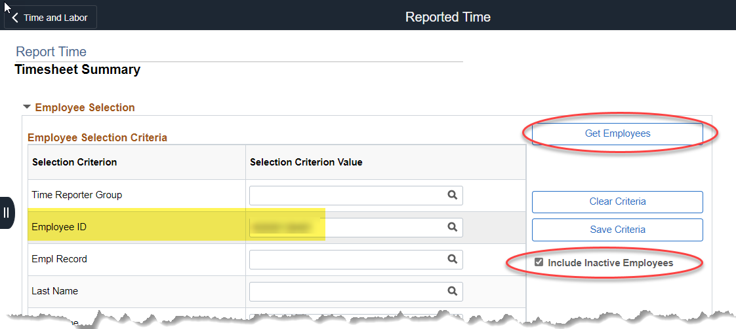
2. | Scroll to the bottom of the page.  Select the employee Last Name link. | 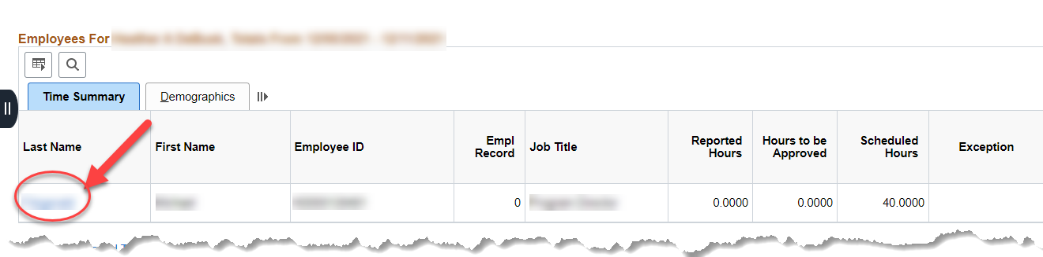
3. | Change the date to the date the hours in error are reported on.  Click on the Refresh Icon. | 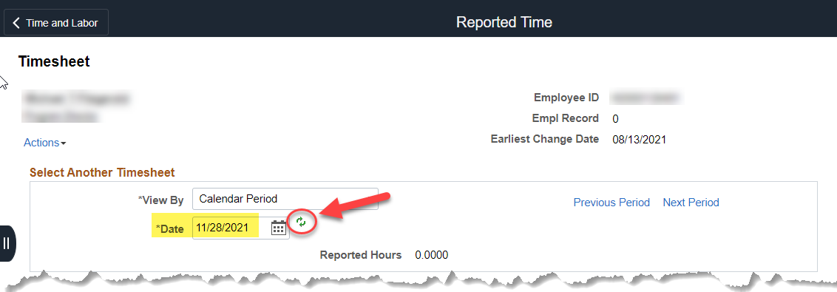
4. | The employee timesheet will display.  If one of the following Time Reporting Codes (TRC’s) are being used on the timesheet with the error, the Taskgroup MUST be SOKLVFUND.  VLK SLK  VLP SLP  *In the screenshot example, the question to ask is: is the VLK TRC the correct code to use? Yes: Change the Taskgroup to SOKLVFUND No: Change the TRC to a valid TRC  For further information on the payout Time Reporting codes, please reach out to sharp@ks.gov. | 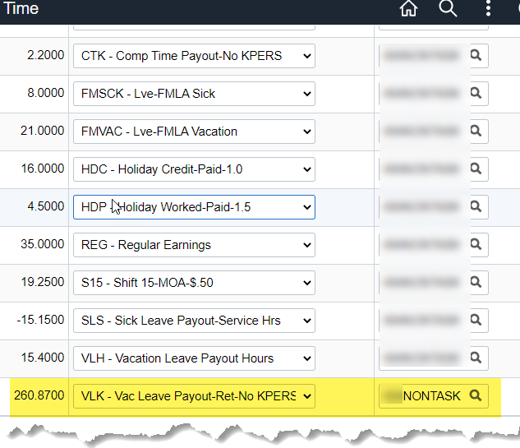
5. | Submit the Timesheet
6. | Approve Timesheet
 | END OF PROCESS

