State of Kansas
Taskgroup Details WorkCenter Query
Statewide Human Resource and Payroll System

Date Created |  | 11/1/2022
Date Updated
Security |  | - SHARP  KS_HR_WORKCENTER_USER  KS_PAYROLL_WORKCENTER_USER  KS_TL_WORKCENTER_USER
Purpose |  | Review the Task Profiles attached to each Taskgroup.
Navigation |  | SHARP > Payroll Homepage > U.S. Payroll WorkCenter > Payroll Queries > Taskgroup Details
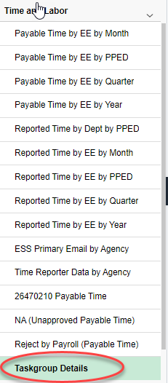

1. | Click on the Taskgroup Details Query Name  Enter three digit agency number. Select View Results. | 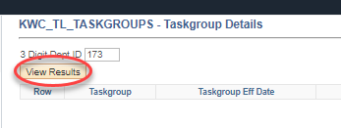
2. | Download Results to Excel | 