State of Kansas
Taskgroups
Statewide Human Resource and Payroll System

Date Created |  | 1/6/2022
Version |  | 1.0
Security |  | - SHARP  Role: Agency Time and Labor Task Reporter
Purpose |  | To create or modify taskgroups.  A taskgroup is a group of task profiles that will be available on an employee timesheet for an employee to report time to.
Navigation |  | SHARP > Time and Labor Homepage > Time and Labor Funding  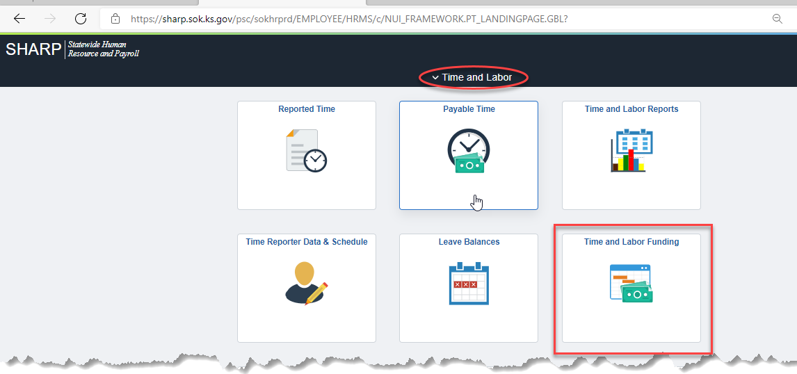
1. | Select Taskgroup | 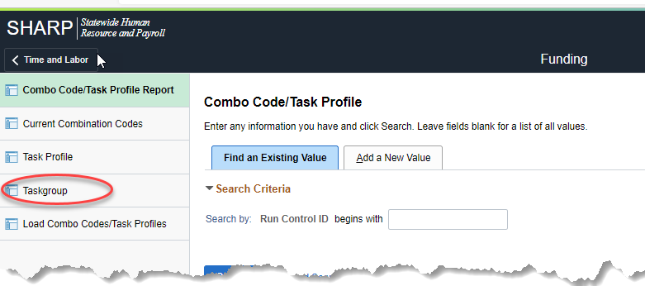
2a. | Adding a New Taskgroup  Add a New Value  Taskgroup: 10 character field- must start with the 3-digit agency number  Add | 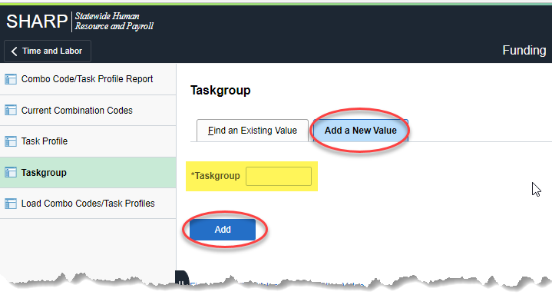
3a. | Effective Date: MUST be a pay period begin date. (If this is not a pay period begin date, employees may not be able to view the taskgroup details on their timesheet until the following period.)  Description: 30 character field  Task Template ID: SOKDETAIL  Elapsed: See Chart to the right – select from values available  Punch: PSPCH_NONE  Status: Will default to Active  Commitment Accounting box must be checked ON | 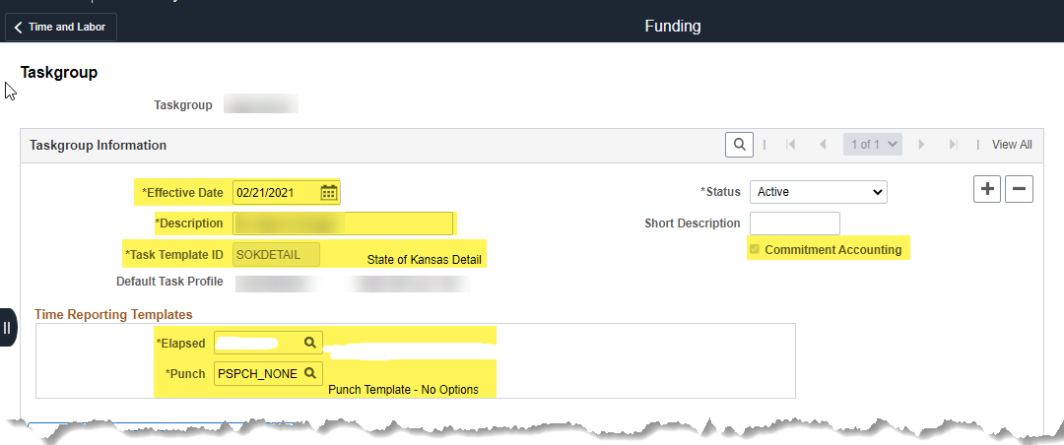  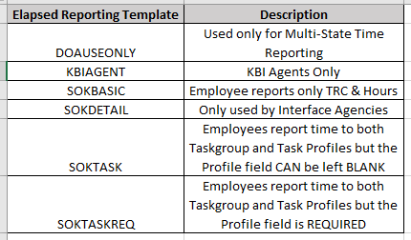
4a. | Under the Valid Task Profile section, enter each task profile that should be included in this group.  To add more than one task profile to the group, select + to add a new line for a new task profile  Each taskgroup requires ONE default profile. Make sure to select a default prior to saving.  Save | 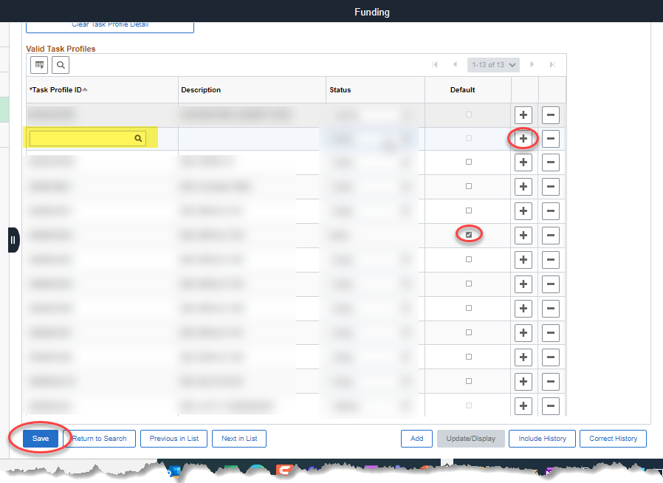
 | Taskgroup is ready to use.
2b. | Update an Existing Taskgroup  Find an Existing Value  Taskgroup: Enter the Taskgroup that is being updated  Search | 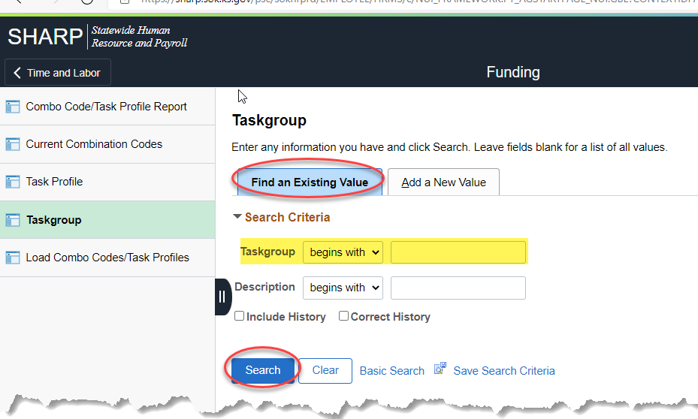
3b. | Add (+) a new Effective Dated Row  Effective Date: Pay Period begin date (If this is not a pay period begin date, employees may not be able to view the taskgroup details on their timesheet until the following period.) | 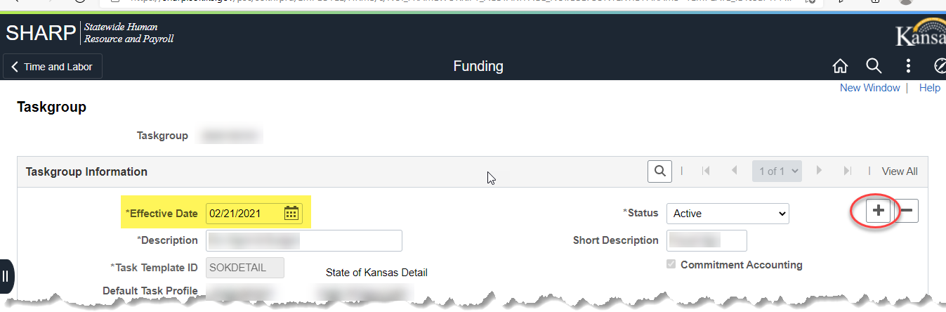
4b. | Under the Valid Task Profiles section:  Add (+) a new row, select the Task Profile ID that needs to be added  Save  On the row that corresponds to the profile that needs to be removed from the group, select the drop down under Status and select Inactive.  Save | Adding a Profile to the Group:  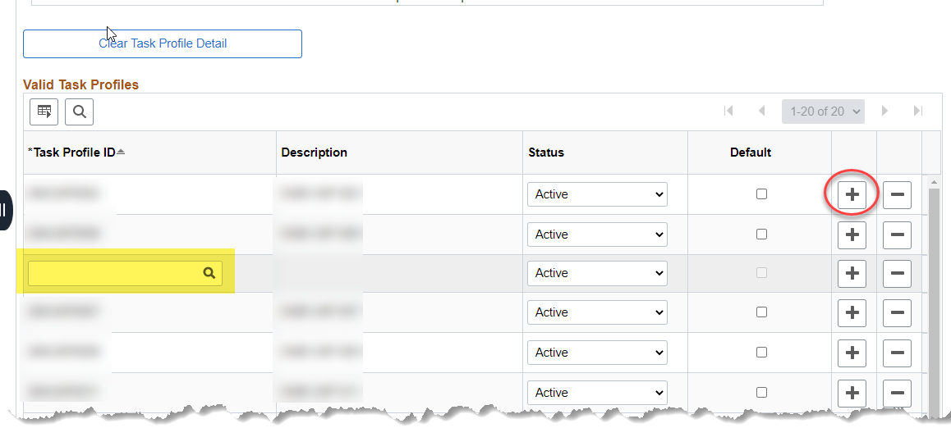  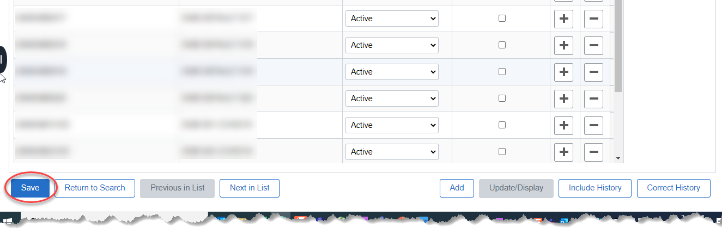  Removing a Profile from a Group:  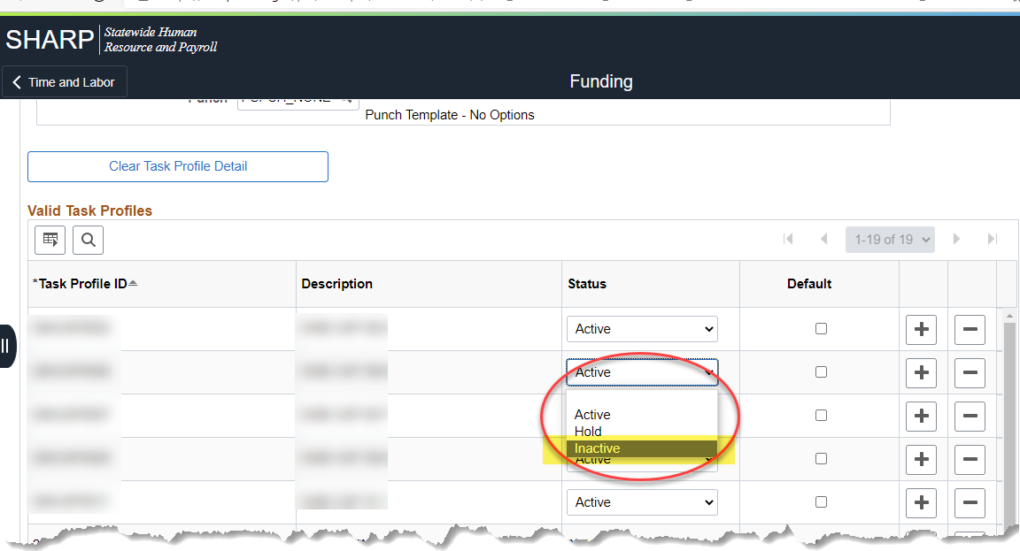
 | END OF PROCESS

