State of Kansas
Supplemental Requests WorkCenter Query
Statewide Human Resource and Payroll System

Date Created |  | 4/19/2022
Version |  | 1.0
Security |  | - SHARP  KS_HR_WORKCENTER_USER  KS_PAYROLL_WORKCENTER_USER  KS_TL_WORKCENTER_USER
Purpose |  | Verify that the supplemental that was requested through the timesheet is set to run when the next off-cycle payroll processes.
Important Information |  | This query will only pull Supplemental Requests entered by the User ID of the user who is running the report. It will not pull all Supplemental Requests entered for the agency.
Navigation |  | SHARP > Payroll Homepage > U.S. Payroll WorkCenter > Payroll Queries > Supplemental Requests
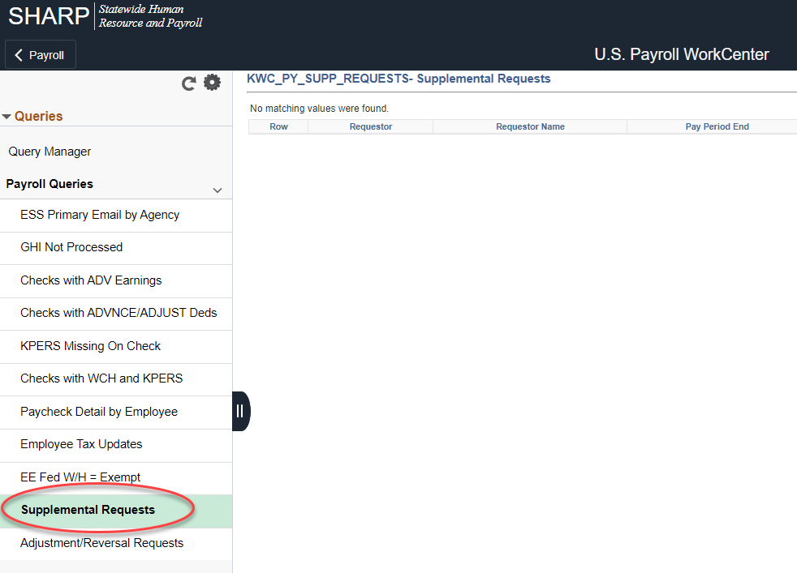

1. | Click on the Supplemental Request Query Name  Requestor and Requestor Name  Pay Period End  Dept ID  ID: Employee ID for the Supplemental Request  Empl Record  Request Date: Date the request was entered | 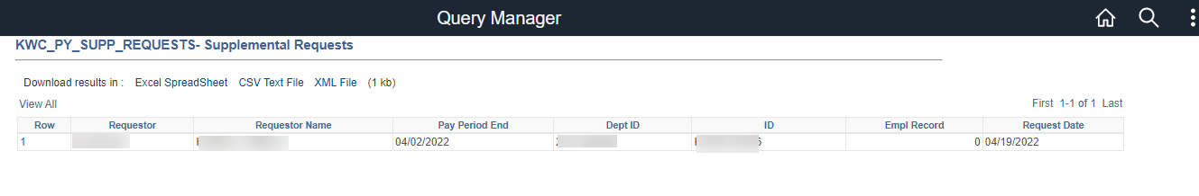  This display shows all supplementals requested by your user ID. Anything listed here is scheduled to process when the next off-cycle payroll is ran.

