State of Kansas
Supplemental
Statewide Human Resource and Payroll System

Date Created |  | 9/20/2022
Version |  | 1.0
Security |  | - SHARP  Access to the following to request Supplemental:  Role: Agency Time and Labor HR  Agency Payroll Specialist
Purpose |  | Request paycheck adjustment using the Supplemental process.  A supplemental is only used when there was NO ON-CYCLE paycheck created.  The supplemental will create a paycheck based on the hours entered on the timesheet. The process is run in one of the 3 off-cycle payroll runs for the pay period immediately following the on-cycle confirmation.  If it is discovered that a supplemental needs to process after the three off-cycles for the period have run, a DA-180 will need to be submitted.  Step One should always be to request a supplemental.
Navigation |  | SHARP > Time and Labor Homepage > Reported Time > Timesheet
1. | Enter Employee ID  Get Employees | 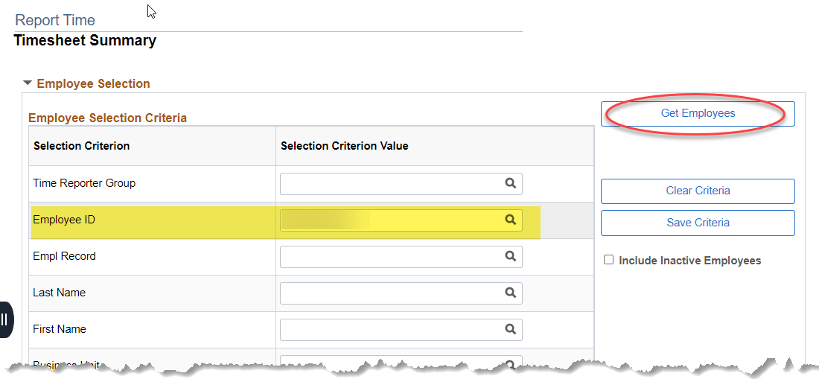
2. | Select Employee ID | 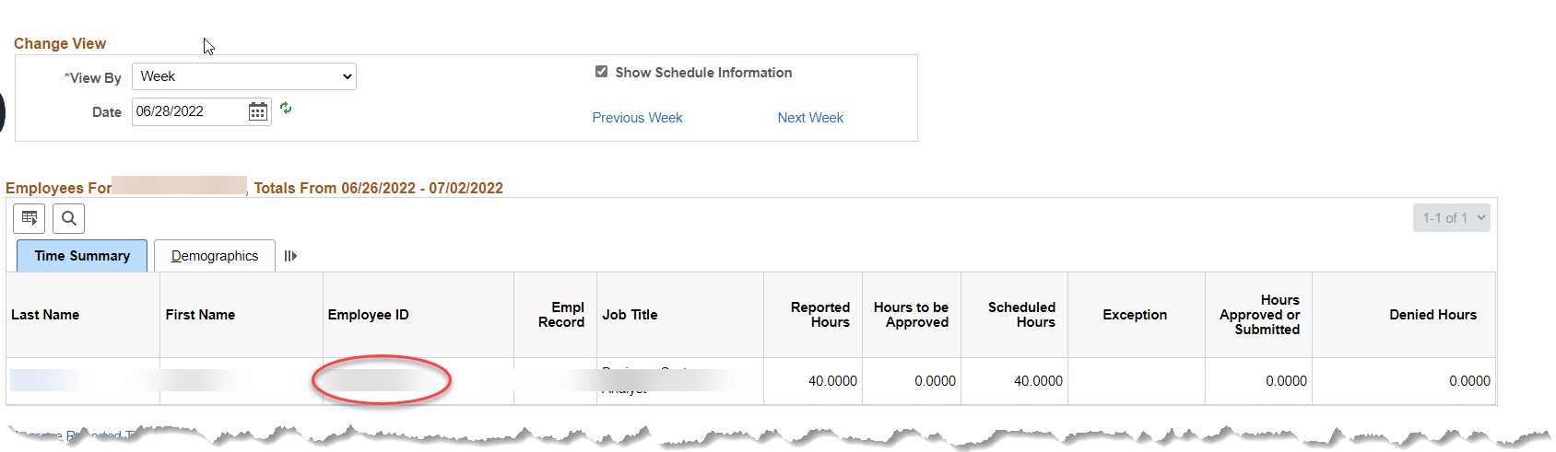
3. | *Go to the period needing adjusted  *Verify Request Supplement Supplemental Box is available (if this box is not available, a DA-180 will need to be requested)  *Enter hours to be paid | 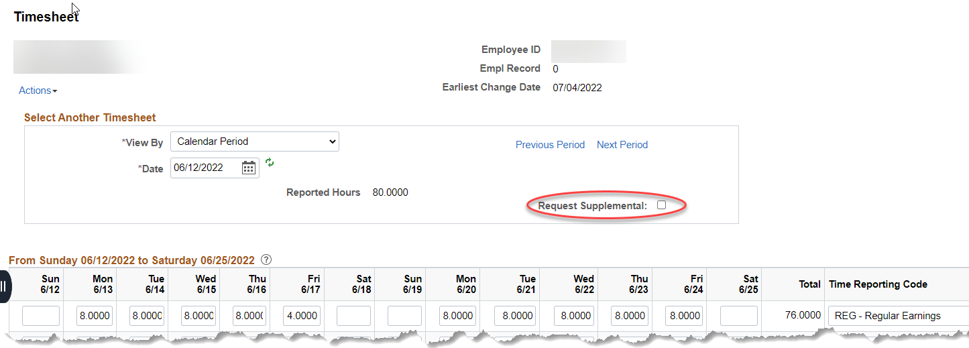
4. | Select Request Supplement Box | 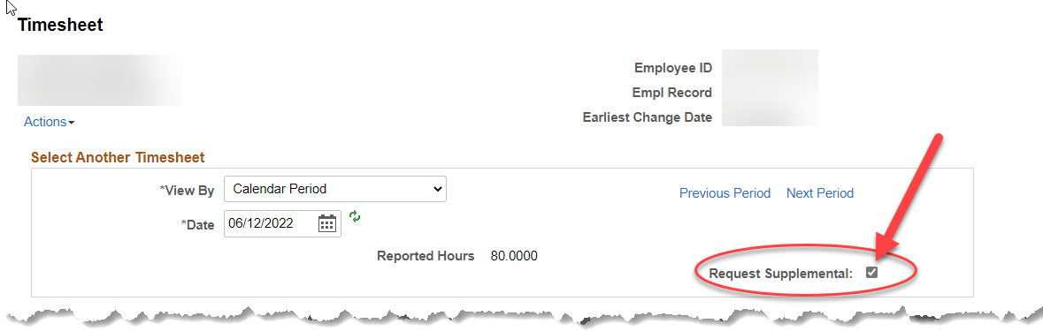
5. | Submit Timesheet  Select OK | 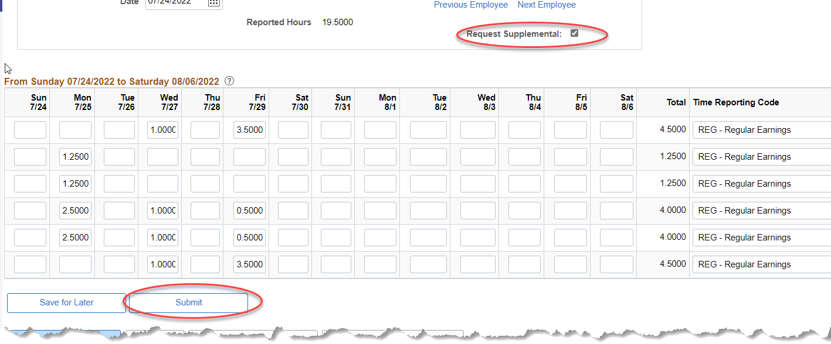  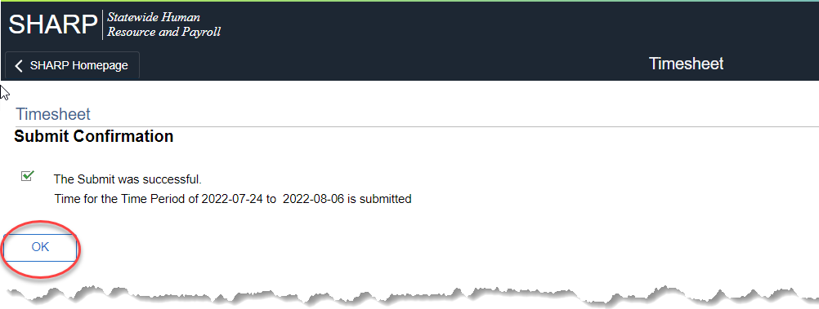
6. | *Select the hours you want to approve.  *Approve | 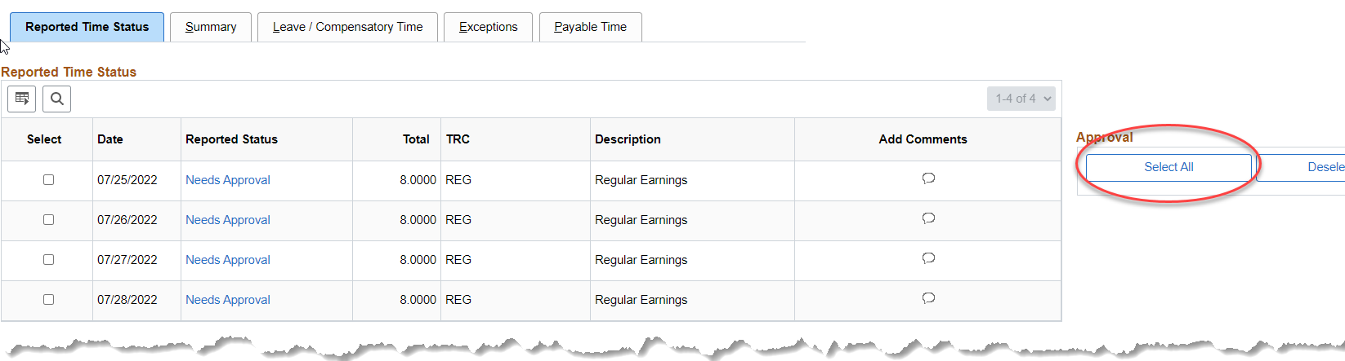  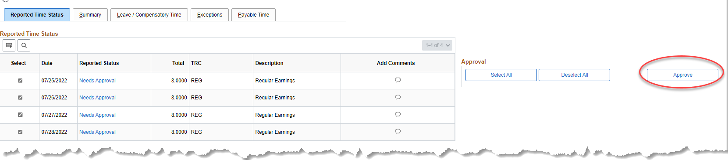
7. | *After Time Administration has ran, approve Payable Time
8. | Once all approvals are completed, run the Payroll WorkCenter Query Supplemental Requests to make sure the request is staged to be processed.  Simply click on the query name. If the supplemental is set to process, it will show. There are no parameters to enter. | 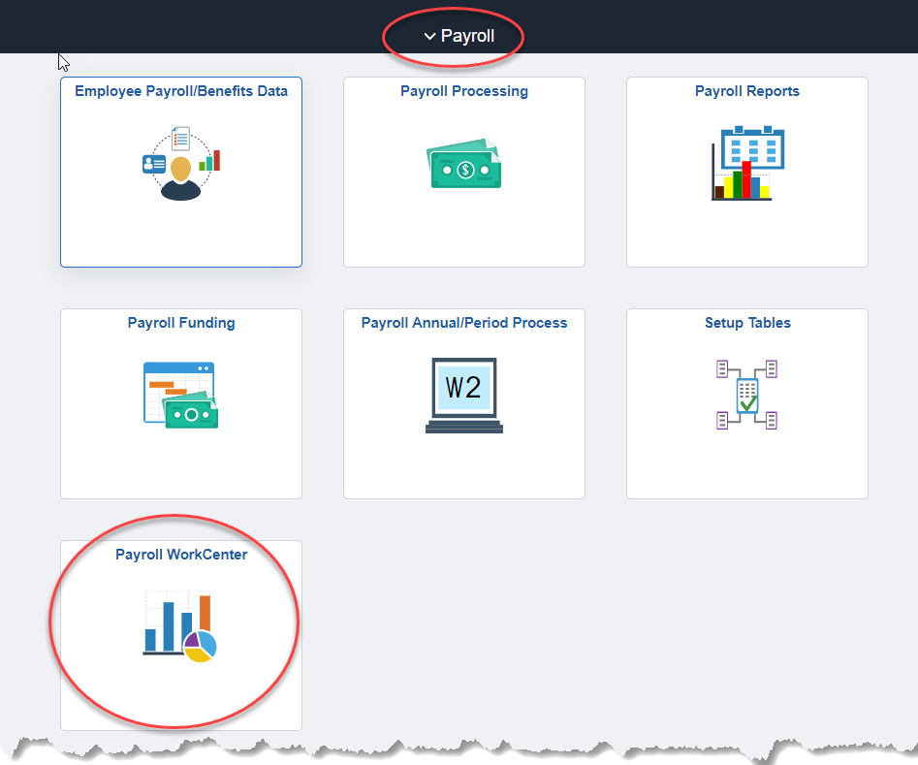  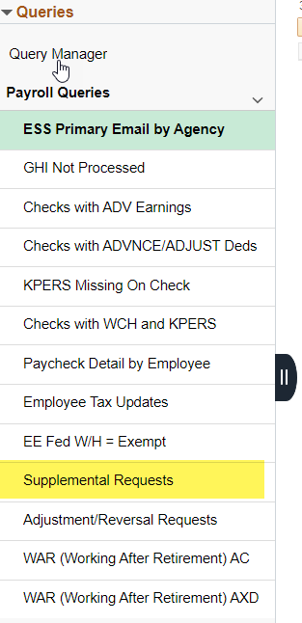
Refer back to Payroll Checklist for Final Steps

