State of Kansas
Setting up Direct Deposit in SHARP
Statewide Human Resource and Payroll System

Date Created |  | 3/21/2022
Date Updated |  | 7/25/2023
Security |  | - SHARP  Role: Agency Payroll Specialist
Description |  | These steps are completed once the employee has filled out the DA-184 form to authorize direct deposit.
Examples for Multiple Accounts |  | Employee has 3 bank accounts.  *10% to Account A  *5% to Account B  *Balance to Account C  Set employee Account A as priority 1, Account B as priority 2, and Account C as priority 3 for Balance of Net Pay.  Employee has 4 bank accounts.  *$100.00 to Account A  *$200.00 to Account B  *$50.00 to Account C  *Balance to Account D  Set employee Account A as priority 1, Account B as priority 2, Account C as priority 3, and Account D as priority 4 for Balance of Net Pay.
Things to Remember |  | For an employee with multiple bank accounts, split by amount:  - If an adjustment is processed for an employee, and the net pay of the adjustment is less than the total of priority 1, the entire net pay will go to priority 1  - If an adjustment is processed for an employee, and the net pay of the adjustment is less than the total of priorities 1 and 2, the net pay will go to priority 1, and the balance to priority 2.  If an employee has terminated before they had a chance to update their banking information, a paper check will be issued.
Navigation |  | SHARP > Payroll Homepage > Employee Payroll/Benefits Data > Request Direct Deposit
1. | Enter the Employee ID  Select Search.  *Before proceeding with adding any information, verify the name listed matches the name on the DA-184 form. If the name does not match, verify the employee ID is correct and reconfirm information with employee.  If there is no existing row, enter the data directly to this page. If this is an upate, add a new row of banking information by selecting +. | 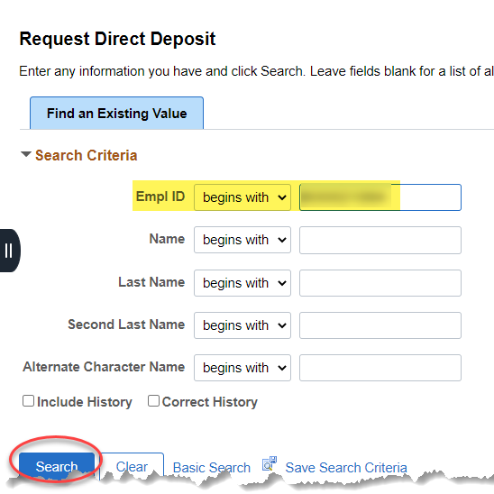  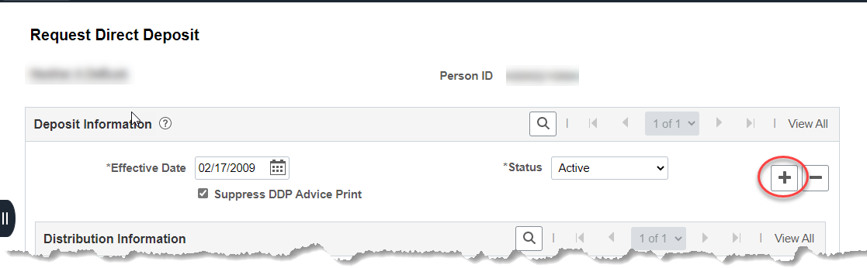
2a. | For Direct Deposit to 1 Bank Account  Effective Date: Enter the current date  Bank ID: Enter the bank routing number, the Bank Name and Address will load based on this entry  Account Type: Select Checking or Savings  Net Pay Percent: 100  Priority: 1  Account Number: Enter the account number including any leading zeroes  Deposit Type: Percent  Select Save. | 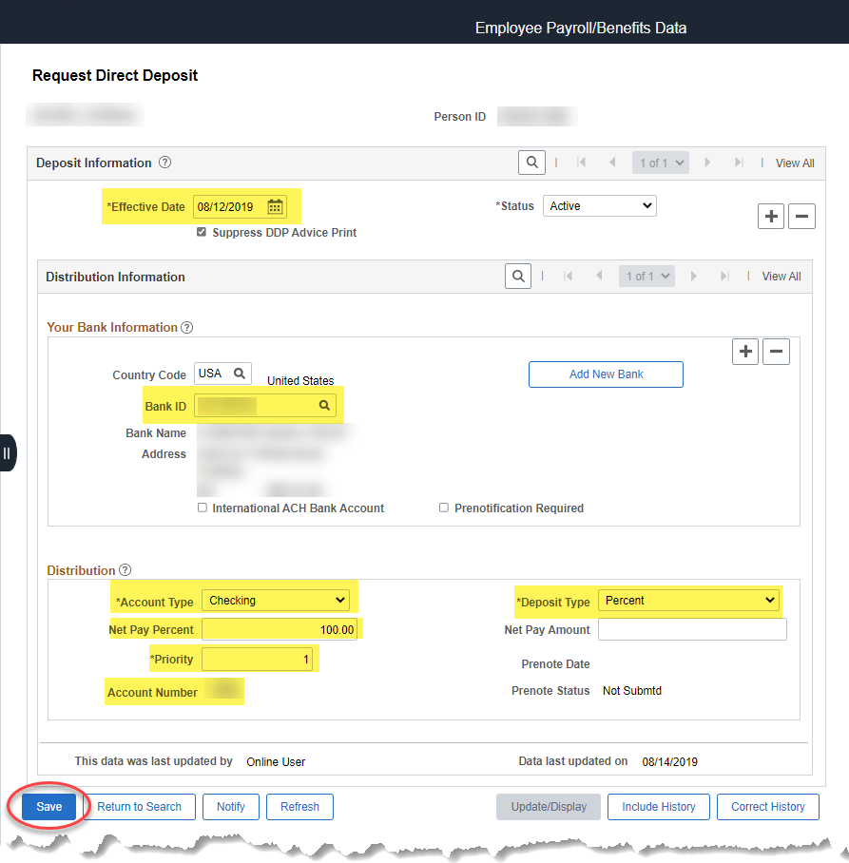
2b. | For Direct Deposit to multiple Bank Accounts  Effective Date: Enter the current date  Bank ID: Enter the bank routing number, the Bank Name and Address will load based on this entry  Account Type: Select Checking or Savings  Net Pay Percent: For multiple accounts, this can either be blank or be a percent of the total payment. The Net Pay Percent and Net Pay Amount cannot both be populated. It’s one or the other, not both.  Priority: Must be populated 1-XXX  Account Number: Enter the account number including any leading zeroes  Deposit Type: Amount or Percent, depending on whether Net Pay Percent or Net Pay Amount was populated. Amount=Amount, Percent=Percent  + to add the next bank account  Add all Percentage and/or Dollar amount rows. | 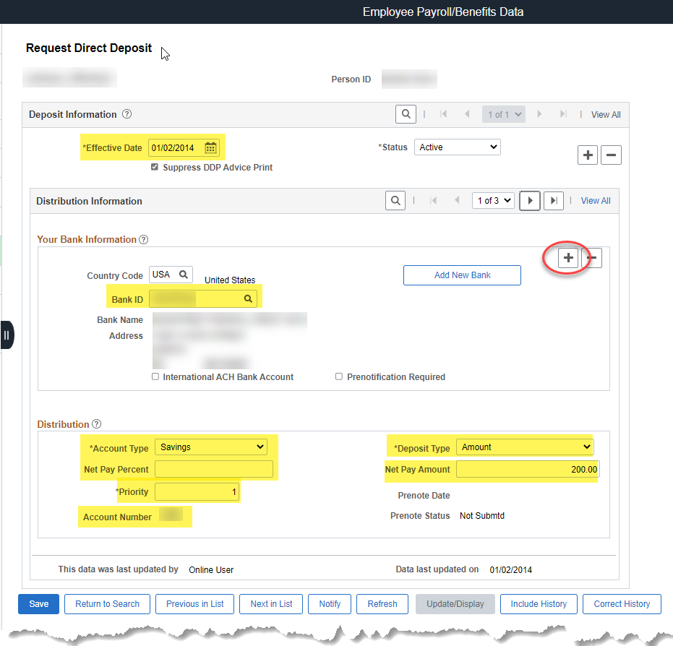
3. | Adding Balance of Net Pay Account  + to add row for Balance of Net Pay Account  Effective Date: Enter the current date  Bank ID: Enter the bank routing number, the Bank Name and Address will load based on this entry  Account Type: Select Checking or Savings  Priority: This will be the last number in the sequence of account number count. (4 bank accounts entered? This priority will be 4.)  Account Number: Enter the account number including any leading zeroes  Deposit Type: Balance of Net Pay  The last row added will need to have the Deposit Type of Balance of Net Pay.  Save | 