State of Kansas
PRA Adjustment
Statewide Human Resource and Payroll System

Date Created | 7/26/2023
Date Updated | 9/5/2023
Purpose | The PRA adjustment is a pay affecting retroactive earning adjustment due to pay rate changes.
Information | Any retroactive earnings adjustments due to pay rate changes, such as late step increases or late promotions, should be calculated as an amount owed to the employee and processed in the next on-cycle payroll through the Time and Labor process.
- Use the Online Check job aid (Payroll Procedures/Job Aids > Adjustments > Online Check), Step #3, to calculate the “should be” gross amount.
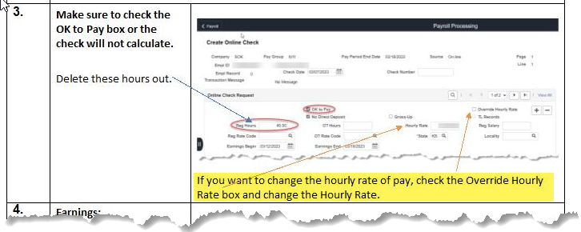
- Once the online check has created, verify that the only thing that has changed is the pay. If any hours have changed, this will need to be processed through an adjustment.
- Once the online check has been verified, the PRA will be the difference between the original check gross and the online check gross. This total of the difference in all TRC’s will be the PRA amount.
  - If this affects several pay periods, please follow the above step for each pay period and add together the total of all differences to get the PRA amount.
  - If an employee has been overpaid, follow the same steps as above.
- Go to the current timesheet for the EE and enter PRA as the Time Reporting Code (TRC) and the dollar amount from #3 in the hours field on the last day of the pay period. Submit the timesheet and approve payable time.
  - If this affects several pay periods, the PRA will only need to be entered on the current timesheet.
  - If an employee has been overpaid, follow the same steps as above. The only difference would be, the PRA would be entered as a negative. This will take money back from the on-cycle check.

If the EE is terminated, and there is no on-cycle check being processed, a DA-180 will need to be completed.

Please note:
- If multiple terminated employees need to be paid using the PRA code, a separate DA-180 needs to be completed for each employee being paid.
- The agency will need to keep the details that were submitted, that way if the agency were to ever get audited on how they came up with the PRA amount they would have the details.

