State of Kansas
Opening .DAT Files
Statewide Human Resource and Payroll System

Date Created |  | 12/21/2021
Version |  | 1.0
Security |  | Microsoft Excel
Purpose |  | Instructions to open SHARP .DAT files in Excel.
1. | Open Microsoft Excel  Open a Blank Workbook  Within the Data toolbar ribbon, select Get Data > From File > From Text/CSV  If Get Data is not in your ribbon, you can search for ‘get data from text’ in your Search box  Navigate to the Folder where the file is saved that you want to open. Change the file version to All Files.  Import  Make sure Delimited is selected.  Next  Semicolon  Next  If you need to format any columns you can do that here.  *For the Combination Code_TaskProfile Report, highlight all of the columns and format the columns as Text.  Finish  OK | 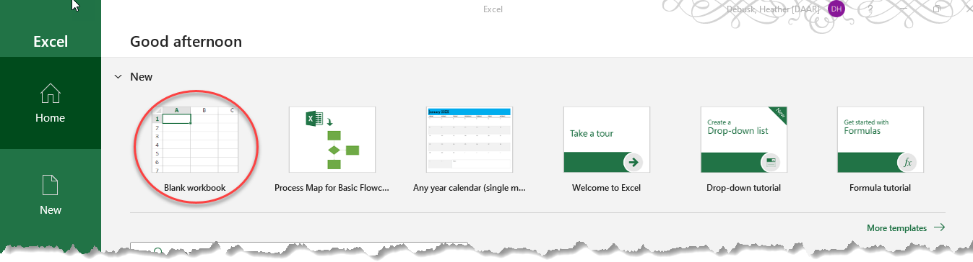  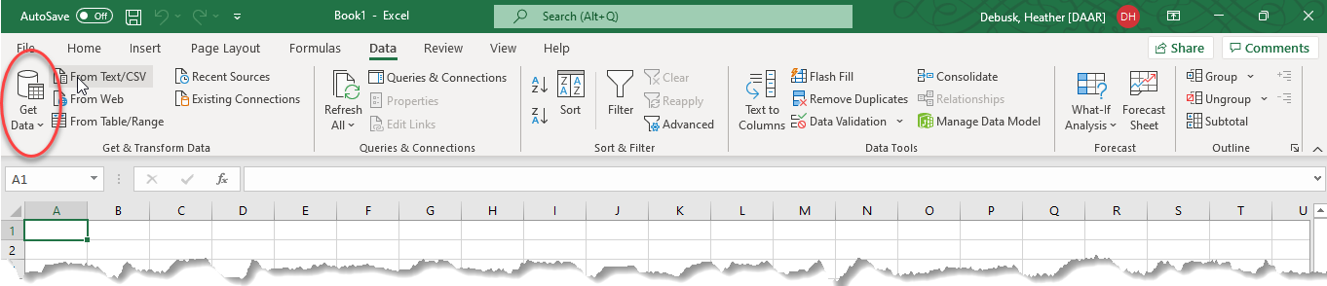  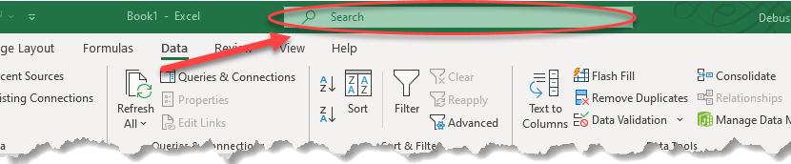  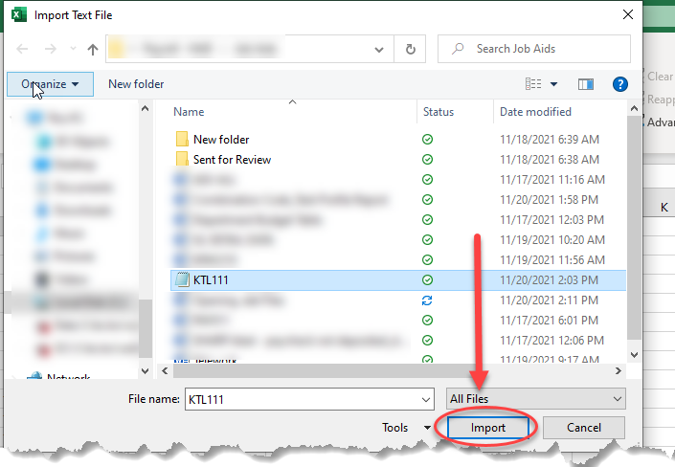  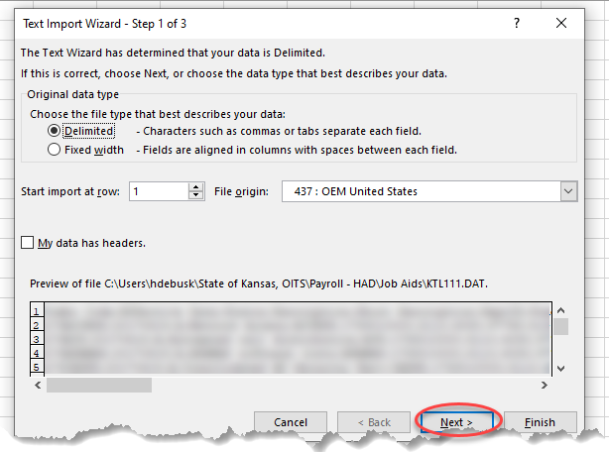  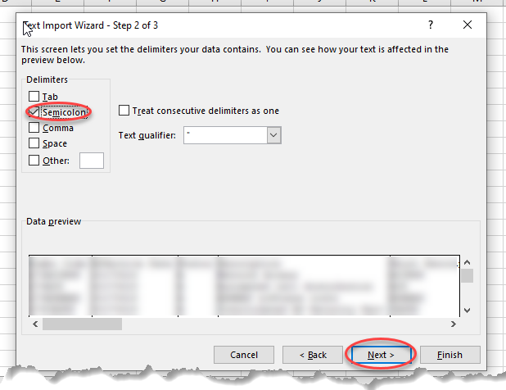  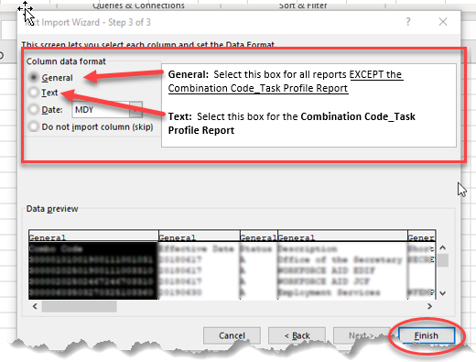  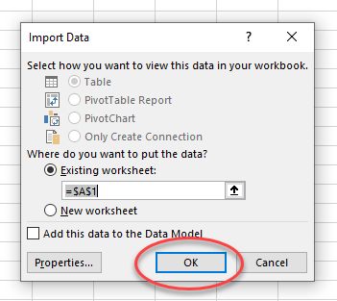
Instructions |  | Report has been loaded to Excel.
Save File |  | Save File to a place where it can be retrieved again. Save the file as an Excel Workbook.  