State of Kansas
Online Check
Statewide Human Resource and Payroll System

Date Created |  | 4/5/2023
Date Updated |  | 6/9/2023
Security |  | - SHARP  Role: KS_AGY_PAYROLL_MANAGER
Purpose |  | Replicate paycheck to visualize any potential changes.  - Taxes  - Deductions  - Pay
IMPORTANT NOTES |  | - This tool is to TEST different scenarios and to see the impact those changes would have on net pay. Nothing done in this tool will change how an employee is currently paid.  - Agencies will be referred to this tool for any calculations needed to complete non-settlement related requests. Payroll Services will no longer be providing these calculations to agencies.  - Make sure to DELETE the online check when finished with your paycheck modeling.
Navigation |  | SHARP > Payroll Home Page > Payroll Processing > Online Checks > Create Online Check  -OR-  SHARP > Navigator > Payroll for North America > Payroll Processing USA > Create Online Checks > Create Online Check  Online check cannot be used if the on-cycle payroll is being processed. (Wednesday-Friday) You will have to wait until the day of OffCycle A.
1. | Pay Period End Date: This is the end date for the NEXT Pay period  Empl ID  Search | 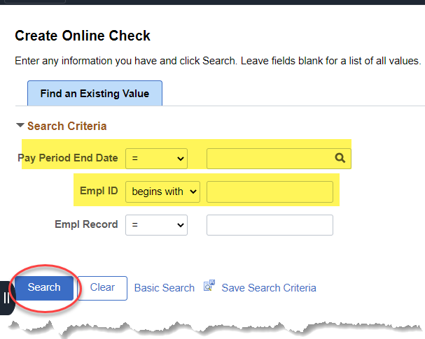
2. | Note: If you are processing an online check for a terminated employee, you will want to select ‘NO’ here. Otherwise, a paysheet will not create.  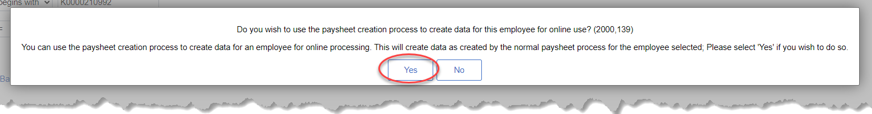  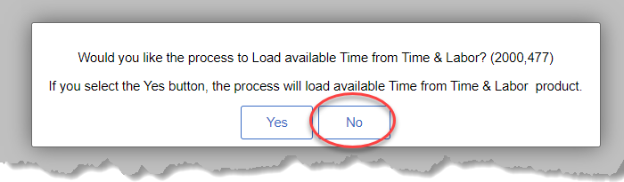
3. | Make sure to check the OK to Pay box or the check will not calculate.  Delete these hours out. | 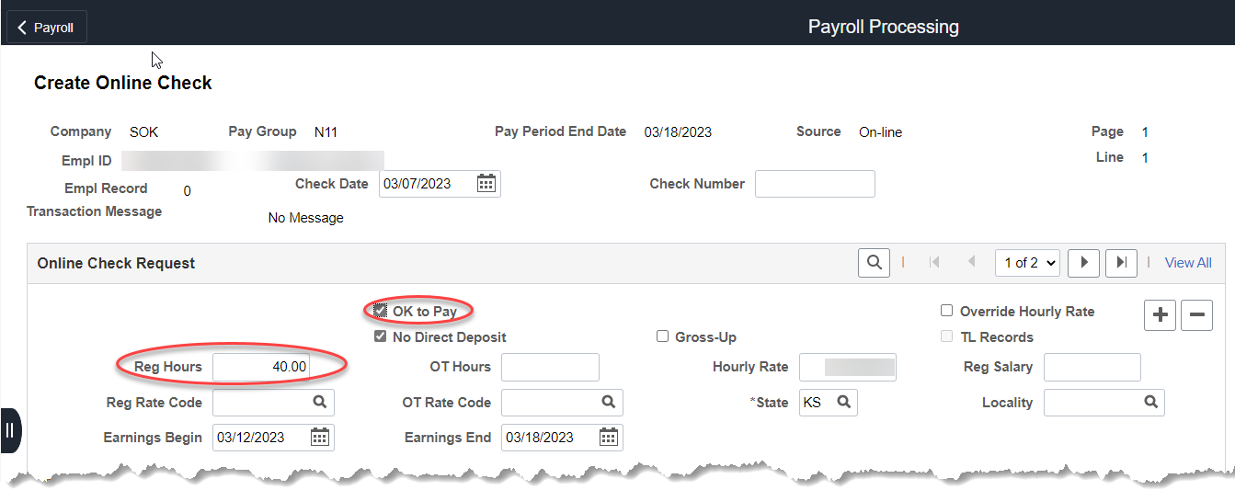  If you want to change the hourly rate of pay, check the Override Hourly Rate box and change the Hourly Rate.
4. | Earnings:  Add the earnings you need to calculate here.  Add Row (+) to add additional rows. You can also delete rows. (-) | 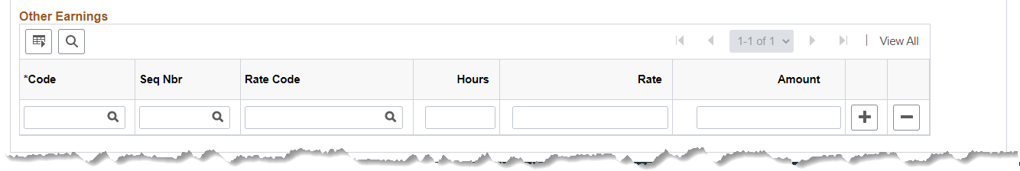  Make sure to pull the TGL (Taxable Group Life) amount from the paycheck you are adjusting and include that amount as part of the earnings.
5. | Deductions:  Deduction Taken: Subset  Deduction Subset: NGN This will pull all deductions in that are set up in the system, like KPERS, Arrears, etc. You will have to manually set up GHI.  Deduction Taken: None  Deduction Subset: Blank  No deductions will be calculated.  You can manually add deductions to be calculated with the online check, using this screen.  Since the employee deductions are the only deductions that affect the employee pay, you do not enter the employer deductions. | 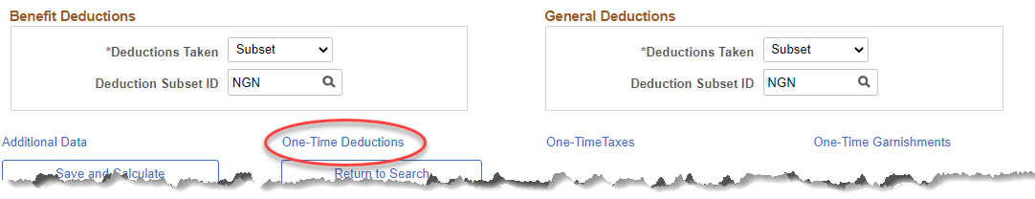  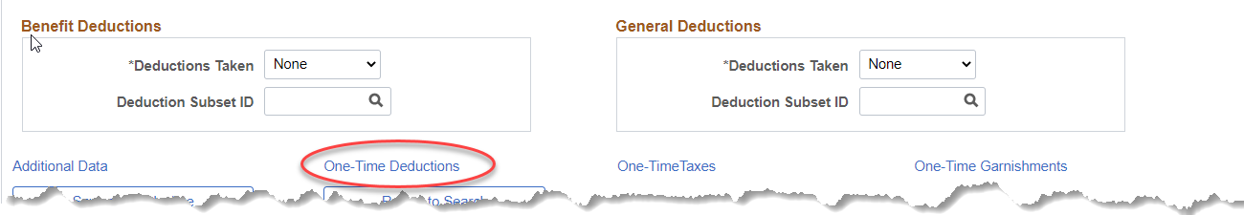  Selecting One-Time Deductions  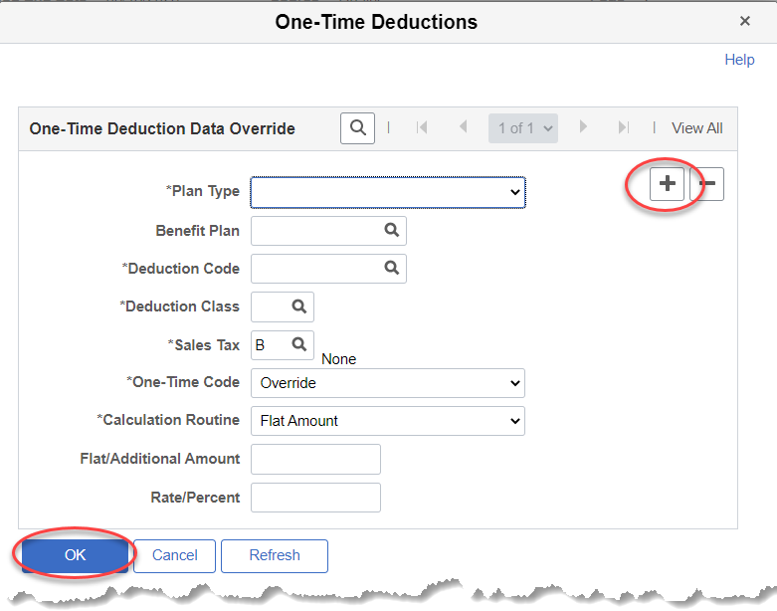
6. | Save and Calculate | 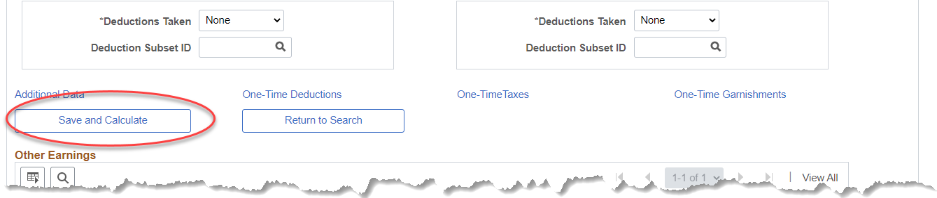
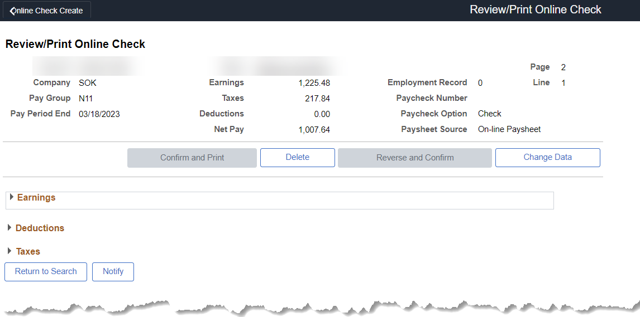
You can select Earnings, Deductions, or Taxes for the details. If you need to change the data, select Change Data.
This will take you back to step #3.

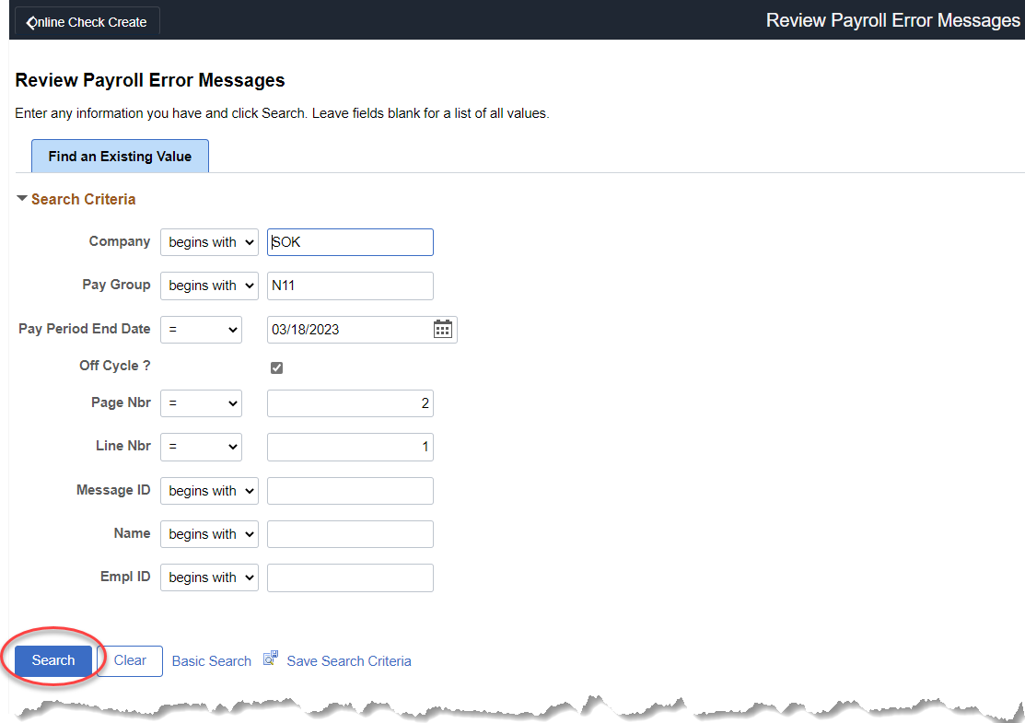
If your check has an error, you will see this screen. Select Search.
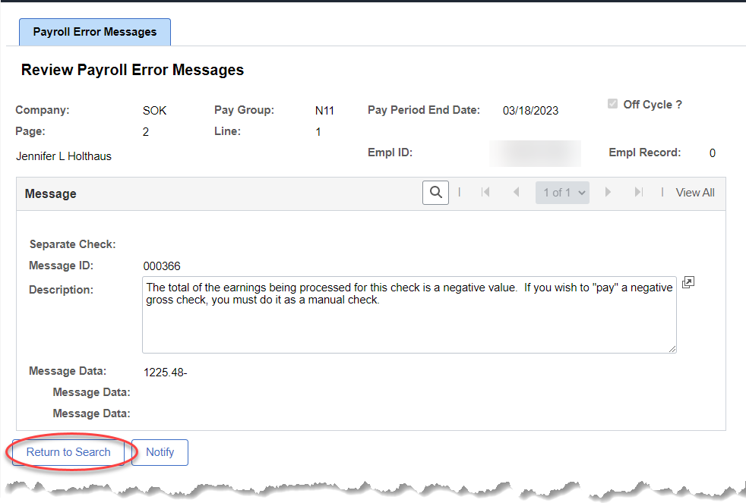
If you need help deciphering the error, email payadj@ks.gov. Once you have identified the error, go back to the paycheck by selecting Online Check Create

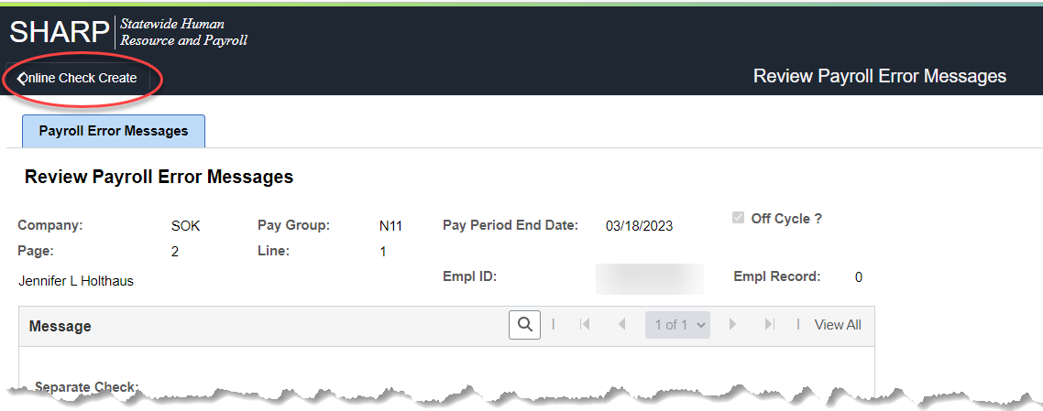

7. | Once you have successfully gathered all of your information, Delete the Online Check | 