State of Kansas
Max Arrears Payback
Statewide Human Resource and Payroll System

Date Created |  | 5/5/2023
Updated |  | 9/21/2023
Security |  | - SHARP  Role: Agency Payroll Specialist
Purpose |  | This process is used to split an existing arrearage into several pay periods.
Reference |  | - Max Arrears Payback form: https://admin.ks.gov/offices/accounts-reports/state-agencies/payroll/payroll-procedures-job-aids  - PAY007: Deductions in Arrears
1.  Total Amount to be Collected: Total amount employee is paying back, Arrears Balance  Number of Pay Periods: Pay periods that employee will be using to pay debt back  Amount per Pay Period: Total amount divided by number of pay periods. |  | Employee is showing on the PAY007. The agency and employee must have a completed Max Arrears Payback form on file in order to recoup the arrears balance over several payperiods. Otherwise, this amount will be recouped, in its entirety, from the next available paycheck. This form must be completed, signed by both parties, and on file at the agency before moving to Step  2.  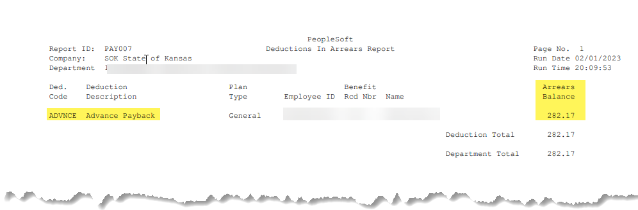  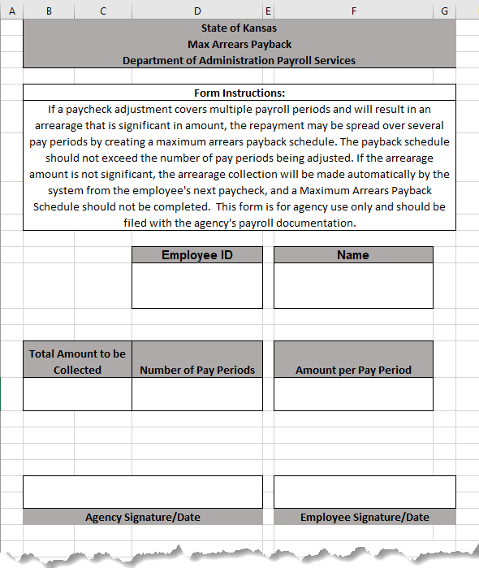
2. | Payroll Home Page > Employee Payroll/Benefits Data > Employee Deductions/ER Contrib > Override General Deductions  Enter Empl ID  Search |  | 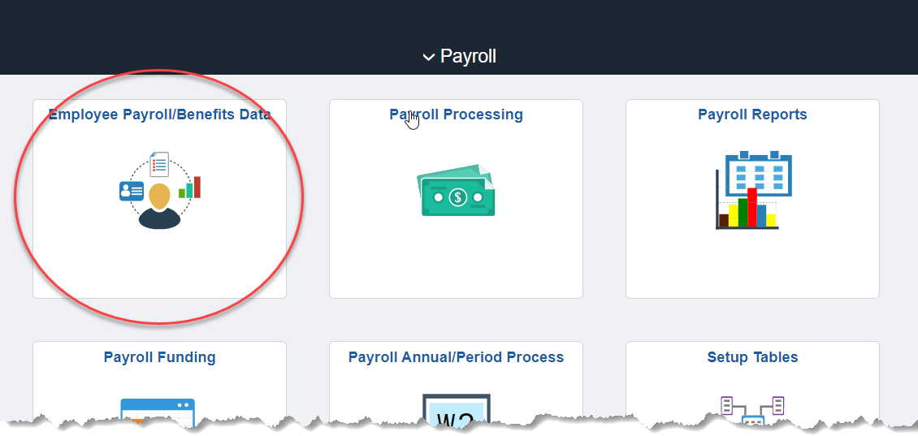  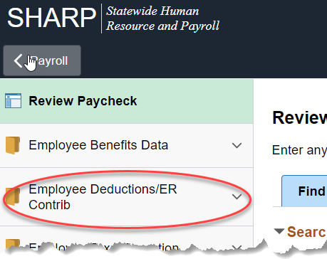  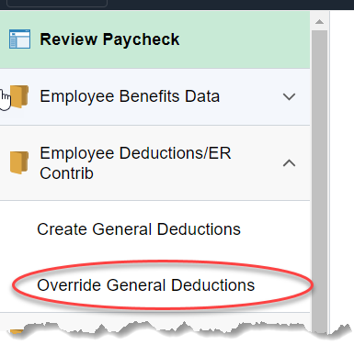  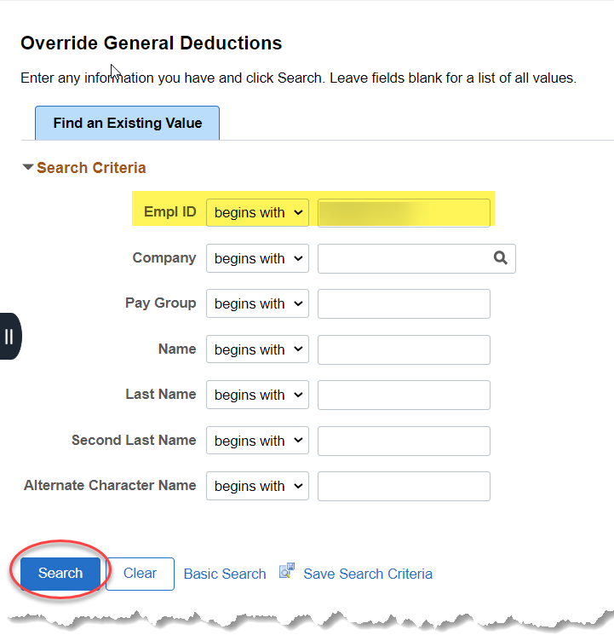
3. | Enter the Deduction Code that is in arrears  ADVNCE or ADJUST  Leave the Pay Period boxes alone.  Check the Maximum checkbox.  Enter the Maximum Amount: This will be the amount that the employee agrees to pay back each pay period.  - Ex: If there is a total ADV of $2,390.01 and the EE agrees to pay back the ADV in 7 pay periods, take $2,390.01 and divide by 7, this will get your maxmium amount of $341.43, put $341.43 in the maximum amount box. This amount will be taken every pay period. For the last payment please see the last bullet point under please note on the right hand side, please use this only if there is a rounding issue.)  If you need to set up another pay back for another code, select the ‘+’ and repeat the process.  Save |  | 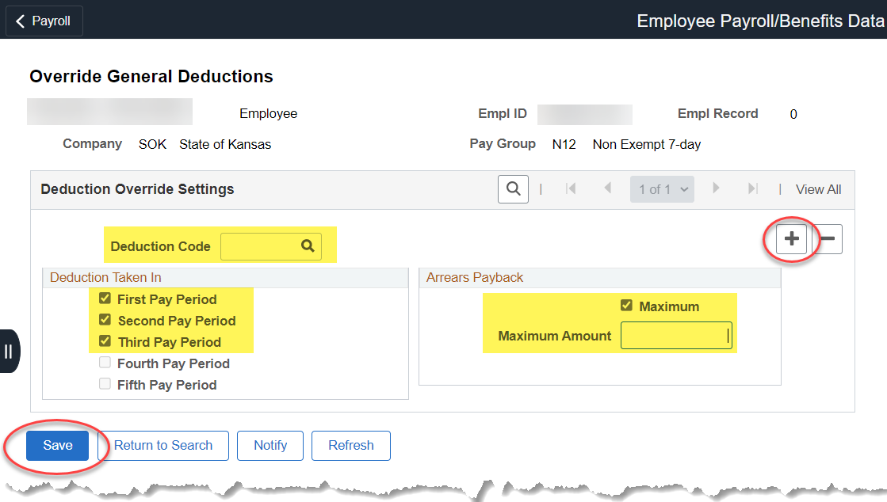  PLEASE NOTE:  - DO NOT LEAVE THE MAXIMUM AMOUNT BLANK. If you leave the Maximum Amount blank and check the maximum box, no deduction will be taken.  - If the maximum box is left unchecked and the maximum amount is blank then this will take out arrearages as normal.  - For the last payment, delete out the max arrears by clicking the minus button (then save.) This allows any rounding scenarios to be resolved with the final payment.
Pay Calc Week: An Employee has a large deduction coming out of their paycheck and they want to pay that amount over a period of time instead of allowing it to come out of the paycheck all at once. Follow the steps below:
4. | Enter the arrearage amount on the current timesheet.  Enter either the ADV (Advance) or ADJ (Adjust)  ADV- Before Tax Deduction  ADJ- After Tax Deduction  Submit and approve the payable time |  | 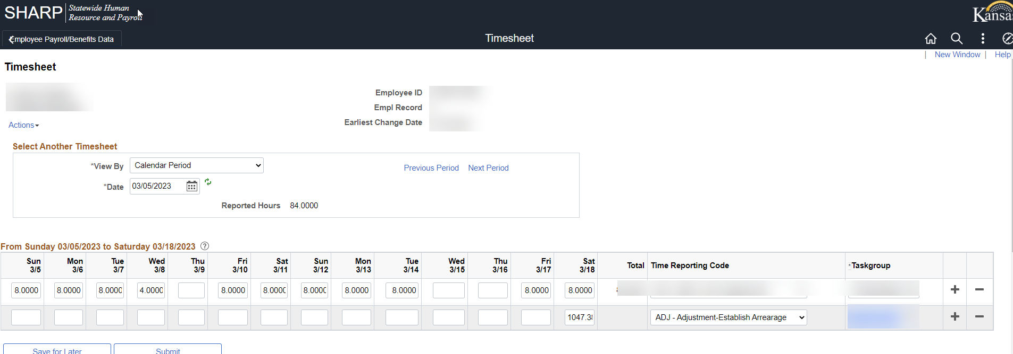
Once the ADJ or ADV has been entered and approved, proceed back to #1. Please note: You will can set up the Max Arrears Payback for this employee but this will not process until next payroll. The arrearage needs to be established before it the payback will process.

