State of Kansas
Maintain Teleworkers in SHARP
Statewide Human Resource and Payroll System

Date Created |  | 5/9/2022
Version |  | 1.0
Security
Description |  | At the beginning of the COVID pandemic, the Office of Accounts and Reports asked that agencies utilize the Maintain Teleworkers functionality to track employees who were working in places other than their typical work location. It has since been discovered that this page doesn’t carry the functionality that is needed for payroll taxation. The Office of Accounts and Reports no longer requires that this page be utilized. If your agency is currently using this page, please continue your established process. Just know that this is no longer a requirement set forth by the Office of Accounts and Reports to utilize this page.
1. | This page is only available through the Navigation Bar.  Workforce Administration > Job Information > Maintain Telework | 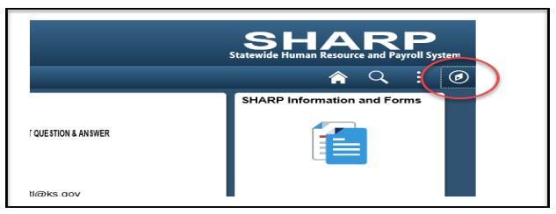  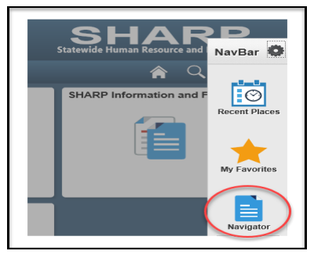  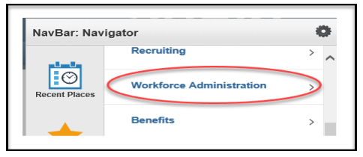  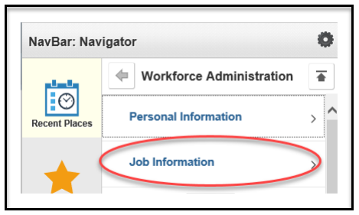  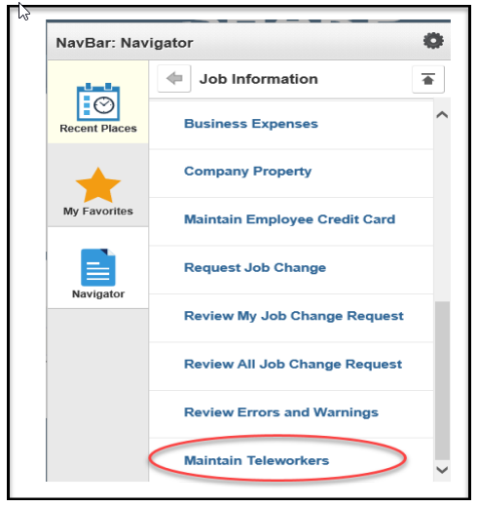
2. | To add a new Telework Record:  Highlights identify fields that need to be entered or actions required. | 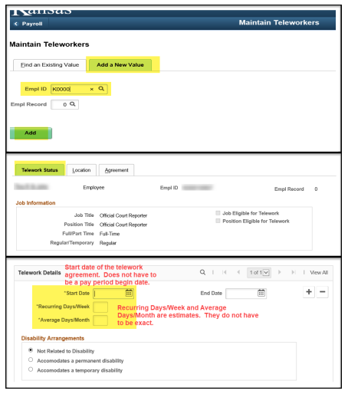  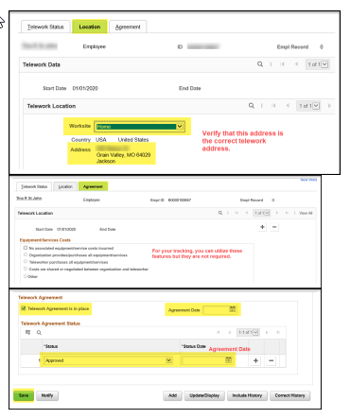
3. | To terminated a Telework Record: Highlights identify fields that need to be entered or actions required. | 