State of Kansas
KTL109- Payable Time Extract
Statewide Human Resource and Payroll System

Date Created |  | 1/6/2022
Date Updated |  | 4/9/2024
Security |  | - SHARP  Role: Agency Time and Labor Timekeeper  -OR-  Role: Agency Time and Labor HR
Description |  | The KTL109D report is an extract of data from the Payable Time Table for the pay period specified. This report can be used for identifying total hours and estimated gross dollars reported to specific time reporting codes (TRCs) for a specific pay period.  Fields included in the report KTL109:  - Department ID  - Employee Name  - Employee ID  - Employee Record Number  - Date Under Report (DUR)  - Time Reporting Code (TRC)/TRC Description  - TL Quantity (Hours/Amount per DUR)  - Payable Status/Payable Status Description  - Taskgroup  - Combo Code  - All Project Costing and General Ledger Chartfields  Sorted by Employee ID/Date Under Report (DUR)  If a report is needed for a past pay period, generally 5 years of data remain available based on the SHARP archive schedule.
Information |  | In order to access cumulative Time Reporting Code (TRC) and Funding data, agencies are encouraged to generate the Payable Time Extract (KTL109) every pay period. The final Payable Time Extract should be saved after confirming that all employee timesheet data has been entered and submitted/approved for the pay period and after reviewing/approving all employee Payable Time data. Saving the results as a cumulative report will allow for filtering on any TRC(s) at any point in time. Having a cumulative Payable Time Extract will provide estimated gross funding data as well as hours in which to filter.  *Please note the Payable Time Extract (KTL109) is the report the Payroll Processing Team will direct agencies to for questions concerning cumulative hours reported to certain TRCs, such as Overtime.*
Navigation |  | SHARP > Time and Labor Homepage > Time and Labor Reports > Payable Time Extract
1. | Payable Time Extract Run Control Page will open.  Select Add a New Value if you have never used this report.  Enter any value you want into the Run Control ID Field.  Select Add  -OR-  Find an Existing Value if this report has been used before.  Search  Select the Run Control ID you want to use | 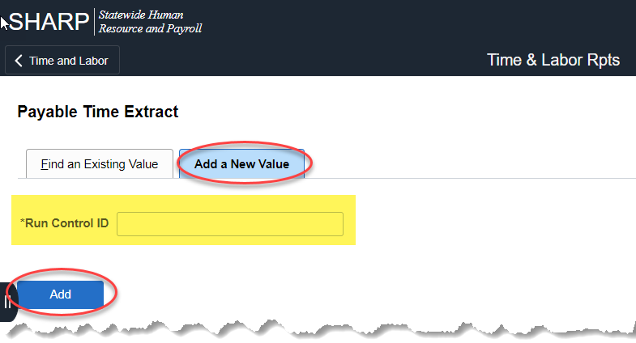  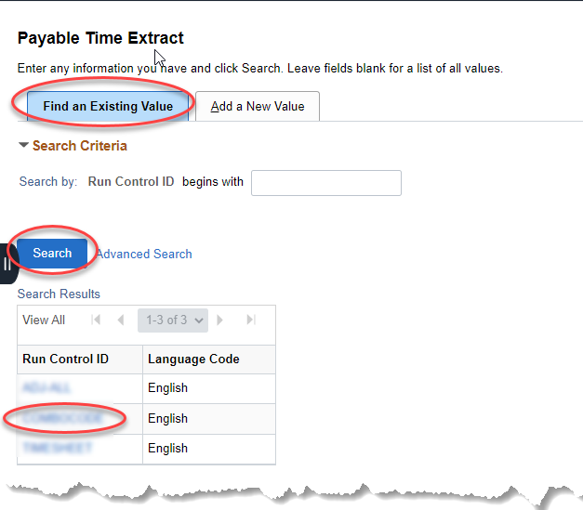
2a. | If running for a specific employee:  Report Request Parameters for Individual  All three fields are required:  Pay Period End Date: Enter the Pay Period End Date for the period needed  Empl ID: Enter the Employee ID  Empl Record: Enter the employee record number  Select Run | 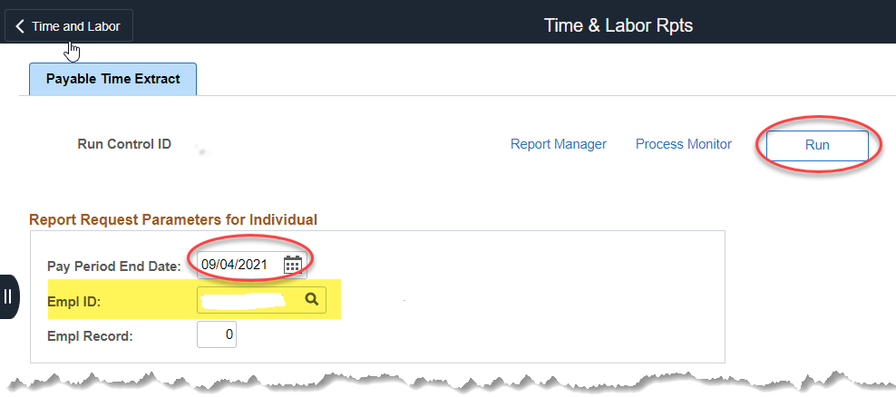
2b. | If running for an entire Department or Agency for a specific Pay Period:  Report Request Parameters for Department  Pay Period End Date: Enter the Pay Period End Date for the period needed  Department: Enter either the Department ID needed, or if running for the entire agency, enter first three digits followed by all zeroes- xxx0000000  Department Group ID: optional (Used for KDADS and Corrections Umbrella Facilities. When using this field, leave the Department field blank.)  Select Run | 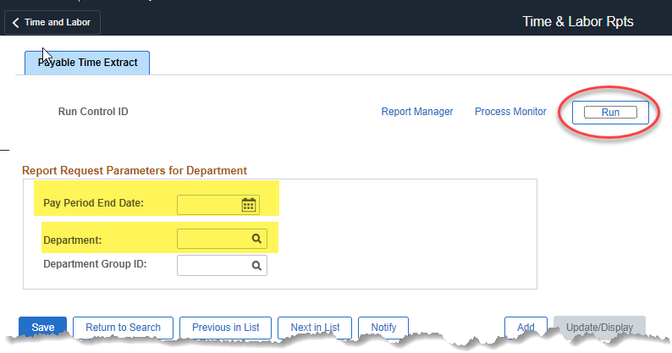
3. | Once Run is selected, the Process Scheduler Request page will display.  Select OK  After selecting OK, the Payable Time Extract page displays. Select the Process Monitor hyperlink. | 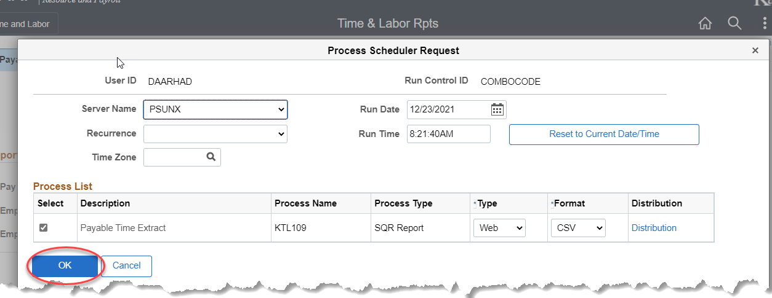  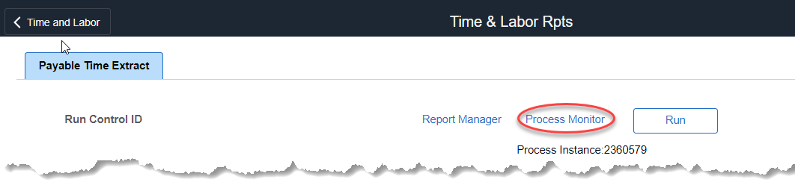
4. | Once the Run Status shows Success and the Distribution Status shows Posted, select the Details hyperlink. | 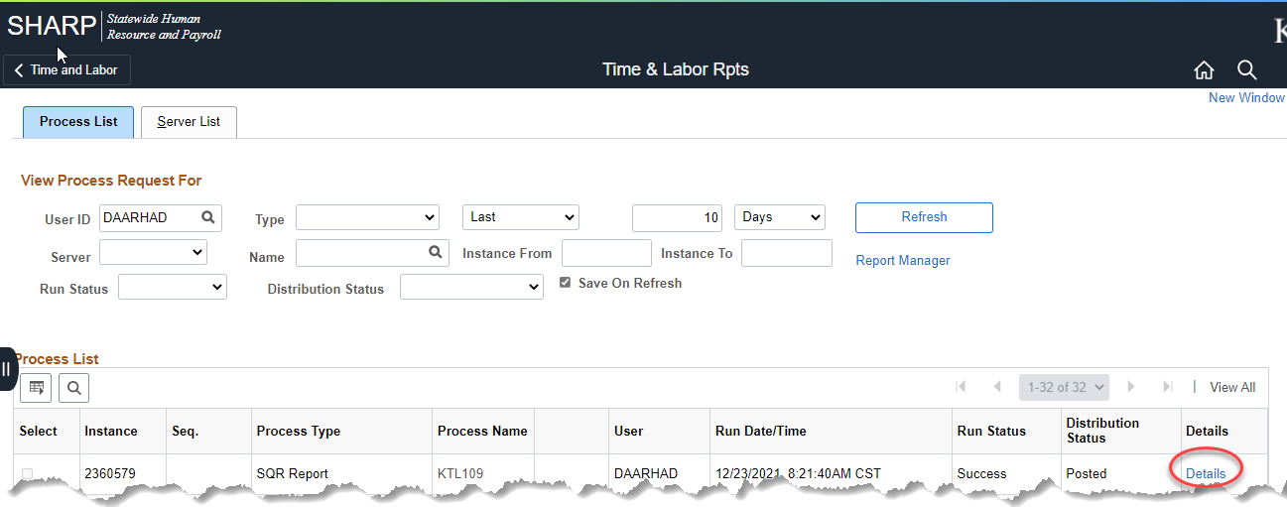
5. | Select the View Log/Trace link. | 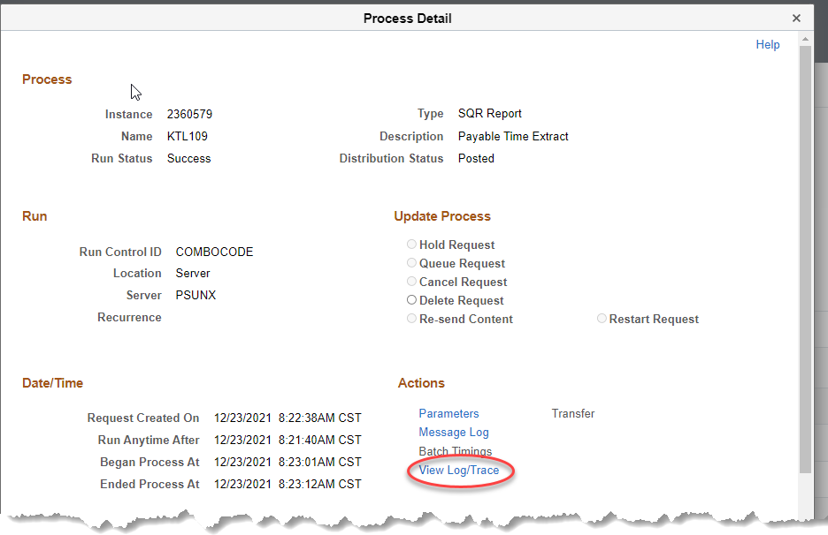
6. | Right-click the KTL109D.DAT hyperlink to save the file.  Save this file in a place where it can be accessed again. | 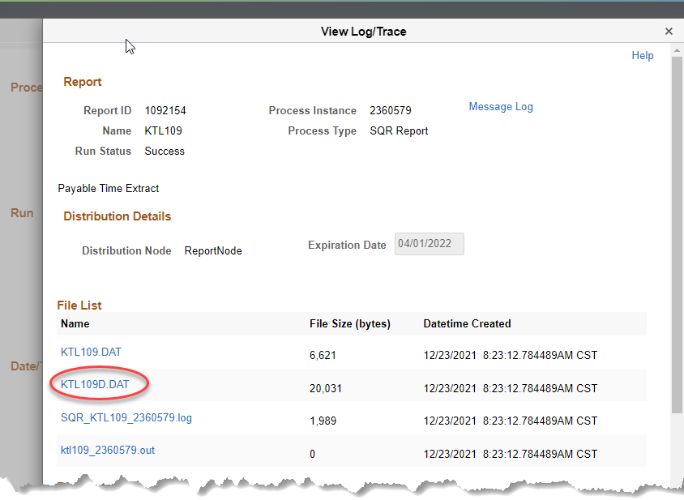  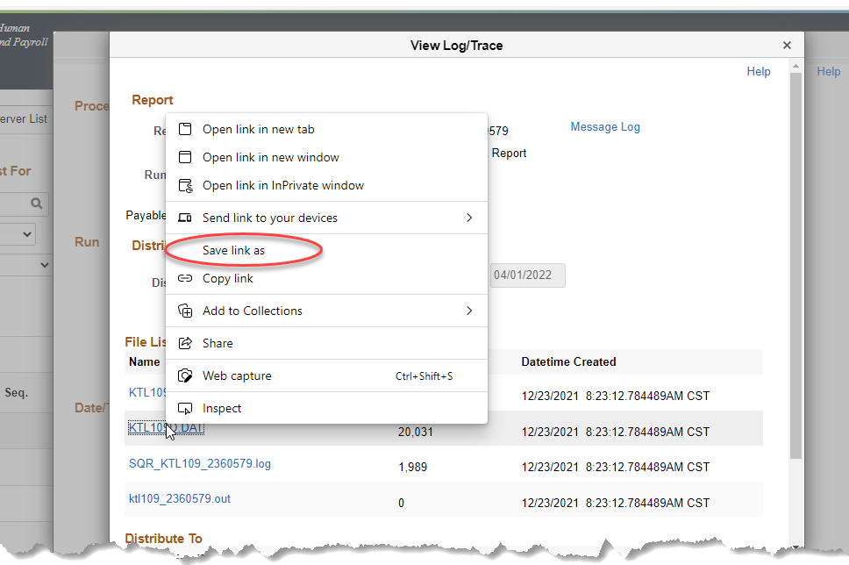
7. | Refer to Opening.DAT Files Job Aid  *Format column M as Text
8. | Report example. | 