State of Kansas
KPAY711- Department Positions and Budget Earnings
Statewide Human Resource and Payroll System

Date Created |  | 12/28/2021
Version |  | 1.0
Security |  | - Core FTP
Description |  | This report shows the current Department Budget Table Funding. It is organized by Department, Pool ID, Position, and Employee Name. It is ran every Day 06 of the payroll cycle. The report is accessed via agency CoreFTP account.  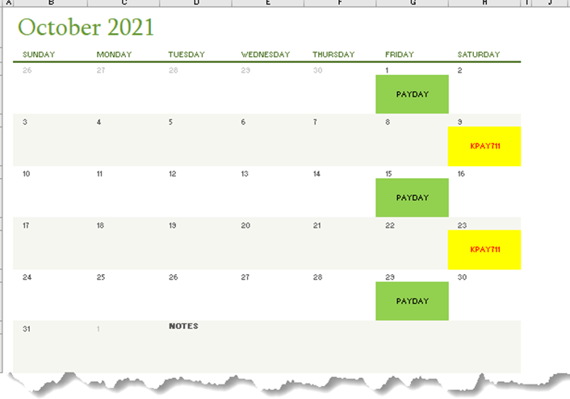  This report can be used to assist agencies when large funding updates are needed to the Department Budget Table. This report will show how all agency employees are funded on the Department Budget Table as of the day the report was ran.
1. | Double-Click the lastest .CEN file | 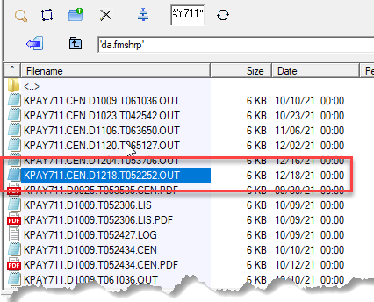
2. | Select View  OK | 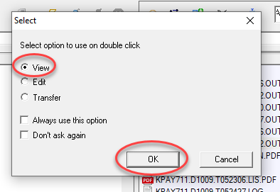
3. | Report opens in Notepad | 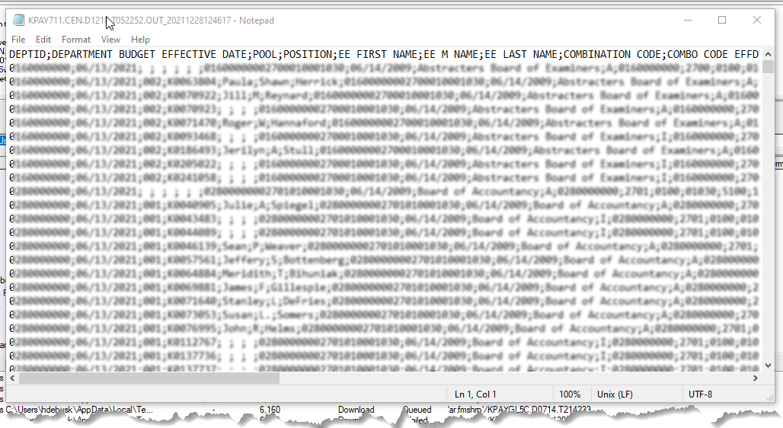
3. | File > Save As  Save the file as .txt in a folder that can be accessed again. | 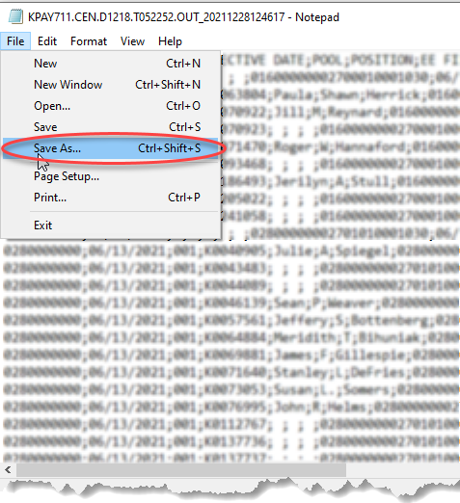  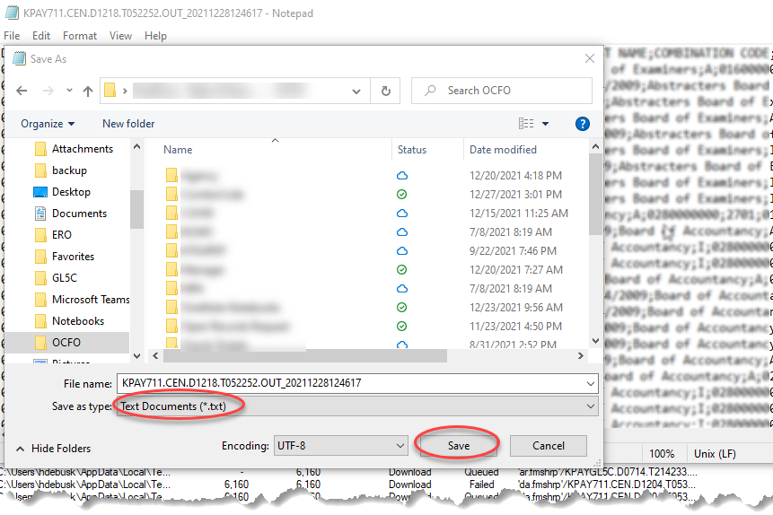
Instructions |  | Open the file in Excel. Refer to the Opening .DAT Files Job Aid for assistance. (These procedures will work even though this file is a .txt file.)
Report Details |  | Report Contains the following information:  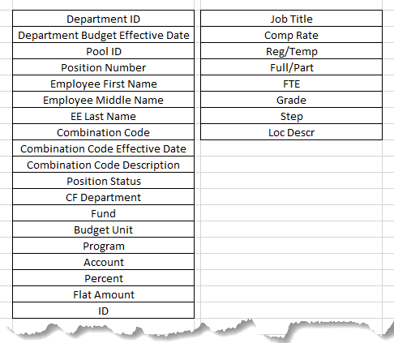
4. | To use the Report for Department Budget Table Updates  Delete the following columns:  Combo Code Effdt  Combo Code Description  Acct  Comp Rate  Class/Uncl  Reg/Temp  Full/Part  FTE  Grade  Step  Loc Descr | 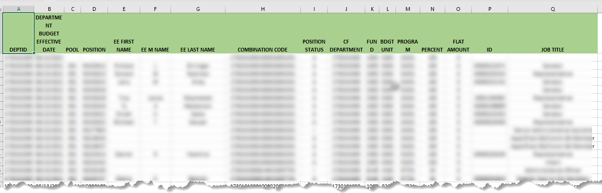  Note: DeptID= HR Department ID  These results show all Department Budget Table setup for all Departments across the agency.  Refer to KAGYBUD1 – Department Budget Table Load job aid

