State of Kansas
KPAY210 – PAYROLL EFT RETURNS AND NOTIFICATIONS OF CHANGE
Statewide Human Resource and Payroll System

Date Created |  | 3/21/2022
Version |  | 2.0
Security |  | - CoreFTP: User must have access to CoreFTP to download reports from the agency MVS mailbox. If you need access to CoreFTP, please contact your agency security liason to get the system security requested.  - SHARP  Role: Agency Payroll Specialist
Description |  | The KPAY210 report provides a listing to agencies of any employee funds that have been returned to the State of Kansas due to a bank’s inability to post a deposit to a bank account. These funds can be returned any time after the date of deposit. It can take up to a week for the funds to be returned to the State of Kansas.  Reasons funds may be returned include:  - Account closed  - No account/Unable to locate account  - Incorrect Transit Routing Number and Account Number  Reasons an employee may show on report with $0.00 funds being returned:  - Incorrect account number (the bank still accepted the transmittal)  - Incorrect routing number (the bank still accepted the transmittal)  - Incorrect transaction code (the bank still accepted the transmittal)  - A correct data field showing transaction code of 21 or 22 signifies a checking account.  - A correct data field showing transaction code of 31 or 32 signifies a savings account.
1. | The KPAY210 report runs daily. Agencies should plan to look for this report daily. Agencies that have employees with EFT returns, including $0.00 returns, will receive the KPAY210 in the agency MVS mailbox. No report is available to the agency when there are no employees with EFT returns, including $0.00 returns.  The report will notify agencies of a return and the reason for the return.  Agencies should confirm the address listed on the report is correct. If the address is not correct, agencies shall update the address in SHARP and email DOA_PAYROLL@ks.gov with the corrected address by 11:00 AM on the same day of the report. If an email is not sent to Statewide Payroll, the reissue will be sent to the existing address in SHARP. | 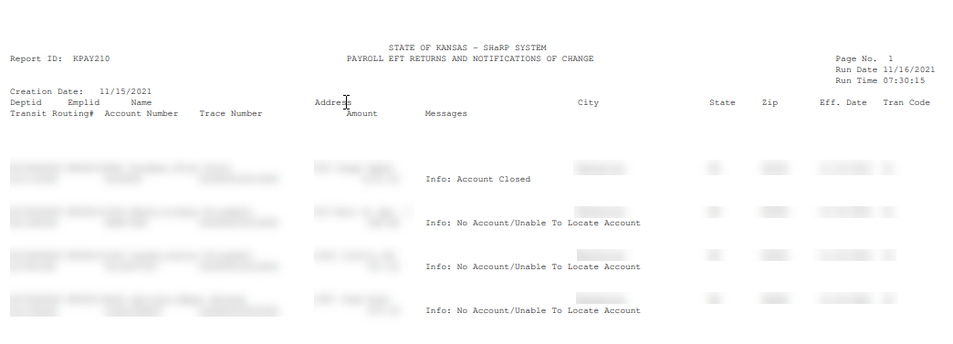
Immediately after Reviewing the KPAY210 |  | Agency must notify employee that funds have been returned to the State of Kansas and confirm the following:  - Employee address  - Employee banking information
Instruction |  | Verify that the Employee Address in SHARP is correct.
Navigation |  | SHARP > Payroll Homepage > Employee Payroll/Benefits Data > Modify a Person
2. | SHARP opens to the Personal Information page.  Enter the Employee ID.  Select Search.  Select the Contact Information tab.  Is the address correct?  If so, continue to Step 3.  If not, select the View Address Detail link.  After selecting the View Address Detail link: Select + to add the correct address.  Effective Date: Enter the current date  Select the Add Address link.  Enter the correct address.  Select OK.  Current address will now display in Address History.  Select OK.  This page automatically displays after selecting OK.  Select Save  Once Save is selected, the address has been updated and the page can be closed. | 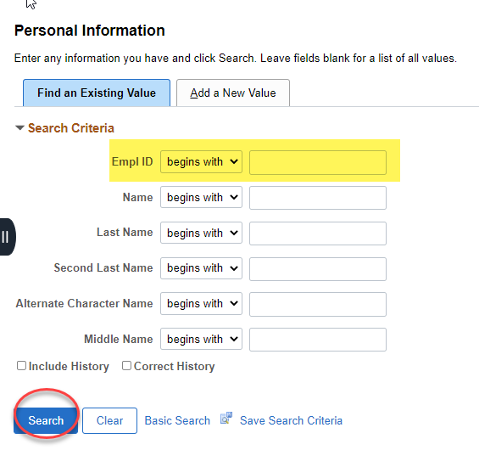  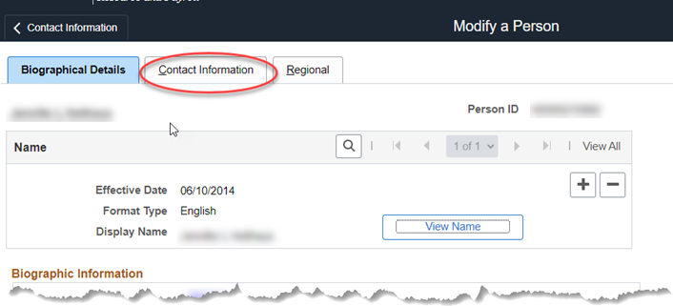  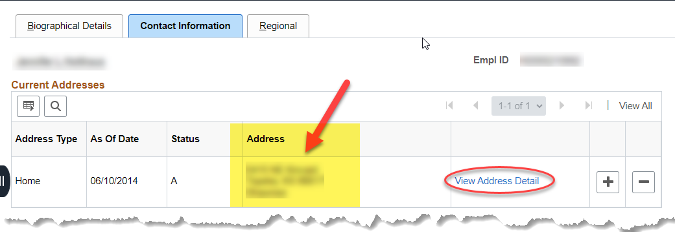  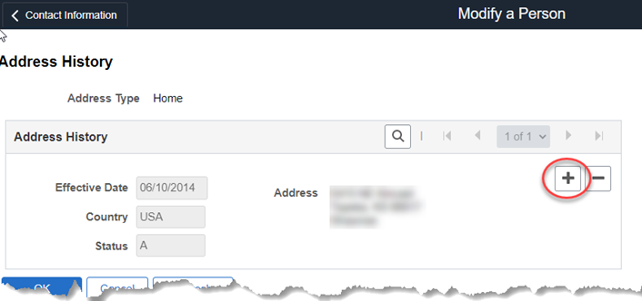  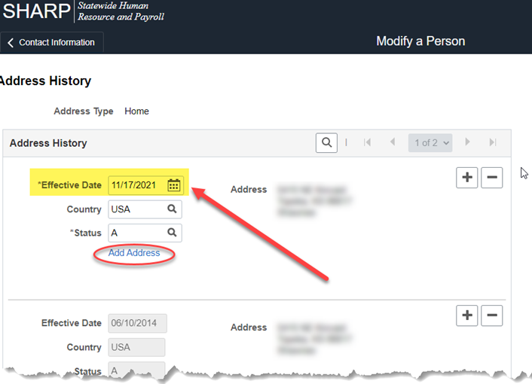  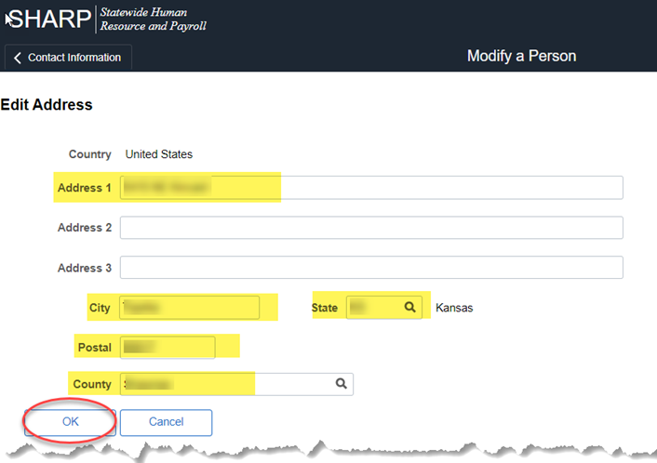  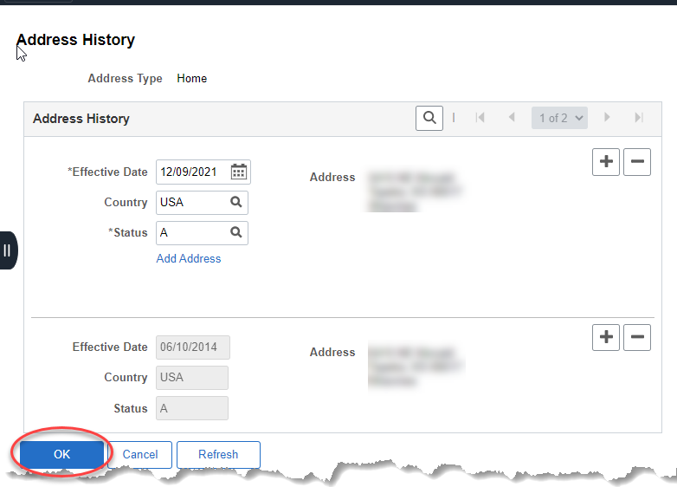  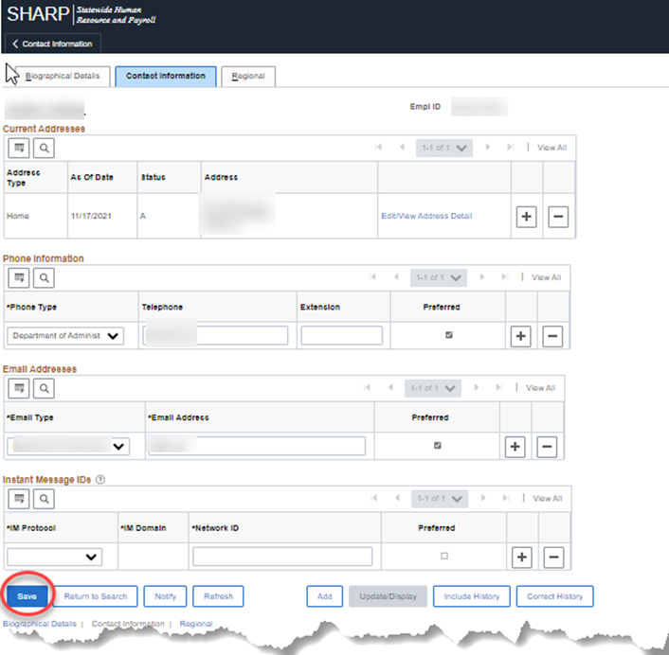
Instruction |  | If the employee banking information is incorrect, follow Step 3 to add new banking information.
Navigation |  | SHARP > Payroll Homepage > Employee Payroll/Benefits Data > Request Direct Deposit
3. | Enter the Employee ID.  Select Search.  Add a new row of banking information by selecting +.  Effective Date: Enter the current date  Bank ID: Enter the bank routing number, the Bank Name and Address will load based on this entry  Account Type: Select Checking or Savings  Account Number: Enter the account number including any leading zeroes  Select Save. | 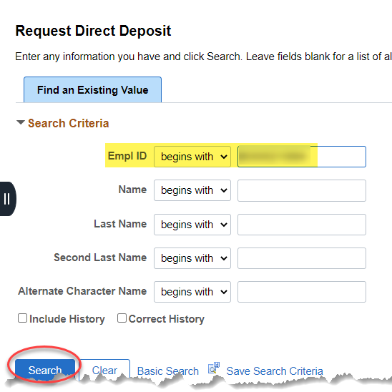  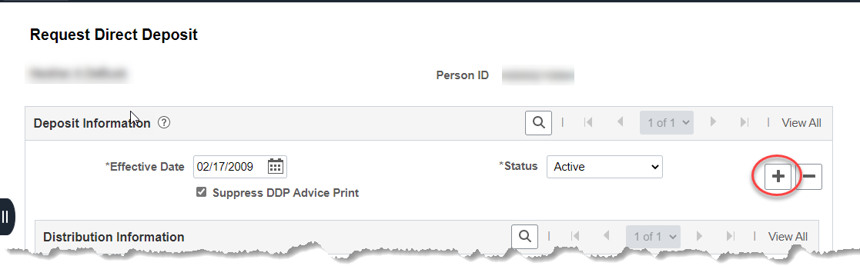  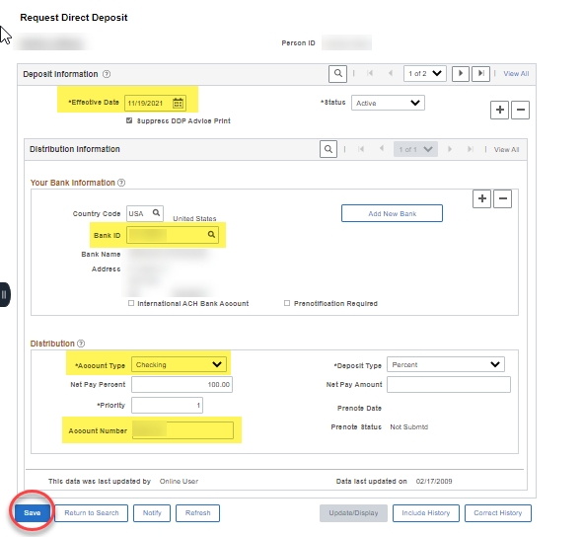
Instruction |  | Employee address is correct and banking information has been updated.  -STOP- Nothing further to do.
For Agency Information Only  (Outline of steps completed by Statewide Payroll for the KPAY210) |  | - Payroll EFT Returns and Notifications of Change, KPAY210 report is run daily.  - Agencies are notified of funds being returned to the State of Kansas on the KPAY210 report delivered to the agency MVS mailbox.  - Based on the returns on the KPAY210 report, the Statewide Payroll Processing Team will enter a SMART voucher to pay the employee by check to be mailed directly to the employee at the current home address in SHARP. The SMART voucher will be entered on the same day the EFT return is listed on the KPAY210 report.  - The SMART voucher will process through the SMART paycycle the same day the voucher is entered and approved, and the check will be in the mail to the employee the next business day.

