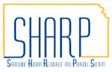
State of Kansas
International ACH
Statewide Human Resource and Payroll System

Date Created |  | 9/13/2022
Version |  | 1.0
Security |  | - SHARP  Role: Agency Payroll Specialist
Reference Informational Circulars |  | - 10-P-012  - 11-P-012
Purpose |  | Instructions on setting up employee direct deposit to an International bank account.
Important Notes |  | If an employee wishes to have their pay directed to a foreign bank, they will need to establish a U.S. Bank account as a ‘pass through’ account and designate the payment as an International ACH Transactions by selecting the appropriate box on the DA-184 form. This box is the identifier that the transaction is intended to go through a U.S. bank account in full and transfer to an international banking account as the final destination.
Navigation |  | SHARP > Payroll Homepage > Employee Payroll/Benefits Data > Request Direct Deposit
1. | Enter Employee ID  Select Search.  *Before proceeding with adding any information, verify the name listed matches the name on the DA-184 form. If the name does not match, verify the employee ID is correct and reconfirm information with employee.  *If there is no existing row, refer to the Job Aid “Setting up Direct Deposit in SHARP”. | 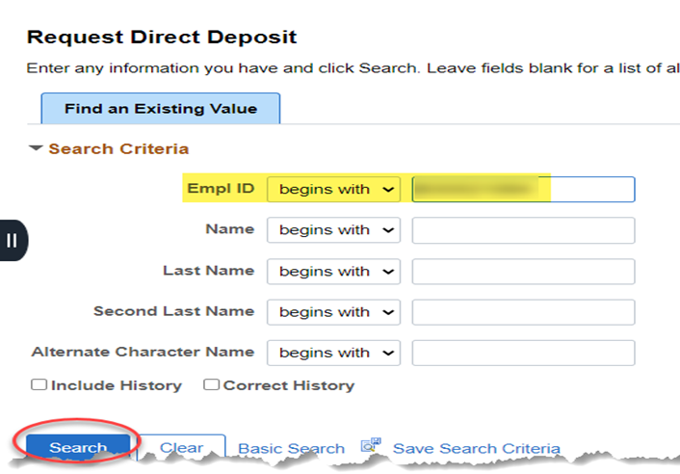
2. | Select International ACH Bank Account if the funds will be transferred to a financial institution outside of the United States. | 