State of Kansas
Inactivating Employee Org Membership Dues Deductions
Statewide Human Resource and Payroll System

Date Created | 11/7/2022
Date Updated
Form | DA-193  Document Center  Payroll Forms  https://admin.ks.gov/for-state-agencies/agency-information-center/document-center
Instructions: | Employee must complete the highlighted sections of the DA-193 and submit to their agency HR/Payroll office.  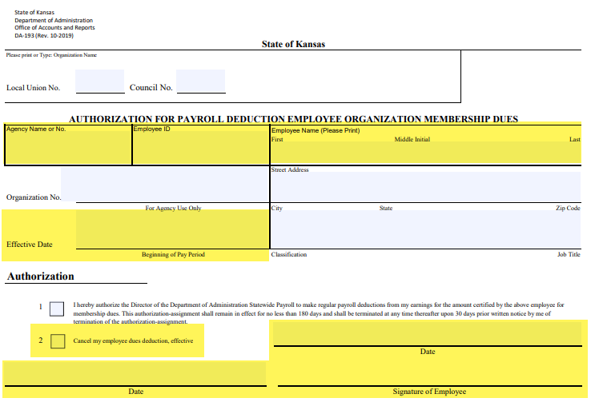
Agency Steps After Receiving the Form:  Navigate to the Payroll Homepage > Employee Payroll/Benefits Data  Select Employee Deductions/ER Contrib  Select Create General Deductions  Enter Empl ID  Search  To find the deduction you need to inactivate, select the search button. Enter the deduction code you are looking for and select OK.  For the Deduction End Date, enter the pay period begin date for the period you want the deduction stopped for.  Select Save. | 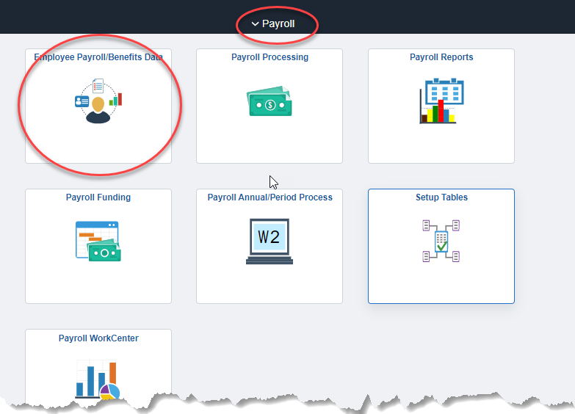  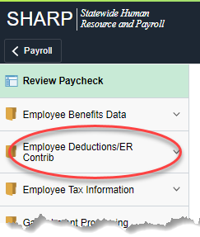  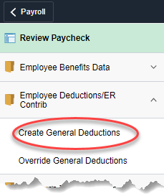  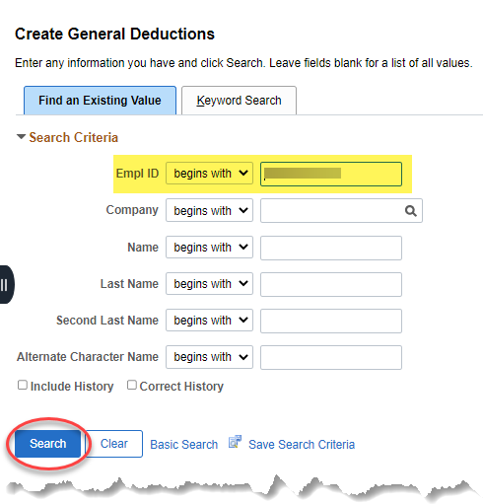  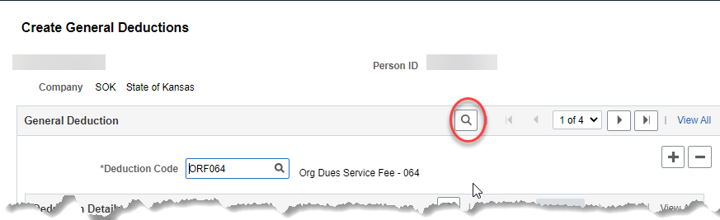  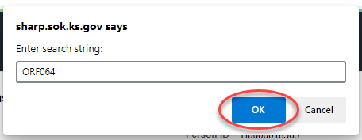  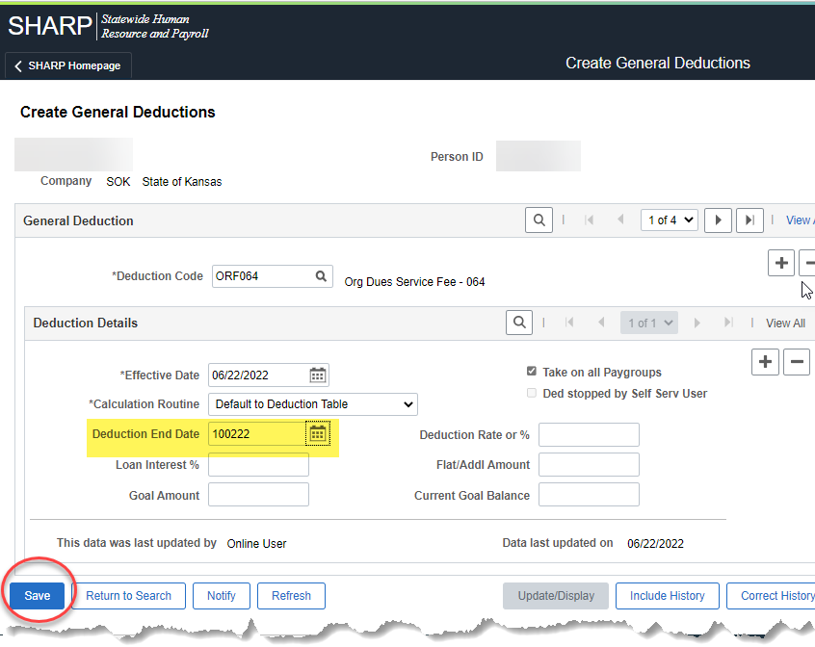
For every ORGXXX deduction code for the Org Membership, there will be a matching ORFXXX deduction code for the Org Fee – both deduction codes need to be stopped for the same period.

Agency should file this form at the agency for documentation for the change made to the employee general deduction panel.

