State of Kansas
Inactivate Department Budget Table
Statewide Human Resource and Payroll System

Date Created |  | 7/6/2022
Version |  | 1.0
Security |  | - SHARP  Role: Agency Commitment Accounting Specialist
Purpose |  | To inactivate Department Budget Table.  **Before inactivating an entire budget table, make sure that there are not any employees attached to this budget table.**  To verify if employees are attached to the budget table:  - Run the KPAY711 Report (Job Aid listed under Funding Procedures)  If an employee is attached to the budget table:  - Update the funding using the KAGYBUD1. Do not inactivate the budget table.
Navigation |  | SHARP > Payroll Homepage > Payroll Funding  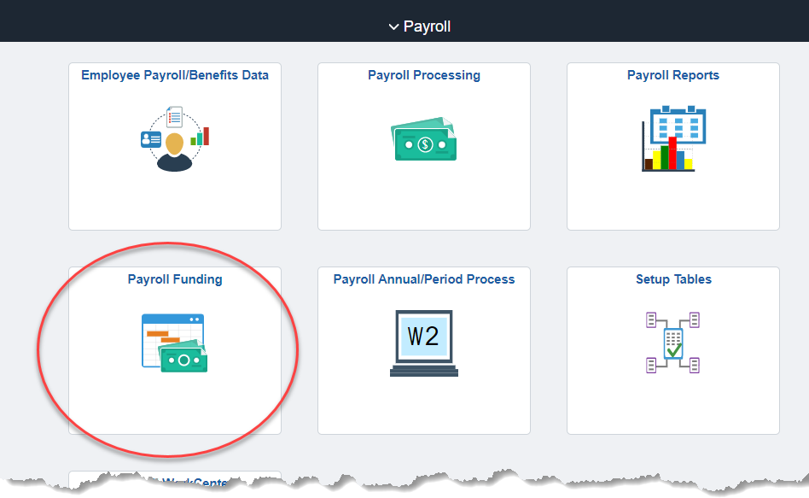
1. | Select Department Budget Tbl Funding > Department Budget Table USA | 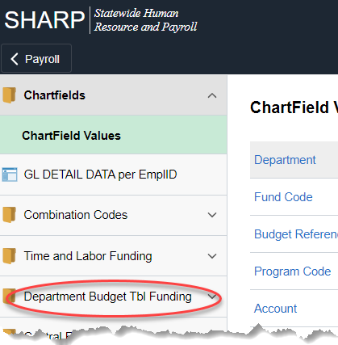  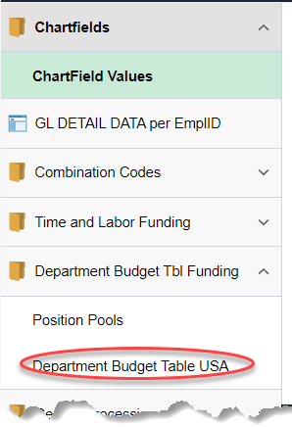
2. | Pull up the row that needs to be inactivated  Set ID  Department  Fiscal Year  Budget Level (Department or Position Pool)  Position Pool ID (If you are inactivating the Postion Pool level funding) | 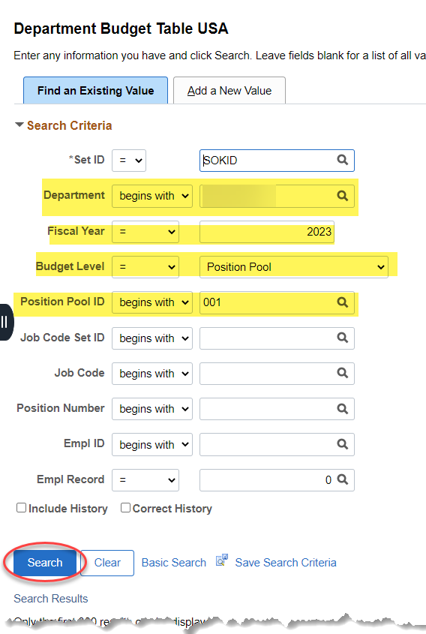
3. | Dept Budget Earnings tab  Select the + to add a row | 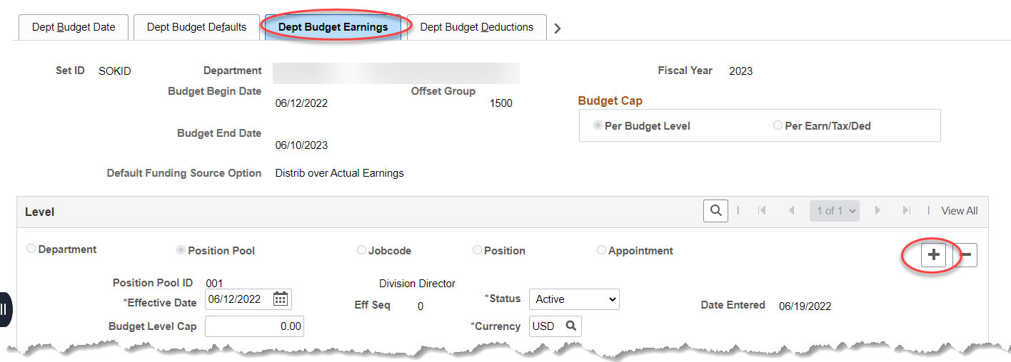
4. | Effective Date  Status: Inactive  Save | 