State of Kansas
ESS Paycheck Modeler
Statewide Human Resource and Payroll System

Date Created |  |  | 1/25/2023
Date Updated
Purpose |  |  | Replicate paycheck to visualize any potential changes.  - Taxes  - Deductions  - Pay
IMPORTANT NOTES |  |  | - This tool is to TEST different scenarios and to see the impact those changes would have on net pay. Nothing done in this tool will change how you are currently paid.
Employee Self Service- Paycheck Modeler Tile |  | 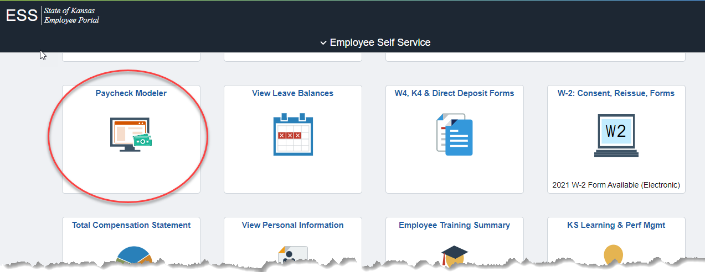
1. | Start - Step 1 of 6  Select Yes, I have reviewed and agree to the terms and conditions.  Let’s Get Started |  | 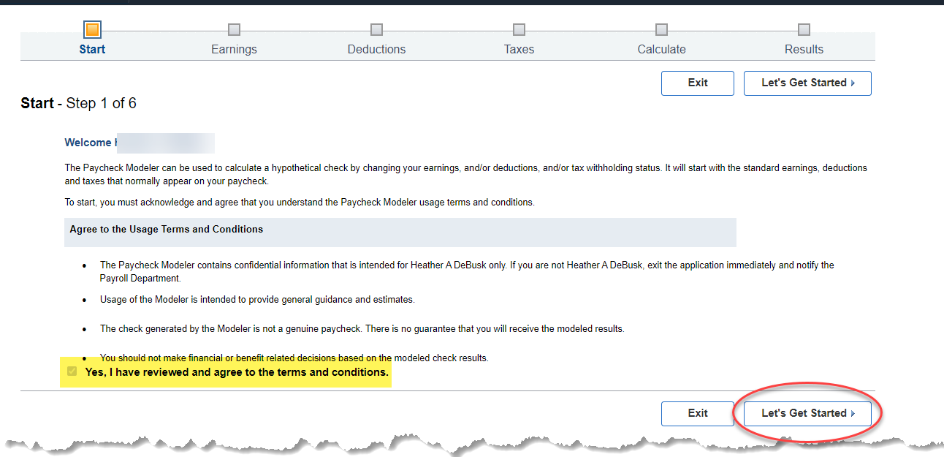
2. | Earnings - Step 2 of 6  **Note: If you are trying to replicate an already calc’d check, you will need to add a line for Taxable Group Life. This Earnings Code, TGL, will be located in your Paycheck Earnings section.  You can modify or change the earnings that are showing for your modeled check.  Depending on the Earnings Type, you will enter either Hours or Amount.  Once finished modifying, or if no changes are wanted for Earnings, select Next. |  | 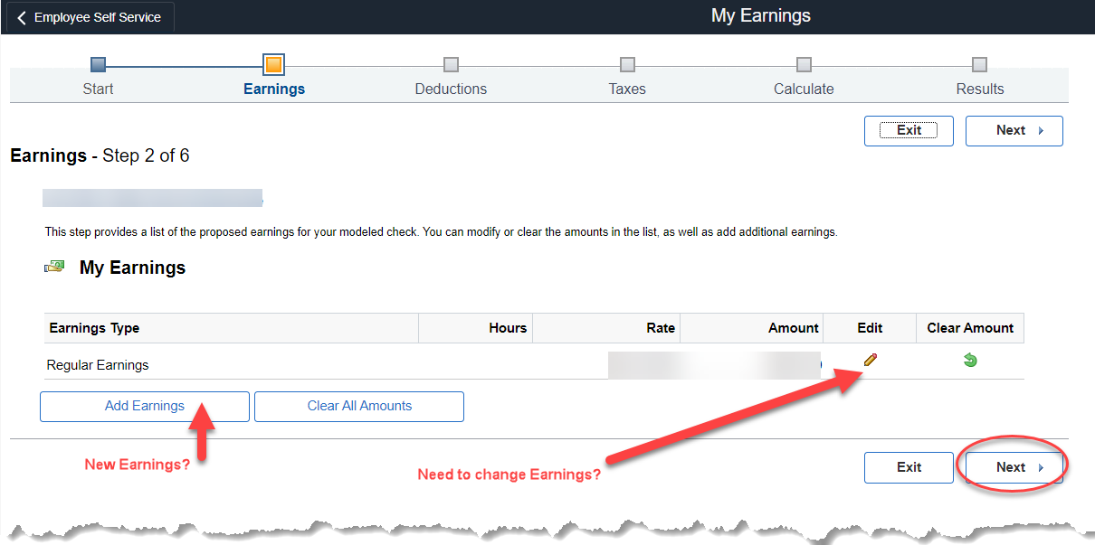  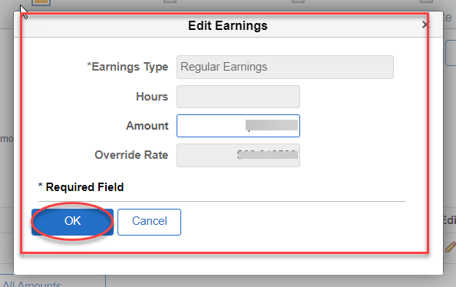
3. | Deductions - Step 3 of 6  Some deductions will automatically be picked up.  Any deductions not seen here will need to be manually entered. Refer to a previous paycheck for current employee deductions.  When possible, copy and paste your deduction description. This field is case sensitive. |  | 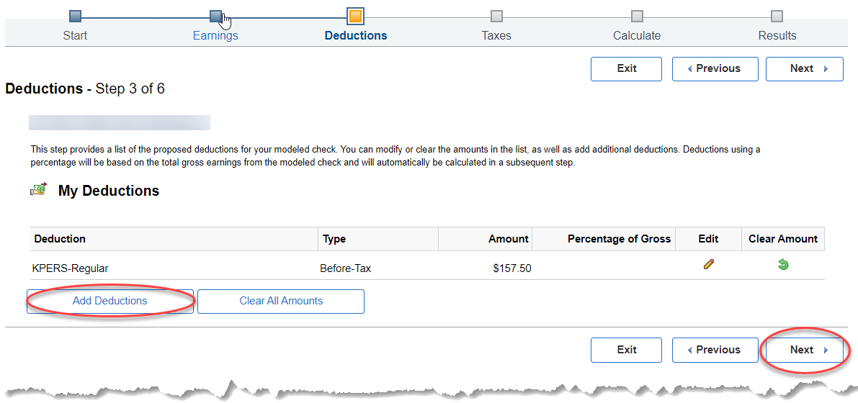  Add Deductions – use Look Up Deduction to find the deduction you want to add.  When searching for a Deduction, you will search for the Description that is found on a paycheck. **Please note, you may see a deduction listed multiple times. For the paycheck modeler, any selection will provide the same result. If you do not find a deduction, please email doa_payroll@ks.gov for assistance.  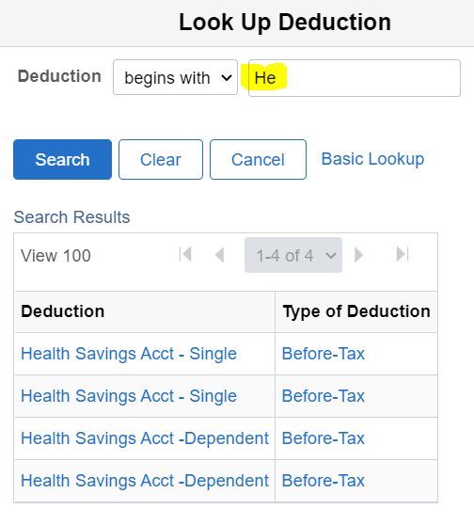  If you need assistance in finding an amount to be used for a health insurance deduction, go to State Employee Health Benefits Program:  https://sehp.healthbenefitsprogram.ks.gov/benefits/  Go to Enrollment Resources, in the Enrollment Guide, you will find the rates for the plan year.  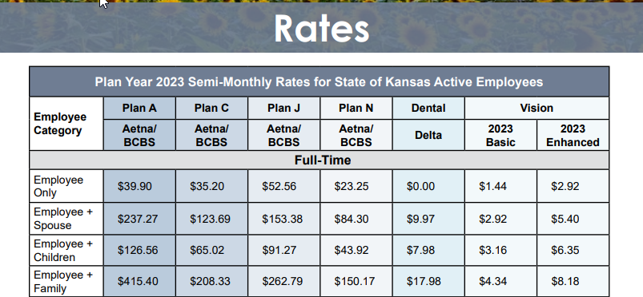  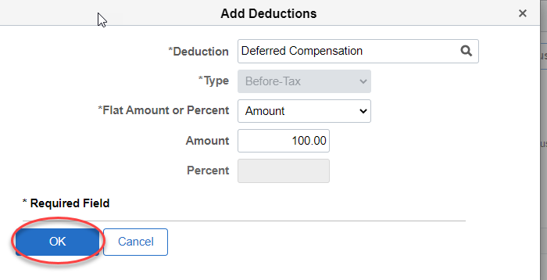  Once you have selected the deduction(s) you want to add, select OK.  When you are finished adding your deductions, select Next.  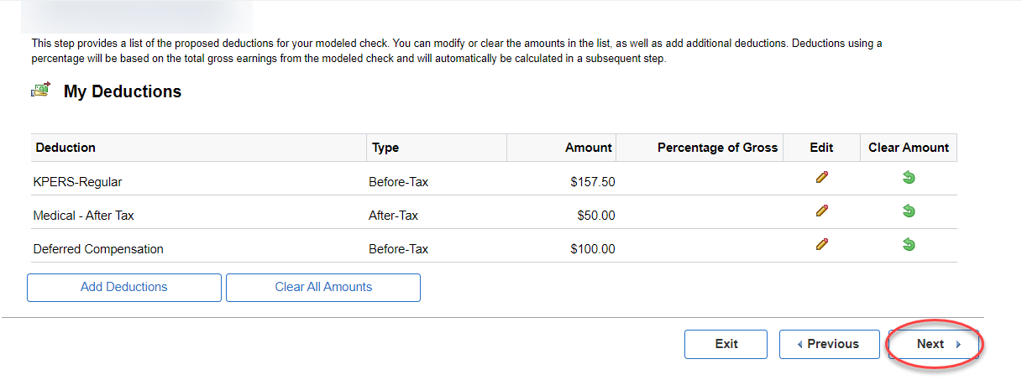
4. | Taxes - Step 4 of 6  Select Edit next to either the Federal or State Tax Jurisdiction to see the impact a change in taxes would make on your paycheck. |  | 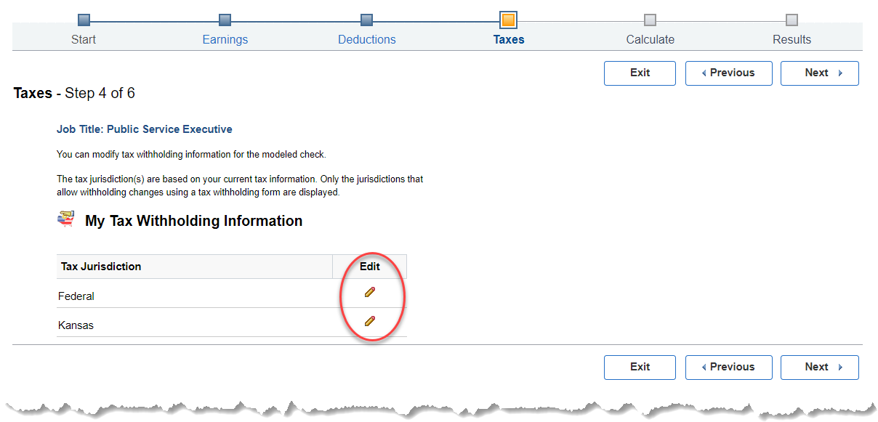
4a. | Federal Tax Withholding  Use this page to see the impact a change to a federal W-4 form could make, select Submit. |  | 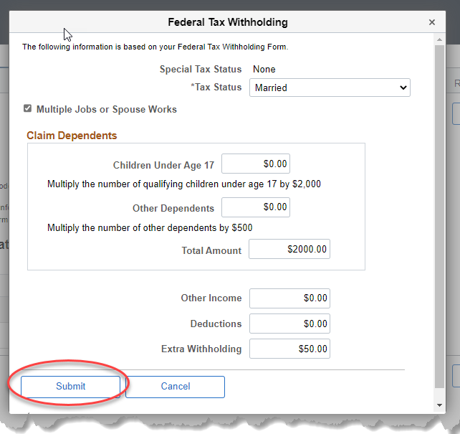
4b. | State Tax Withholding  Use this page to see the impact a change to a state withholding form could make, select Submit. |  | 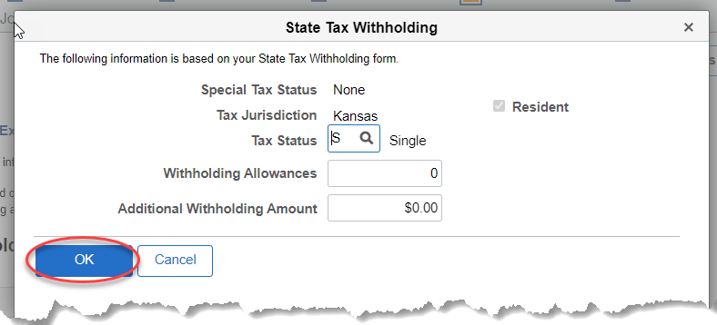
5. | When you are finished making changes to your taxes, select Next.  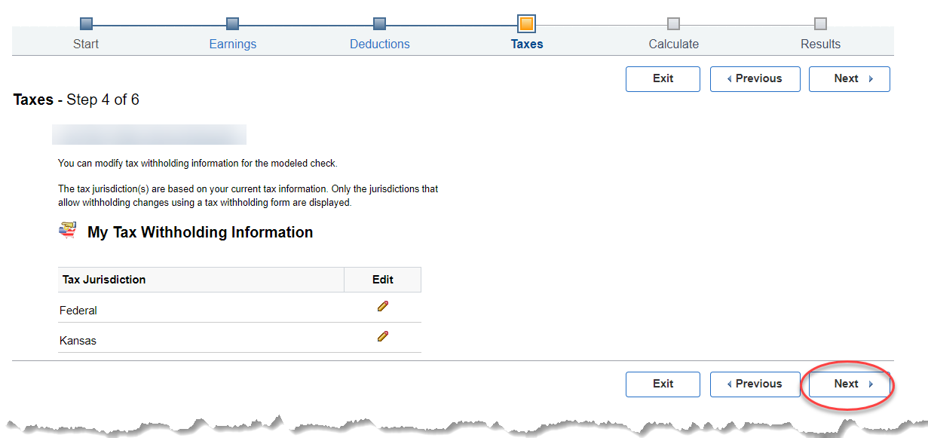
7. | Calculate – Step 5 of 6  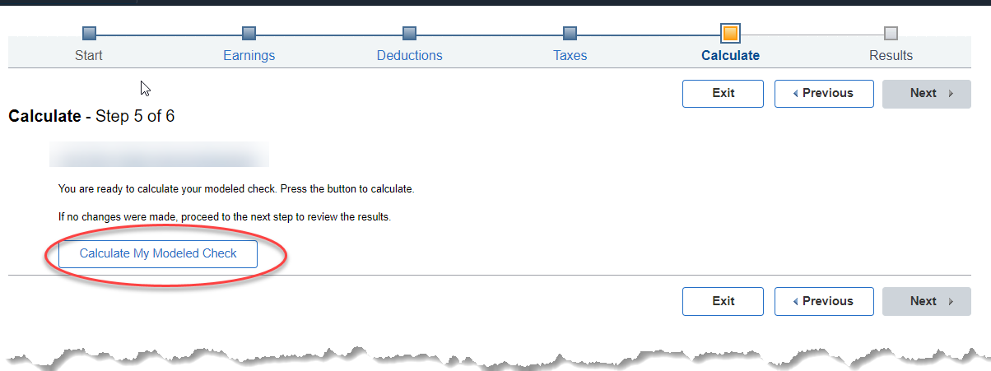  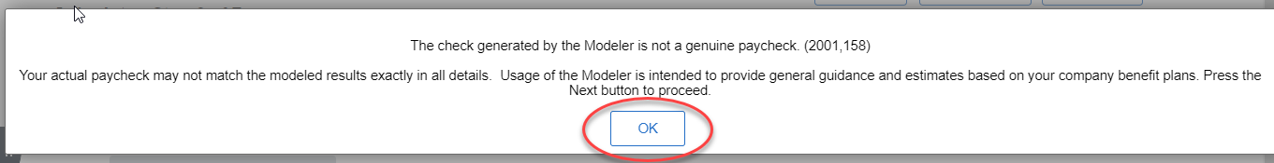  Once you select Calculate and OK, you must select Next to see the modeled paycheck.  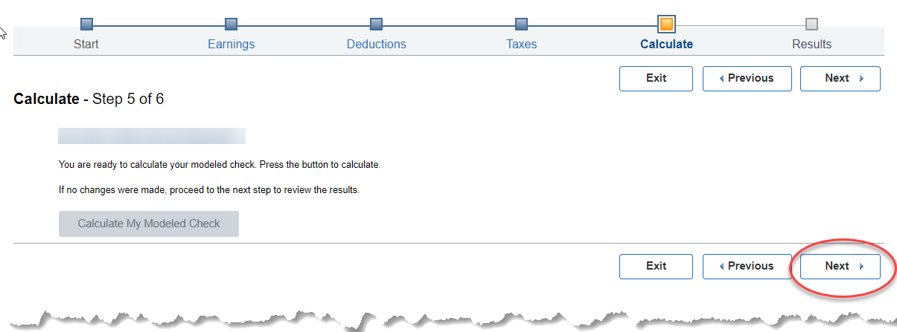
8. | Results – Step 6 of 6  Please note, you do have the option to print and/or save your modeled paycheck which will provide a .pdf version of the details entered for your modeled paycheck.  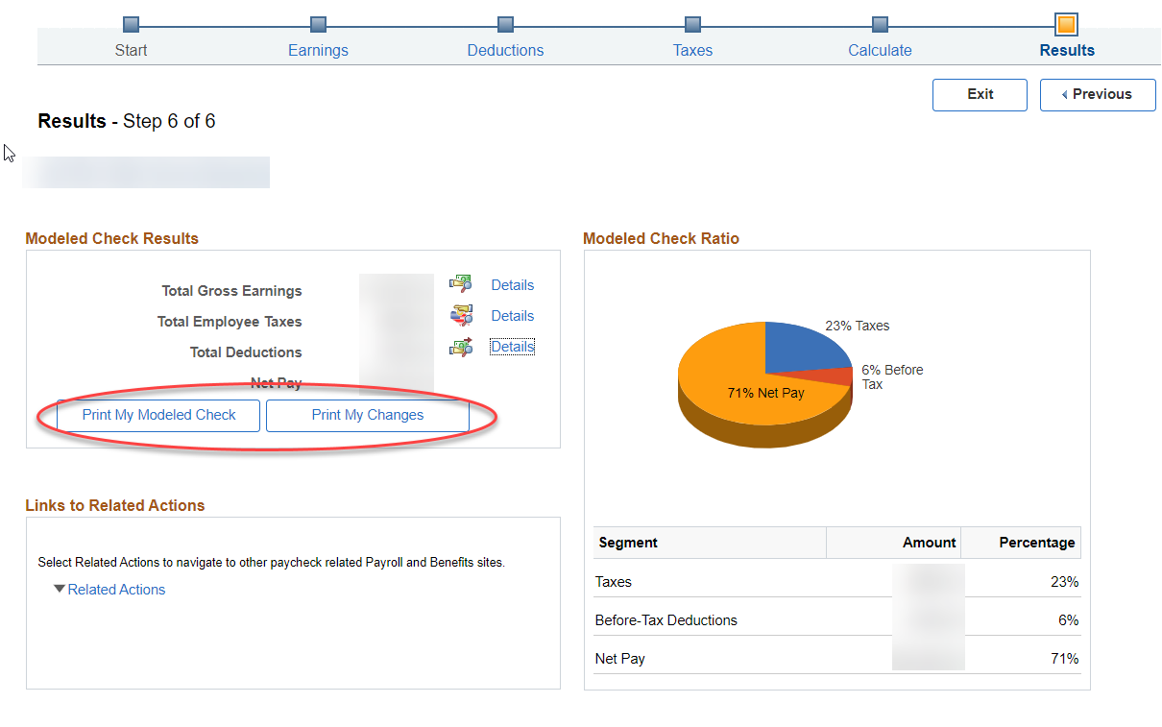  Once you are finished reviewing the modeled paycheck, select Exit.  