State of Kansas
DA-180 Centrally Entered Adjustment
Statewide Human Resource and Payroll System

Date Created |  | 3/6/2023
Updated |  | 6/9/2023
Please continue to check for updates to the DA-180 form and Job Aid, as this is a work in progress and is subject to change as we work through the updates. If you notice any issues with the form, please email payadj@ks.gov.
Reference Documents |  | - DA-180 Form  - Online Check  - PRB Form
Purpose |  | To manually adjust an employee paycheck when the ADJ_ALL or Supplemental checkbox cannot be used.  Reasons the ADJ-ALL cannot be used:  - An adjustment has already been requested for the paycheck that needs to be adjusted.  - Cannot process ADJ-ALL for employee that has an active garnishment or where there was a garnishment on the original paycheck.  - Cannot process ADJ-ALL for employee that has ADV earnings codes.  If the Supplemental Checkbox is not available on the timesheet, it is past the three pay period limit and the supplemental adjustment can’t be requested.
Information |  | - A paycheck adjustment is where a correction should be processed to a paycheck created for an employee for a particular pay period.  - A paycheck adjustment does not stop the original paycheck from being issued and sent to the employee.  - The adjustment process will create either an additional check to the employee for additional hours or refund taxes or deductions, or it will create an arrearage (ADJ earnings) for an overpayment of hours reported or increased taxes or deductions.  - Any adjustment scenario that can be completed by an agency, in 3 or less off-cycles, should be submitted on separate DA-180 forms, over the course of 3 or less off-cycles. (Central Payroll will only process one adjustment for multiple of 4 or more periods.)  - Note: If an employee changes their tax data between the issuance of the original check and the adjusted check, there will be a difference in the calculation of the federal and state withholding taxes based on the current tax data. This can also happen if you cross calendar years.  - Payroll Services does not process adjustments for tax withholding differences only.
Tips and Tricks |  | - If the adjustment involves the timesheet, you should adjust the timesheet and approve through Payable Time prior to requesting an adjustment.  - If the adjustment involves a non-GHI deduction, make sure the deduction has been updated in SHARP. Then request the adjustment for the pay periods that need to be adjusted.  - Any Leave Accrual questions should be sent to sharp@ks.gov  - Any GHI related adjustments should mostly come directly through the BERF file. If there would be any manual adjustments to be made to GHI deductions, those will most likely come at year end and will be at the instruction of SEHBP.
Completing the DA-180
Before Proceeding to Step #1, if the adjustment involves Timesheet corrections, update the timesheet and approve BOTH reported and payable time. Once those hours are both approved, proceed to Step #1.

You MUST use the excel spreadsheet that is saved at https://admin.ks.gov/offices/accounts-reports/state-agencies/payroll/payroll-procedures-job-aids, under the Adjustments Folder.

If this form is not used, the request will be sent back to the agency.

1. | Complete the following required fields:  - Name  - ID#  - 3 Digit Agency #  - Employment Status  - Check #  - Check Issue Date  - Paycheck Earnings Date  - Type of Adjustment: Why is the adjustment being requested? | 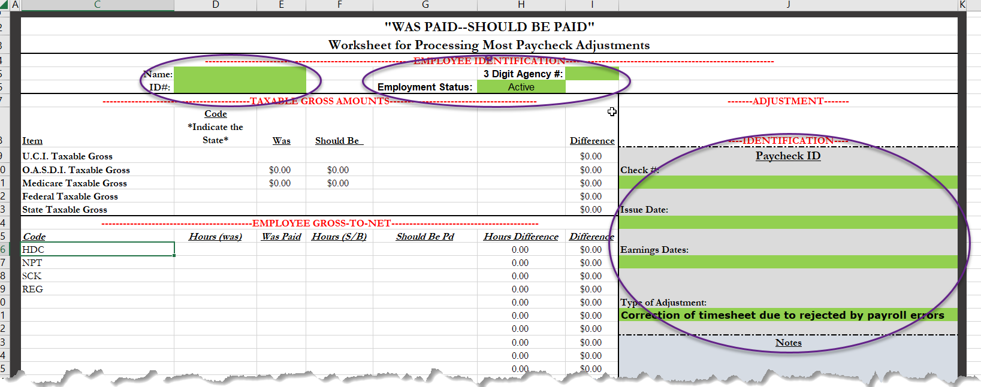  If there are multiple paychecks involved in the pay period being adjusted, list all of the pay periods under the ‘Notes’ section. The more information you note in this section, the better.
2. | Complete the following required fields:  - Code (TRC)  - Hours (Was)  - Was Paid  - Hours (Should Be)  - Should Be Paid | 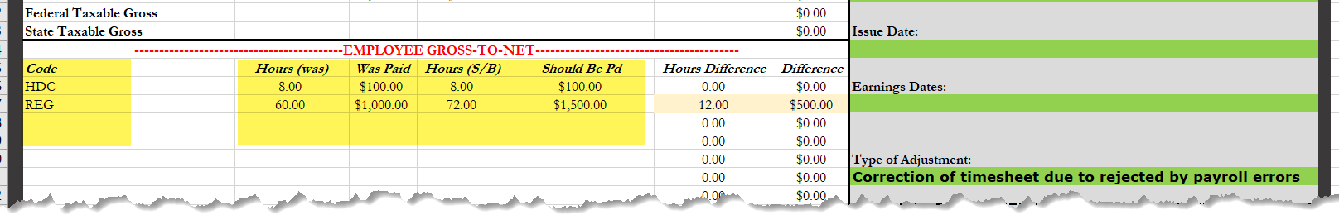
3. | Complete the following required fields:  - If there is State Tax, note the State  - OASDI, Medicare, and Federal Tax Was Paid  - OASDI, Medicare, and Federal Tax Should be Paid | 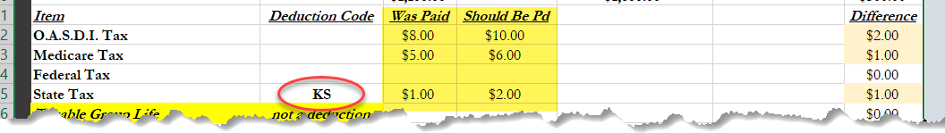  To identify the Tax Amounts, replicate this adjustment in the Paycheck Modeler or Online Check. If the employee has never had a paycheck, you will have to get these numbers by using the Online Check. There is a separate Job Aid for that process, under the Adjustment folder.
4. | Select ALL applicable deductions from the drop down box (to get rid of a deduction code hit the delete button, it will clear out the deduction code.)  - Enter both the Was and Should Be amounts  If you find that there is a deduction code not listed here, please email payadj@ks.gov to get that added. | 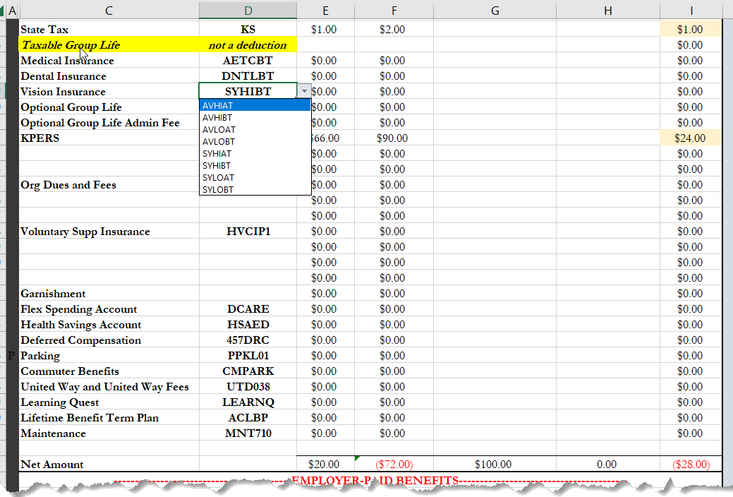
5. | Complete the following required fields & select ALL applicable deductions (Medical, Dental, KPERS, Health Savings Account, GTL) from the drop down box:  - OASDI and Medicare Tax Was Paid  - OASDI and Medicare Tax Should Be Paid  - Any Employer Deduction amounts Was Paid  - Any Employer Deduction amounts Should Be Paid | 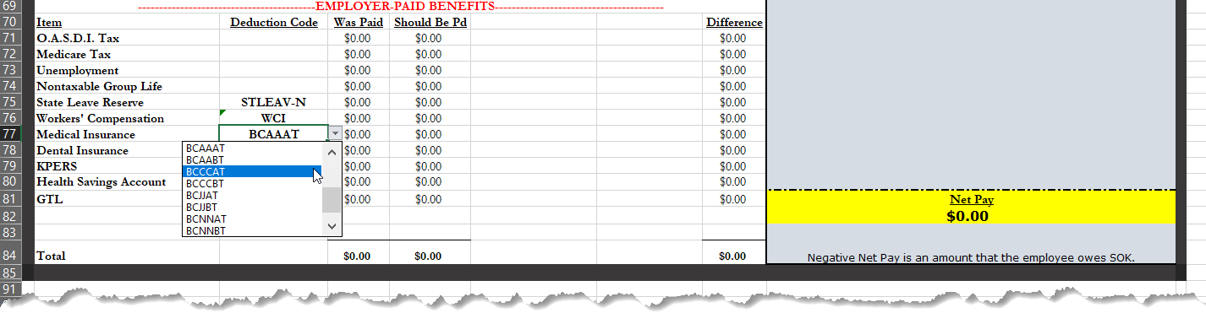  To identify the Tax Amounts, replicate this adjustment in the Paycheck Modeler. If the employee has never had a paycheck, you will have to get these numbers by using the Online Check. There is a separate Job Aid for that process, under the Adjustment folder.  The Net Pay amount is the amount that will be paid to the employee. If it is a negative amount, the arrears amount will be calculated centrally and you will be able to see what that amount is once the paycheck has been created.
Submit the DA-180 for Processing
Completed forms (in Excel formal) should be emailed to payadj@ks.gov, with the approver CC’d on the email. This will serve as the approval for the adjustment.

Faxed forms are no longer accepted. ALL forms should be emailed in the excel sheet. If this form is not used, the request will be sent back to the agency.
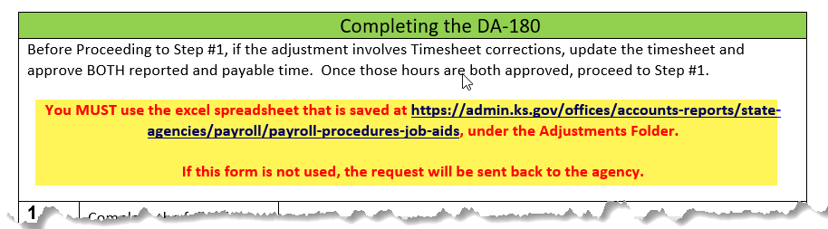

Make sure all required fields are populated. Any incomplete forms will not be accepted and will be sent back to the agency.

Any forms received in the payadj box by 11 a.m. will be processed on the next off-cycle payroll. Anything received after 11 a.m. will be processed on the following off-cycle being processed.

