State of Kansas
Agency Requested W2 Reprints
Statewide Human Resource and Payroll System

Date Created |  | 12/07/2021
Version |  | 1.0
Security |  | - SHARP  Role: Agency Payroll Specialist
Purpose |  | Allow agencies to request W2 Reprints for W2’s that are from the last 5 years . If the reprint request is for a W2 that is older than 5 years, agency should verify employee identity then email doa_payroll@ks.gov to request the reprint.
Informational |  | If the request does not come in by person, identity verification is required. When verifying identity agency must speak directly to the employee.  Examples of information used to verify identity:  - Employee ID  - Date Of Birth  - Last 4 Digits of SSN  - Position Held  Deceased Employee  If employee is deceased and the executor of the estate is requesting a W2 Reprint, requestor must provide a copy of the Letter of Administration issued by the court.  Military Leave  If employee is deployed on military duty, requestor must provide Military Power of Attorney.  Agency must have secure envelopes available to use when mailing W2 statements to employees. W2 requests that are not older than 5 years old should not be sent to central payroll. Those requests will be handled at the agency level.
Navigation |  | SHARP > Navigator > Payroll for North America > US Annual Processing > Create W2 Data > View W2/W2c Forms
1. | Enter the Employee ID  Search  (Reprints for W2’s are only available from the last 5 years. Contact doa_payroll@ks.gov if you need an older W2.)  If the Tax Year that needs to be printed displays, click on the Year End Form Link  (*Note: Only years that have been finalized will be displayed. If the final W2 run has not completed, the W2 for that Tax Year will not display.)  Form will display  Print the form  Be sure to write REISSUED STATEMENT on the the top of the form before delivering to the employee. | 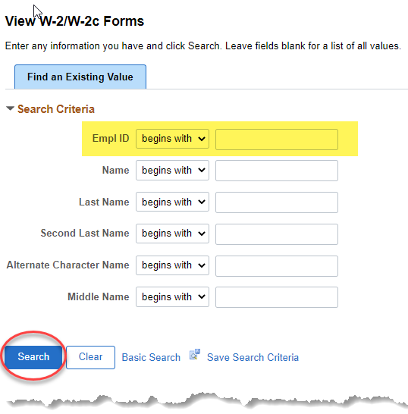  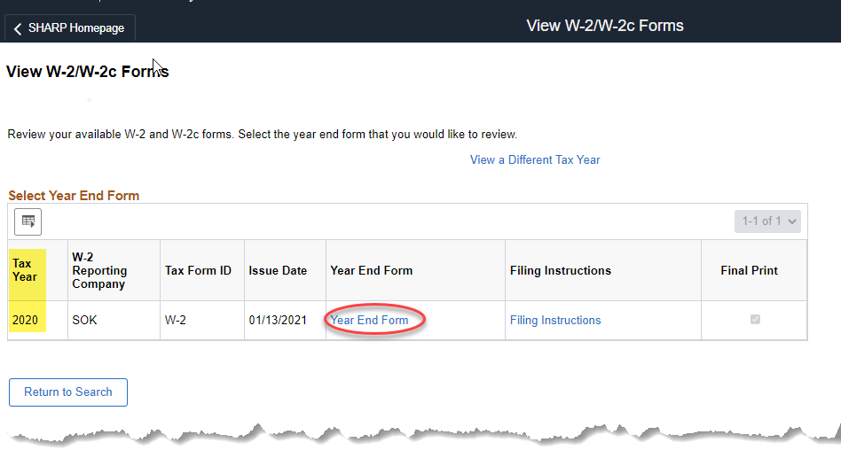  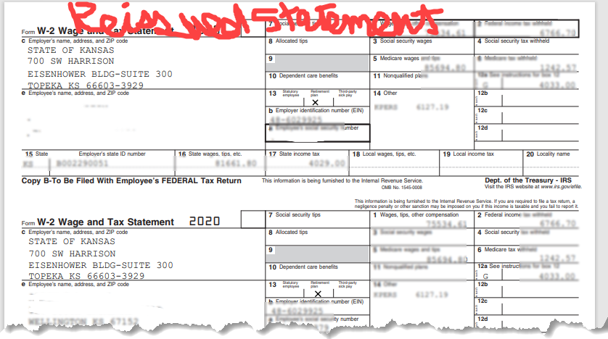
Other Years  Select View a Different Tax Year  Select Tax Year that needs to be printed  Click on the Year End Form link  Form will display  Print the form  Be sure to write REISSUED STATEMENT on the the top of the form before delivering to the employee. |  | 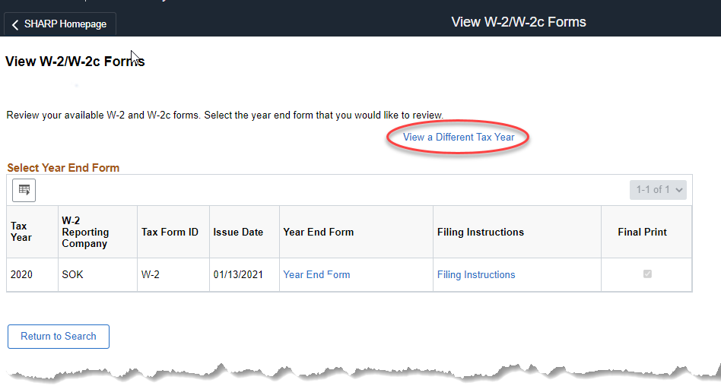  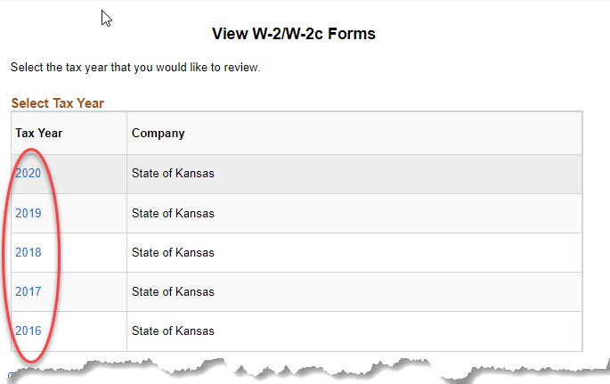  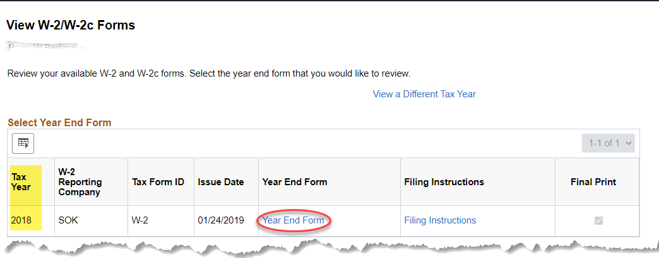  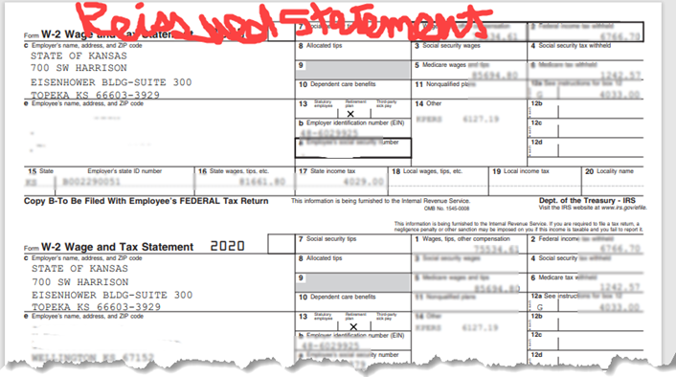
Informational |  | - Make note of the address on the W2. If the employee address is not correct, update the employee address in SHARP.  - If mailing the W2 to the employee, the agency is responsible for providing secure envelopes and addressing the envelopes and mailing the W2 to the employee.

