State of Kansas
Adding New Combination Code
Statewide Human Resource and Payroll System

Date Created |  | 1/3/2022
Version |  | 1.0
Security |  | - SHARP  Role: Agency Commitment Accounting Specialist
Purpose |  | Adding a funding string (Combination Code) to SHARP. The Combination Code (Combo Code) contains Department ID, Fund, Budget Unit, and Program Code. A Combo Code may also contain PC Business Unit, Project ID, Activity ID, Resource Type, Resource Category, Resource SubCategory, Service Location, and Agency Use.
Instruction |  | Refer to KTL111-Combo Code/Task Profile Report Job Aid  Run the Combo Code/Task Profile Report and load into Microsoft Excel.  This is the Template to work off of to add a new Combo Code.
1. | Copy the Combo Code/Task Profile report to a second tab and save before starting the report. This tab will become the load template.  Add a filter to the report header. On the load tab, delete out colums S-Z.  What chartfields need to be added?  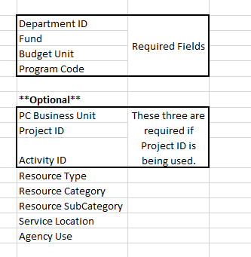  Once you have identified what chartfields you want to use for the combo code, filter on that combination of chartfields to make sure that combination DOES NOT ALREADY EXIST.  For example:  You want to add a combo code for the following chartfields:  Department ID: 1231100000  Fund: 1000  Budget Unit: 0712  Program Code: 01031  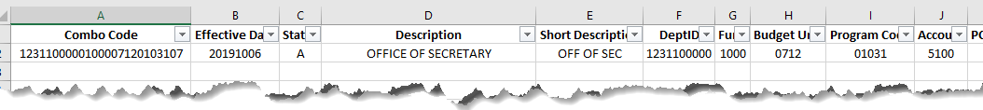  When the filter is used, searching for the combination of those chartfields, I can see that the combination already exists.  -STOP- Nothing needs to be loaded. The combo code already exists.  If, when the filters are applied, the combination of chartfields does not already exist, proceed to Step #2.
Instruction |  | Before proceeding to Step #2:  Do the chartfields you want to use for the Combo Code exist in SMART?  YES: Proceed to Step #2  NO: Refer to SMART job aid Adding Chartfields. Once you have confirmed the chartfields exist in SMART, you can continue to Step #2.
2. | 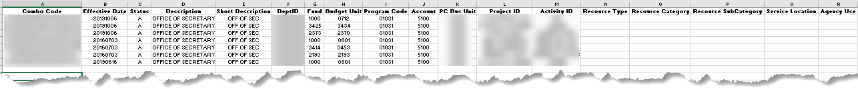  Using the report headers, and deleting out all the existing data, this will create the template needed to load a new combo code. Once all of the existing data is deleted, enter the new chartfields in columns E-R to create a new combo code. Step #1 outlines the required and optional fields.
3. | Create a value for Column A (Combo Code)  A recommended naming convention is the Department ID+Fund+Budget Unit+Program Code. However, the field has a limit of 25 characters. If the agency is using more chartfields than the 4 chartfields above, the agency will need to create its own internal naming convention.  The value in Column A (Combo Code) cannot be loaded into the system more than once. That means once a Combo Code is loaded into the system with a set of chartfields attached, it cannot be loaded again with different chartfields attached. It is VERY important to check to make sure the value you have input into Column A does not already exist in the system. You can do this by looking at the original Combo Code/Task Profile Report that you downloaded. If the value in Column A does already exist, you will need to make the value unique, without going over 25 characters.  If a load is submitted with a value in column A that already exists with different chartfields, an error will be sent stating that the Combo Code Exists with Different Chartfields.
3. | Final Step- Add an Effective Date to the File:  Effective Date:  - Must be in YYYYMMDD format.  - Must be a pay period begin date.  - Cannot be a prior pay period begin date.
Important Notes |  | - When adding a new combo code, anytime a chartfield value changes, a new combo code needs to be created. (Column A)  - An existing combo code cannot be modified.
Next Steps |  | Once you have completed the combo code load form, email the finished spreadsheet to: tlload@ks.gov
Load Times |  | Files are loaded daily. Any files received before 11 AM are loaded that day. Any files received after 11 AM are loaded the following business day.

