State of Kansas
Adding a New Position Pool ID
Statewide Human Resource and Payroll System

Date Created |  | 12/13/2021
Version |  | 1.0
Security |  | - SHARP  Role: Agency Commitment Accounting Specialist
Purpose |  | Adding a New Position Pool ID
Navigation |  | SHARP > Payroll Homepage > Payroll Funding > Department Budget Tbl Funding > Position Pools
1. | SHARP opens to the Position Pool Table page.  On the Add a New Value tab  Set ID: SOKID  Department: Enter the Department the Position Pool ID is attached to  Position Pool ID: The 3-character Pool ID to be used. This can be any 3-character value you choose. Typically it’s a numerical value.  Add | 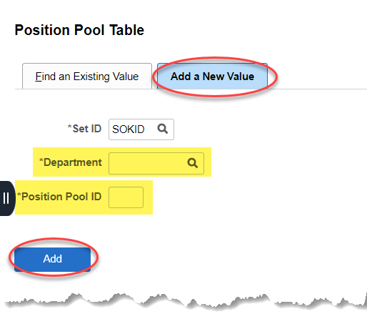
2. | Effective Date: Pay Period Begin Date  Status: Active  Description: (30 Character Limit)  Save | 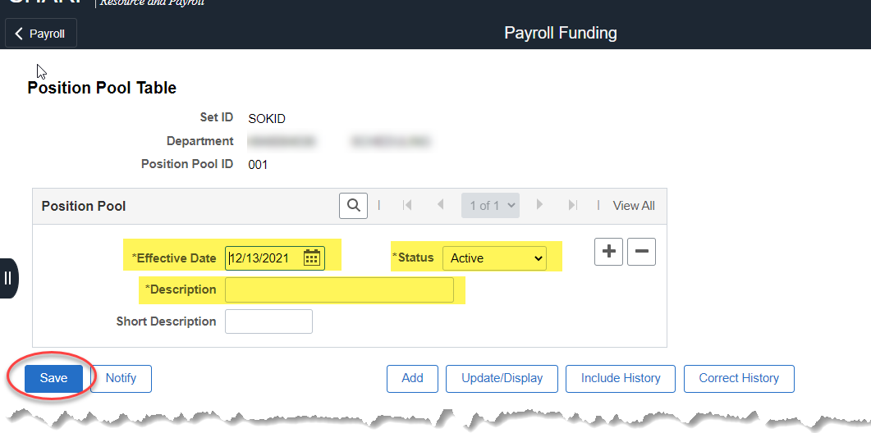
Instruction |  | Add the funding for the new Position Pool ID to the Department Budget Table, using the KAGYBUD1 load form. See job aid KAGYBUD1 – Department Budget Table Load  In order for the employee to be funded correctly, make sure the employee’s Position is reflecting the Department/Position Pool ID that was just set up. If assistance is needed with this step, contact the Office of Personnel Services at sharp@ks.gov

