State of Kansas
ADJ-ALL
Statewide Human Resource and Payroll System

Date Created |  | 6/2/2022
Updated |  | 10/3/2022
Security |  | - SHARP  Access to the following to request ADJ-ALL:  Role: Agency Payroll Specialist
Purpose |  | Request paycheck adjustment using the ADJ-ALL process. An Agency Entered Adjustment is the transaction an agency processes on-line by requesting the adjustment on the Reverse/Adjust Paychecks page.
Information |  | - A paycheck adjustment is where a correction should be processed to a paycheck created for an employee for a particular pay period.  - A paycheck adjustment does not stop the original paycheck from being issued and sent to the employee.  - The adjustment process will create either an additional check to the employee for additional hours or refund taxes or deductions, or it will create an arrearage (ADJ earnings) for an overpayment of hours reported or increased taxes or deductions.  - Note: If an employee changes their tax data between the issuance of the original check and the adjusted check, there will be a difference in the calculation of the federal and state withholding taxes based on the current tax data. This can also happen if you cross calendar years.
Tips and Tricks |  | - If the adjustment involves the timesheet, you should adjust the timesheet and approve through Payable Time prior to requesting an adjustment.  - If the adjustment involves a non-GHI deduction, make sure the deduction has been updated in SHARP. Then request the adjustment for the pay periods that need to be adjusted.
When will the Agency Entered ADJUSTMENT (ADJ-ALL) NOT work for my employee? |  | - An adjustment has already been requested for the paycheck that needs to be adjusted.  - An adjustment and a supplemental cannot be processed for the same employee in the same off-cycle.  - Cannot process more than one adjustment for a specific employee in one off-cycle. (You will need to process each pay period in a separate off-cycle run.)  - Cannot process ADJ-ALL for employee that has an active garnishment. Or where there was a garnishment on the original paycheck.  - Cannot process ADJ-ALL for employee that has ADV earnings codes.  - A change in Pay Rate will not be automatically picked up throug the ADJ-ALL. Pay Rate Adjustment’s (PRA) will be entered directly to the next on-cycle timesheet to pay the employee the difference in gross earnings.
After reading the above information, will an ADJ-ALL work for your employee? If so, proceed.
1a. | ADJ-ALL Process initial set up  If the ADJ-ALL is set up, proceed to step #2.  Company: SOK  Pay Group:  KAA- Off Cycle A  KAB- Off Cycle B  KAC- Off Cycle C  Pay Period End Date:  Pay Period End Date for the last confirmed on-cycle paycheck. (This is NOT the period end date for the check being adjusted.)  **This step only needs to be completed once. After the initial Run Control set up, you can start on step 1b. | If this is the first time you have ever used the ADJ-ALL process:  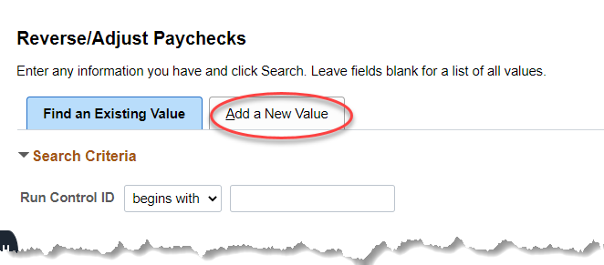  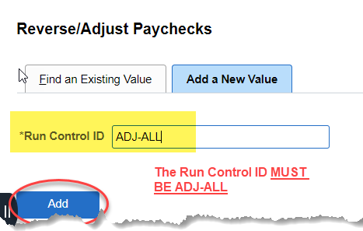  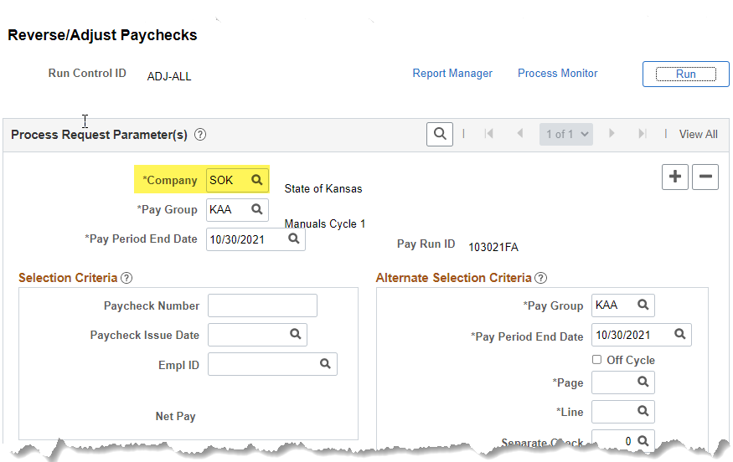
1b. | On the Find an Existing Value Tab, select the ADJ-ALL Run Control ID | 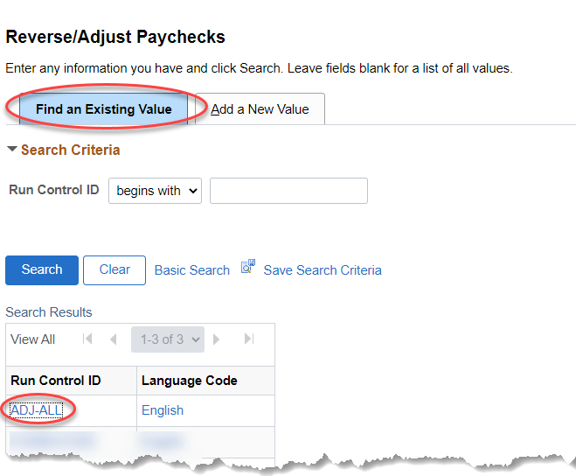
2. | Agency will only need to enter the following:  Paycheck Number: Paycheck Number that is being adjusted  Paycheck Issue Date: The Issue date of the paycheck being adjusted  -tab out of the Paycheck Issue Date field-  Empl ID: This value will automatically populate once the user tabs out of the Paycheck Issue Date field.  Verify the Empl ID value and the Net Pay amount. The paycheck data including the original paycheck pay period end date will show on the data on the right hand side (Alternate Selection Criteria).  The Reversal/Adjustment radio button should be selected.  No other fields should be modified.  If any of the values are not correct, exit the page without saving and start the process again, after you have verified the information you are adjusting.  If there are several checks to adjust, select ‘Save’ after the first check that was entered, select ‘+’ and do the process again. Select ‘Save’ after each entry. Do not write over any paycheck number or you will erase the prior request. The paycheck data fields must be blank to enter a new check number.  Do Not Click on Run | 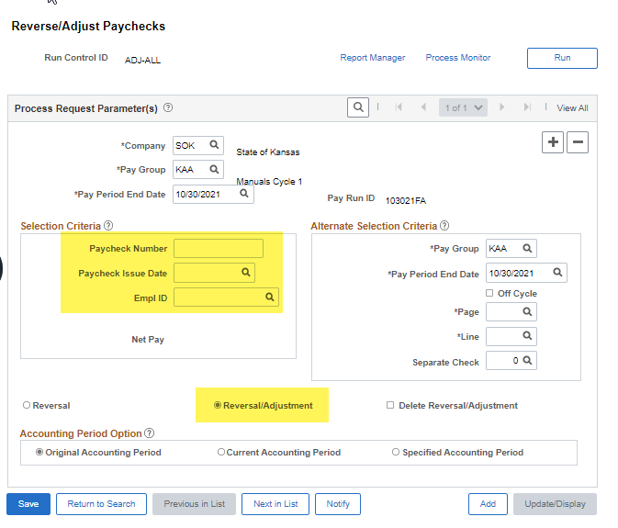  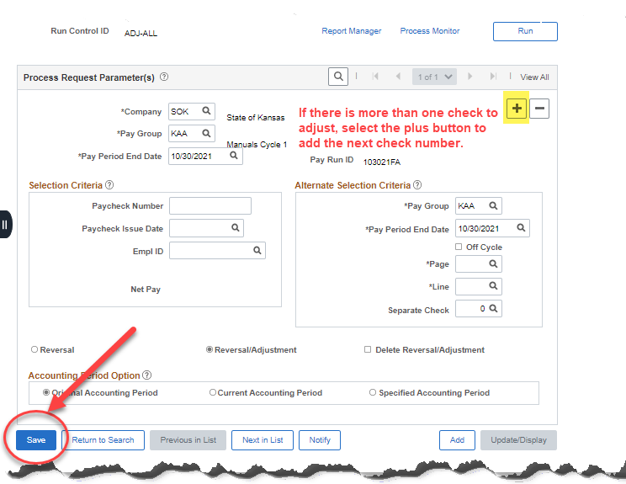
I Entered and Saved an Adjustment I didn’t Mean to Enter!
If you have entered more than one check in the screen, you will select the – button for the check that you don’t want to adjust, save.
If there is only one check saved and that is the check you want to delete, select the box Delete Reversal/Adjustment and Save.
Refer back to Payroll Checklist for Final Steps

