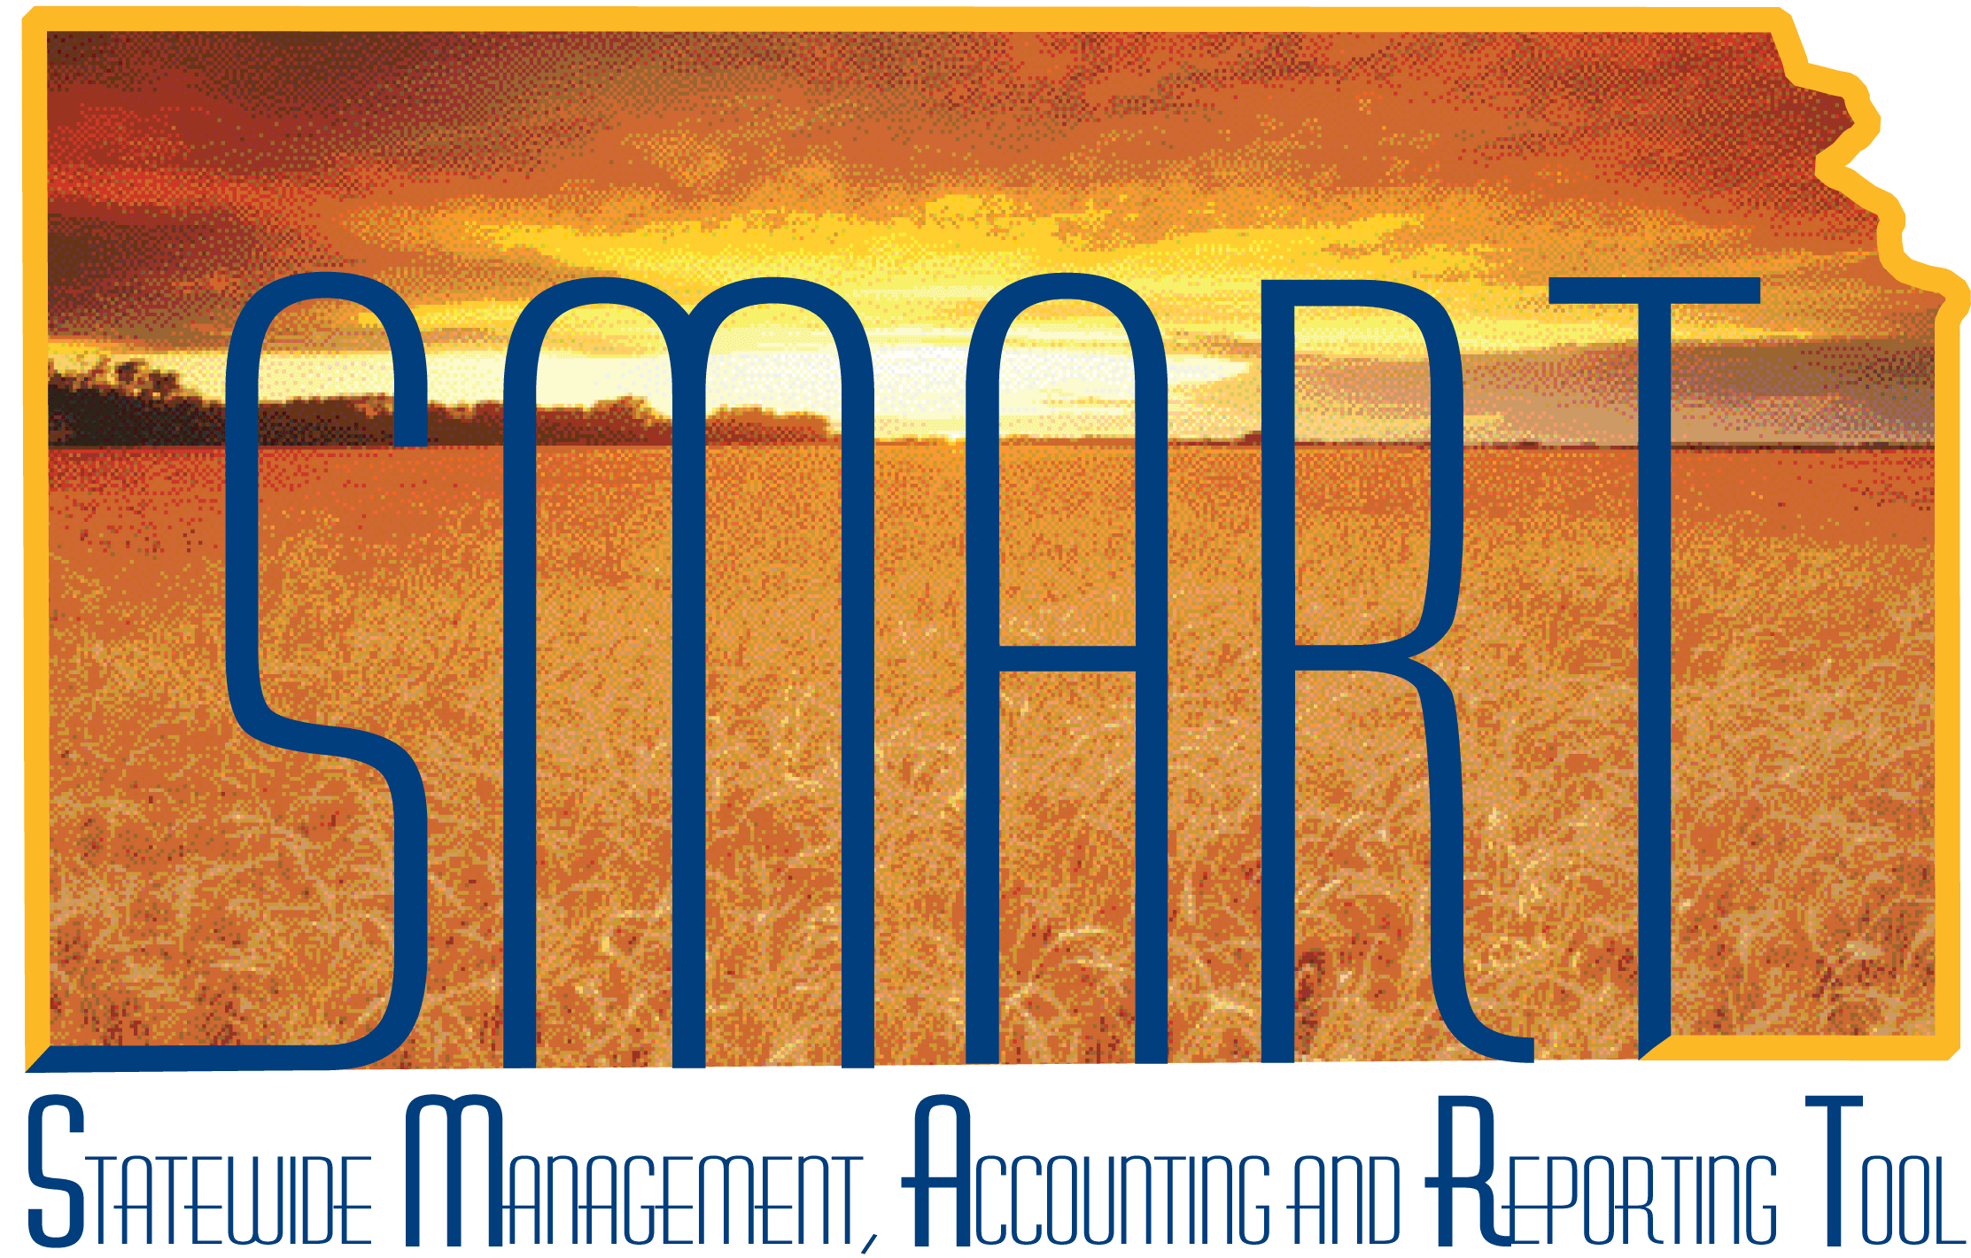
Training Guide – Purchasing
Procurement Cards (PCards)

State of Kansas
Applicable Role(s):

PO Agency PCard Admin
PO Agency PCard Reconciler Approver
PO Agency PCard Approver
PO Agency PCard Holder
PO Agency PCard Reconciler
Table of Contents
KEY TERMS 4
Key Concepts 8
Security 8
Roles 8
Register Roles & Assign Access Rights 8
Cardholder Profile 8
Using PCards on Requisitions and/or Purchase Orders 8
Loading PCard transactions 9
PCard Approval Process 9
Voucher Building Process 9
Key Agency Roles and Tasks 9
Cardholder Profiles – Creating / Maintaining 10
New Employee 10
Adding a PCard To Existing Cardholder Profile 26
New Proxy 29
Cardholder Profile 30
Mass Update 34
Employee Leaving Agency 37
Cardholder 37
Proxy 38
Associating PCards to Requisitions and Purchase orders 41
PCards on Requisitions 42
PCards on Purchase Orders 43
PCard flowed from Requisition 43
No PCard on Requisition 45
Changing PCard After PO Dispatched 47
Adding a PCard – PO Dispatched 47
Changing a PCard – PO Dispatched 49
Removing a PCard – PO Dispatched 53
PCard Link Not Appearing on PO 56
Check the PCard Expiration Date 56
Action to take if the Expiry date is NOT current 58
Check to see if the Buyer has ‘Proxy’ to this PCard 59
Action to take if the Buyer does NOT have Proxy to the PCard 61
Supplier Location’s Effective Date is on or before the PO Date 64
Supplier’s Location Code Effective Date is AFTER the PO Date 66
Change the Location Code on the PO 67
Change the PO Date 68
Open ManageEngine Service Desk Request 68
Reconciling PCard Transactions 70
Applying ‘Description’ settings to Reconciliation Page 70
No Purchase Order 72
With Purchase Order 76
PO Merchandise Amt total = PCard transaction amt 77
PO Merchandise Amt total > PCard transaction amt 82
PO Merchandise Amt total < PCard transaction amt 89
PCard Disputes / Incorrect Charges 98
Instructions for Processing Disputes and/or Incorrect Charges 98
Review Disputes Page 100
Reviewing / Approving PCard Transactions 106
Reviewing PCard Transactions 106
Description 107
Dollar Amount 108
Purchasing Details 110
Chartfield Information 113
No Purchase Order 113
With Purchase Order 114
Approving PCard Transactions 115
PCard Vouchers 117
Building the PCard Voucher 117
PCard Voucher – Do Not Make Changes 117
Voucher Build Errors 117
Match Exceptions 118
Approving PCard Vouchers 118
Tips 119
Line Details Icon 119
Comments 120
Budget Validation 121
PO is not available for selection 122
Unit Price – Calculated Field 122
PCard Queries 122

KEY TERMS

Term | Brief Description of Term
PCard (carded or cardless) | A Purchasing Card (PCard) is a type of Commercial Card that allows organizations to take advantage of the existing credit card infrastructure to make electronic payments for a variety of business expenses (e.g., goods and services). In the simplest terms, a PCard is a charge card, similar to a consumer credit card. However, the card-using organization must pay the card issuer in full each month, at a minimum. PCards are also known as Procurement Cards (ProCards), Payment Cards, Purchase Cards or similar terms. [The State of Kansas will use the term PCard.]  PCards are not limited to plastic cards; they can also take the form of non-plastic account numbers. The term "card" is typically used within the industry when describing any type of Commercial Card product, regardless of whether or not a plastic card is issued. One variation of a PCard is a:  - Ghost Card/Ghost Account – a card account that an end-user organization issues to a specific supplier or supplier type and the supplier processes all the organization's purchases to the account; functions like a PCard.  Definition from NAPCP web site: http://www.napcp.org/?page=WhatArePCards
Cardholder | Organizations that use PCards come from the Corporate, Education and Government sectors and are often called "end-users." The individual employees who are issued a PCard to initiate transactions/payments on behalf of their employer (the end-user organization) are known as "cardholders."  Definition from NAPCP web site: http://www.napcp.org/?page=WhatArePCards
PCard Issuer  The ‘Issuer’ for the State of Kansas is currently UMB. | Issuers work directly with end-users to implement and grow programs, issue cards and invoice posted PCard transactions. The issuer uses the services of the networks and processors to facilitate card issuance, authorize transactions and provide data. Many financial institutions are issuers. Issuers are sometimes referred to as card "providers."  The card issuer typically provides a single electronic invoice to the end-user organization—at a minimum of once per month—reflecting all cardholders and their respective PCard transaction totals plus a grand total. An organization does not carry a balance, instead paying its card issuer in full (at a minimum of one payment per month) for all cardholders’ transactions. The organization processes the invoice, creating accounting entries and facilitating payment to the card issuer.  Definition from NAPCP web site: http://www.napcp.org/?PCardProcess
Agency PCard Employee ID  Format: Agency number followed by PCARD.  Example: 17300PCARD | SMART requires that each Procurement Card (PCard) be assigned to an individual Employee ID (Empl ID) under the Cardholder Profile. The State has previously allowed for Cardless Travel accounts and Vehicle cards be assigned to a non-person, i.e. the vehicle card has the vehicle tag number imprinted on the card. By allowing such assignment, the agency was able to allow more than one person to use the card, yet still have one individual responsible for all charges.  At SMART go-live (July 2010), each PCard was required to be assigned to one Empl ID. As employees have changed positions or left employment, transactions have become more difficult to reconcile and problems were discovered when moving a PCard from one Cardholder Profile to another Cardholder Profile.  To address this situation, each agency is allowed to have a new ‘non-person’ Empl ID (“Agency PCard Empl ID”) to be used EXCLUSIVELY for assignment of Cardless Travel accounts and Vehicle PCard accounts. This allows for these PCard accounts to remain with the “Agency PCard Empl ID” regardless of employment changes.  Please review Procurement Information Circular 11-02 for detailed information concerning obtaining an Agency PCard Employee ID and/or the accepted use of the Agency PCard Employee ID.
Agency PCard Payment Employee IDs  Format: First three digits of the agency number followed by PCRDPYMT.  Example: 173PCRDPYMT | An ‘Agency PCard Payment Employee ID’ was created for each agency so that informational data received from the Issuer (UMB) and associated to the agencies Control Account numbers could be retained in SMART.  The ###PCARDPYMT ID is to be used SOLELY by the Central PCard Administrator (Tim Hund). Do not associate any agency PCards to this Employee ID when setting–up cardholder profiles in SMART.  The PCard file provided by UMB includes not only debit / credit information that agencies need to reconcile but also includes informational data which consists of UMB payments and internal UMB adjustments to move information between accounts, etc. The informational data should not be reconciled by agencies nor should it be included on vouchers.  Prior to the ‘Agency PCard Payment Employee IDs’ being established, the informational data was landing on an error page and not becoming an active transaction in SMART because UMB associated these transactions to the agency Control Account Number and not a specific PCard number. The error list page grew to the point that it was no longer usable.  To resolve these issues, the SMART team took the following steps:  - An ‘Agency PCard Payment Employee ID’ was created for each agency.  - The Central PCard Administrator (Tim Hund) created PCards using the agency Control Account number where the PCard number would normally go and associated the PCard to the '%PCRDPYMT" PCard Holder profile for each of the agencies.  - Modifications were made to the PCard load process so that all informational transactions associated to a ‘###PCRDPYMT‘ employee ID were automatically loaded with a status of ‘Closed’. These transactions will not show up for reconciliation, approval, or payment.  NOTE: When running SMART queries for PCard transactions, you may see some transactions (payment confirmations and adjustments) charged to your agency’s control accounts for PCards. These PCard transactions will be associated to an Empl ID that looks like ###PCRDPYMT. Please disregard these PCard transactions, no action is required on the agencies part.
Billing Date | The Billing Date is the date that the PCard transaction was loaded into SMART.
Transaction Date | The Transaction Date is the date that the transaction actually occurred, PCard was swiped or PCard Account Number entered by Supplier.
Post Date | The Post Date is the date that the transaction was posted to UMBs system.

Key Concepts

Security
There are layers of security surrounding the PCard module. The first layer provides page access by assigning roles to the users within SMART. The second layer is to set up card holder profiles and give proxy rights to the cards.

Roles
Users who will have a role in the PCard process will need to have the appropriate roles assigned to them so that they will have the correct page access. The PCard related roles in SMART will be discussed in detail in the ‘Key Agency Roles and Tasks’ section of this training document.

Register Roles & Assign Access Rights
The PCard roles have been registered in the PCard module and each role has been given access rights.
When the PCard profile is established, the card will be associated to an employee identification number (Empl ID), that Empl ID will be assigned one (1) and only one (1) role for that particular card. The role determines what actions a particular user can perform with a specific card.

Cardholder Profile
The PCard Cardholder Profile connects an Empl ID to the PCard data and also matches the card to the various roles and users that need access to this card. See the ‘Setting up PCard Holder Profiles’ section of this training document for detailed instructions on creating a PCard Holder Profile.

Using PCards on Requisitions and/or Purchase Orders
Agencies may submit requisitions for purchases being made with a PCard. For example, an agency may want to purchase a book from an online company and would like to pay for the purchase using a PCard. During the creation of a requisition a PCard can be selected from a drop-down list of available PCards. The PCard drop down box will display if the ‘Requeseor’ has proxy to at least one (1) PCard.
The PCard information will flow from the requisition to the PO when:
- the supplier location effective date is on, or before the PO Date,
- the Buyer has proxy to the PCard, and
- the PCard has a current expiration date.

Note: All suppliers are now setup to accept PCards.
If a PCard was not selected at the requisition level but the Buyer will be making payment using a PCard, a PCard can be added to the Purchase Order (PO) later. The ‘Use Procurement Card’ link will be available on the PO for the Buyer to select provided that the above listed statements are true.

Loading PCard transactions
UMB sends a PCard transaction file to the State of Kansas on a nightly basis Monday through Saturday. UMB does not generate a file on Sunday. The PCard transactions are loaded into SMART during the nightly batch processes. The ‘Billing Date’ on the PCard transaction is the date that the transaction was loaded into SMART.

PCard Approval Process
SMART does NOT have an automated approval process for PCard transactions. A process is ran on a weekly basis that initiates email notifications to the PCard Holder announcing when PCard transactions have been loaded for their specific card; however, there are no notifications to move a PCard transaction from one (1) reviewer to the next.
The status of PCard transactions can be manually changed from ‘Initial’ or ‘Staged’ to ‘Verified’ and finally to ‘Approved’. The Reconciler’s role will dictate whether or not they can ‘Approve’ a PCard transaction.
Note: All transactions enter SMART with a status of ‘Initial’. This status is used by the weekly email notification of new transactions process. Once ran, it changes the status of these transactions to ‘Staged’.

Voucher Building Process
PCard vouchers are created through batch processes which the State of Kansas runs twice weekly, Monday and Thursday mornings before the hourly batch processes begin.

Key Agency Roles and Tasks

Role | Description
PO Agency PCard Admin | Each agency should have at least one (1) user with the PO Agency PCard Admin role.  This role is responsible for managing agency business procurement cards. For example: Assigning business procurement card proxies, adding new business procurement cards / users, and maintaining business procurement card holder profile information.
PO Agency PCard Holder | This role should be given to any employee who has been issued a PCard.  This role by itself provides no access to functions in SMART. Giving an employee a role within SMART does not mean that they have to log into SMART; in this case, there will be some employees that have this role and will never log into SMART.  Assigning all PCard holders this role allows their PCards to be used on Requisitions and Purchase Orders when appropriate.
PO Agency PCard Reconciler | Employees with the PO Agency PCard Reconciler role are responsible for reviewing the PCard transactions and manually changing the status from ‘Staged’ to ‘Verified’. This individual is NOT the final ‘Approver’.
PO Agency PCard Approver | Employees with the PO Agency PCard Approver role are responsible for the final approval of the PCard transaction. This individual will manually change the status from either ‘Staged’ or ‘Verified’ to ‘Approved’.  The PCard transaction is available to be built to a voucher once the status is ‘Approved’, the Budget Status is ‘Valid’, and the Chartfield Status is ‘Valid’.
PO Agy PCard Recon Approver | Smaller agencies many times do not have the luxury of having two separate individuals to reconcile and approve PCard transactions. For those isolated cases, a role was designed to allow one (1) individual the ability to both reconcile and approve PCard transactions.  It is important to maintain a division of duties; consequently, this role should be given only when no other option is available.
PO Central PCard Admin | The State of Kansas has an employee who manages the PCard program; that employee is currently Tim Hund. The manager of the PCard program is given the ‘PO Central PCard Admin’ role in SMART and is given ‘Proxy’ to all PCards entered in SMART.

Cardholder Profiles – Creating / Maintaining

New Employee
Your agency has just hired a new employee who will use a business procurement card for the State of Kansas. UMB bank has assigned the business procurement card to the new employee, and the business procurement card number has been assigned to the new employee by your agency. Now, you need to set up the employee’s Cardholder profile information for the business procurement card in SMART.
Navigation:
Fluid: From the SMART Homepage, click on:
SMART Homepage dropdown → Requisitions & PCards → Procurement Cards → Manage PCards → Cardholder Profile

Classic: From the SMART Homepage, click on:
NavBar → Navigator → Purchasing → Procurement Cards → Definitions → Cardholder Profile

- Enter the new employee’s ‘Empl ID’ and click the ‘Search button. In the Search results, click the desired Empl ID link:
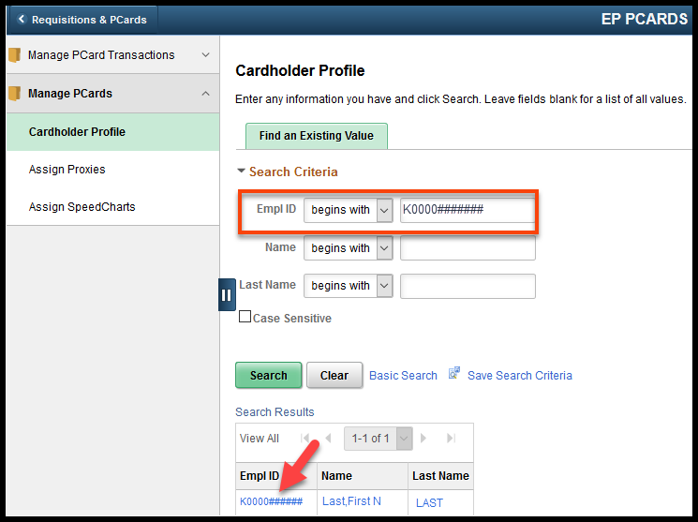
- Click the ‘Card Data’ tab:
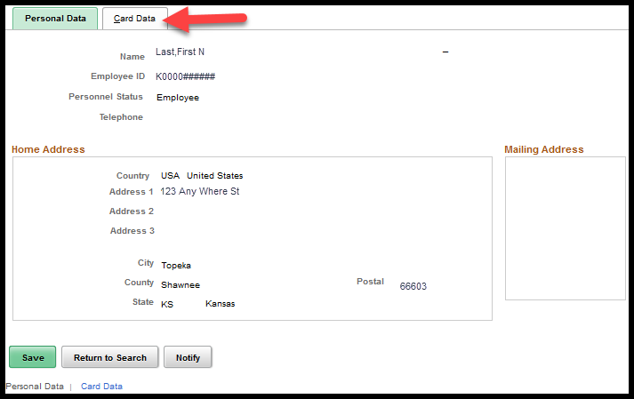

- Enter the ‘Credit Card’ information and ‘Save’ the record:
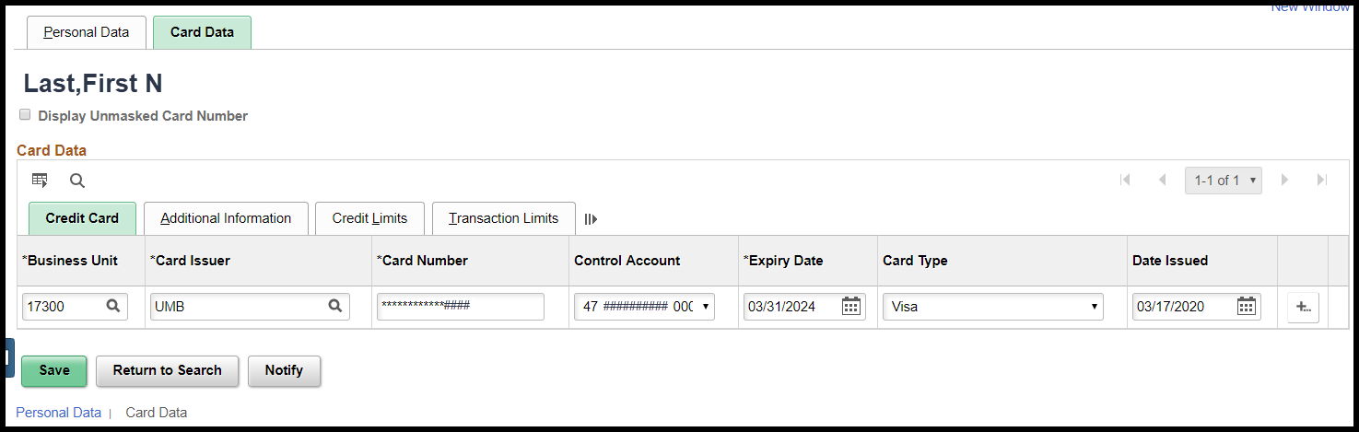
Field | Description
Business Unit | Use the Business Unit field to enter your agency’s Business Unit number (5 digits).
Card Issuer | UMB Bank is the current card issuer for all State of Kansas business procurement cards. Enter ’UMB’ into the Card Issuer field.
Card Number | Use the Card Number field to enter the business procurement card number assigned to the employee.  NOTE: The entire PCard number will display while you are entering the number. When you ‘Tab’ to the next field, SMART will encrypt the PCard number, for security purposes, and will display only the last four digits.  Users with the PO Agency PCard Admin role have the option to ‘Display Unmasked Card Number’. To ensure that the encryption process completes successfully, it is recommended that the ‘Display Unmasked Card Number’ remains Unchecked while adding PCards to a Cardholder Profile:  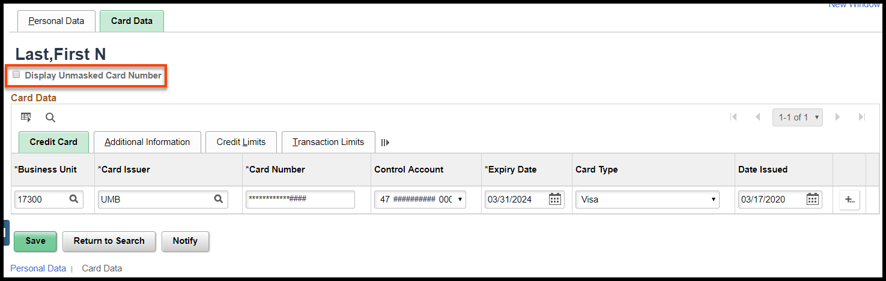
Control Account | Use the Control Account field to enter the Control Account associated to this card. All procurement cards must be associated to a Control Account to process in SMART.  NOTE: Control Accounts are maintained centrally. If you need to add or delete a Control Account please contact the State of Kansas Procurement Card Program Administrator, currently Tim Hund.
Expiry Date | Use the Expiry Date to enter the expiration date for the employee’s business procurement card. Expiry Date is entered in the format of MM/DD/YYYY.  Hints:  - The State of Kansas is not using SMART to maintain PCards from the perspective of expiration dates, expense limits, etc. The PCard Issuer, currently UMB, takes responsibility for the maintenance of the PCard. Since SMART is not managing the actual PCard expiration, it is acceptable to enter an expiration date that is far into the future. This will prevent agencies from having to frequently update PCard expiration dates in SMART.  - When an employee leaves employment in your agency, the agency PCard Administrator will need to change the expiration date on the PCard to the date the employee left service, this will prevent Requisitioners and/or Buyers from selecting this PCard. The agency PCard Administrator will then need to contact the PCard issuer (UMB) to ‘Cancel’ the PCard. The PCard should NOT be deleted from SMART.  - Use the calendar icon to enter the expiry date. Dates in the past can be used.  - If the Expiry Date is NOT current, the PCard will not be available for selection on either requisitions or PO’s.
Card Type | Use the Card Type field to enter ‘Visa’. VISA business procurement card numbers begin with a ’4’ and contain a total of 16 digits.
Date Issued | Use the correct date of issue of the business procurement card.  Hint: Use the calendar icon to enter the date.

- Click the ‘Additional Information’ tab:
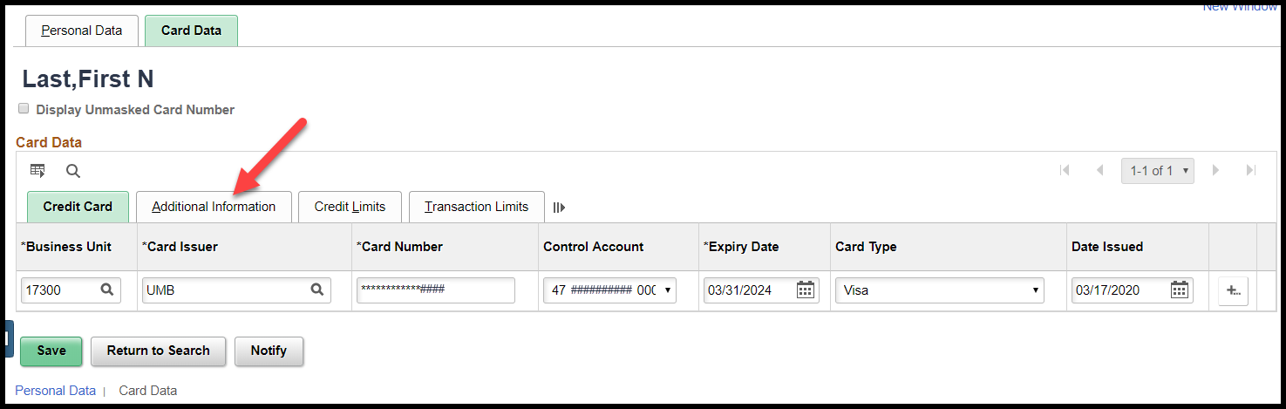
- Click the ‘Proxies’ link:
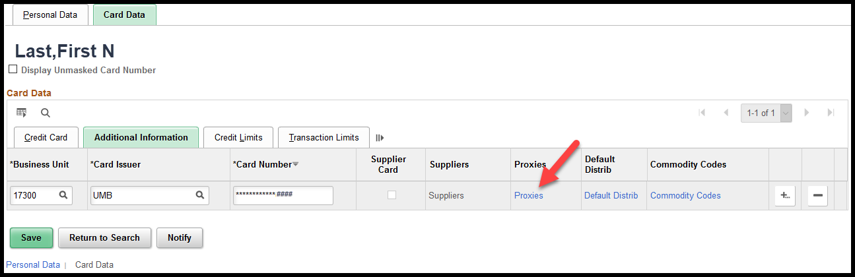
NOTE: Only those users with Proxy rights to a PCard can use that PCard in SMART. When assigning Proxy rights, you must assign one (1) and only one (1) role to that user for that specific PCard. Below are some examples:
Situation | Role
The User has been assigned a PCard. | PO Agency PCard Holder
The Proxy has been asked to reconcile the PCard transactions for another employee’s card. | PO Agency PCard Reconciler
The Proxy has been asked to approve PCard transactions for another employee’s PCard. | PO Agency PCard Approver
The Proxy has been asked to reconcile and approve PCard transactions for another employee’s card. | PO Agy PCard Recon Approver
The Proxy is a Buyer for your agency and will need Proxy access to the PCard before they will be able to associate the PCard to a Purchase Order. | PO Kansas Buyer
The Proxy will be managing / updating the PCard Holder Profile and will need access to all PCards issued within their respective agency. | PO Agency PCard Admin
The manager of the State of Kansas Procurement Card program, currently Tim Hund, is given Proxy rights to all PCards. When adding a new PCard, Tim Hund must be given Proxy to the PCard. | PO Central PCard Admin.
- Enter the Users who will have ‘Proxy’ rights to a particular PCard:
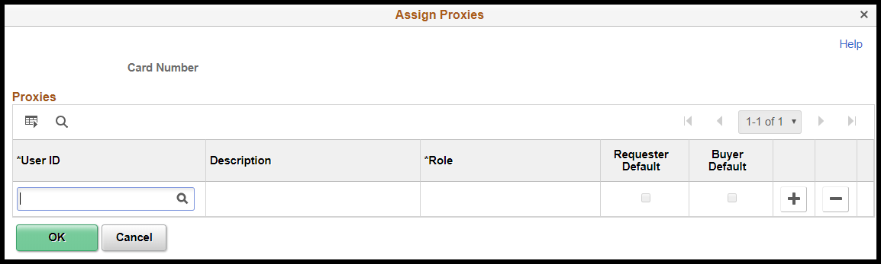
Field | Description
User ID | Use the User ID field to enter the SMART User ID for the employee receiving the Proxy rights.
Description | The Description field displays the users name captured in SHARP.
Role | The User who is being given ‘Proxy’ to the PCard must be given one (1) and only one (1) role per PCard. There are several role options available for PCard Proxies in SMART:  - PO Agency PCard Holder – Allows card to be used on requisitions / Purchase Orders. This role by itself does not have access to SMART but if the user has additional access they may reconcile transactions with this PCard Proxy role.  - PO Agency PCard Reconciler – Reconciles the PCard transactions in SMART  - PO Agency PCard Approver – Approves the PCard transactions in SMART  - PO AGY PCard Recon/Approver– Reconciles and approves the transactions for the PCard  - PO Agency PCard Admin – Performs administrative duties associated with PCards in SMART  - PO Central PCard Admin – Performs administrative duties for the State of Kansas PCard program and must be given proxy to all PCards.  - PO Kansas Buyer – To be able to associate a PCard to a Purchase Order, the Buyer must have Proxy Access to the PCard.  The ‘Roles’ available from the drop-down box vary depending on the role access given to the employee ID selected.
Requester Default | Click this checkbox if the Cardholder is a Requester in your agency and every time they are selected as a ‘Requester’ you want this specific PCard to default as the payment method on the purchase requisition in SMART.  NOTE: The default PCard information can be manually overridden on the requisition if desired.
Buyer Default | Click this checkbox if the Cardholder is a Buyer in your agency and every time they are selected as a ‘Buyer’ you want this PCard to default as the payment method on the Purchase Order.
+ button | Use the ‘+’ button to add additional proxies as necessary.
- button | Use the ‘-‘ button to delete or remove proxy rows as desired.
OK button | Click the OK button to save the changes you have made to the Assign Proxies page.
Cancel button | Click the Cancel button to exit the Assign Proxies page without saving any changes you made.

- Click the ‘OK’ button:
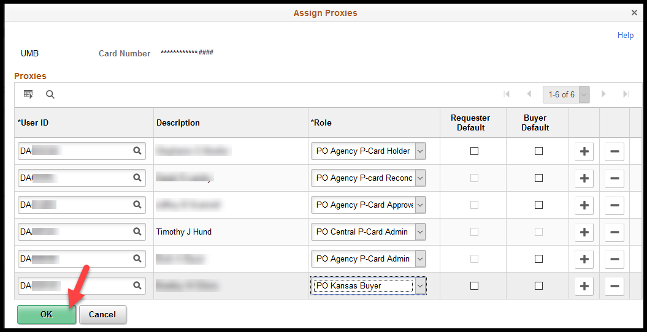
- Click the ‘Default Distrib’ link:
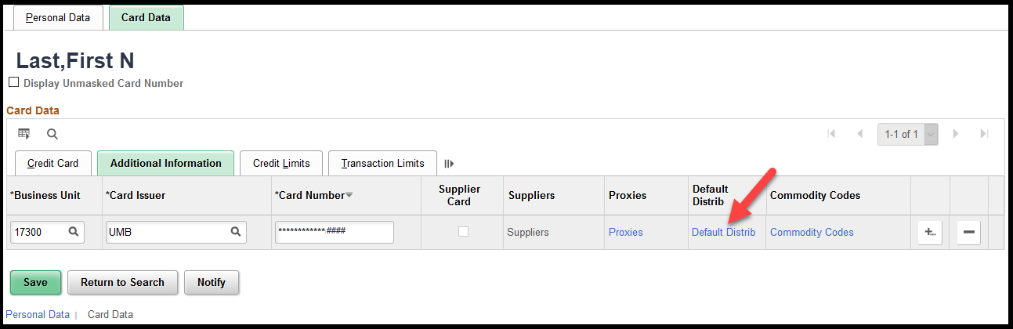
- Ship To – This is an optional field. Use the field to enter the desired ‘Ship To’ location value. If you do not know the ‘Ship To’ location, use the Lookup button to view a list of available options.
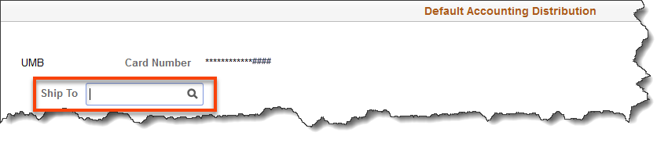
- Distribution Choices - This is the default ‘Distribution Choices’ option in SMART.

Important! The Single-Line Distribution default page MUST be completed even if you plan on using a ‘Speedchart’. If the Single-Line Distribution default page is left blank, i.e. a default distribution line is not entered, users will NOT be able to search for PCard transactions using the Employee ID.
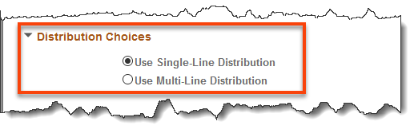

- Click the Single-Line Distribution radio button to enter one single line of default funding which SMART applies as the default value(s) for EVERY transaction incurred using this business procurement card.
NOTE: Single line distributions entered here will default into EVERY transaction loaded into SMART. These values may be changed during the PCard reconciliation process.
NOTE: The Single-Line Distribution default page MUST be completed even if you plan on using a ‘Speedchart’. If the Single-Line Distribution default page is left blank, users will NOT be able to search for PCard transactions using the Employee ID.
Important! The default funding information must be valid and active. If any required field in the default funding or the Speedchart becomes inactive, it MUST be updated, or it will prevent the reconciliation of transactions using the card. Contact your agency PCard Administrator to update default funding or submit a ManageEngine Service Desk Ticket.

- Enter the chartfield information:
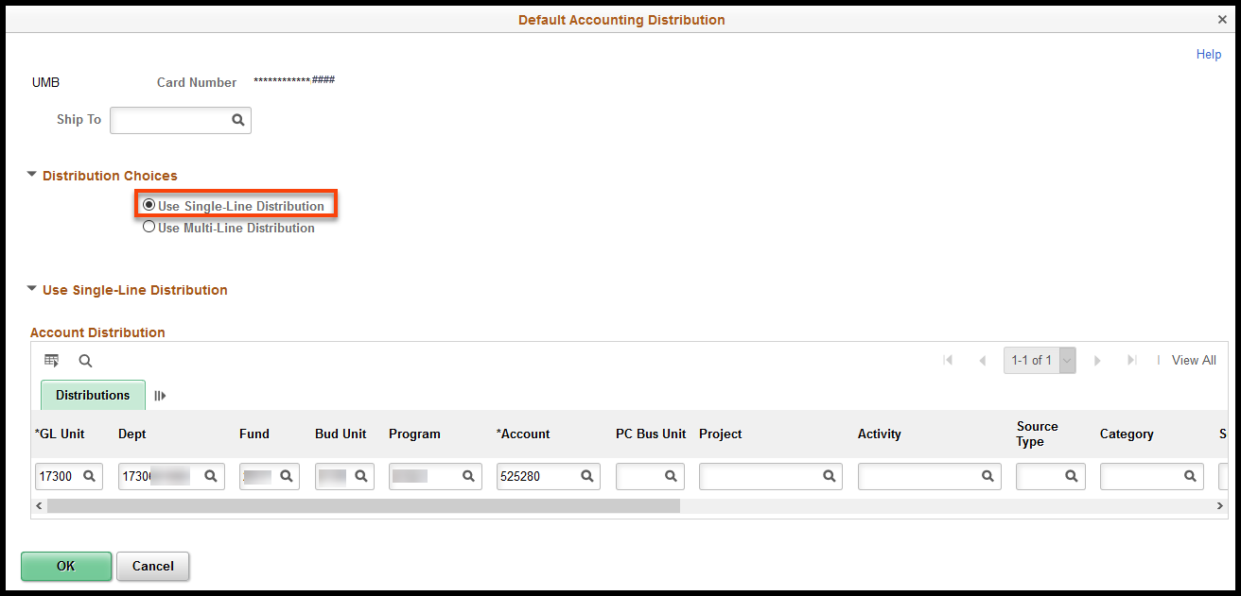
Required Fields | Description
GL Unit | Required field. SMART defaults the GL Unit number based on the Business Unit number entered on the Card Data page.  NOTE: The GL Unit number on the Default Accounting Distribution page must match the Business Unit number specified on the Card Data page.
Dept | Required field. Use the Dept field to enter the Department number. If you do not know the Department number, click the Lookup button to access a list of available options.
Fund | Required field. Use the Fund field to enter the Fund number. If you do not know the Fund number, click the Lookup button to access a list of available options.
Bud Unit | Required field. Use the Bud Unit field to enter the Budget Unit number. If you do not know the Budget Unit number, click the Lookup button to access a list of available options.

Program | Required field. Use the Program field to enter the Program number. If you do not know the Program number, click the Lookup button to access a list of available options.
Account | Required field. Use the Account field to enter the Account number. If you do not know the Account number, click the Lookup button to access a list of available options.
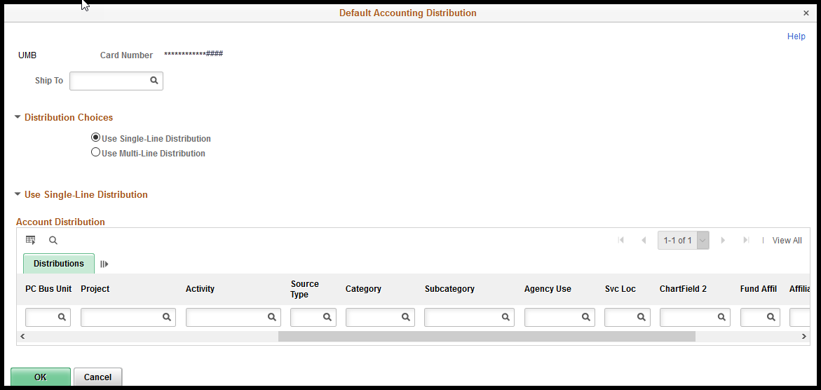
Optional Fields | Description
PC Bus Unit | Optional field. Use the PC Bus Unit field to enter the Project Costing Business Unit number if applicable. If you do not know the PC Bus Unit number, click the Lookup button to access a list of available options.
Project | Optional field. Use the Project field to enter the Project number if applicable. If you do not know the Project number, click the Lookup button to access a list of available options.
Activity | Optional field. Use the Activity field to enter the Activity number if applicable. If you do not know the Activity number, click the Lookup button to access a list of available options.
Source Type | Optional field. Use the Source Type field to enter the Source Type number if applicable. If you do not know the Source Type number, click the Lookup button to access a list of available options.
Category | Optional field. Use the Category field to enter the Category number if applicable. If you do not know the Category number, click the Lookup button to access a list of available options.
Sub Category | Optional field. Use the Sub Category field to enter the Sub Category number if applicable. If you do not know the Sub Category number, click the Lookup button to access a list of available options.
Svc Loc | Optional field. Use the Svc Loc field to enter the Service Location code if applicable. If you do not know the Service Location code, click the Lookup button to access a list of available options.
Agy Use | Optional field. Use the Agy Use field to enter the Agency Use value if applicable. If you do not know the Agency Use value, click the Lookup button to access a list of available options.
ChartField 2 | Optional field. Use the ChartField 2 field to enter the ChartField 2 value if applicable. If you do not know the ChartField 2 value, click the Lookup button to access a list of available options.
Location | Optional field. Use the Location field to enter the Location code if applicable. If you do not know the Location code, click the Lookup button to access a list of available options.

Important! The default funding information must be valid and active. If any required field in the default funding or the Speedchart becomes inactive, it MUST be updated, or it will prevent the reconciliation of transactions using the card. Contact your agency PCard Administrator to update default funding or submit a ManageEngine Service Desk Ticket.
NOTE: The Single-Line Distribution default page MUST be completed even if you plan on using a ‘Speedchart’. If the Single-Line Distribution default page is left blank, users will NOT be able to search for PCard transactions using the Employee ID.
- Use the Multi-Line Distribution radio button to enter a SpeedChart Key. A SpeedChart key splits the distribution (funding) into multiple lines of funding. SpeedChart Keys are maintained by your Agency.

SMART applies the split distribution value(s) as the default funding values for ALL business procurement card transactions incurred using this business procurement card.

Multi-Line distributions entered here will default into EVERY transaction loaded into SMART. These values may be changed during the PCard reconciliation process.

Important! The default funding information must be valid and active. If any required field in the default funding or the Speedchart becomes inactive, it MUST be updated, or it will prevent the reconciliation of transactions using the card. Contact your agency PCard Administrator to update default funding or submit a ManageEngine Service Desk Ticket.

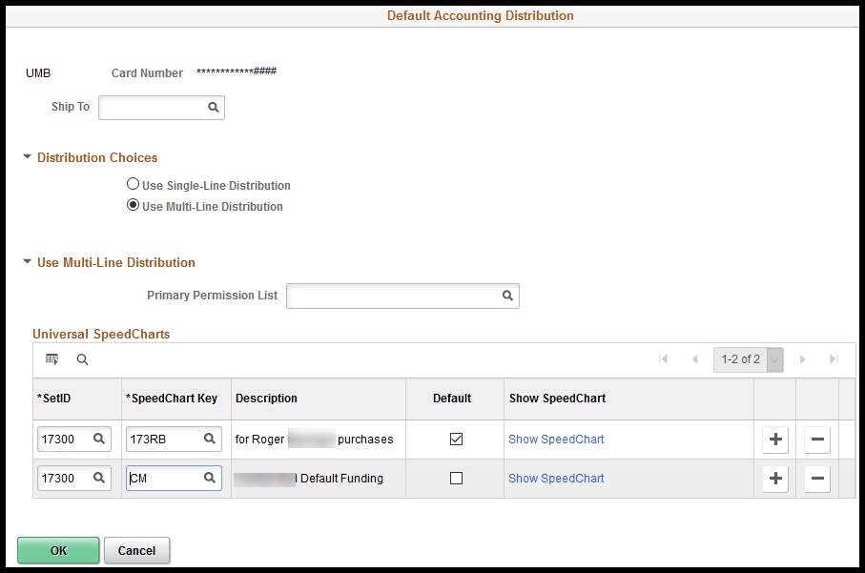
Primary Permission List - The State of Kansas is not using the Primary Permission List option. Do not use this field.
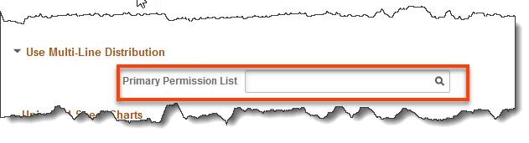
- Enter SpeedChart information:
Fields | Description
SetID | Use the SetID field to enter the Business Unit number for your agency.
SpeedChart Key | Use the SpeedChart Key field to enter the desired SpeedChart Key value. If you do not know the SpeedChart Key value, click the Lookup button to view a list of available options.  SpeedChart Keys are maintained by your Agency.
Description | The Description field displays the description for the SpeedChart Key value entered in the SpeedChart Key field.
Default checkbox | Click the Default checkbox to select a SpeedChart Key and to set it up as the default for EVERY transaction loaded into SMART for this PCard.  All the available SpeedChart values listed here will be accessible during the PCard reconciliation process.  NOTE: The default funding information can be overridden by the PCard Reconciler during the PCard transaction reconciliation process.
Show SpeedChart Link | Click the Show SpeedChart link to access the SpeedChart Detail page. Use the SpeedChart Detail page to view the distribution (split funding) details for the SpeedChart Key.
+ button | Use the ‘+’ button to add a new row to enter an additional SpeedChart Key.  NOTE: The speedchart will NOT be available for selection during the reconciliation process if the speedchart is NOT associated to the PCard on the ’Default Accounting Distribution‘ page.
- button | Use the ‘–‘ button to delete or remove SpeedChart Key rows as desired.
- The ‘Show SpeedChart’ link will allow you to view the distribution details for the SpeedChart Key. Click the ‘Show SpeedChart’ link:
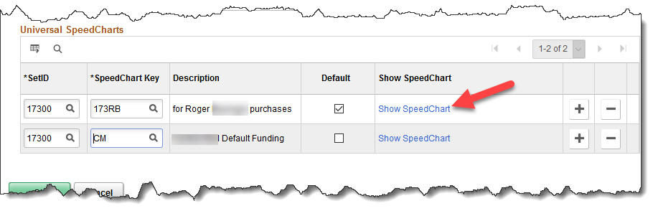
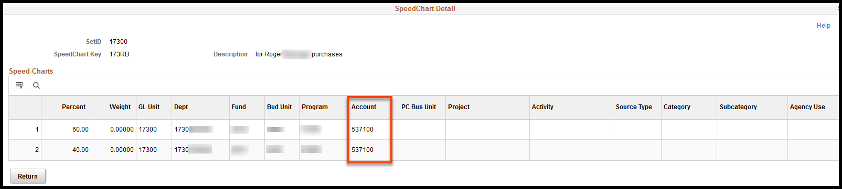
NOTES:
  - In order for a speedchart to be available for use during the reconciliation process, it must be associated to the PCard on the PCard Holder Profile
  - Important! The ‘Account’ chartfield value is a required field for PCard transactions. PCard transactions will NOT split correctly if the Account ChartField is left blank (empty).
  - Account code is NOT a required field in a Speedchart key. Be sure that the Speedchart key has an Account code value if the Speedchart is going to be used as a default on a PCard.
  - The Account code can be overridden during the PCard transaction reconciliation process.
  - Important! The default funding information must be valid and active. If any required field in the default funding or the Speedchart becomes inactive, it MUST be updated, or it will prevent the reconciliation of transactions using the card. Contact your agency PCard Administrator to update default funding or submit a ManageEngine Service Desk Ticket.
- Click the ‘Return’ button:
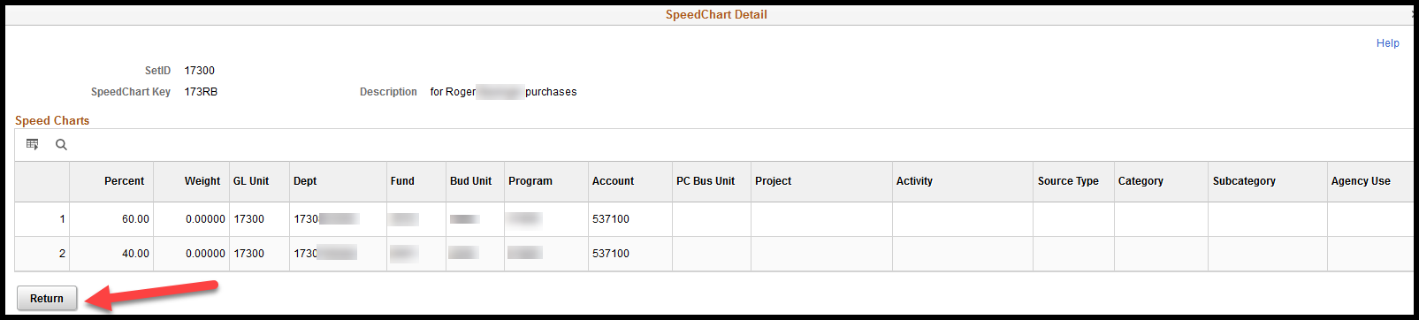
- Click the ‘OK’ button:
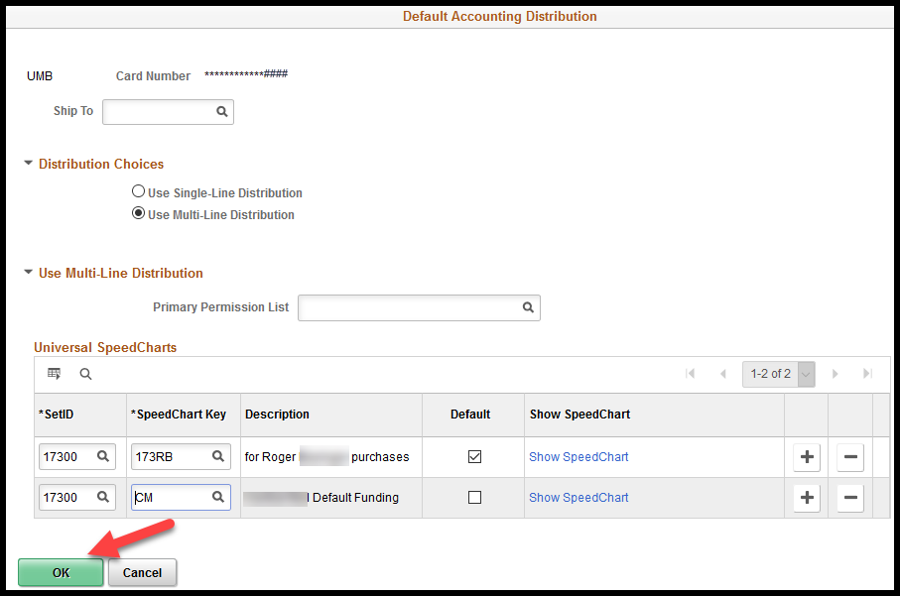

- Click the ‘Save’ button:
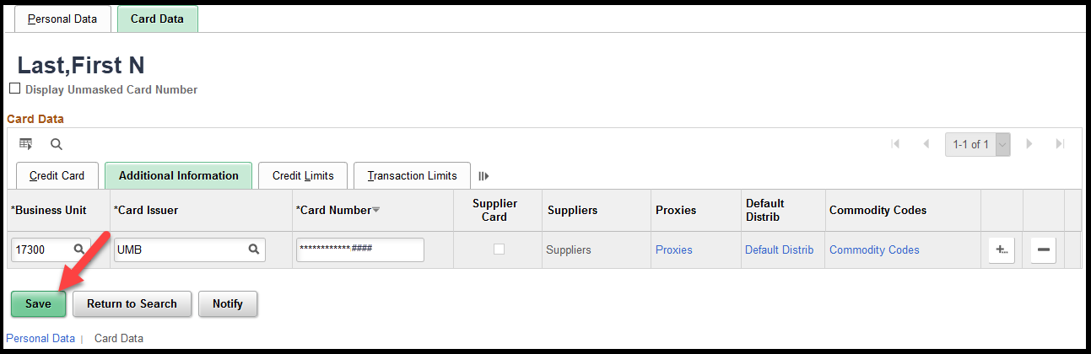
- A new Cardholder Profile has been created.
NOTE: The management of the PCard itself is the responsibility of the Issuer (UMB); consequently, the following pages are NOT being used by the State of Kansas:
- Commodity Codes (link): This page set PCard credit limits based on Commodity Code.
- Credit Limits (Tab): This page sets the credit limits for a specific PCard.
- Transaction Limits (Tab): This page sets the transaction credit limits for a specific PCard.

Adding a PCard To Existing Cardholder Profile
An employee has discovered fraudulent activity on his existing PCard. The agency has contacted the Issuer (UMB), the existing card has been ‘Canceled’ and a new ‘PCard’ has been issued.
The PO Agency PCard Amin will need to take the following steps.
Navigation:
Fluid: From the SMART Homepage, click on:
SMART Homepage dropdown → Requisitions & PCards → Procurement Cards → Manage PCards → Cardholder Profile

Classic: From the SMART Homepage, click on:
NavBar → Navigator → Purchasing → Procurement Cards → Definitions → Cardholder Profile
- Search for the Cardholder Profile by entering the Empl ID, clicking the ‘Search’ button and then clicking the link for the Cardholder Profile that needs to be updated:
- Click the ‘Card Data’ tab:
- The existing PCard has been canceled with the Issuer (UMB). Change the ‘Expiry Date’ to the date that the card was canceled. This will remove the PCard from the drop down options when creating requisitions and Purchase Orders. Click the ‘Save’ button:
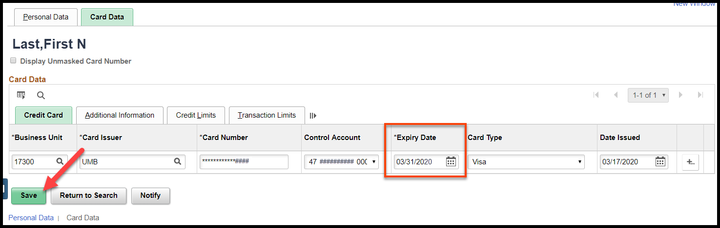
NOTES:
- PCards should NOT be deleted from SMART. When the connection is broken between the PCard Holder Profile and the PCard transactions, the PCard transactions are no longer accessible on-line and outstanding PCard transactions cannot be reconciled. A modification was applied to SMART that removed the ability for agencies to delete PCards from PCard Holder Profiles.
- PCards should NOT be transferred to another employee/PCard Holder profile. When the connection between the PCard and the PCard Holder Profile is broken, the PCard transactions are no longer accessible on-line and outstanding PCard transactions cannot be reconciled.
- If an Employee ID is inactivated in SHaRP due to a retirement or the employee leaving state employment, the connection between the PCard Holder Profile and the PCard transactions will be broken. What this means is that all outstanding PCard transactions for the employee should be reconciled and paid as soon as possible.
- To add the new replacement PCard, click the plus (+) sign at the far right hand side of the PCard line:
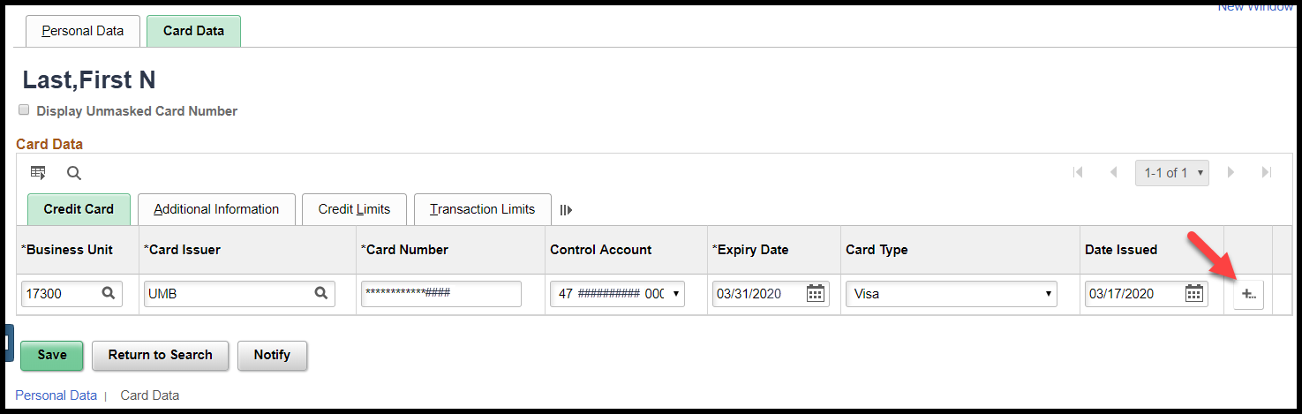
- A pop-up box will display asking for the number of rows to be added. Enter the number of rows to be added and click the ‘OK’ button:
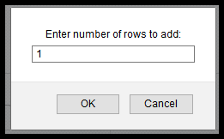
- The new row(s) will display:
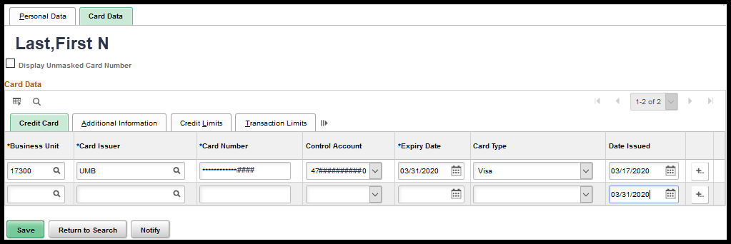
- Enter the new PCard information. [For detailed instructions on entering PCard information, see the ‘New Employee’ section of this document.]
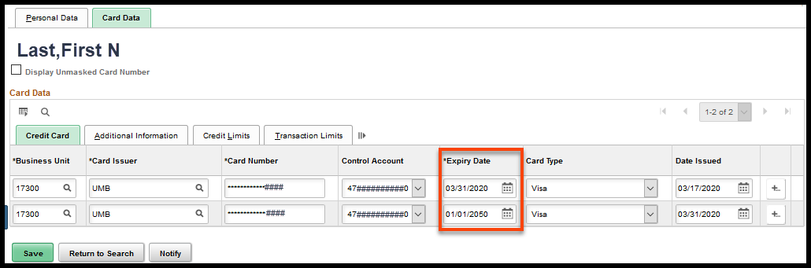

New Proxy
A new employee will be taking over the reconciliation of PCard transactions for the agency and needs proxy rights to the agencies PCards.
OR
The agency has hired a new Buyer and that new Buyer needs to be given proxy rights to all the agencies PCards.
OR
The agency has hired a new PCard Administrator and that new PCard Administrator needs to be given proxy rights to all of the agency’s PCards.
Proxy rights can be added by directly accessing the Cardholder Profile or through a mass update process.

Cardholder Profile

In this example we will give an employee proxy rights to an existing PCard.

Navigation:
Fluid: From the SMART Homepage, click on:
SMART Homepage dropdown → Requisitions & PCards → Procurement Cards → Manage PCards → Cardholder Profile

Classic: From the SMART Homepage, click on:
NavBar → Navigator → Purchasing → Procurement Cards → Definitions → Cardholder Profile

- Search for the Cardholder Profile of the employee who is holding the PCard for which additional Proxy rights need to be given.
- Click the ‘Card Data’ tab:
- Click the ‘Additional Information’ tab:
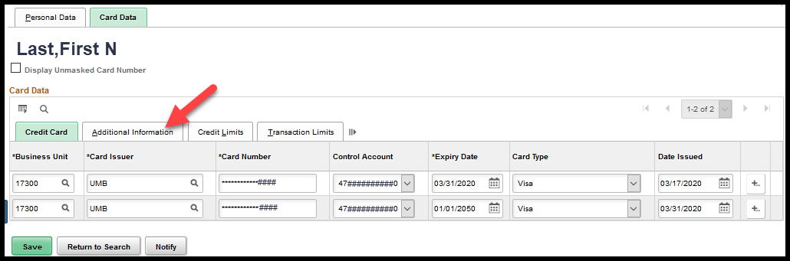
- Click the ‘Proxies’ link for the PCard that needs a new proxy added:
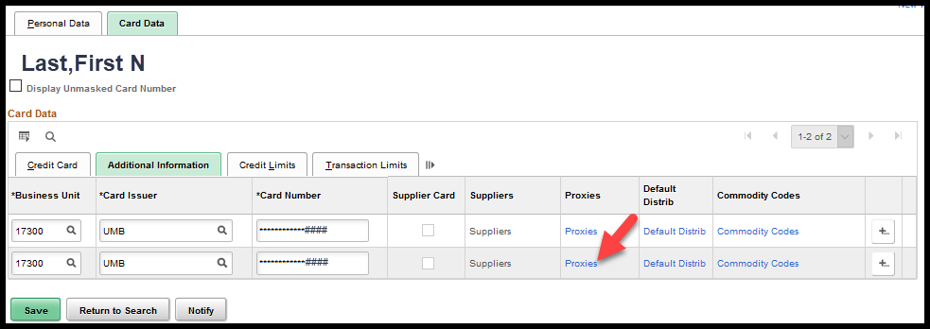

- Click the plus (+) sign at the far right of the Proxy line:
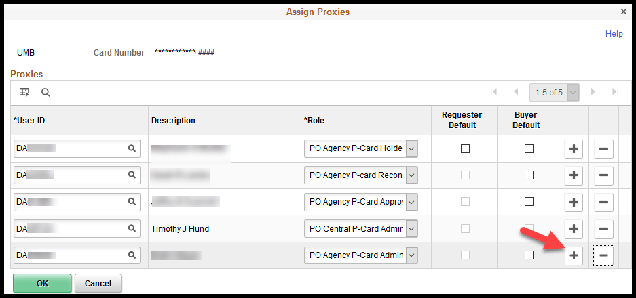
- A new line will display. Select the User ID of the new ‘Proxy’:
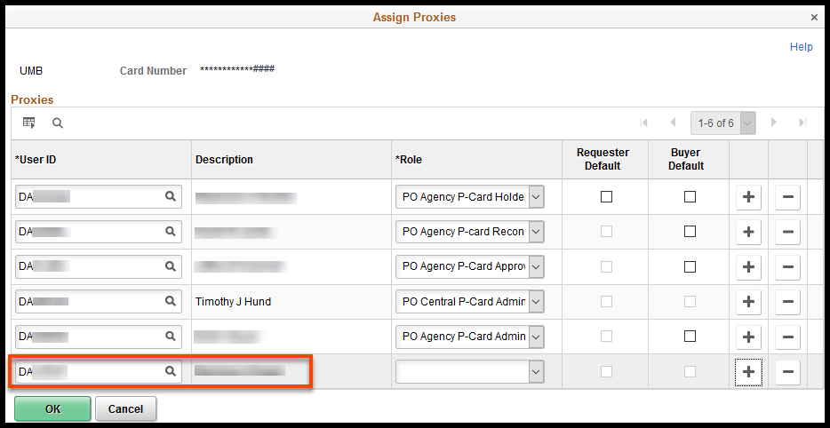
- Select the appropriate ‘Role’ from the drop down box:
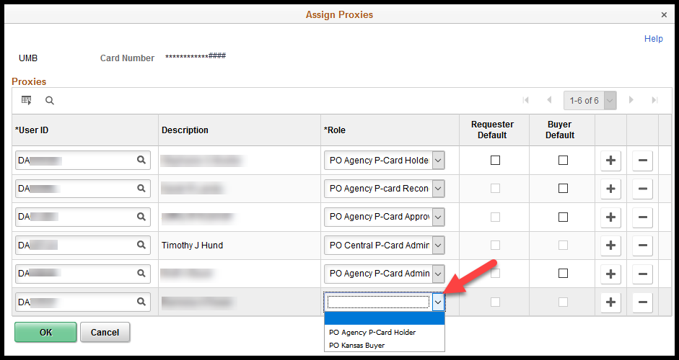
- Click the ‘OK’ button:
- Click the ‘Save’ button:
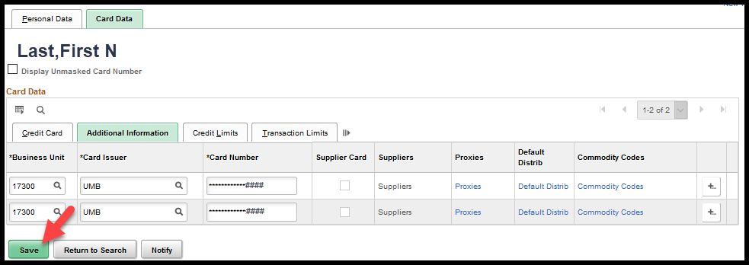
- A new Proxy has been added successfully to SMART’s Cardholder Profile for the PCard.

Mass Update
In this example, we will remove an employee from proxy access of multiple PCards, such as when an employee leaves an agency, and we will give an employee proxy to multiple PCards, such as with a new employee.
Navigation:
Fluid: From the SMART Homepage, click on:
SMART Homepage dropdown → Requisitions & PCards → Procurement Cards → Manage PCards → Assign Proxies

Classic: From the SMART Homepage, click on:
NavBar → Navigator → Purchasing → Procurement Cards → Security → Assign Proxies
- Enter the User ID of the individual for whom you wish to assign proxies. For example, if you want to assign a new PCard Administrator to all of your agency’s cards, enter the User ID of the new Buyer. Click the ‘Search’ button.
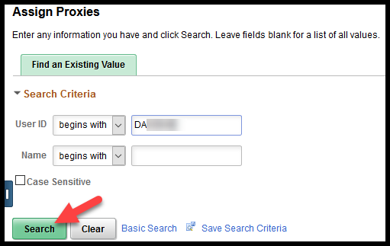
- The resulting ‘Assign Proxies’ page will show all of the PCards to which this user currently is assigned as a proxy. Click on the ‘Select Procurement Cards’ link:
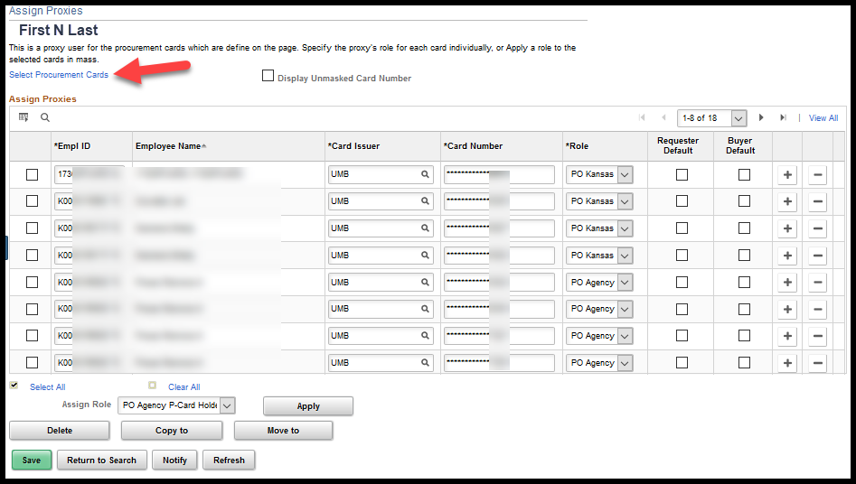

- On the ‘ProCard Proxy – Select Cards’ page, enter your Business Unit, then click the ‘Search’ button. The remaining PCards in your agency to which this user does not have proxy will be displayed. The cards can either be selected to apply individually or the ‘Select All’ link can be used populate a checkmark on all lines. Then click the ‘OK’ button:
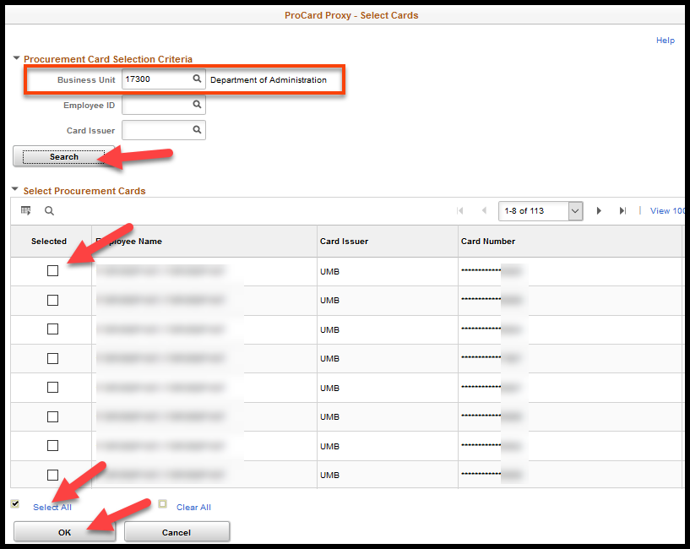
- Selected lines are then moved to the ‘Assign Proxies’ page. All new rows will display with a checkmark to the left of each line. Identify the role that needs to be assigned as a proxy to these cards, then click the ‘Apply’ button. In this case, the role is the PO Kansas Buyer:
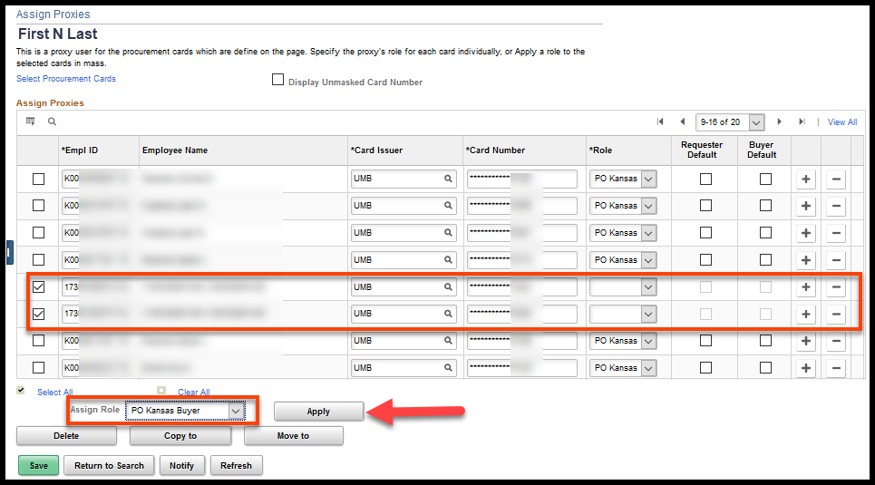
- The role is populated for all cards now. Click the ‘Save’ button to save the changes:
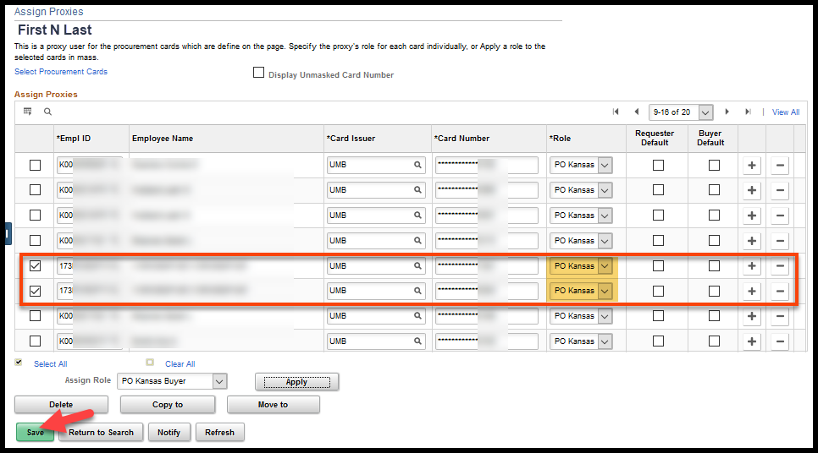

Employee Leaving Agency
What actions need to be taken when an employee no longer is assigned to a PCard? This could be due to the employee switching positions, moving to another agency, leaving state employment or retiring.

Cardholder

If the employee was a cardholder, Contact the PCard issuer (UMB) and request that the card be canceled. Log into SMART and change the expiration date to the last date that the employee is eligible to use the PCard.

Navigation:
Fluid: From the SMART Homepage, click on:
SMART Homepage dropdown → Requisitions & PCards → Procurement Cards → Manage PCards → Cardholder Profile

Classic: From the SMART Homepage, click on:
NavBar → Navigator → Purchasing → Procurement Cards → Definitions → Cardholder Profile
- Change the ‘Expiry Date’:
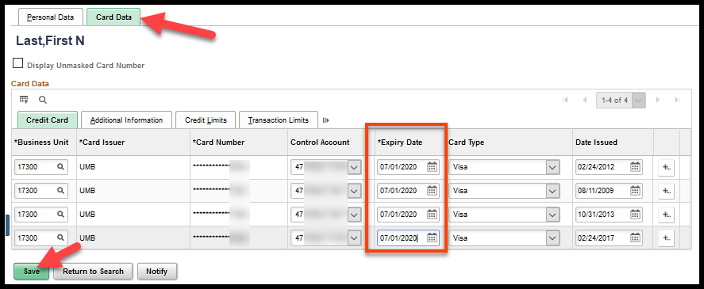
- Save the changes. The Card will no longer be an available option when selecting a PCard from the Requisition and/or Purchase Order on or after the ‘Expiry Date’.

NOTES:
- If a new employee will be issued a PCard, contact the card issuer (UMB) and request that a new card be issued.

- PCards should NOT be deleted from SMART. When the connection is broken between the PCard Holder Profile and the PCard transactions, the PCard transactions are no longer accessible on-line and outstanding PCard transactions cannot be reconciled.

- PCards should NOT be transferred to another employee/PCard Holder profile. When the connection between the PCard and the PCard Holder Profile is broken, the PCard transactions are no longer accessible on-line and outstanding PCard transactions cannot be reconciled.

- If an Employee ID is inactivated in SHaRP due to a retirement or the employee leaving state employment, the connection between the PCard Holder Profile and the PCard transactions will be broken. Outstanding PCard transactions for these employees should be reconciled and paid as soon as possible.

- A modification was applied to SMART that removed the ability for agencies to delete PCards from PCard Holder Profiles.

Proxy
If the employee was a proxy on one or more PCards, they will need to have their User ID removed from those cards. Employees that have left an agency or switched roles where they are no longer involved with PCard processing will have their roles removed for security purposes. Blank roles on any User ID associated as to a PCard will prevent changes made to the cards proxies from saving. This will prevent any other users from being added as a proxy until the User ID with blank roles has been removed.
Navigation:
Fluid: From the SMART Homepage, click on:
SMART Homepage dropdown → Requisitions & PCards → Procurement Cards → Manage PCards → Assign Proxies

Classic: From the SMART Homepage, click on:
NavBar → Navigator → Purchasing → Procurement Cards → Security → Assign Proxies
- Enter the User ID of the employee. Click the ‘Search’ button.

- The resulting ‘Assign Proxies’ page will show all of the PCards to which this user currently is assigned as a proxy. Notice that (Invalid Value) is listed in the Role section for this employee:
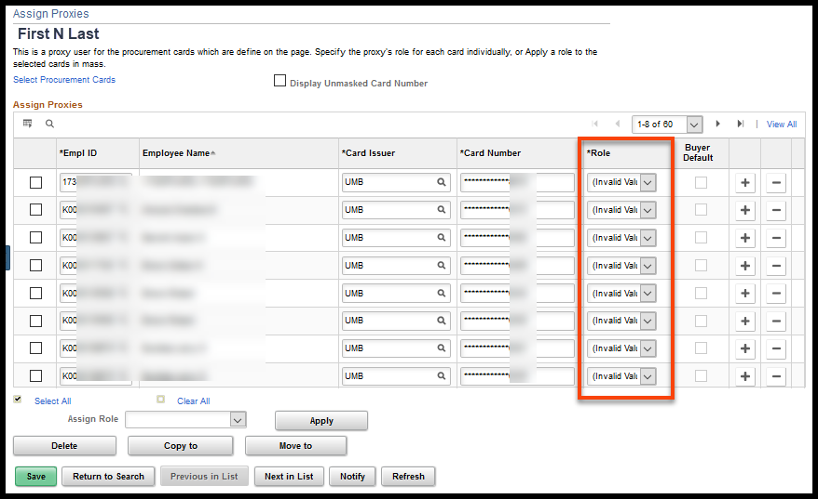
- Click on the ‘Select All’ link, which will populate a checkmark on all lines. Then click the ‘Delete’ button:
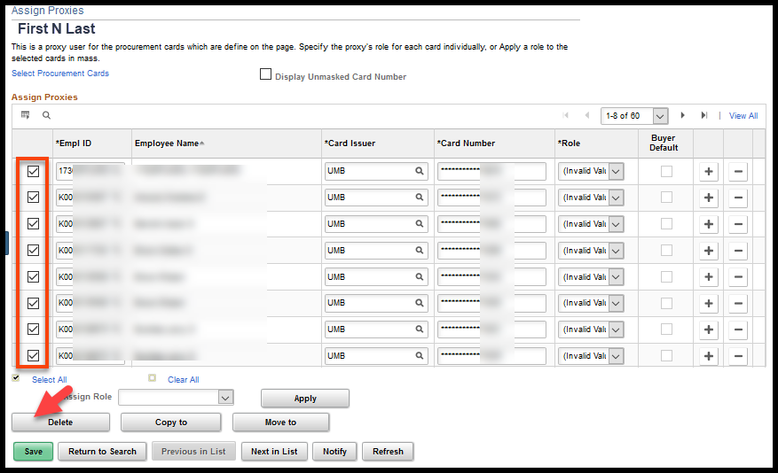
- All selected lines are removed. Click the ‘Save’ button to save the changes:
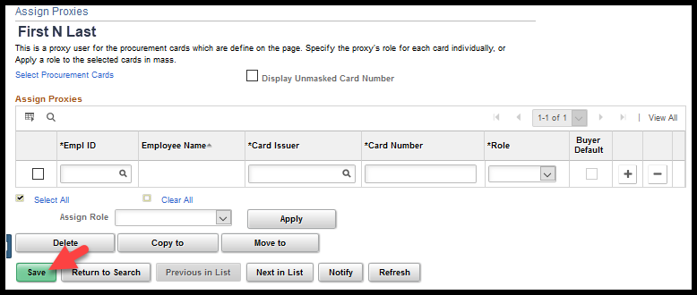
- All proxies for this User ID have successfully been deleted.

Associating PCards to Requisitions and Purchase orders
Agencies should enter a requisition / Purchase Order (PO) and associate the PCard to the requisition / PO for PCard purchases if the employee has prior knowledge of the purchase, if the purchase is under contract, or if the purchase will cause total fiscal year spend to the supplier to exceed the agency’s Delegated Purchasing Authority. This section will provide information on how to associate a PCard to the requisition and the PO.
NOTES:
- PCards can still be used as a form of payment even if there is no prior knowledge of the purchase. The PCard transaction can be paid without reconciling to a PO ONLY if the purchase & supplier are not under contract and the purchase does not cause the agency’s Delegated Purchasing Authority to be exceeded (Info Cir 17-A-005). If there is a contract, there MUST be PO reconciled to the PCard purchase (Policy Manual 10,300).
Example: An employee is on the road and the light bulb in the projector they are using burns out. They have authorization to go to a local office supply store and get a replacement bulb and they may use their PCard to make the purchase. In this case no requisition / PO would be entered as long as there was not contract with the supply store and this purchase did not cause total annual purchases to the supplier to exceed the agency’s Delegated Purchasing Authority.
- If a PCard is NEVER associated to a PO, ALL POs will be available for selection during the reconciliation process for that PCard. This makes it very easy to reconcile PCard transactions to incorrect POs. It is highly recommended that agencies associate PCards to POs so that the POs available for selection during the reconciliation process are limited to only those POs with that PCard associated.
- Once a PCard has been associated to a PO, the PO is NOT available to pull directly into a voucher. To release the PO encumbrance the PO must be associated to the PCard transaction during the reconciliation process. The PCard transactions will build to a PCard Voucher once the PCard transaction is ‘Approved’ and has ‘Valid’ budget and chartfield statuses. The PCard Voucher Build process runs twice weekly, Monday and Thursday mornings before hourly batch processes begin.

PCards on Requisitions
The PCard is associated at the requisition header level on the ‘Requisition Settings’ page. Before the ‘Card Number’ drop down box will display, the Requester must meet the following conditions:
- They must be assigned as a proxy to at least one (1) PCard, AND
- They must have the Agency P-Card Holder OR Kansas Buyer role.
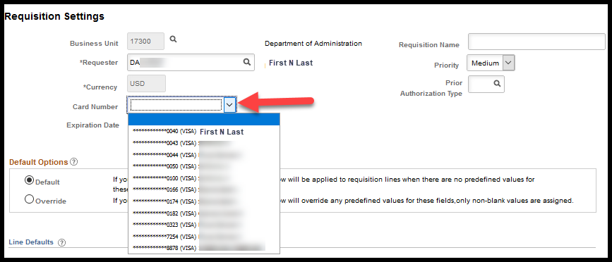
The PCard will be available for selection on the requisition if the requester has proxy to the PCard; however, the PCard information may NOT flow to the PO. For the PCard information on the requisition to flow to the PO, the following must be true:
- The PCard is associated to a requisition that sources to a PO;
- The supplier location effective date is less than or equal to the PO Date;
- The Buyer has proxy to the PCard; AND
- The PCard has a current expiration date.

Note: All suppliers are now setup to accept PCards.

PCards on Purchase Orders
The ‘Use Procurement Card’ link will appear on the Purchase Order (PO) if the following statements are ALL true:
- The supplier location effective date is less than or equal to the PO Date;
- The Buyer has proxy to the PCard; AND
- The PCard has a current expiration date.

Note: All suppliers are now setup to accept PCards.

The ‘Use Procurement Card’ link will appear on the PO if the above listed statements are all true:
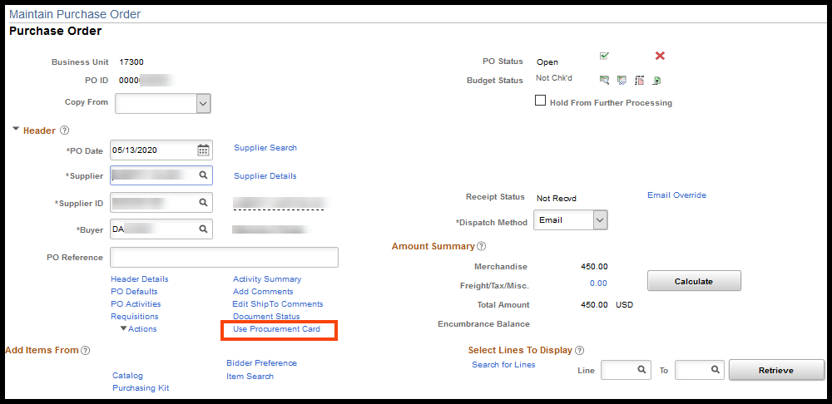

PCard flowed from Requisition
Navigation:
Fluid: From the SMART Homepage, click on:
SMART Homepage dropdown → POs & Receiving → Purchase Orders → Add/Update Purchase Orders → Find an Existing Value (Tab)

Classic: From the SMART Homepage, click on:
NavBar → Navigator → Purchasing → Purchase Orders → Add/Update POs → Find an Existing Value (Tab)
- When the Buyer clicks the ‘Use Procurement Card’ link, the ‘Procurement Card used for payment’ section will be populated if the PCard information flowed from the requisition to the PO:
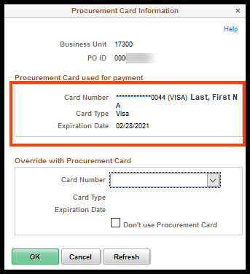
- The Buyer may choose to change the PCard by selecting a different ‘Card Number’ from the drop down box and then clicking the ‘OK’ button:
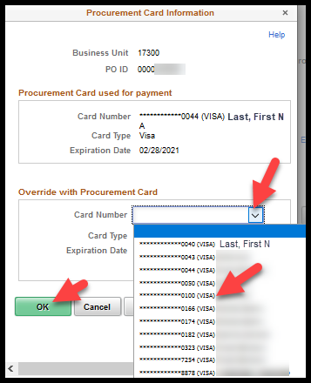
- The Buyer may choose to remove the PCard by checking the ‘Don’t use Procurement Card’ check box and clicking the ‘OK’ button:
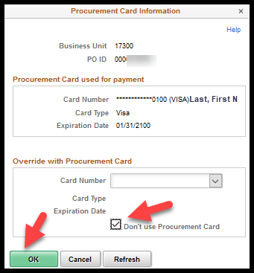

No PCard on Requisition
Navigation:
Fluid: From the SMART Homepage, click on:
SMART Homepage dropdown → POs & Receiving → Purchase Orders → Add/Update Purchase Orders → Find an Existing Value (Tab)

Classic: From the SMART Homepage, click on:
NavBar → Navigator → Purchasing → Purchase Orders → Add/Update POs → Find an Existing Value (Tab)

- If the requisition did not contain a PCard, the Buyer may still add a PCard to the PO. Click the ’Use Procurement Card’ link:
- The ‘Procurement Card used for payment’ section will be blank. Select the drop down arrow beside the ‘Card Number’ field:
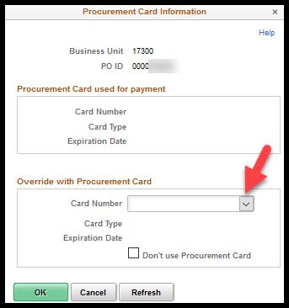
- Select a PCard and then click the ‘OK’ button:
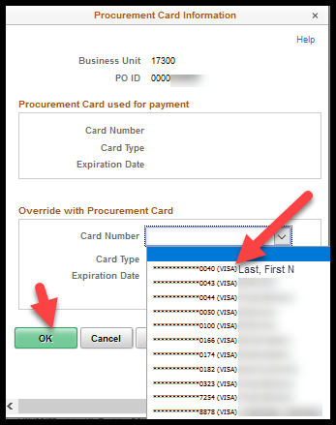
- Clicking the ‘OK’ button will open the ‘Maintain Purchase Order’ page. Clicking the ‘Use Procurement Card’ link will display the selected PCard in the ‘Procurement Card used for payment’ section:
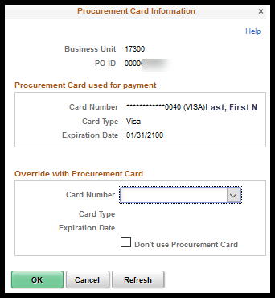

Changing PCard After PO Dispatched
The State of Kansas implemented a modification to allow Buyers the ability to remove, add or change PCard information after the Purchase Order (PO) has been dispatched.
Part of the modification was to capture the changes to the PCard information on the ‘Manage Change Order’ pages. The change order history will not provide detailed information but will indicate the action that was taken:
- PCard Not Assigned: PCard has never been associated to the PO
- PCard Added: PCard has been added
- PCard Removed: PCard has been removed
- PCard Changed: PCard has been changed

Adding a PCard – PO Dispatched
A requisition has been submitted and sourced to a Purchase Order (PO). The PO was dispatched, without a PCard. The Buyer is now informed that the product had already been paid for with a PCard. To reconcile the PCard transaction AND release the encumbrance that has been established by the PO, the Buyer must associate the PCard to this PO.
Navigation:
Fluid: From the SMART Homepage, click on:
SMART Homepage dropdown → POs & Receiving → Purchase Orders → Add/Update Purchase Orders → Find an Existing Value (Tab)

Classic: From the SMART Homepage, click on:
NavBar → Navigator → Purchasing → Purchase Orders → Add/Update POs → Find an Existing Value (Tab)
- When the Buyer navigates to the PO, the ‘Use Procurement Card’ link will NOT be visible. To activate the ‘Use Procurement Card’ link, click the ‘Change Order’ icon at the PO header level:

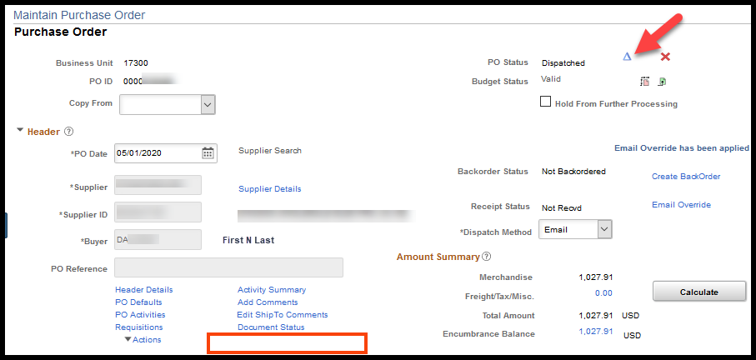
- The ‘Use Procurement Card’ link will appear. Click the ‘Use Procurement Card’ link:
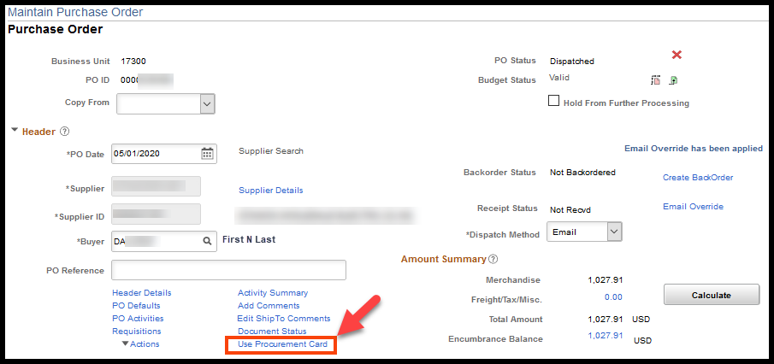
- Click the arrow beside the ‘Card Number’ drop down box. Select the PCard from the list. Click the ‘OK’ button:
- Clicking the ‘OK’ button will open the ‘Maintain Purchase Order’ page. Clicking the ‘Use Procurement Card’ link will display the selected PCard in the ‘Procurement Card used for payment’ section:

Changing a PCard – PO Dispatched
A Requester submitted a requisition, and the Requester’s PCard information flowed to the PO. The PO was then dispatched. In the meantime, the Buyer calls the supplier and places the purchase on his PCard. Finally, the Buyer is reconciling his PCard transactions, but the PO is NOT available.
The PO is not available because the PCard being reconciled is not the PCard associated to the PO. To reconcile the PCard transaction AND to release the encumbrance that has been established by the PO, the Buyer must change the PCard on the PO.
Navigation:
Fluid: From the SMART Homepage, click on:
SMART Homepage dropdown → POs & Receiving → Purchase Orders → Add/Update Purchase Orders → Find an Existing Value (Tab)

Classic: From the SMART Homepage, click on:
NavBar → Navigator → Purchasing → Purchase Orders → Add/Update POs → Find an Existing Value (Tab)
- When the Buyer navigates to the PO, the ‘Use Procurement Card’ link is active. Clicking the ‘Use Procurement Card’ link will open the ‘Procurement Card Information’ page, but the values on this page cannot be edited:
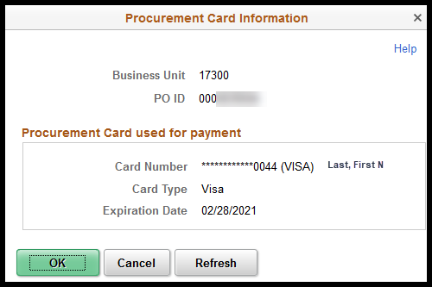
- To change the PCard, the Buyer must click the ‘Change Order’ icon at the header level of the PO on the ‘Maintain Purchase Order’ page:
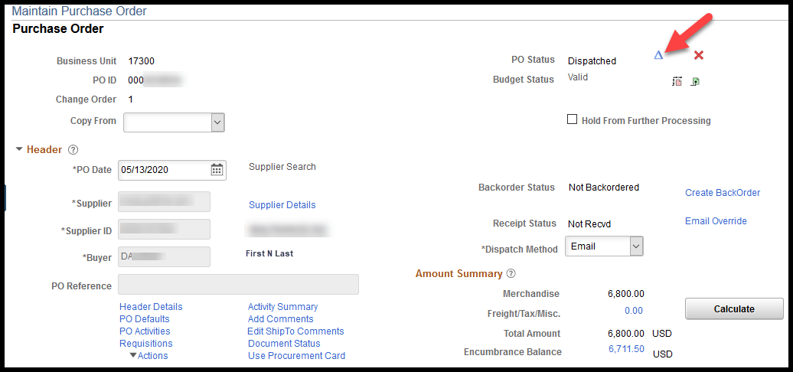
- The ‘Change Order’ icon will no longer be displayed and when the ‘Use Procurement Card’ link is clicked the page will be editable:
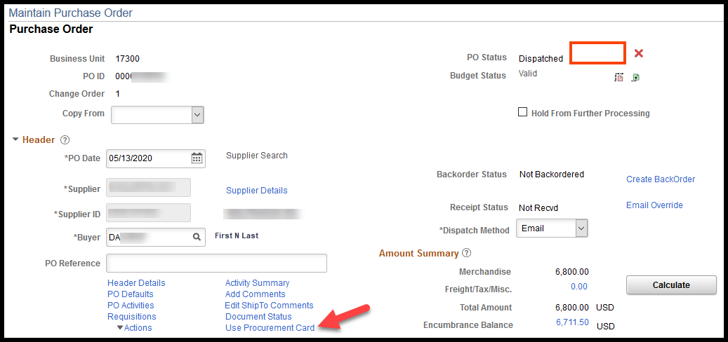
- The current PCard information is displayed in the ‘Procurement Card used for payment’ section. To correct the PCard information, select the arrow beside the ‘Card Number’ drop down box:
- Select the correct PCard from the list, and then click the ‘OK’ button:
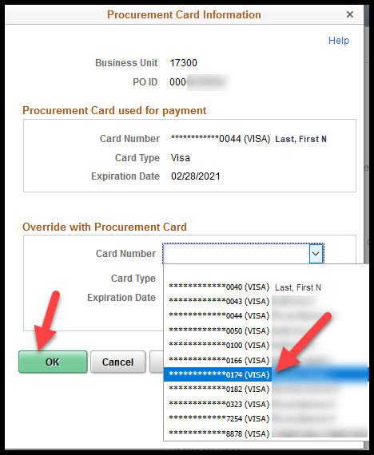
- Clicking the ‘OK’ button will open the ‘Maintain Purchase Order’ page. Clicking the ‘Use Procurement Card’ link will display the selected PCard in the ‘Procurement Card used for payment’ section:
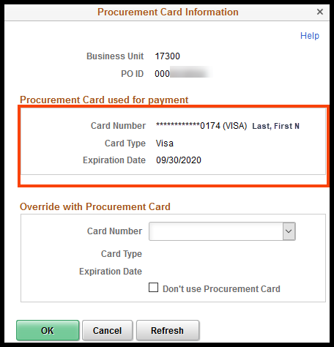

Removing a PCard – PO Dispatched
A requisition has been submitted. A PCard was associated to the requisition and the Requester’s PCard information flowed to the PO. The PO was dispatched. The Supplier has contacted the Buyer and indicated that they will not accept PCard payment.
The Buyer needs to remove the PCard information from the PO so that a voucher can be created.
NOTE: Once a PCard has been associated to a PO, the PO is NOT available to pull directly into a voucher. To release the PO encumbrance the PO must be associated to the PCard transaction during the reconciliation process. The PCard transactions will build to a PCard Voucher once the PCard transaction is ‘Approved’ and has ‘Valid’ budget and chartfield statuses. The PCard Voucher Build process runs twice weekly, Monday and Thursday mornings before hourly batch processes begin.
Navigation:
Fluid: From the SMART Homepage, click on:
SMART Homepage dropdown → POs & Receiving → Purchase Orders → Add/Update Purchase Orders → Find an Existing Value (Tab)

Classic: From the SMART Homepage, click on:
NavBar → Navigator → Purchasing → Purchase Orders → Add/Update POs → Find an Existing Value (Tab)
- When the Buyer navigates to the PO, The ‘Use Procurement Card’ link is visible. Clicking the ‘Use Procurmenet Card’ link will open the ‘Procurement Card Information’ page, but the values on this page cannot be edited:
- To change the PCard, the Buyer must click the ‘Change Order’ icon at the header level of the PO on the ‘Maintain Purchase Order’ page:
- The ‘Change Order’ icon will not be displayed, and, when the ‘Use Procurement Card’ link is clicked, the page will be editable:
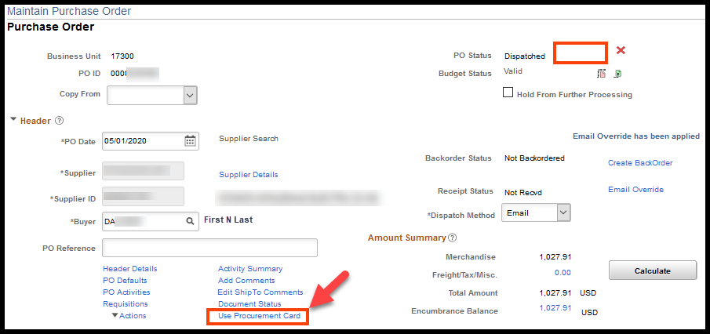
- The current PCard information is displayed in the ‘Procurement Card used for payment section. Click the ‘Don’t use Procurement Card’ check box:
- Clicking the ‘OK’ button will open the ‘Maintain Purchase Order’ page. Clicking the ‘Use Procurement Card’ link will show that the ‘Procurement Card used for payment’ section is blank:
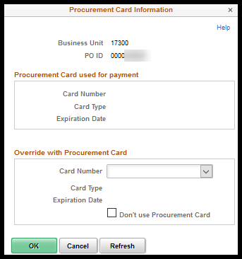

PCard Link Not Appearing on PO
I want to pay for an item with a PCard, but the 'Use Procurement Card' link (PCard link) is not displaying on the Purchase Order (PO). How do I get the PCard link to display on the PO?
There are several criteria that must be met before the ‘Use Procurement Card’ link will display on a PO:
- The PCard must have a current expiration date;
- The Buyer must have ‘proxy’ rights to the PCard;
- The Supplier Location effective date must be on or before the PO Date.

Note: All suppliers are now setup to accept PCards.

Check the PCard Expiration Date
The Agency PCard Administrator can check to see if the PCard expiration date is current.

Navigation:
Fluid: From the SMART Homepage, click on:
SMART Homepage dropdown → Requisitions & PCards → Procurement Cards → Manage PCards → Cardholder Profile

Classic: From the SMART Homepage, click on:
NavBar → Navigator → Purchasing → Procurement Cards → Definitions → Cardholder Profile
- Search for the PCard holder’s profile and select the desired Empl ID link. In this example, we searched by the employee’s name. The Agency PCard Administrator can also search by the Employee’s ID number (Empl ID), if known.
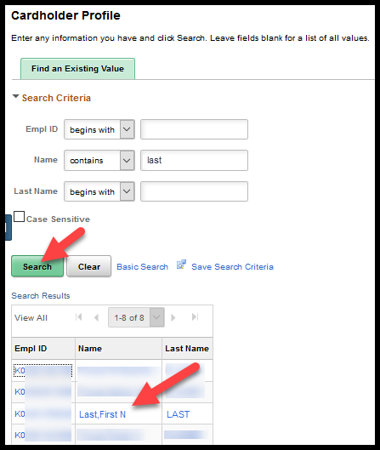

- Click the ‘Card Data’ tab:
- Validate that the ‘Expiry Date’ for the PCard is current:
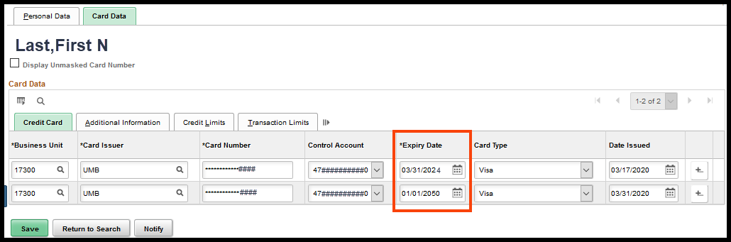

Action to take if the Expiry date is NOT current
Update the Expiry date to some date in the future. It is acceptable to use expiration dates that are 50 or more years in the future; however, when the PCard expires or is canceled, the Agency PCard Administrator needs to enter the actual expiration or cancelation date into SMART.
NOTE: The State of Kansas does not use SMART to manage the issuance of PCards; including PCard expiration dates and PCard transaction limitations. Those items are handled by UMB Bank. However, the PCard Holder Profile in SMART must be assigned a current expiration date for the PCard to be available on a transaction (such as a Purchase Order) in SMART.

Check to see if the Buyer has ‘Proxy’ to this PCard
The Agency PCard Administrator can check to see if the Buyer has ‘Proxy” to the PCard in question.
Navigation:
Fluid: From the SMART Homepage, click on:
SMART Homepage dropdown → Requisitions & PCards → Procurement Cards → Manage PCards → Cardholder Profile

Classic: From the SMART Homepage, click on:
NavBar → Navigator → Purchasing → Procurement Cards → Definitions → Cardholder Profile
- Search for the PCard holder’s profile and select the desired Empl ID link. In this example, we searched by the employee’s name. The Agency PCard Administrator can also search by the Employee’s ID number (Empl ID), if known.
- Click the ‘Card Data’ tab:
- In the ‘Card Data’ section, click the ‘Additional Information’ tab:
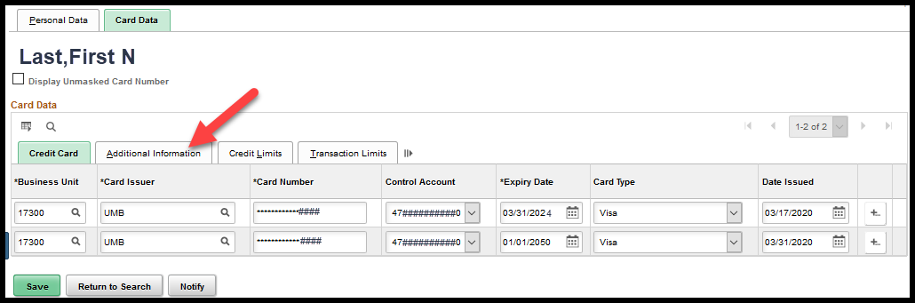

- Click the ‘Proxies’ link on the desired line:
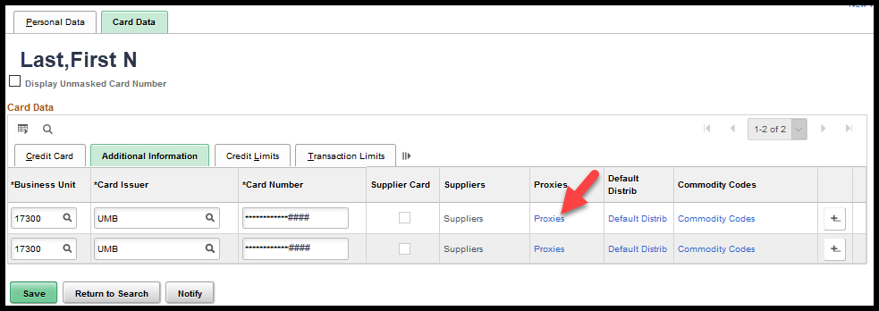
NOTE: Clicking the ‘Proxies’ link opens the ‘Assign Proxies’ page.
- In the ‘Proxies’ section, validate that the applicable Buyer’s ID/Name is listed in the ‘User ID’ and ‘Description’ columns.
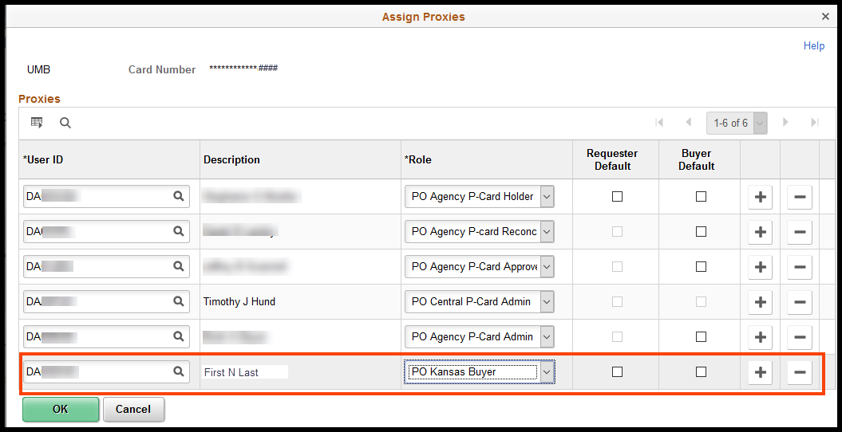

Action to take if the Buyer does NOT have Proxy to the PCard
- On the Assign Proxies page, in the Proxies section, click the plus sign button (+) located at the far-right side of the last row:
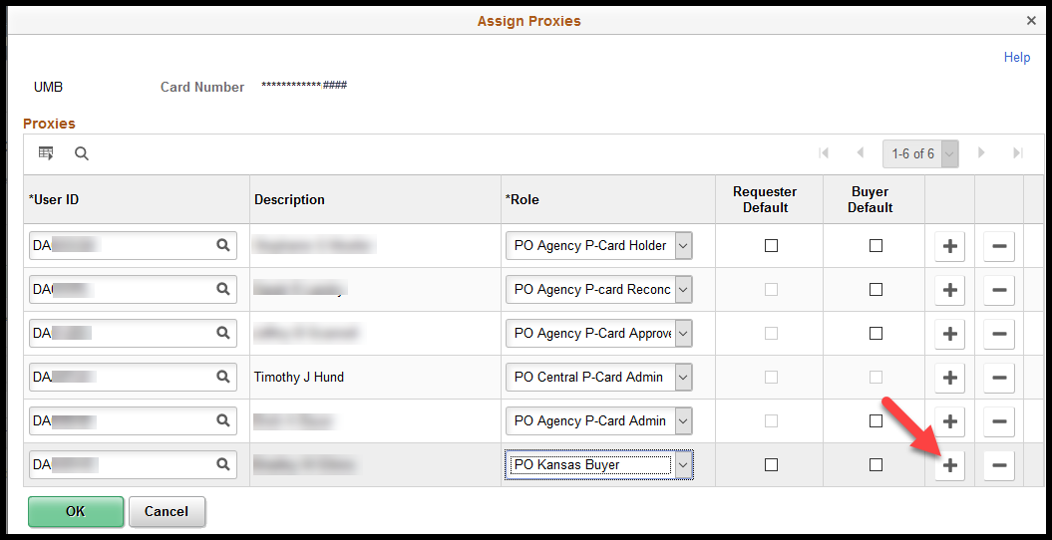
- This will add a new row. In the new row, User ID Column, enter the desired SMART ‘User ID’ for the Buyer:
- In the Role column, click the drop-down list arrow and select the desired role from the drop-down list options.
NOTE: The roles available in the Role drop down box will vary depending on the security access roles that have been assigned to the Buyer. In most cases, the ‘PO Kansas Buyer’ role is the one that will be selected.
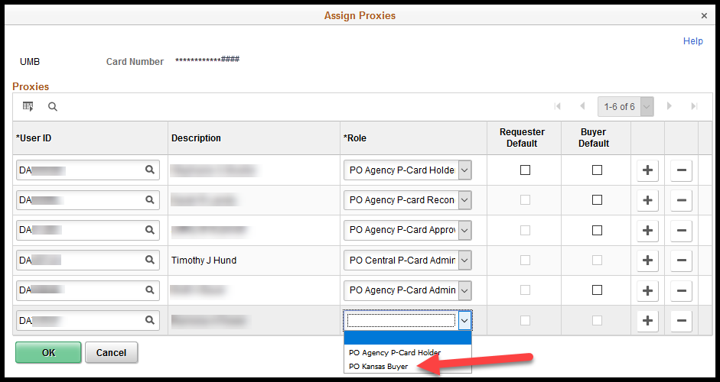
- Click the ‘OK’ button, located at the bottom left corner of the ‘Assign Proxies’ page.
NOTE: Clicking on the ‘OK’ button returns you to the ‘Card Data’ page.
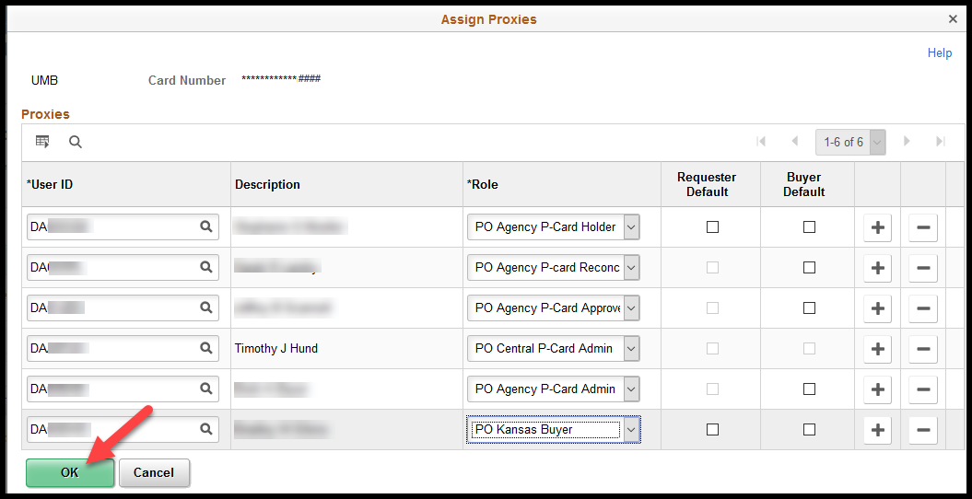
- On the Card Data page, click the ‘Save’ button which is located at the bottom left corner of the page:
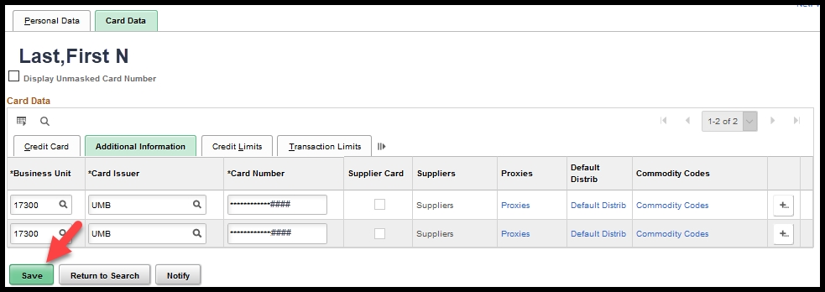

Supplier Location’s Effective Date is on or before the PO Date
The Buyer can validate if the location’s effective date is on or before the PO date.
Navigation:
Fluid: From the SMART Homepage, click on:
SMART Homepage dropdown → POs & Receiving → Purchase Orders → Add/Update Purchase Orders → Find an Existing Value (Tab)

Classic: From the SMART Homepage, click on:
NavBar → Navigator → Purchasing → Purchase Orders → Add/Update POs → Find an Existing Value (Tab)
- Search for, and select, the desired PO. This will open the ‘Maintain Purchase Order’ page. On the ‘Maintain Purchase Order’ page, ‘Header’ section, make a NOTE of the ‘PO Date’. In this example, the PO Date is 05/01/2020.
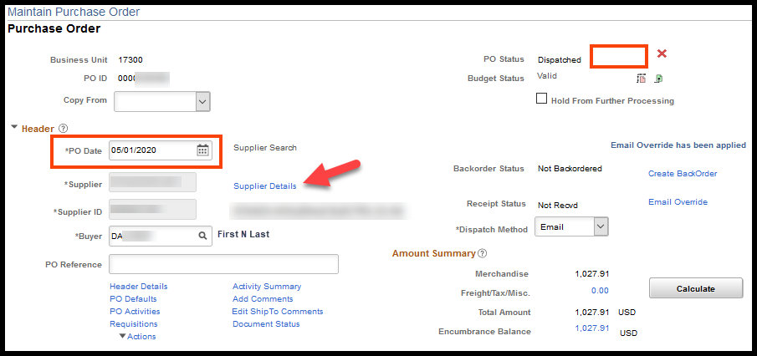
- On the ‘Supplier Details’ page, at the top section of the page, make a NOTE of the ‘Location’ code. In this example, the Location code displayed is ‘002’. Click the ‘Supplier Information’ link.
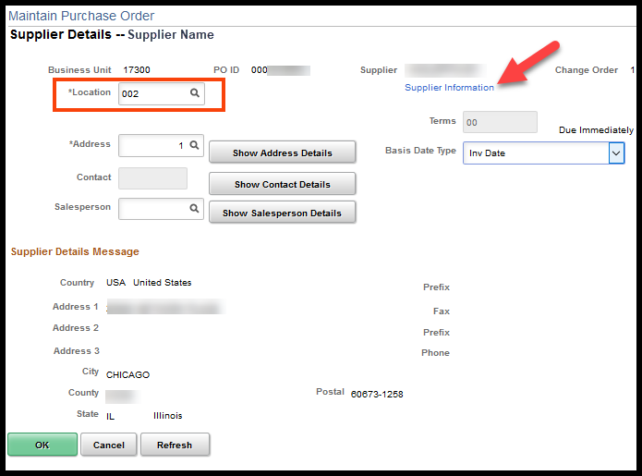
- Clicking the ‘Supplier Information’ link opens a new window which displays the ‘Identifying Information’ tab of the supplier’s file. On the supplier’s file, select the ‘Location’ tab.
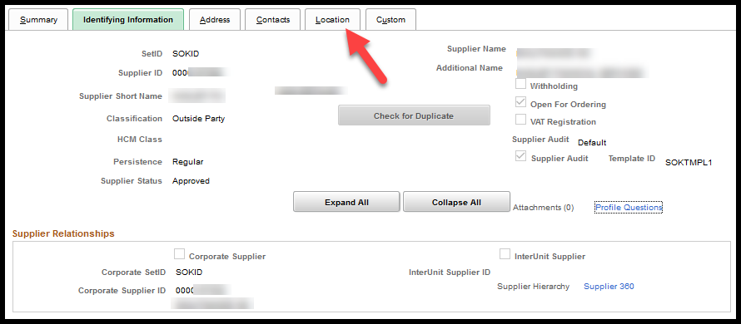
- On the ‘Location’ tab, in the ‘Location’ section, navigate to the desired ‘Location’ code. In this example, the desired Location code is ‘002’. In the ‘Details’ section of this location validate that the Effective Date is on, or before, the PO Date. In this example, the PO Date is 05/01/2020 and the Location code ‘Effective Date’ is 01/01/1901. The Effective Date of 01/01/1901 occurs before the PO Date of 05/01/2020.
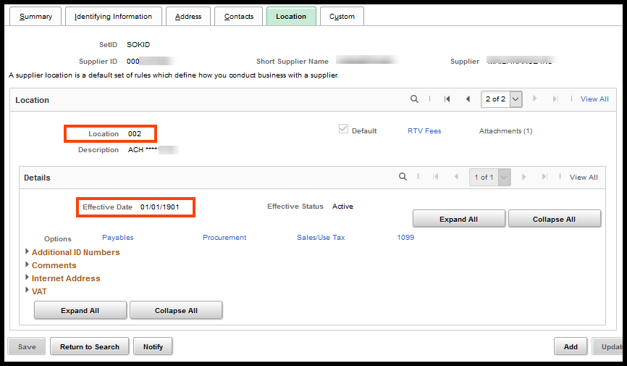

Supplier’s Location Code Effective Date is AFTER the PO Date
Agencies should try the following options, in the following order:
- Change the Location Code on the PO
- Change the PO Date
- If the prior two options do not resolve the issue, please submit a ManageEngine Service Desk ticket and the SMART team will review the issue.

Change the Location Code on the PO
- Navigate to, and open, the desired PO. In the header section, click the ‘Supplier Details’ link.
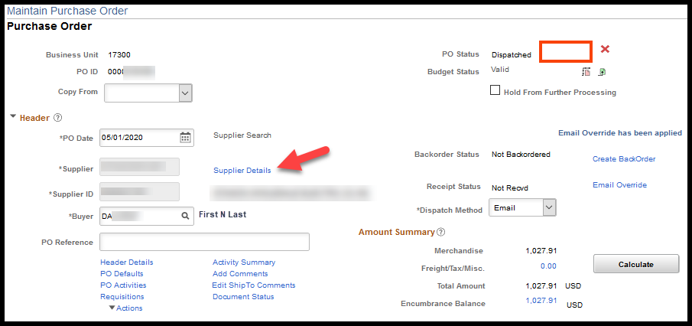
- Click the ‘Look Up’ icon for the ‘Location Code’ field. This will open the ‘Look Up Location’ page:
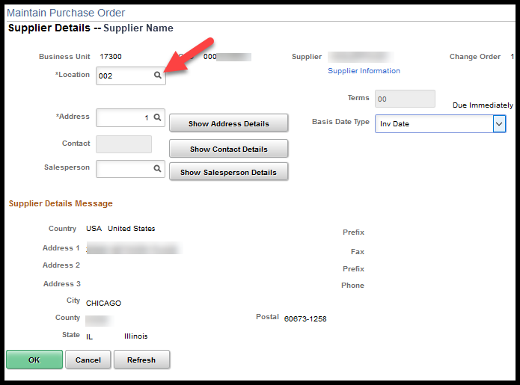
- On the ‘Look Up Location’ page, select a different location code (if available).
NOTE: Since this is a PCard transaction, changing the location code will have minimal impact.
CAUTION: On POs that are not associated to PCards, Buyers should NOT change the location code without first thoroughly evaluating the situation.
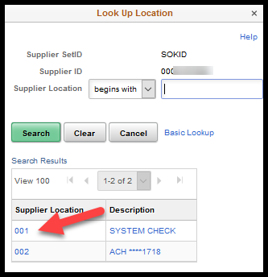

Change the PO Date
- Navigate to and open the desired PO. On the PO, in the Header section, enter a new PO Date that is on or after the Supplier’s location code ‘Effective Date’.
NOTE: If a contract is associated to the PO, you will also need to verify the contract’s effective dates.
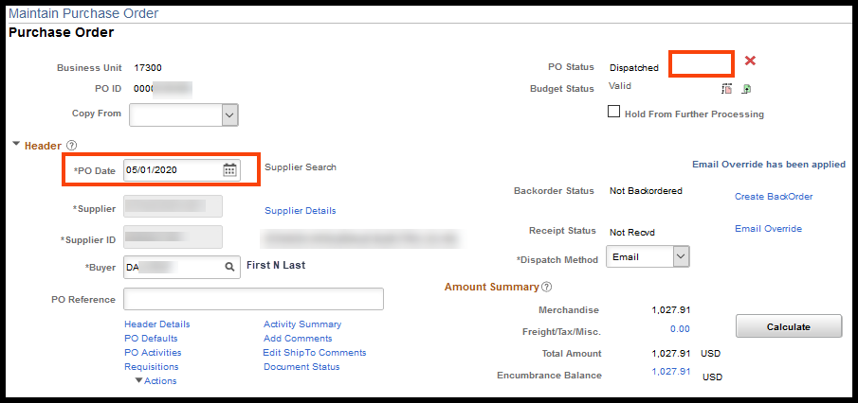

Open ManageEngine Service Desk Request
- If you have validated all criteria listed above, including creating a change order if the PO has been dispatched, but the ‘Use Procurement Card’ link is still NOT visible on the PO, open a ManageEngine Service Desk Request. Please be sure to include the following information in the Service Desk Request:
- PO number
- PCard holder’s name
- Last four (4) digits of the PCard number

Reconciling PCard Transactions
PCard transactions are loaded into SMART every evening Monday through Saturday. Agencies are strongly encouraged to reconcile PCard transaction using receipts/invoices on a daily or weekly basis. This will allow payments to be made to UMB on a timely basis and the State may enjoy financial benefits from UMB for paying within a specified time frame. Agencies do NOT need to wait for the UMB statement before reconciling PCard transactions.

Applying ‘Description’ settings to Reconciliation Page
Agencies have been directed to enter a ‘Description’ for each PCard transaction. As delivered the ‘Description’ field is located on the ‘Billing’ tab.
This training guide also provides agencies with instructions for using the ‘Disputes’ options within SMART. As delivered the ‘Dispute Amount’ and ‘Credit Collected’ fields are also located on the ‘Billing’ tab.
To reduce the number of clicks, the ‘Description’, ‘Dispute Amount’ and ‘Credit Collected’ fields can be moved to the ‘Transaction’ tab by using the following steps:
Navigation:
Fluid: From the SMART Homepage, click on:
SMART Homepage dropdown → Requisitions & PCards → Procurement Cards → Manage PCard Transactions→ Reconcile Statement

Classic: From the SMART Homepage, click on:
NavBar → Navigator → Purchasing → Procurement Cards → Reconcile → Reconcile Statement
- Search for the PCard transactions to be reconciled. In this example the Employee ID was entered. Click the ‘Search’ button.
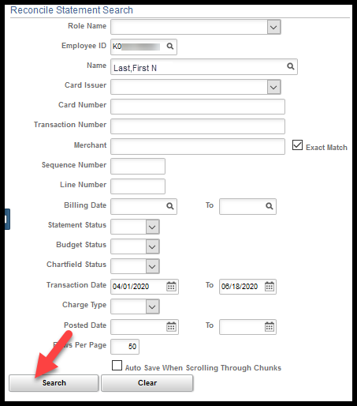
- The ‘Reconcile Statement – Procurement Card Transactions’ page displays. Click the ‘Billing’ tab in the ‘Bank Statement’ header:
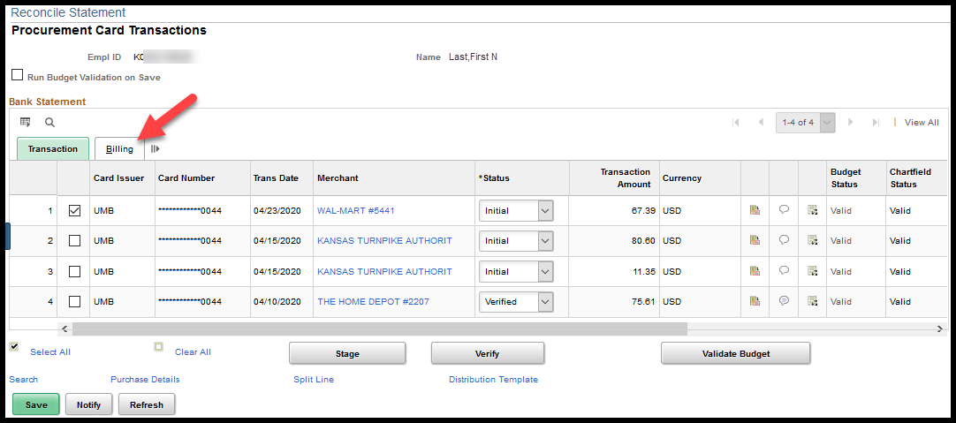
- Provide a description of the purchase:
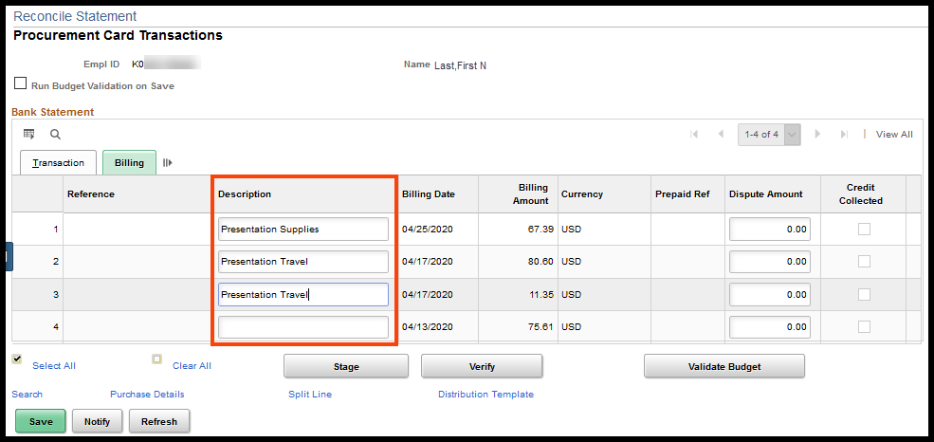

No Purchase Order
The PCard transaction can be paid without reconciling to a Purchase Order ONLY if the purchase & supplier are not under contract and the purchase does not cause the agency’s Delegated Purchasing Authority to be exceeded (Info Cir 17-A-005). If there is a contract, there MUST be PO reconciled to the PCard purchase (Policy Manual 10,300).

Navigation:
Fluid: From the SMART Homepage, click on:
SMART Homepage dropdown → Requisitions & PCards → Procurement Cards → Manage PCard Transactions→ Reconcile Statement

Classic: From the SMART Homepage, click on:
NavBar → Navigator → Purchasing → Procurement Cards → Reconcile → Reconcile Statement
- Search for the PCard transactions to be reconciled. In this example the Employee ID was entered. Click the ‘Search’ button.
- The ‘Reconcile Statement – Procurement Card Transactions’ page displays. Click the ‘Billing’ tab in the ‘Bank Statement’ header:
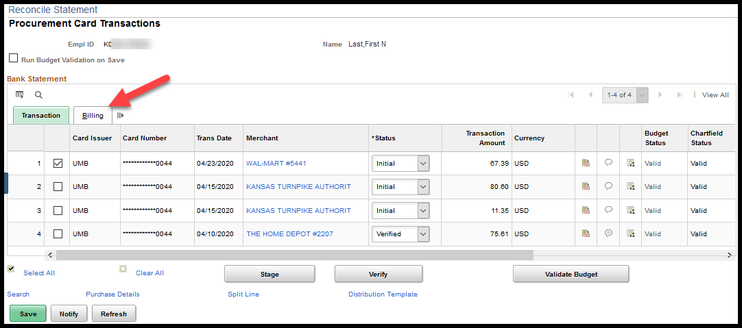:
- Enter a ‘Description’ and then click the ‘Transaction’ tab:
NOTE: The ‘Description’ will be transferred to the voucher when the PCard voucher is created.
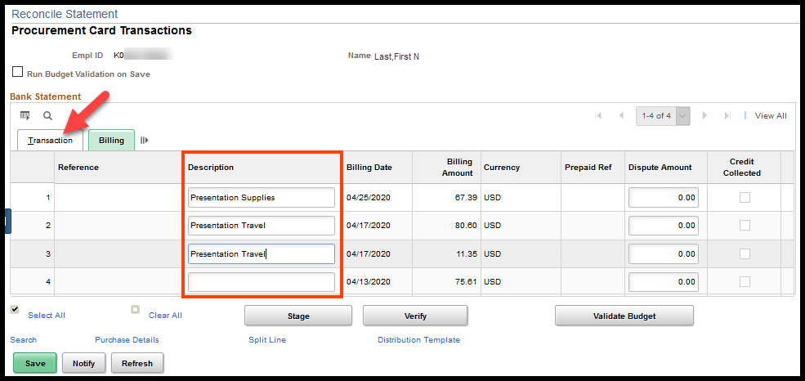
- Click the ‘Distribution’ icon:
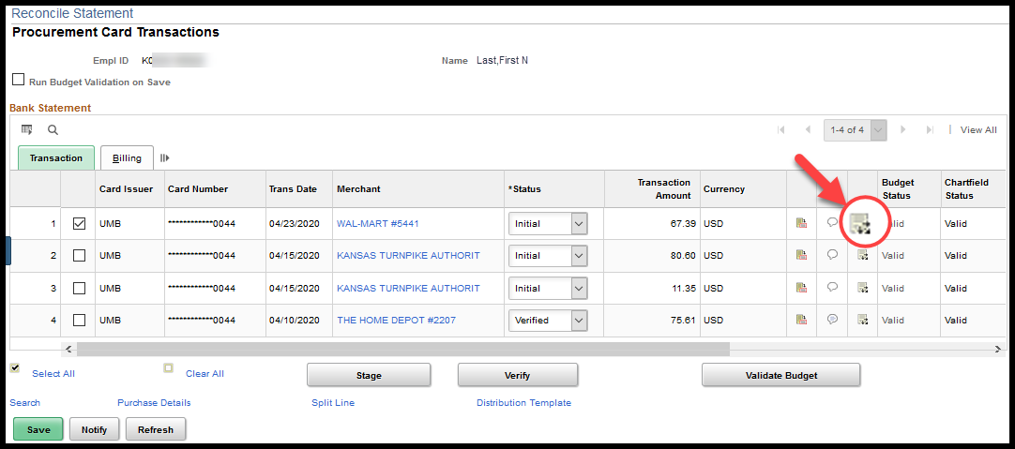
- Correct and/or validate the chartfield information that defaults in from the Cardholder Profile and click ‘OK’:
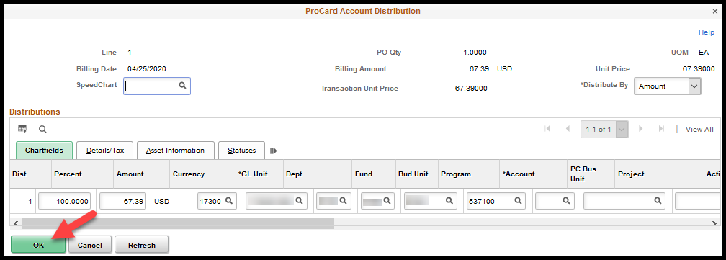
NOTE: The Account code is a required field for reconciling PCard transactions; however, the ‘Account code’ is NOT required on Speedcharts. If a speedchart is the default for the reconcilers chartfield values, the reconciler must enter an ‘Account code’ for each distribution line on ALL PCard transactions. It is highly recommended that the ‘Account code’ be populated on speedcharts that will be used on PCard Holder profiles.
- Change the status from ‘Initial’ or ‘Staged’ to ‘Verified’ and click the ‘Save’ button:
Note: All transactions enter SMART with a status of ‘Initial’. This status is used by the weekly email notification of new transactions process. Once ran, it changes the status of these transactions to ‘Staged’.
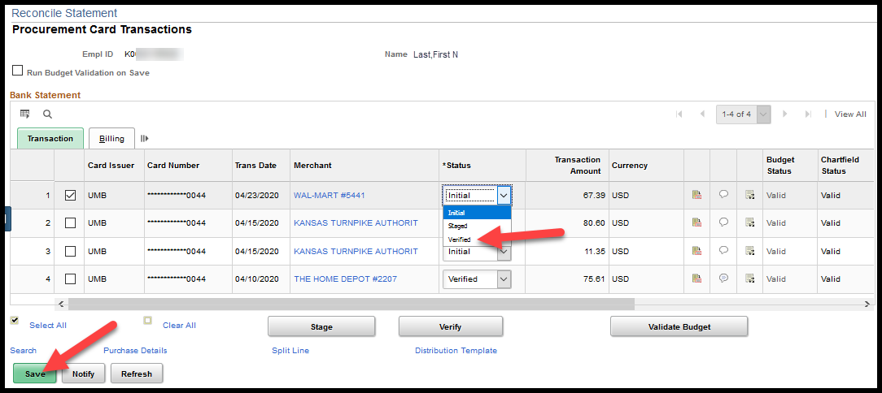
NOTE: SMART will attempt to save ALL the PCard transactions that were pulled into the ‘Reconcile Statement – Procurement Card Transactions’ page as a result of a search; even those transactions that are not displaying. In the below example, SMART would try to save ten (10) PCard transactions even though only nine (9) transactions are currently visible:
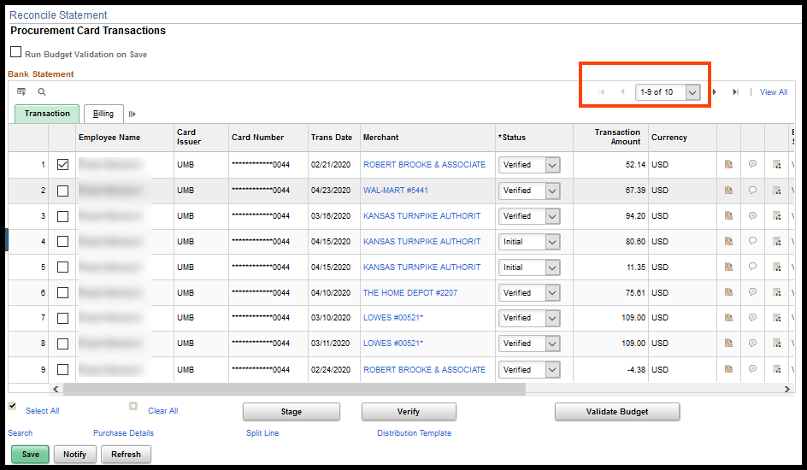
The Reconciler would NOT be able to save changes on the PCard transaction that they are working on if there is even one (1) PCard transaction that does not have correct chartfield information. For example, if PCard transaction number 10 doesn’t have an ‘Account code’, the reconciler would not be able to save this page, even if the only PCard transaction that the Reconciler touched was the first listed PCard transaction. For this reason, it is highly recommended that Reconcilers use Search criteria that will produce the least number of PCard transactions on a page.

With Purchase Order
The PCard transaction MUST be reconciling to a Purchase Order (PO) if the purchase & supplier are under contract or the purchase will cause the agency’s Delegated Purchasing Authority to be exceeded (Info Cir 17-A-005). If there is a contract, there MUST be PO reconciled to the PCard purchase (Policy Manual 10,300).
If a PCard is associated to a PO, that PO cannot be directly pulled into a voucher. The PO MUST be reconciled to a PCard transaction. The Approved PCard transaction will build to a PCard voucher during the PCard Voucher Build batch process, which is ran Monday and Thursday mornings.
There are three (3) possible scenarios:
- The PO Merchandise Amount total and the PCard transaction amount are the same.
- The PO Merchandise Amount total is more than the PCard transaction amount.
- The PO Merchandise Amount total is less than the PCard transaction amount.

PO Merchandise Amt total = PCard transaction amt
Navigation:
Fluid: From the SMART Homepage, click on:
SMART Homepage dropdown → Requisitions & PCards → Procurement Cards → Manage PCard Transactions→ Reconcile Statement

Classic: From the SMART Homepage, click on:
NavBar → Navigator → Purchasing → Procurement Cards → Reconcile → Reconcile Statement
- Search for the PCard transactions to be reconciled. In this example the Employee ID was entered. Click the ‘Search’ button.
- The ‘Reconcile Statement – Procurement Card Transactions’ page displays.
Notice in the following screen shots that the PCard transaction for $125.00 to Staples matches the PO total amount. Also NOTE, that the PO has three PO Lines.
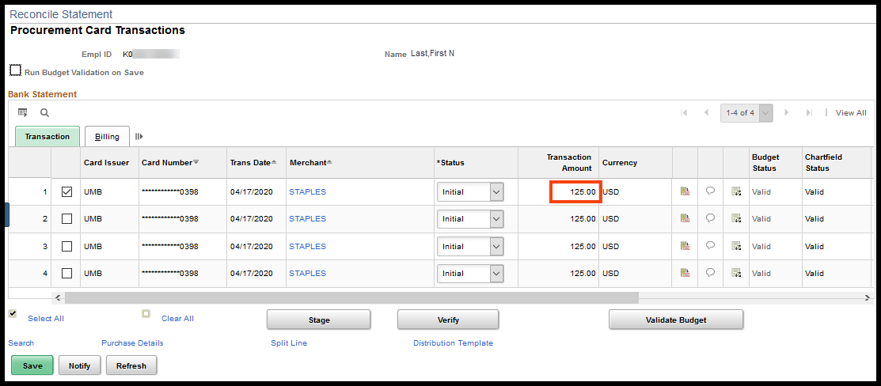
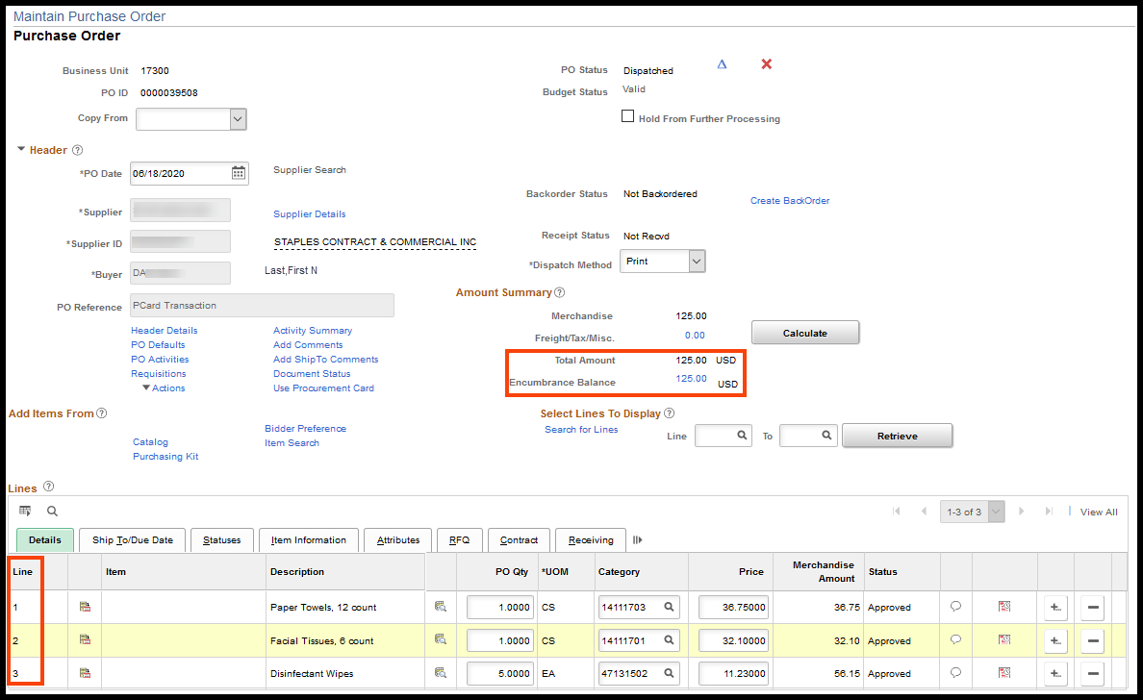
- Select the PCard transaction to be reconciled and click the ‘Purchase Details’ link: 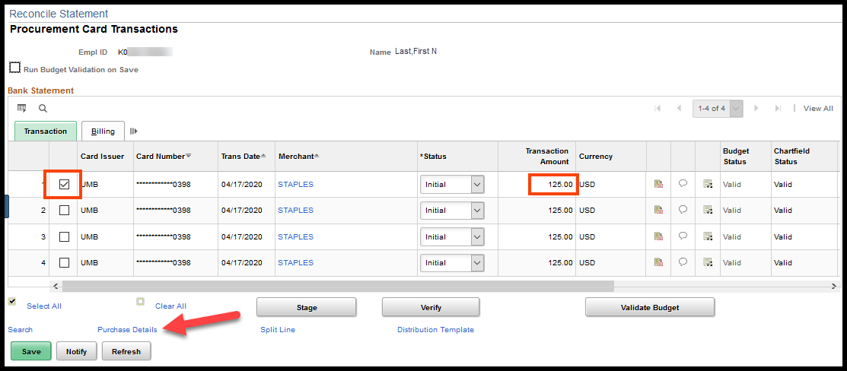
- Enter the PO ID and click the ‘OK’ button:
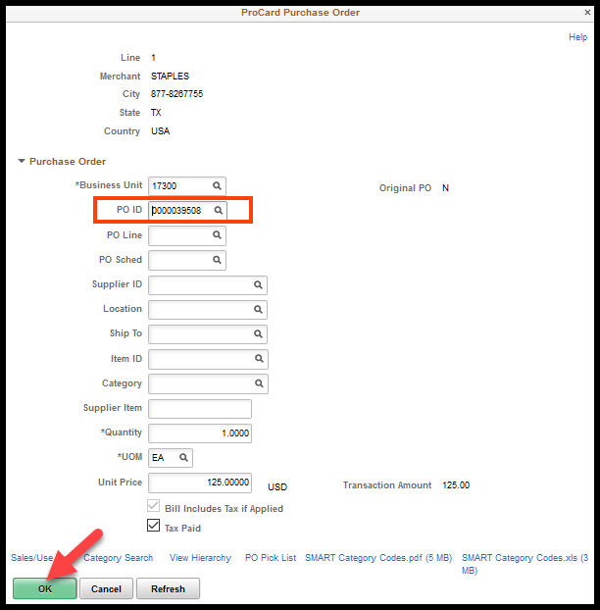
- Clicking the ‘OK’ button will open the ‘Reconcile Statement – Procurement Card Transactions’ page. Please notice that PCard transaction line three (3) has been split into three (3) PCard transaction lines. The PCard transaction amounts match the PO line amounts:
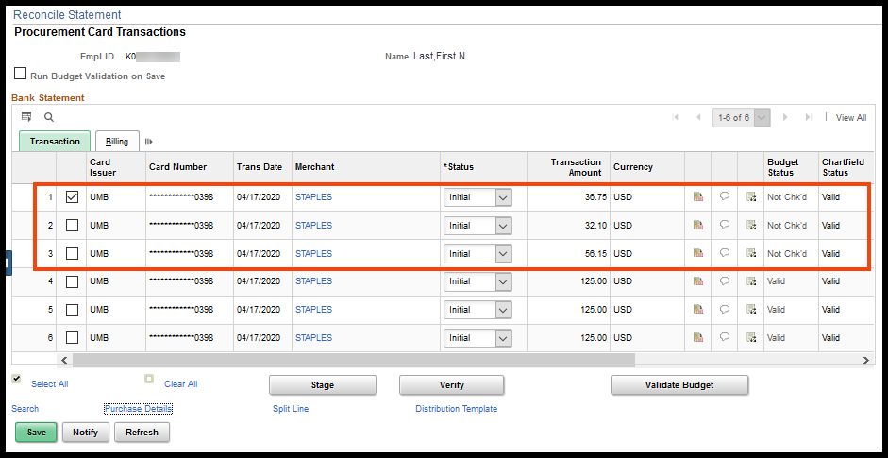
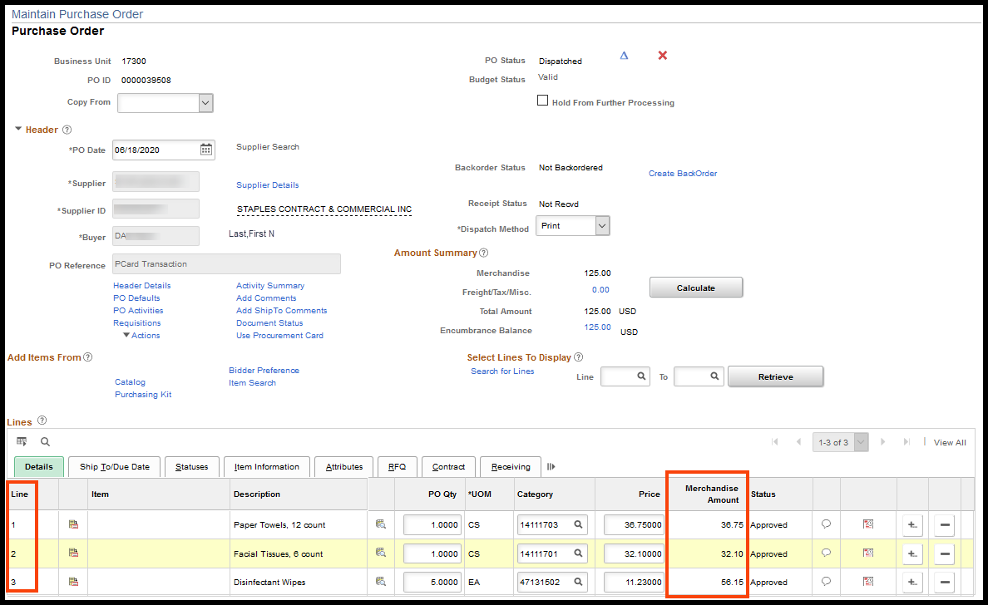
- The Reconciler can see that the PO has been attached to the PCard transaction by navigating back to the ‘Purchase Details’ page:
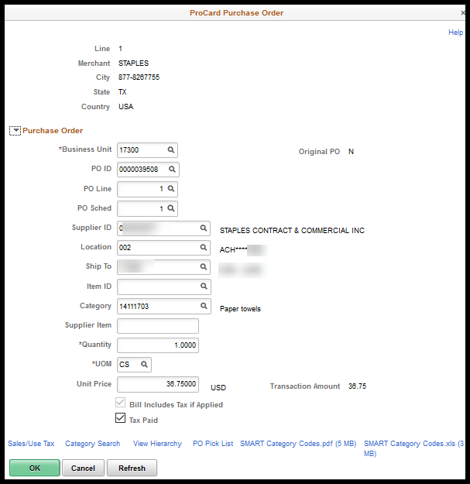
- Navigate back to the ‘Reconcile Statement – Procurement Card Transactions’ page by selecting the ‘OK’ button. Enter a description on the ‘Billing’ tab:
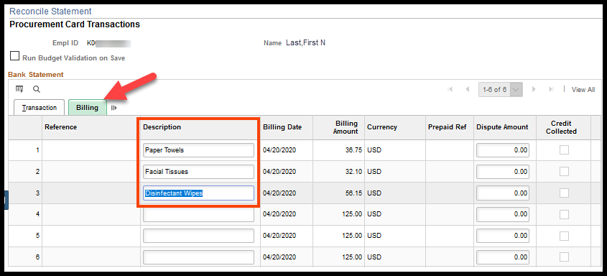
- Change the ‘Status’ from ‘Initial’ or ‘Staged’ to ‘Verified’ on the ‘Transaction’ tab, and click the ‘Save’ button:
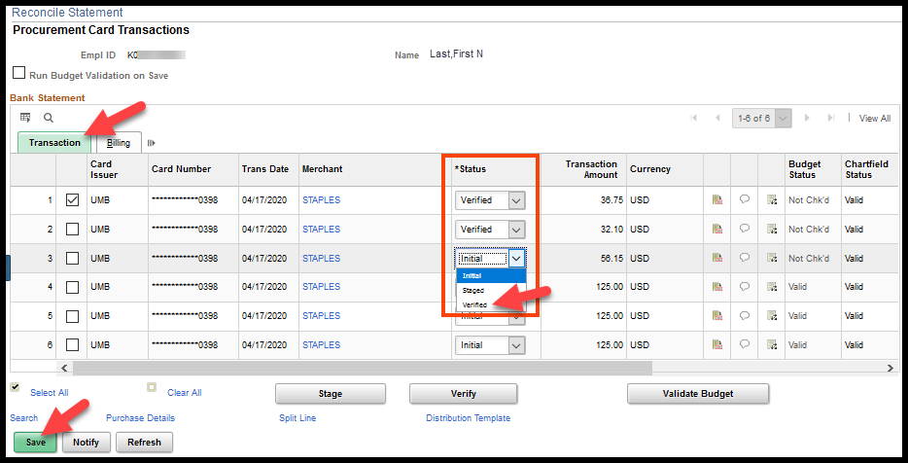
NOTE: The chartfield values are inherited from the PO and are NOT editable on the PCard transaction once the PO is pulled in. The chartfield values are grayed out.
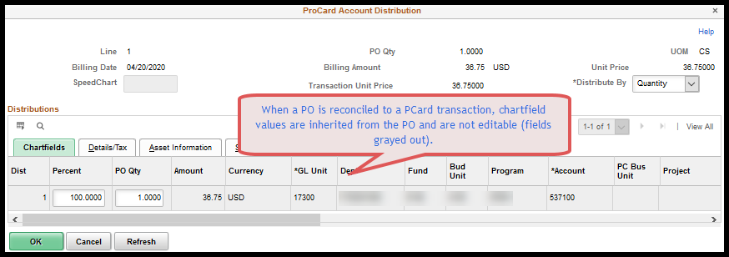

PO Merchandise Amt total > PCard transaction amt
Navigation:
Fluid: From the SMART Homepage, click on:
SMART Homepage dropdown → Requisitions & PCards → Procurement Cards → Manage PCard Transactions→ Reconcile Statement

Classic: From the SMART Homepage, click on:
NavBar → Navigator → Purchasing → Procurement Cards → Reconcile → Reconcile Statement
- Search for the PCard transactions to be reconciled. In this example the Employee ID was entered. Click the ‘Search’ button.
- The ‘Reconcile Statement – Procurement Card Transactions’ page displays.
Notice in the following screen shots that the PCard transaction for $125.00 to Staples is less than the Purchase Order (PO) total amount. Also NOTE that the PO has two (2) PO Lines and that the ‘Amount’ on PO line one (1) matches the transaction amount.
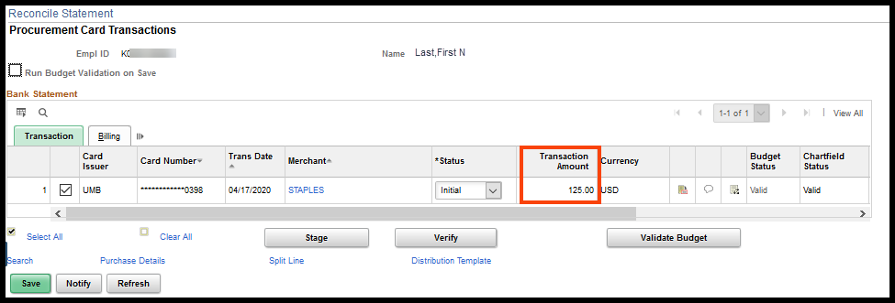
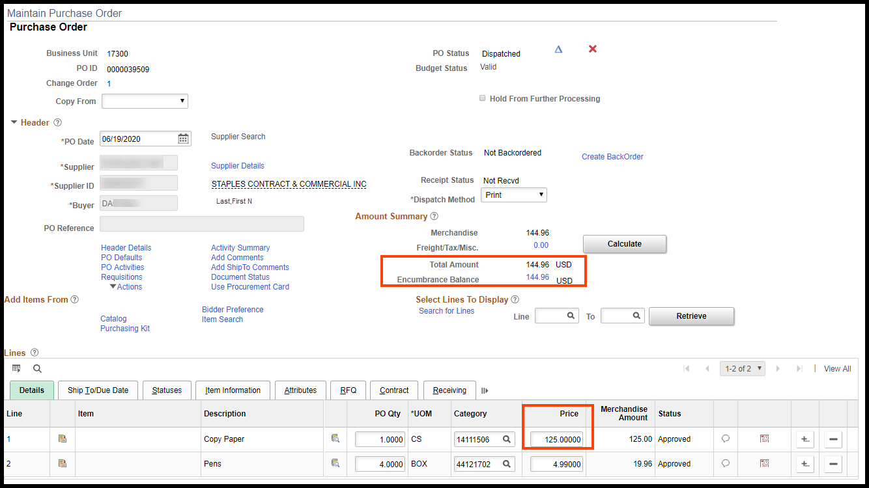

- Select the PCard transaction to be reconciled, and click the ‘Purchase Detail’ link:
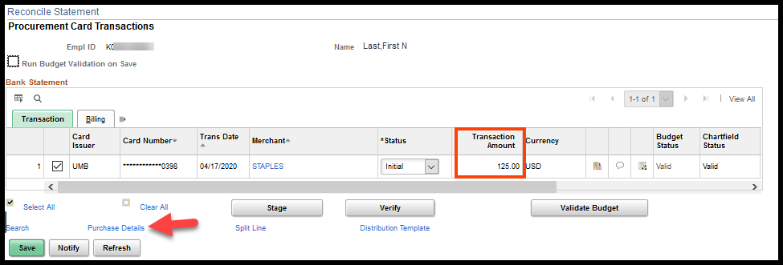
- Enter the PO ID and enter the PO Line number. Click the ‘OK’ button:
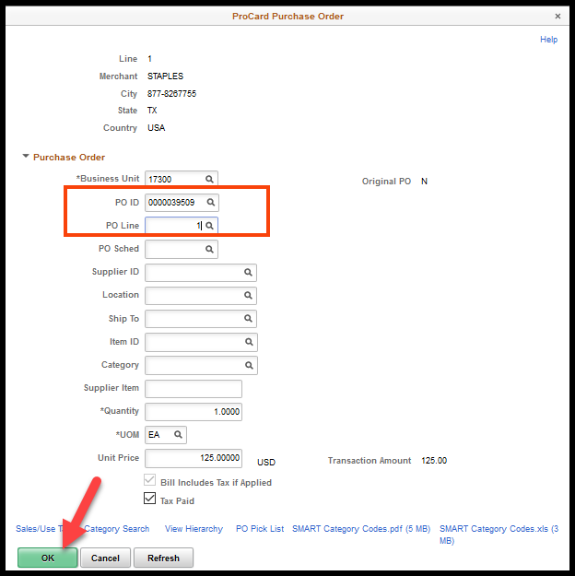
- Clicking the ‘OK’ button will open the ‘Reconcile Statement – Procurement Card Transactions’ page.
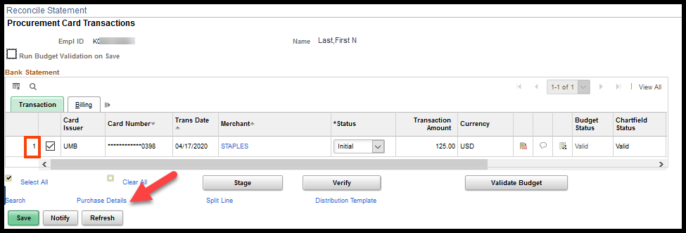
- The Reconciler can see that the PO has been attached to the PCard transaction by navigating back to the ‘Purchase Details’ page:
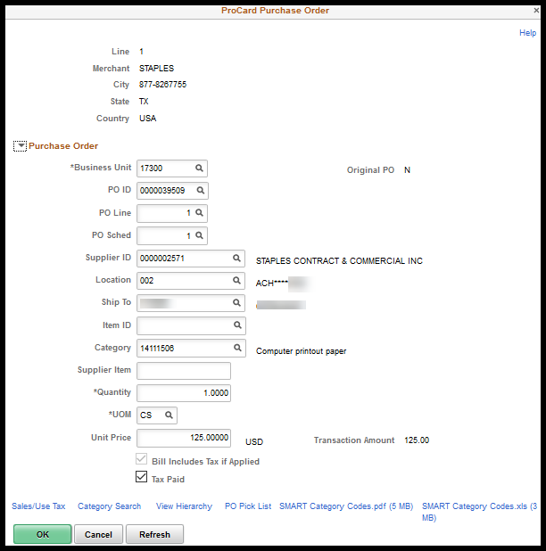
- Navigate back to the ‘Reconcile Statement – Procurement Card Transactions’ page by selecting the ‘OK’ button. Enter a description on the ‘Billing’ tab:
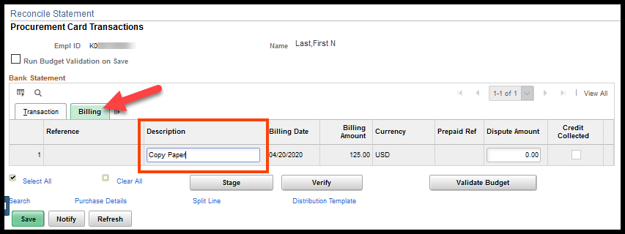
- Change the ‘Status’ from ‘Initial’ or ‘Staged’ to ‘Verified’ on the ‘Transaction’ tab, and click the ‘Save’ button:
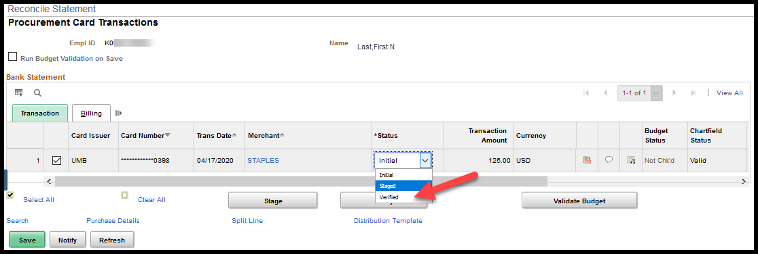
NOTE: If the reconciler enters the PO number on the ‘Purchasing Details’ page and does NOT enter the PO line number, the PCard transaction will automatically split between the number of PO lines. In this example it will split across two (2) PO lines.
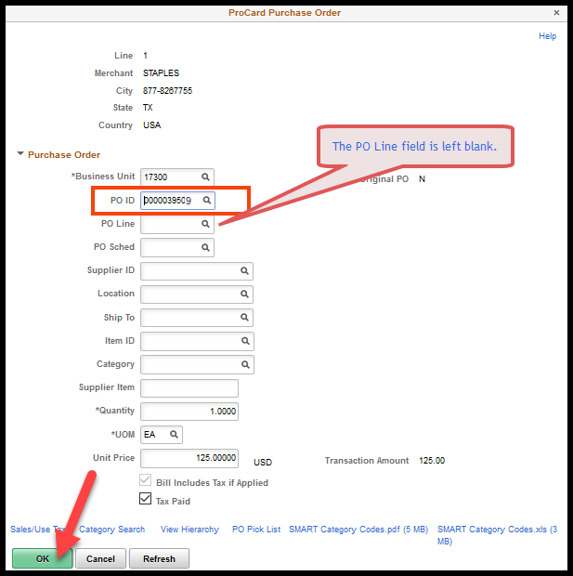
The PCard transaction has split into two (2) PCard transactions:
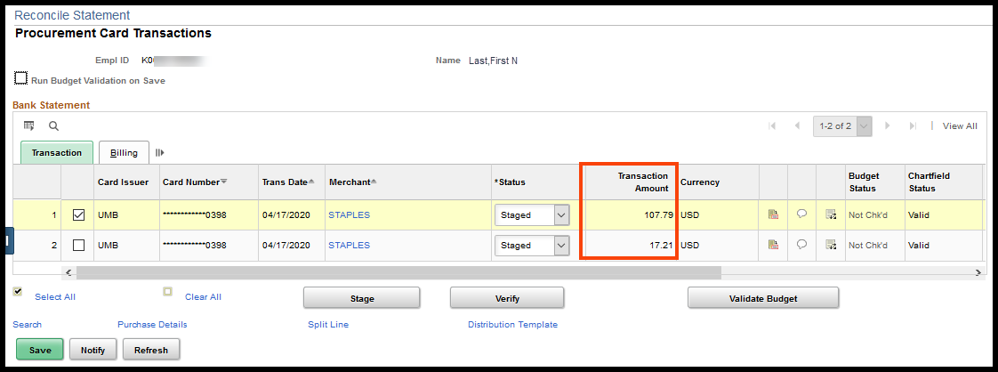
The PCard transaction amount is being incorrectly applied to both PO lines 1 and 2:
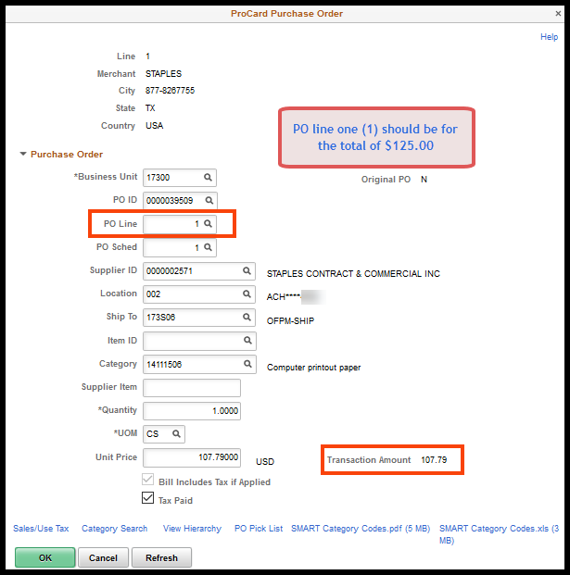
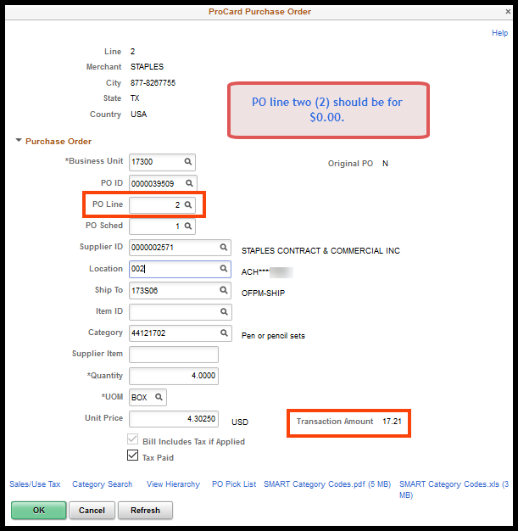
NOTE: The chartfield values are inherited from the PO and are NOT editable on the PCard transaction once the PO is pulled in. The chartfield values are grayed out.

PO Merchandise Amt total < PCard transaction amt
For this example, a Purchase Order (PO) was created for one (1) item. However, when the purchase was made, there were multiple items purchased. The Reconciler needs to associate the PO to only a portion of the PCard transaction.
Navigation:
Fluid: From the SMART Homepage, click on:
SMART Homepage dropdown → Requisitions & PCards → Procurement Cards → Manage PCard Transactions→ Reconcile Statement

Classic: From the SMART Homepage, click on:
NavBar → Navigator → Purchasing → Procurement Cards → Reconcile → Reconcile Statement
- Search for the PCard transactions to be reconciled. In this example the Employee ID was entered. Click the ‘Search’ button.
- The ‘Reconcile Statement – Procurement Card Transactions’ page displays.
Notice in the following screen shots that the PCard transaction for $128.16 to WW Grainger is more than the PO total amount.
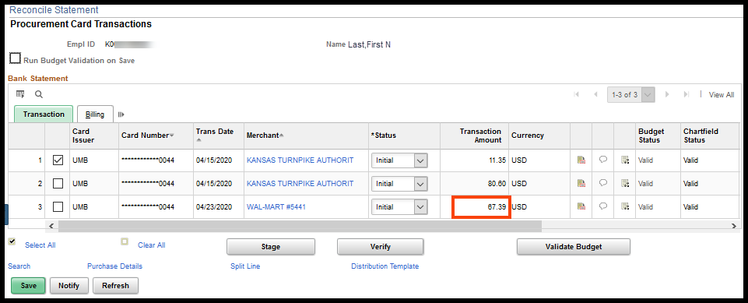
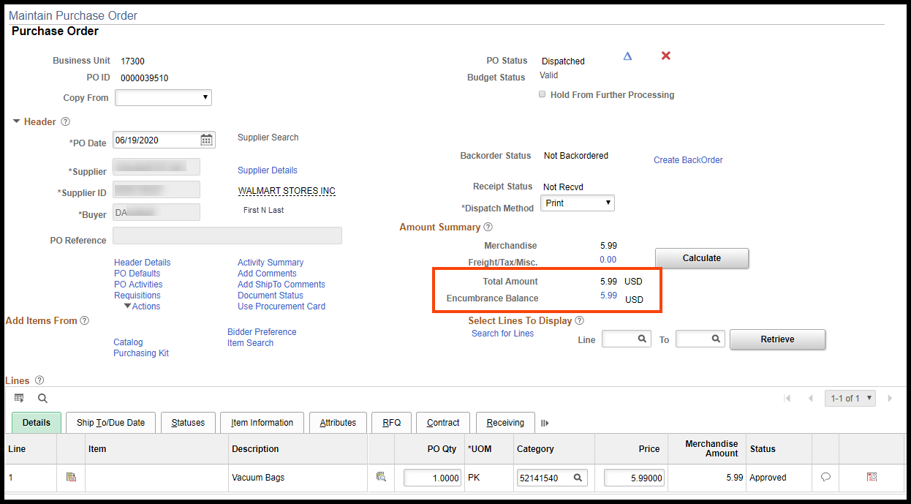
- If there was no contract involved, only a portion of the PCard transaction needs to be associated to the PO. To accomplish this, the PCard transaction will need to be manually split into two PCard transactions. Select the PCard transaction to be reconciled and click the ‘Split Line’ link:
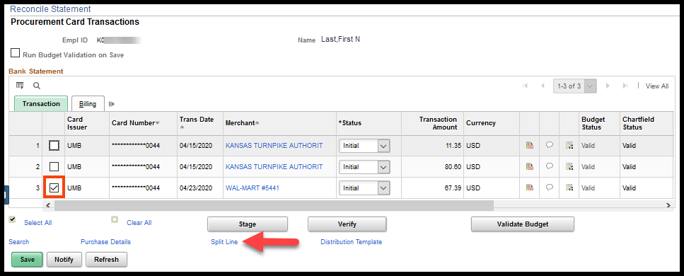
Note: If there is a contract for the purchase, the PO must be updated to include the entire purchase amount before PCard reconciliation.
- The ‘Reconcile Statement – Split Transaction’ page will display:
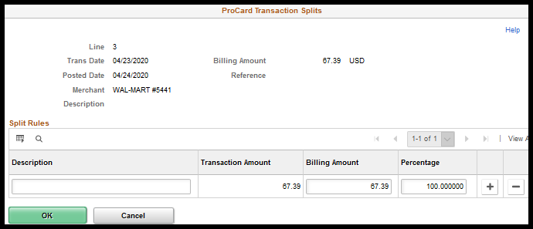
- Enter a ‘Description’, change the ‘Billing Amount’ to $5.99 and click the plus sign (+) at the end of the row:
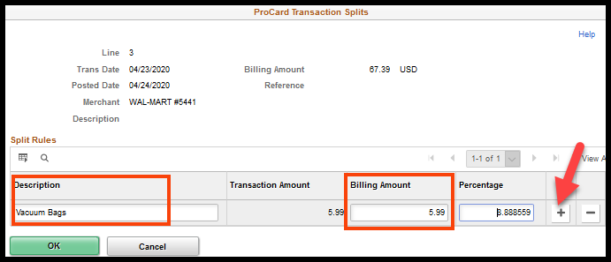
- A new row will be displayed. The Description field on the new row will be the same as the original description, but can be updated. The ‘Billing Amount’ will be the original ‘Billing Amount’ minus the the $5.99. The Percentage will automatically adjust.
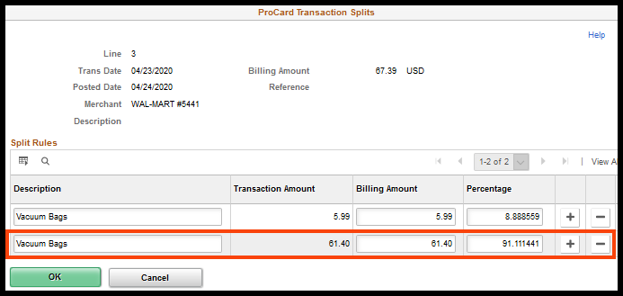
- Change the ‘Description’ field for the new line, and click the ‘OK’ button:
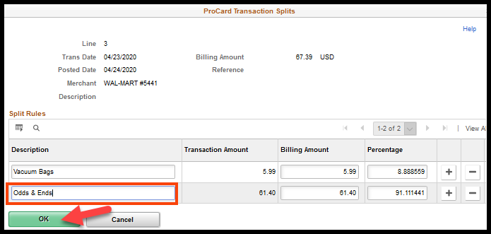
- The Reconciler now has two (2) PCard transactions one (1) of which matches the PO amount:
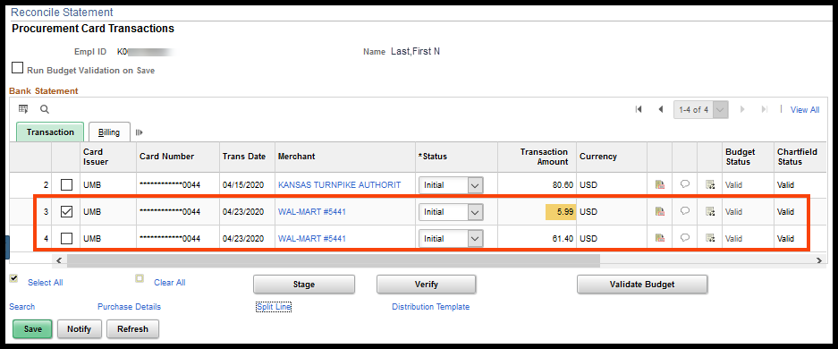
- Select PCard transaction number 3, which is the PCard transaction that matches the PO amount. Next, click the ‘Purchase Details’ link and enter the PO ID and the PO Line numbers and click the ‘OK’ button:
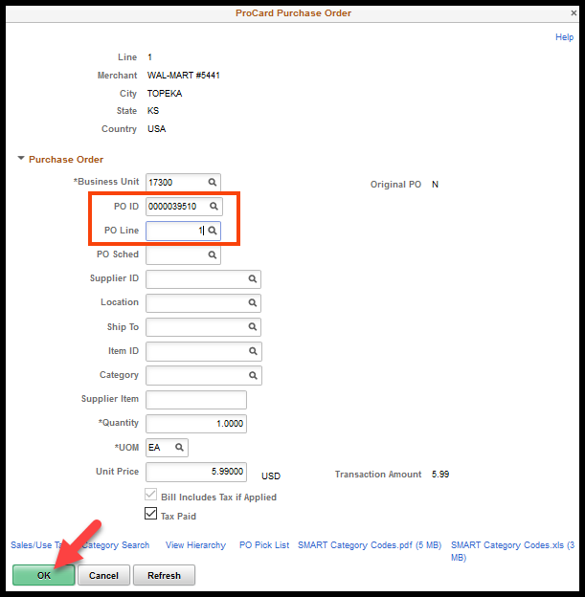
- Clicking the ‘OK’ button will open the ‘Reconcile Statement – Procurement Card Transactions’ page. To validate that the PO has been associated to this PCard transaction, click the ‘Purchasing Details’ link:
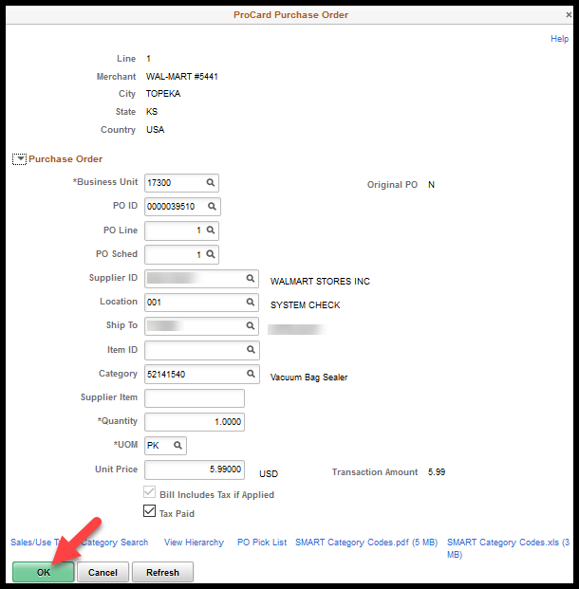
- Click the ‘OK’ button to return to the ‘Reconcile Statement – Procurement Card Transactions’ page. The distribution information is inherited from the PO for PCard transaction number 3. Click the ‘Distribution’ icon for PCard transaction number 4 to review/correct the chartfield information:
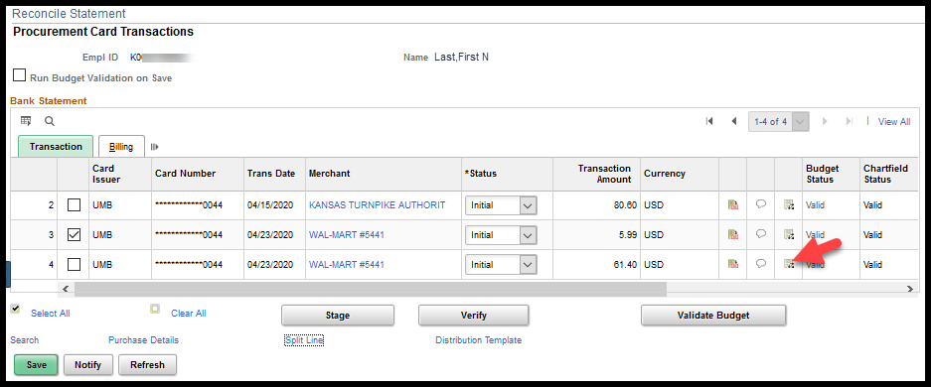
- Make any necessary adjustments and click to ‘OK’ button:
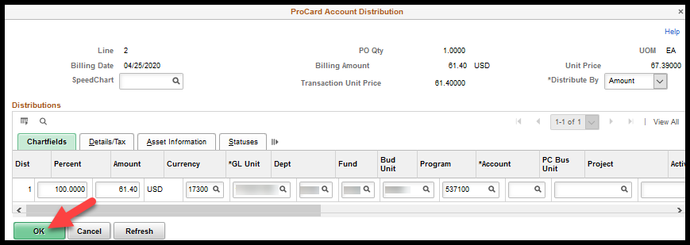
NOTE: The Account code is a required field and must be populated before the PCard transaction can be saved.
NOTE: The chartfield information will default in based on the PCard Holder Profile set up. If the default values need to be updated, contact your agency’s PCard Administrator and request that your chartfield default values be updated.
- For PCard transactions 3 and 4, change the status to ‘Verified’ and click the ‘Save’ button:
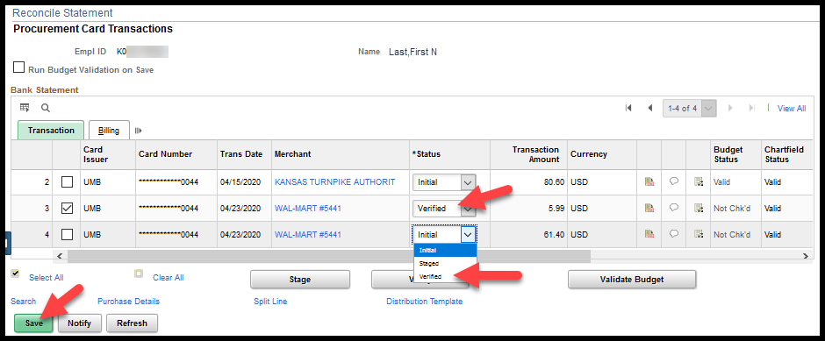

PCard Disputes / Incorrect Charges
If a procurement card transaction is identified as a fraudulent charge (card stolen, card number stolen), and the charges are completely unrelated to State of Kansas business, the Agency must contact the PCard Issuer (currently UMB) to them of the dispute.
The agency must then contact the supplier directly to obtain credits for incorrect charges, damaged goods, etc. If agreement cannot be reached with the supplier for incorrect charges, the agency can then contact UMB for assistance in obtaining the credit.
There is limited time in which credits can be requested; therefore, agencies should contact UMB and/or suppliers as soon as possible.

Instructions for Processing Disputes and/or Incorrect Charges

Navigation:
Fluid: From the SMART Homepage, click on:
SMART Homepage dropdown → Requisitions & PCards → Procurement Cards → Manage PCard Transactions → Reconcile Statement

Classic: From the SMART Homepage, click on:
NavBar → Navigator → Purchasing → Procurement Cards → Reconcile → Reconcile Statement
- Enter the amount that is being disputed (incorrect) in the ‘Dispute Amount’ field on the ‘Billing’ tab.
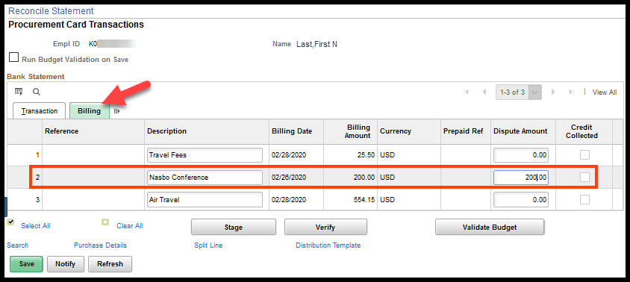
- The ‘Status’ on the ‘Transaction’ tab should remain as ‘Staged’ until the credit for the disputed amount is received. Click the ‘Save’ button.
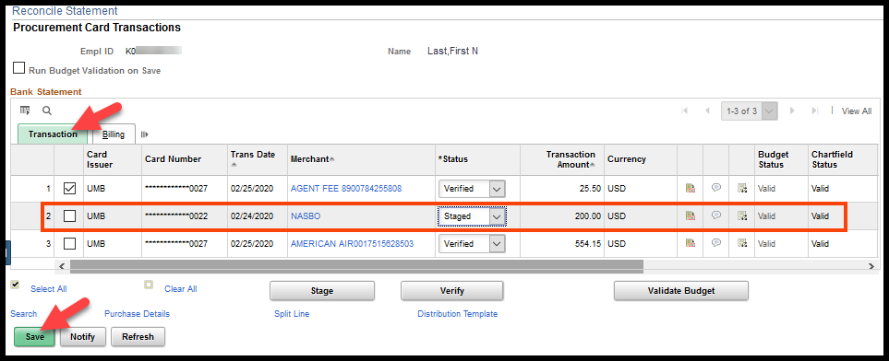
- Once the credit is received, select the ‘Credit Collected’ checkbox next to the disputed amount on the ‘Billing’ tab.
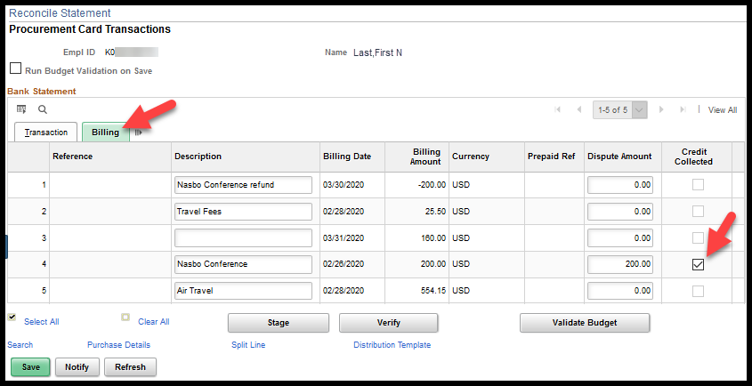
- ‘Verify’ or ‘Approve’ BOTH the original PCard transaction AND the credit transaction. Click the ‘Save’ button.
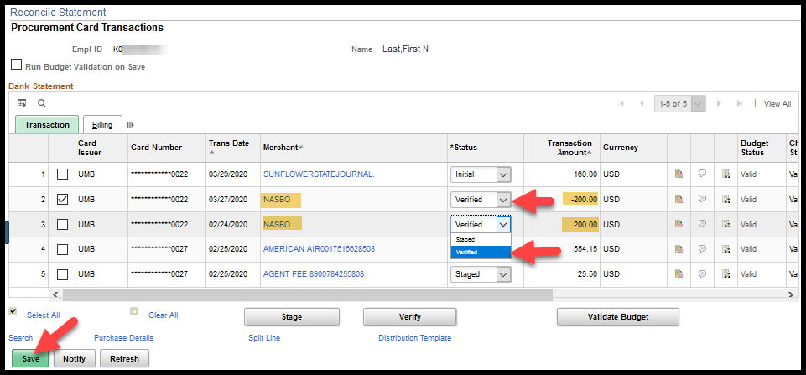
NOTES:
- Both the original PCard transaction and the credit PCard transaction should be approved at the same time so that both transactions will build to the same PCard voucher. This will help ensure that a credit was actually received and provide for more visibility into what transpired.

- Important!: If a credit is not approved at the same time as the charge for which it is offsetting it may not build to voucher. SMART will no longer allow negative vouchers to be created. If there is not a transaction amount approved for payment that offsets the credit amount and is associated to the same control account, the credit will remain on the Reconcile Statement page in Approved status until there is.

- The ‘Dispute Amount’ and ‘Credit Collected’ fields have no functionality behind them. These fields are provided as a tool to assist with keeping track of PCard transactions that are in the Dispute process.

If a ‘Dispute Amount’ has been entered and the PCard transaction status is changed to ‘Approved’ the entire PCard transaction amount will build to a PCard voucher and be paid. Entering a value in the ‘Dispute Amount’ field will NOT stop a payment from being made.

- Exceptions: Charged Kansas Sales Tax - When sales tax has been charged by the supplier the agengcy should approve the original PCard transaction total and pay the total PCard transaction amount. The agency will then need to contact the supplier directly to request a credit for the taxes paid. The tax amount can be noted in the Dispute Amount field for tracking purposes. Entering the Dispute Amount will NOT stop the PCard transaction from building to a PCard voucher. If a Dispute Amount is entered and the PCard transaction is built to a PCard voucher, the PCard transaction will NOT be visible from the ‘Review Disputes’ page.

Review Disputes Page
The Review Disputes page is a tool provided to assist with tracking PCard transactions that are in dispute. Neither the ‘Dispute Amount’ or the ‘Credit Collected’ fields have functionality behind them that would prevent payments from happening. This is to be used strictly for tracking purposes.
Navigation:
Fluid: From the SMART Homepage, click on:
SMART Homepage dropdown → Requisitions & PCards → Procurement Cards → Manage PCard Transactions → Review Disputes

Classic: From the SMART Homepage, click on:
NavBar → Navigator → Purchasing → Procurement Cards → Reconcile → Review Disputes
- Enter search criteria. For this example, a ‘Transaction Date’ range was entered. Click the ‘Search’ button.
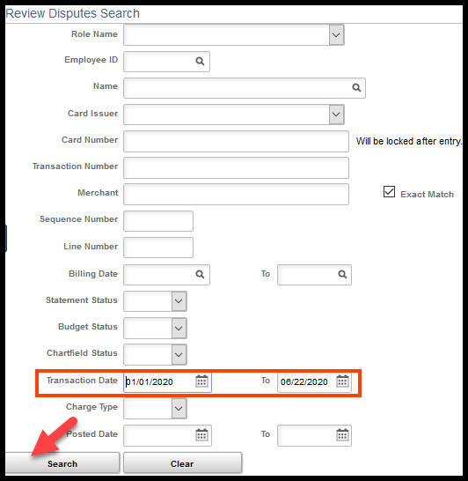
- The results will display those PCard transactions that:
- the user has proxy rights to
- meet the search criteria
- have a dispute amount entered
- the ‘Credit Collected’ checkbox is NOT selected
- have not built to a voucher

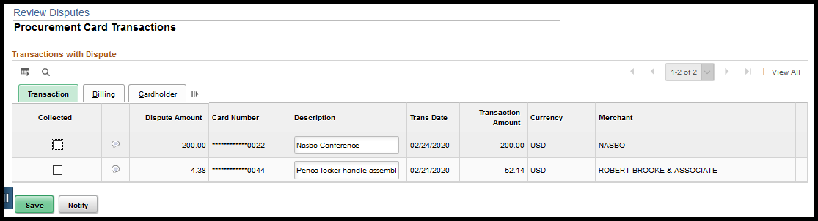
- Comments entered on the PCard transaction from the Reconcile Statement page can be viewed from the ‘Review Disputes’ page:
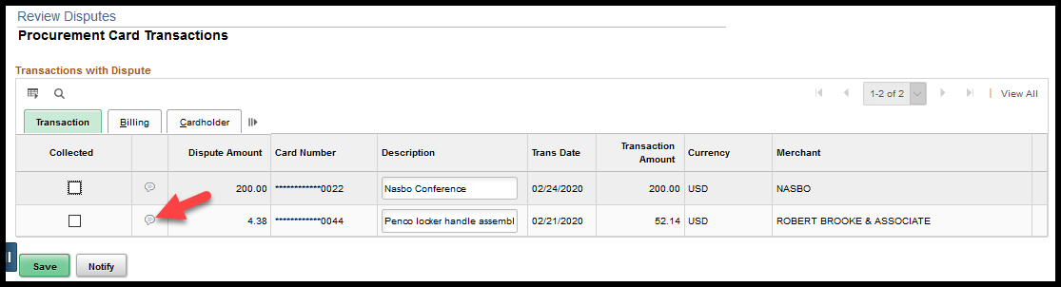
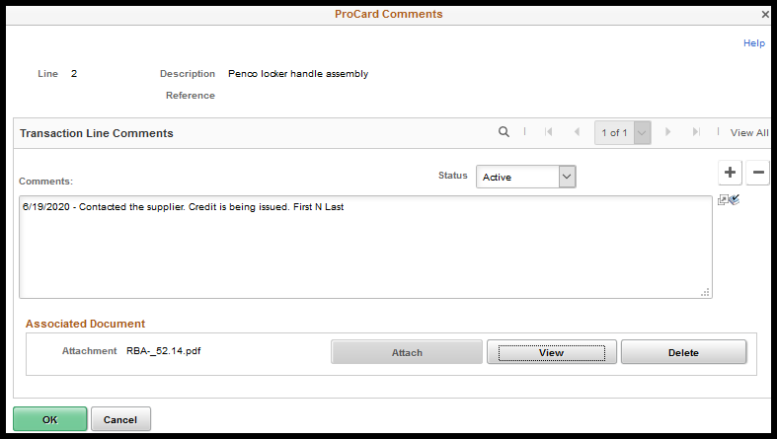
- Comments can be entered from the ‘Review Disputes’ page by clicking the comments icon:
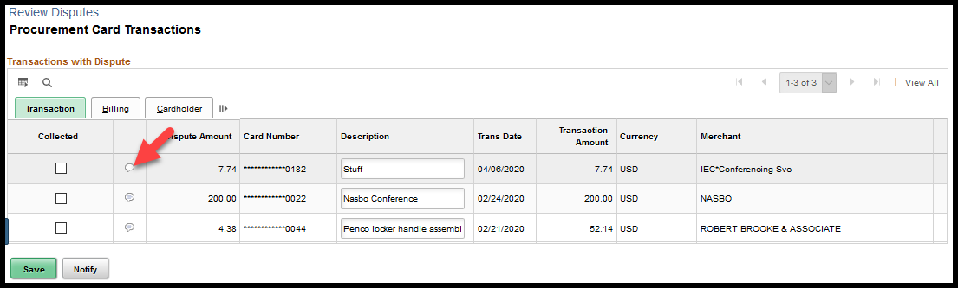

- Enter a comment and click the ‘OK’ button:
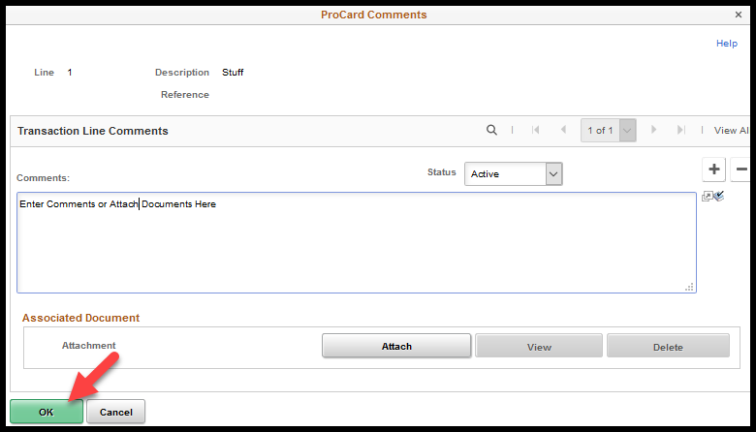
- The comments entered on the ‘Review Disputes’ page are accessible from the ‘Reconcile Statement’ page. Click the comments icon:
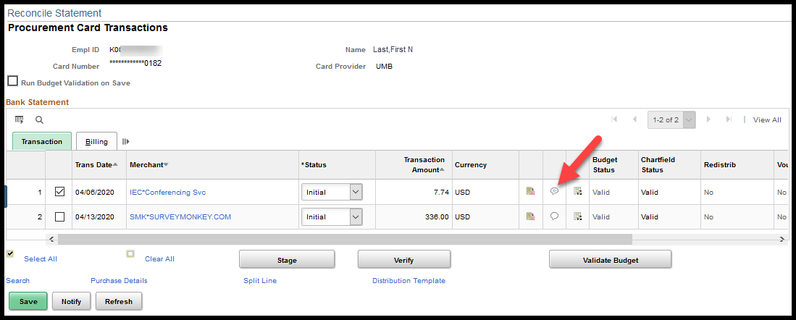
- The comment entered on the ‘Review Disputes’ page is displayed:
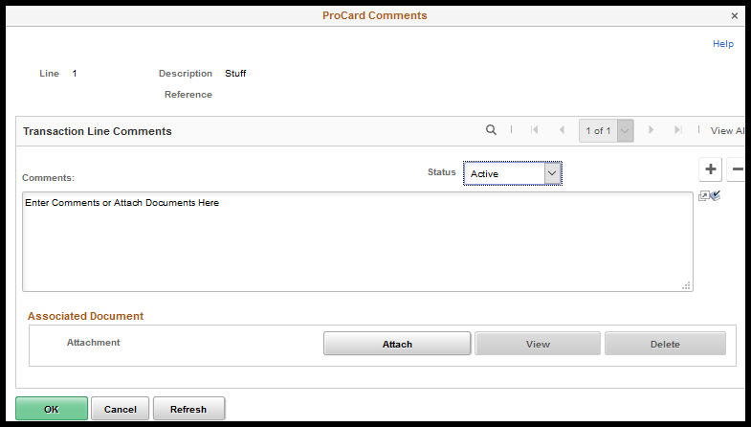
- Once the credit is received, the agency can select the ‘Collected’ check box from the ‘Review Disputes’ page. Click the ‘Save’ button:
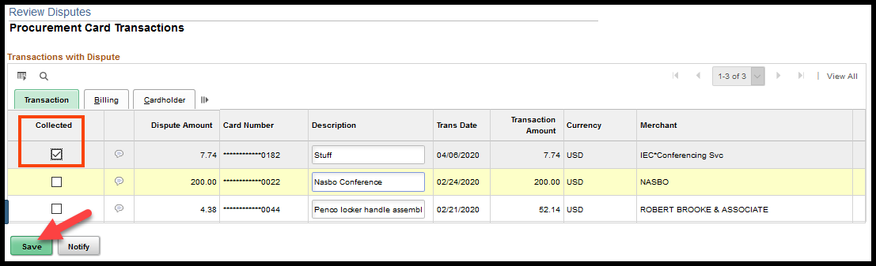

- The ‘Credit Collected’ checkbox will display as checked from the ‘Reconcile Statement’ page.
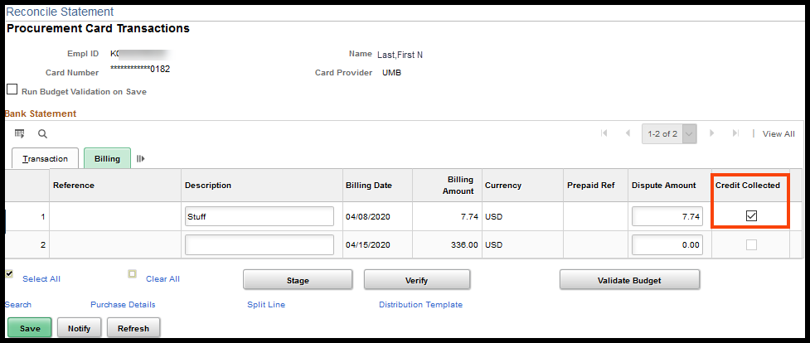
NOTES:
- The Review Disputes page will only display PCard transacations that are in dispute and have NOT been approved and paid. PCard transactions that have built to a PCard voucher will not display on this page even if there is a dispute amount recorded on the PCard transaction.
- The Review Disputes page was made available mid December of 2013 for the following roles: Agency PCard Approver, Agency PCard Reconciler, Agency PCard Recon/Approver, Agency PCard Administrator, Central Purchasing Administrator and Central PCard Administrator.

Reviewing / Approving PCard Transactions
The ‘Approval’ process for PCards is a manual process. PCards transactions will NOT show up on the Approver’s worklist nor will SMART send notifications to indicate when a PCard transaction is ready for review/approval. The Reconciler will need to let the Approver know when PCard transactions are ready for review/approval. Another option would be for the Approver to periodically check to see if there are PCard transactions ready for their review/approval.

Reviewing PCard Transactions
Navigation:
Fluid: From the SMART Homepage, click on:
SMART Homepage dropdown → Requisitions & PCards → Procurement Cards → Manage PCard Transactions → Reconcile Statement

Classic: From the SMART Homepage, click on:
NavBar → Navigator → Purchasing → Procurement Cards → Reconcile → Reconcile Statement
- Search for all PCard transactions in a ‘Verified’ status. This means that the PCard transaction has been reconciled and is ready for review/approval.
Extend the ‘Transaction Date’ and select the ‘Verified’ option from the ‘Statement Status’ drop down list and select the ‘Search’ button:
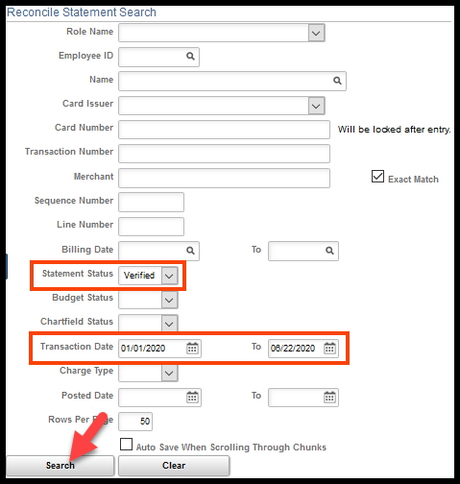

NOTE: This will pull up ALL PCard transactions with a ‘Verified’ status for which you have proxy rights to the PCard. If no other information is entered on the search page, the search results could include PCard transactions from multiple PCards. If the Approver has many PCards that they review/approve and wants to limit the results further, enter either a PCard number of Emplid in addition to the ‘Statement Status’.
The Approver will want to check the following:
- Validate that a description has been entered and contains enough information to identify what was actually purchased.
- Validate that the dollar amount is correct.
- Validate that the information on the Purchasing Details page is correct: a Purchase Order has been applied when there is a contract for the purchase.
- Validate that the Chartfield information is correct.

Description
From the ‘Reconcile Statement – Procurement Card Transactions’ page, validate that the description is populated on the ‘Billing’ tab, and that the information is descriptive enough to identify what was actually purchased.

Dollar Amount
The ‘Reconcile Statement – Procurement Card Transactions’ page has two different Amounts: ‘Transaction Amount’ on the ‘Transaction’ tab and the ‘Billing Amount’ on the ‘Billing’ tab. Since the State of Kansas very rarely makes foreign purchases, the ‘Transaction Amount’ and ‘Billing Amount’ are usually the same and will have ‘USD’ as the currency for both amounts. However, these two amounts can vary.

The ‘Transaction Amount’ represents the amount and currency being used by the supplier. In the example below the currency for the ‘Transaction Amount’ is ‘CAD’:
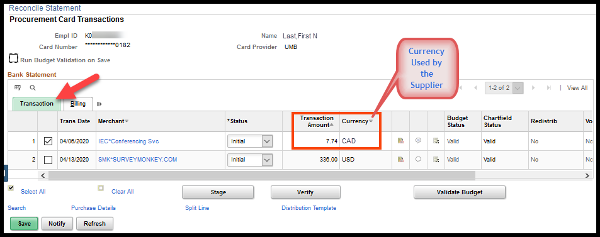
The ‘Billing Amount’ represents the amount and currency being charged to the State of Kansas. The ‘Billing Amount’ is the amount that will build to the voucher once the PCard transaction is approved.
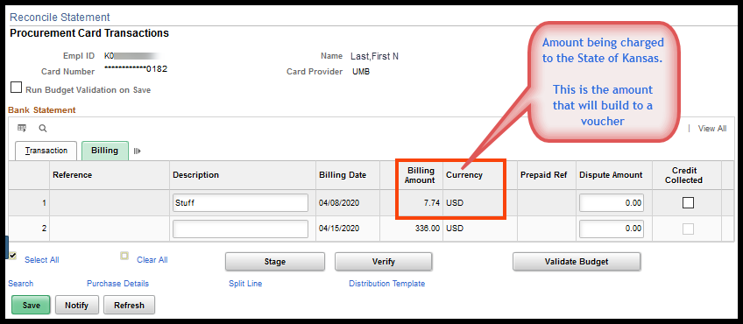

The Approver will need to verify that the ‘Transaction Amount’ and/or ‘Billing Amount’ are correct:
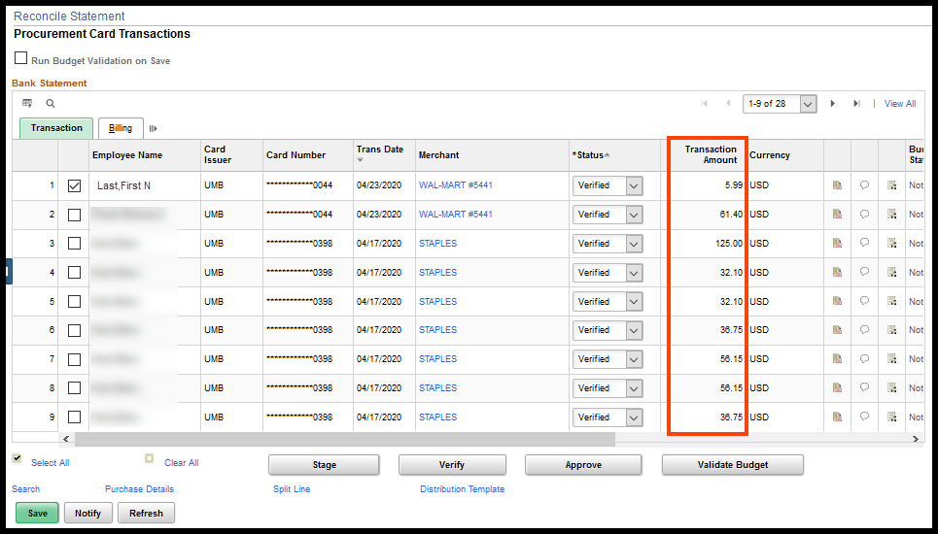

Purchasing Details
The Approver will want to review the ‘Purchasing Details’ page if the purchase is on a contract to ensure that the Purchase Order (PO) associated to the appropriate contract has been reconciled to the transaction.
The PCard transaction MUST be reconciling to a Purchase Order (PO) if the purchase & supplier are under contract or the purchase will cause the agency’s Delegated Purchasing Authority to be exceeded (Info Cir 17-A-005). If there is a contract, there MUST be PO reconciled to the PCard purchase (Policy Manual 10,300).
If a Requisition/PO is created for the PCard transaction, the PO must be associated to the PCard transaction. The PCard transaction will build to a PCard voucher which will release the encumbrance created by the PO.
Not all PCard transactions will have a PO to associate to them; but, for those transactions where the PO indicates that the method of payment is PCard, the PO must be associated to the PCard transaction. The Approver will want to verify that the correct PO and PO lines have been associated.

- Place a check in front of the PCard transaction, and click the ‘Purchase Details’ link:
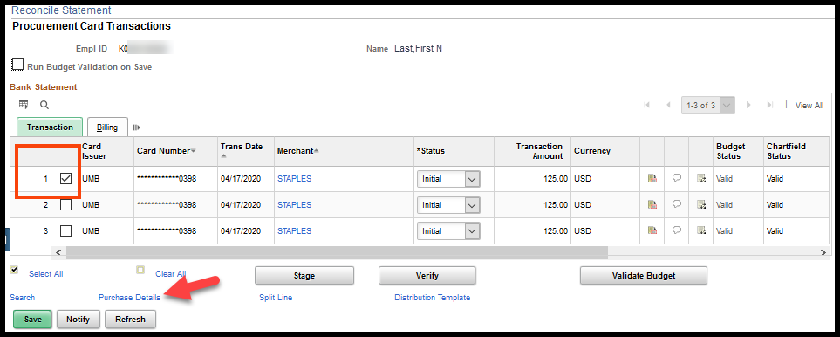
- The ‘Reconcile Statement – Purchase Details’ page will display. Validate that the correct PO and PO Line number have been associated to the PCard transaction:
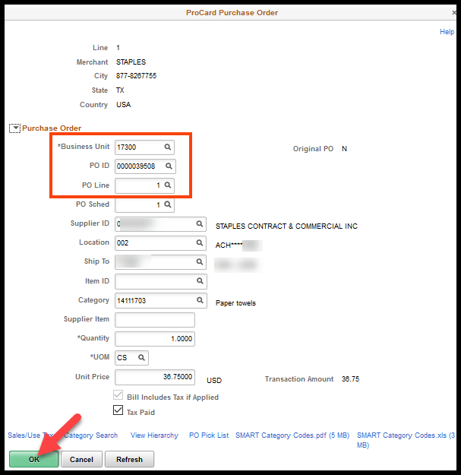
- Click the ‘OK’ button to return to the ‘Reconcile Statement – Procurement Card Transactions’ page.
- Check that the PO has the correct contract associated to the line.
Navigation:
Fluid: From the SMART Homepage, click on:
SMART Homepage dropdown → POs & Receiving → Purchase Orders → Add/Update Purchase Orders → Find an Existing Value (Tab)

Classic: From the SMART Homepage, click on:
NavBar → Navigator → Purchasing → Purchase Orders → Add/Update POs → Find an Existing Value (Tab)
- Select the ‘Line Details’ icon of the PO line associated to the PCard transaction:
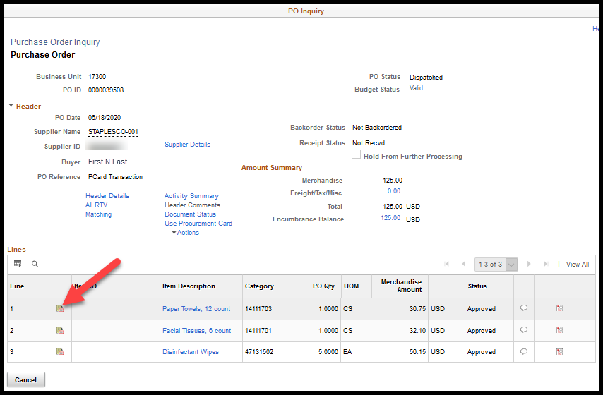

- Make sure the correct contract is associated to the line of the PO:
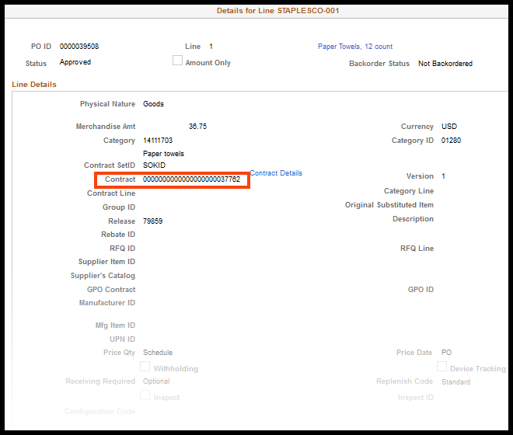

Chartfield Information
The Approver is not only approving the payment of the PCard transaction but is also approving the funding stream being used to make the payment. The chartfield information will default in based upon the default values set up in the PCard Holders profile for that specific PCard. If a Purchase Order (PO) is associated to the PCard transaction, the chartfield information is inherited from the PO and cannot be changed on the PCard transaction.
Important! The default funding information must be valid and active. If any required field in the default funding or the Speedchart becomes inactive, it MUST be updated, or it will prevent the reconciliation of transactions using the card. Contact your agency PCard Administrator to update default funding or submit a ManageEngine Service Desk Ticket.

No Purchase Order
- From the ‘Reconcile Statement – Procurement Card Transactions’ page, click the ‘Distribution’ icon:
- Validate that the chartfield information is correct, and click the ‘OK’ button:
NOTE: If no Purchase Order is associated to the PCard transaction, the chartfield information can be edited.

With Purchase Order
- From the ‘Reconcile Statement – Procurement Card Transactions’ page, click the ‘Distribution’ icon:

- Validate that the Chartfield information is correct and click the ‘OK’ button:
NOTE: The chartfield information is NOT editable because this information is inherited from the Purhcase Order. If a correction needs to be made, the PO will need to be removed from the PCard transaction, the chartfield information would need to be corrected on the PO and then the PO would need to be re-associated to the PCard transaction.

Approving PCard Transactions
- On the ‘Reconcile Statement – Procurement Card Transactions’ page, select the ‘Approved’ option from the Status drop down box:
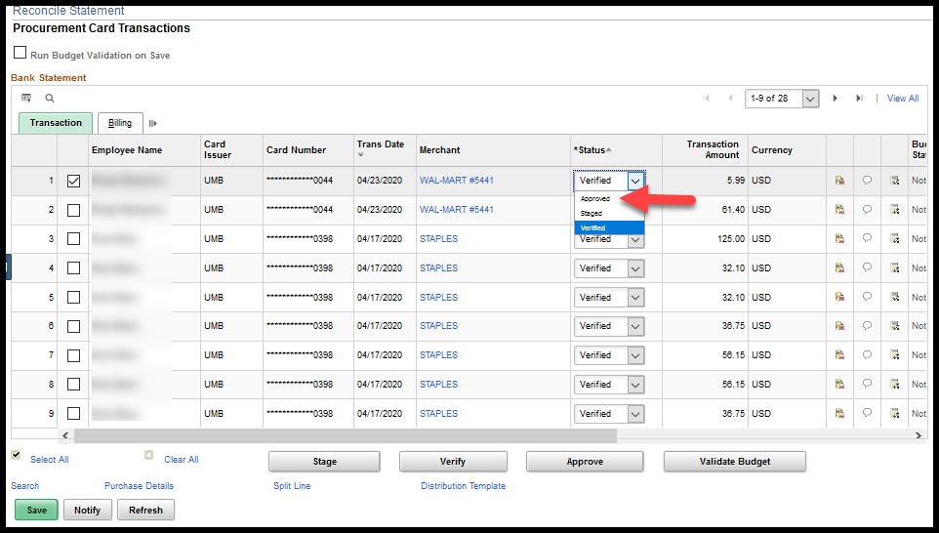
- Click the ‘Save’ button:
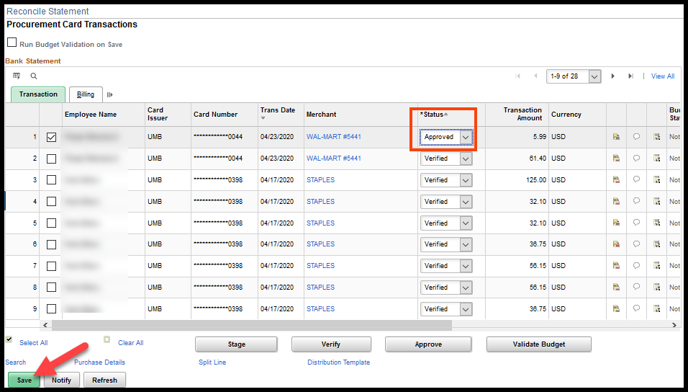
NOTE: If the chartfield information was changed, the ‘Budget Status’ will change from ‘Valid’ to ‘Not Chk’d’. The PCard budget validation process runs Monday through Friday evenings during the nightly batch processes. It is recommended that users allow the automated batch process to pick up the ‘Approved’ PCard transactions for budget validation.
+

PCard Vouchers

Building the PCard Voucher
Unlike regular vouchers, the PCard vouchers are created during a batch process. The PCard voucher build process runs twice a week, Monday and Thursday mornings, before the hourly batch processes begin for the day. The days may change if Monday or Thursday falls on a Holiday.
The PCard transaction will be picked up by the batch process and built to a PCard voucher if the status is ‘Approved’, the Budget status is ‘Valid’ and the Chartfield status is ‘Valid’.
The PCard vouchers are built by control account number and have a maximum of 75 lines. If there are more than 75 PCard transactions for a control account number, a second PCard voucher will be built.
Important!: If a credit is not approved at the same time as the charge for which it is offsetting it may not build to voucher. SMART will no longer allow negative vouchers to be created. If there is not a transaction amount approved for payment that offsets the credit amount and is associated to the same control account, the will remain on the Reconcile Statement page in Approved status until there is.
Important! The default funding information must be valid and active. If any required field in the default funding or the Speedchart becomes inactive, it MUST be updated, or it will prevent the reconciliation of transactions using the card. Contact your agency PCard Administrator to update default funding or submit a ManageEngine Service Desk Ticket.

PCard Voucher – Do Not Make Changes
Do NOT delete PCard vouchers and/or voucher lines. The deletion of a PCard voucher/line does NOT update the PCard transaction. Consequently, the PCard transaction retains a voucher/line that no longer exists in SMART. If a situation arises that requires the deletion of a voucher/line, please submit a SMART Service Desk Request.
Do NOT change quantities or amounts on PCard voucher lines. Changes made at the voucher level will NOT update the PCard transactions. Consequently, the PCard transactions may indicate that the transaction has been paid when it hasn’t been.

Voucher Build Errors
Since the PCard voucher is created during a batch process, it is possible (but not likely) for the PCard voucher to end up with a voucher build error. If an agency expects a PCard voucher but does not see one, please check the Voucher Build Error page. Go to the ‘Voucher Build Error Detail’ job aid for detailed information about this page and troubleshooting issues.

Match Exceptions
As a rule, PCard vouchers should not have match exceptions because SMART should turn off matching when the PCard is associated to the Purchase Order.
There are some instances where matching has not been turned off and match exceptions have occurred. An example of a typical match exception is the Supplier ID on the voucher does not match the Supplier ID on the PO. This match exception is expected since the payment is being made to the PCard Issuer, currently UMB, and not the Merchant.
Match exceptions can no longer be overridden by an agency. If a match exception occurs, the agency should submit a ManageEngine Service Desk Request.

Approving PCard Vouchers
PCard Vouchers are no different from regular vouchers when it comes to the approval process. The agency must review and approve the voucher.
For the voucher to be eligible for payment, the voucher must have an ‘Approved’ status, a ‘Valid’ budget status and a ‘No Match’ or ‘Matched’ match status. In most cases, the match status will be ‘No Match’.

Tips
Below please find a list of things to consider/remember. Included is a listing of PCard Queries.

Line Details Icon
The State of Kansas receives a file nightly from our PCard Issuer, currently UMB. This file contains the PCard transaction information that has been captured by the Merchants and provided to Visa which is in turn provided to the State of Kansas’ PCard Issuer (UMB). There are three levels of PCard data:
- Level 1 data: Standard transaction data including date, supplier and total purchase amount.
- Level 2 data: Enhanced transaction data including Level 1 data plus a customer-defined reference number, such as a Purchase Order number, and separate sales tax amount.
- Level 3 data: Detailed transaction data including Level 2 data plus line-item detail, such as the item purchased. Sometimes referred to as ‘line-item detail.’
SMART is set up to accept Level 3 data; however, not all Merchants are set up to collect Level 3 data.
To see the data being provided by the Merchant, click the ‘Line Details’ icon from the Reconcile Statement – Procurement Card Transactions’ page:
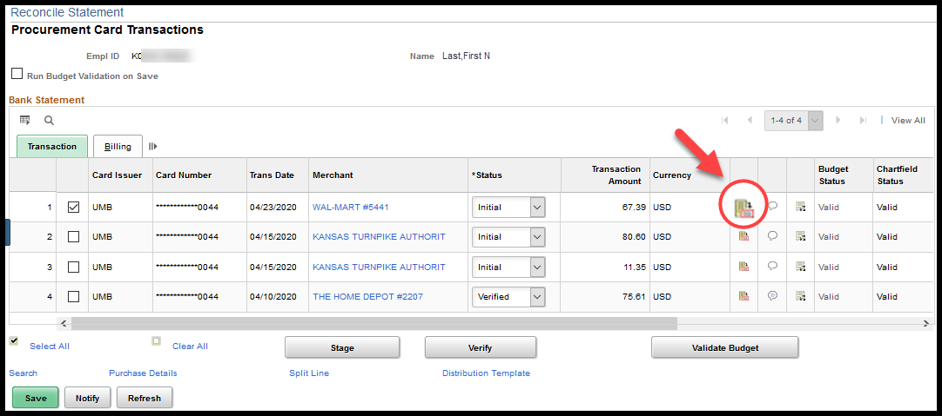
The PCard transaction number is displayed on this page. Whenever possible the PCard transaction number should be provided when entering a Service Desk Request:
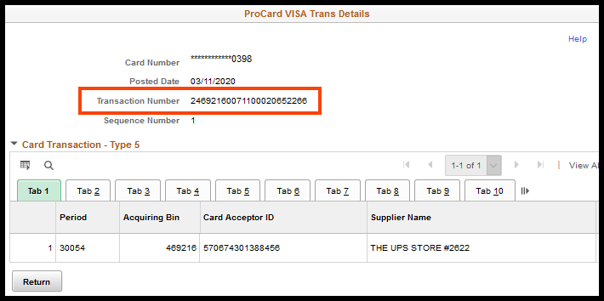
NOTE: The information available on the tabs for this page will vary depending on the type of PCard transaction being viewed.

Comments
- The Reconciler and/or Approver have the option of entering a comment on the PCard transaction by clicking the ‘Comments’ icon:
- Enter a comment or attach a document, and click the ‘OK’ button:
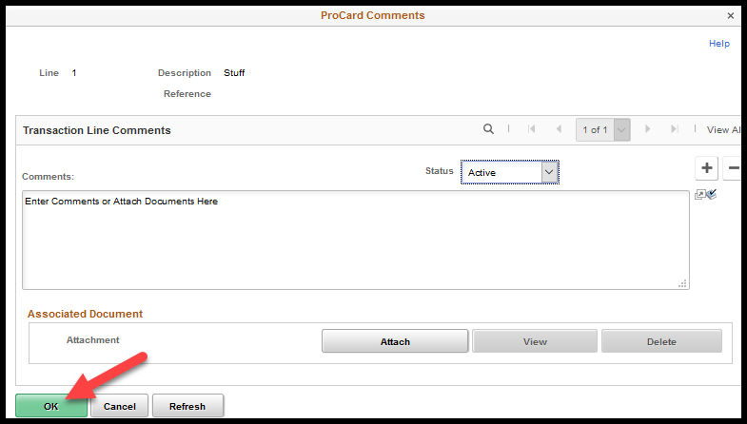
NOTE: Comments entered on the PCard transaction will only reside on the PCard transaction and will NOT copy to the PCard voucher.
NOTE: If a Purchase Order (PO) has comments and the PO is associated to a PCard transaction, the PCard transaction will NOT inherit the PO comments.

Budget Validation
The PCard Budget Validation process does NOT check for available budget. Budget validation only requires that a budget ledger be established with the specified fund and budget unit; it is not validating availability of funds.
If the chartfield information is altered, the Budget Status will change from ‘Valid’ to ‘Not Chk’d’. During the nightly batch processes, PCard transactions with an ‘Approved’ status and a ‘Not Chk’d’ budget status will be picked up and ran through budget validation.
The manual budget validation process takes several minutes to complete; consequently, the SMART team recommends that agencies allow the batch processes to pick up the ‘Not Chk’d’ PCard vouchers.
Important! The default funding information must be valid and active. If any required field in the default funding or the Speedchart becomes inactive, it MUST be updated, or it will prevent the reconciliation of transactions using the card. Contact your agency PCard Administrator to update default funding or submit a ManageEngine Service Desk Ticket.

PO is not available for selection
There are a couple reasons why a Purchase Order (PO) may not be available for selection when reconciling a PCard transaction:
- The PO must be in Dispatched status before it will be available; AND
- The PCard must be associated to the Purchase Order (PO).
NOTE: If a PCard is NEVER associated to a PO, ALL POs will be available for selection during the reconciliation process for that PCard. This makes it very easy to reconcile PCard transactions to incorrect POs. The SMART team highly recommends that agencies associate PCards to POs so that the POs available for selection during the reconciliation process are limited to only those POs associated to a selected PCard.

Unit Price – Calculated Field
The ‘Unit Price’ on the ‘Reconcile Statement – Purchase Details’ page is a calculated field. SMART divides the Transaction Amount by the Quantity to come up with the Unit Price.
This becomes important when a Purchase Order (PO) has a quantity greater than one (1) and the PCard transaction is only for a portion of the total quantity. When the PO and line are entered, the Reconciler will need to make sure that he also changes the quantity so that the correct Unit Price is calculated.
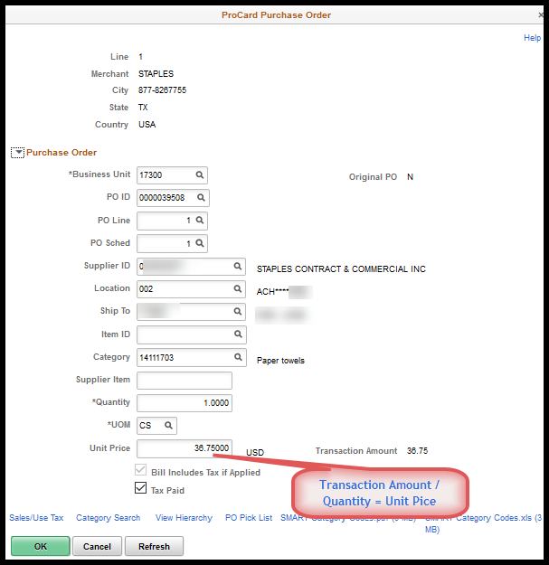

PCard Queries
Report / Query Name | Description | Navigation
KS_PO_PCARD_STATUS | This query will provide a listing of PCard transactions that are not in "Closed" status. | Reporting Tools -> Query -> Query Viewer
KS_PO_PCRD_STTS_BU | This query is designed to identify those PCard transactions, by Business Unit and Billing Date range, which have a status other than “Closed”. | Reporting Tools -> Query -> Query Viewer
KS_PO_PCRD_STTS_EMPLID | This query is designed to identify those PCard transactions, by Emplid and Billing Date range, which have a status other than “Closed”. The query provides information at the “Distribution Line” level so that chartfield information is included in the results. | Reporting Tools -> Query -> Query Viewer
KS_PO_PCRD_VCHR_DELETED | This query is designed to identify those PCard vouchers/lines that have been deleted. | Reporting Tools -> Query -> Query Viewer
KS_PO_PCRD_TO_VCHR_XREF | This query was designed to assist agencies in reconciling their monthly PCard bills.  This query will provide the PCard status and, if the status is “Closed”, will show the voucher ID and voucher line on which that PCard transaction was vouchered/paid. The query can be used to validate which PCard transactions have been vouchered/paid and which PCard transactions still need to be Verified and/or Approved for a specified period of time (i.e. Billing Cycle). | Reporting Tools -> Query -> Query Viewer
KS_PO_VCHR_TO_PCARD_XREF | This query will show the PCard transactions associated to a voucher | Reporting Tools -> Query -> Query Viewer
Bank Statement Inquiry | Review PCard bank statements. | Purchasing -> Procurement Cards -> Review Bank Statement
KS_PO_PCRD_EXPIRATION | This query was designed to provide the expiration dates for PCards associated to a specific Business Unit. | Reporting Tools -> Query -> Query Viewer
KS_PO_POWPCARD_NO_VCHR | This query is designed to provide a listing of Purchase Orders (POs) that have a PCard associated to them and a voucher has NOT been created against the PO. | Reporting Tools -> Query -> Query Viewer

