State of Kansas
Update Email Address
Statewide Human Resource and Payroll System

Date Created |  | 1/5/2022
Version |  | 1.0
System |  | Employee Self-Service
Description |  | Validate the address stored in Employee Self-Service (ESS) is your correct primary email address.
Navigation |  | https//sharp.sok.ks.gov/sokhrprdess/signon.html
1. | Enter your Employee ID and Password. Select Sign In.  If you do not remember your password, click on the Forgot Your Password? link. | 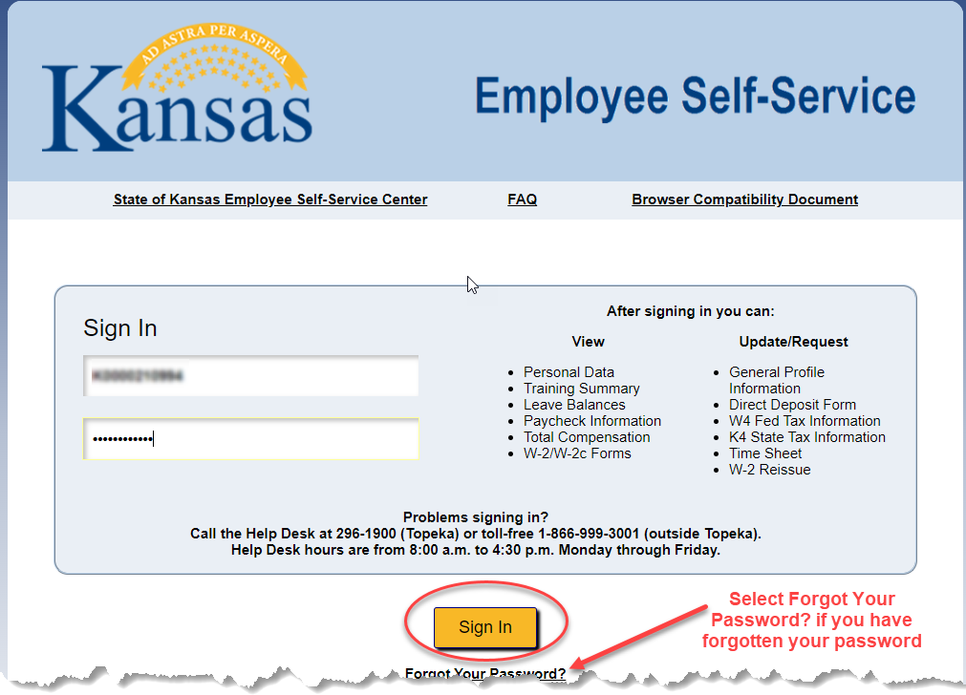
2. | Is the address listed in this box correct?  Yes? Stop. Nothing further to do.  No? Click on the tile. | 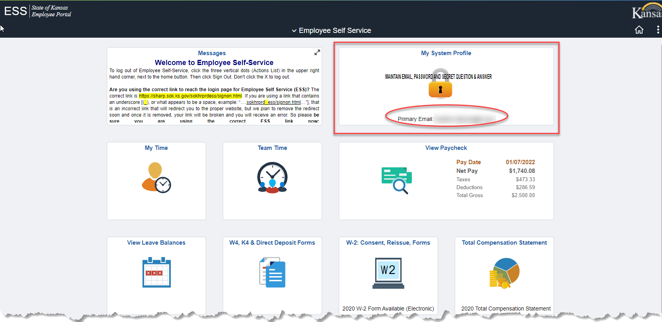
3. | Enter the correct Email Address  Save | 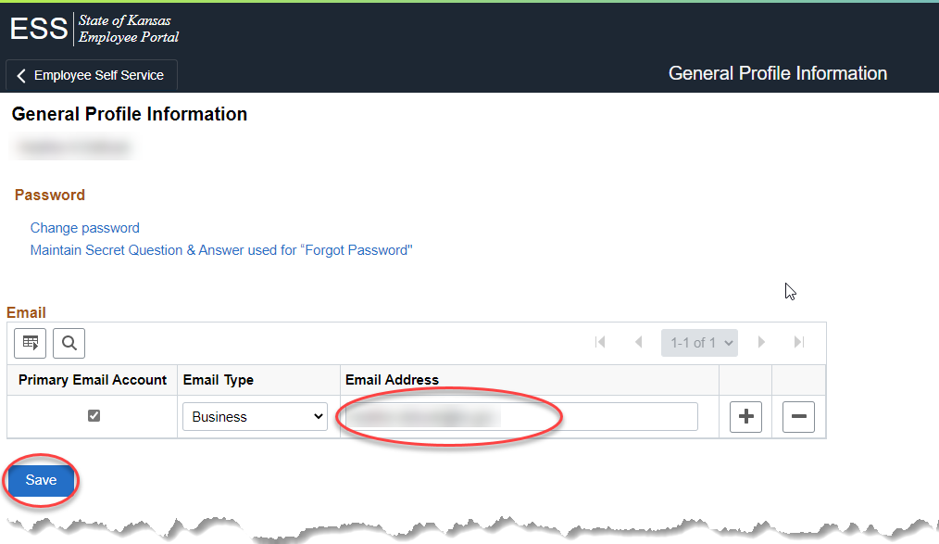
 | END OF PROCESS

