July 2022
SEFA Documentation Instructions

The Office of Management and Budget’s Uniform Grant Guidance (Uniform Administrative Requirements, Cost Principles, and Audit requirements for Federal Awards) requires the preparation of the annual Schedule of Expenditures of Federal Awards (SEFA). The preparation of the SEFA is the responsibility of the State of Kansas (the auditee). Clifton, Larson & Allen, LLP (CLA) will continue to perform the single audit for the State of Kansas for state fiscal year 2022, while the Office of Accounts and Reports (OAR) is responsible for coordinating and compiling the SEFA data.
The Agency Certification, the FY 2022 DA-89 Form, and the SEFA Documentation Instructions below are available for download from the Department of Administration’s website here.
All agencies must submit the Agency Certification form, signed by the agency’s Chief Fiscal Officer, to confirm if federal funds were or were not expended in FY2022. All agencies with federal expenditures in FY2022, must complete the SEFA Form DA-89.
Save the 2022 DA-89 file using the agency number, fiscal year, and SEFA as the file name (e.g., Department for Children and Families will use the file name 629 22 SEFA.xls). Input the data to the 2022 DA-89 using the instructions below. Save and send executed SEFA certification and final DA-89 file (if required) via email to: federal.reporting@ks.gov no later than August 15, 2022. It is imperative that this date is met to allow sufficient time to perform and submit the audit by the federal deadline.
Please direct questions to federal.reporting@ks.gov or call either Gayla Carr Schmitz at 785-296-8668 or Jill Martin at 785-296-2909.

Table of Contents
Agency Certification Document 4
DA89 Form 5
Contact Information 5
SEFA Data Tab Columns 5
Column A – ARRA, COVID or Neither 5
Column B - Subject to the Uniform Grant Guidance 6
Column C - SMART Fund Number(s) 7
Column D - ALN/CFDA Number 7
Column E - Grant or Contract Number (Indirect Grants or Grants with a generic ALN/CFDA Number) 7
Column F - Federal Awarding Agency 8
Column G - Cluster 8
Column H - Official Federal (ALN/CFDA) Program Title 8
Column I - Title Provided in Program/Grant Documents (Indirect Grants, generic ALN/CFDA Number, ALN/CFDA Number is not in catalog) 8
Column J - Research and Development Grants 9
Column K – Source of Funding 9
Column L – Agency Number 10
Column M – Agency Name 10
Column N – Indirect Grants 10
Column O – FY Total Expenditures of Federal Funds 10
Column P – Amounts Transferred to other State Agencies 11
Column Q – Amounts Expended as Pass Through to Sub-recipients 11
Additional Tips for Reporting Expenditures 11
Received federal awards directly from a federal grantor: 11
Received federal awards from another State agency: 11
Received federal awards both directly from the Federal Government and as a Transfer from another State agency 12
Audit Inquiries Columns 12
Column R – Was the program new in FY22? 12
Column S – Were any instances of fraud noted by management related to this program? 12
Column T – Were regulatory or Federal agency reviews performed during FY21 for the program? 12
Column U – Correction needed in Column N 12
Column V – Correction needed in Column L 13
Column W – Correction needed in Column D 13
Column X – Correction needed in Column O 13
Column Y – Correction needed in Column O 13
Column Z – Correction needed in Column A 13
Indirect Cost Tab 14
Column A – ALN/CFDA Number 14
Column B – SMART Fund Number 14
Column C – Account Number (SMART Transaction Code) 14
Column D – Indirect Cost Amount 14
Transfer In Tab 15
Column A – Agency Number 15
Column B – Agency Name 15
Column C – Amount 15
Column D – SMART Fund Number Receipted Into 15
Column E – ALN/CFDA Number 15
Column F – ALN/CFDA Program Title 15
Transfer Out Tab 16
Column A – Agency Number 16
Column B – Agency Name 16
Column C – Transfer Amount 16
Column D – SMART Fund Number Transferred From 16
Column E – ALN/CFDA Number 16
Column F – ALN/CFDA Program Title 16

Agency Certification Document
- All Agencies must complete this document regardless if you will be completing a DA89 spreadsheet.
- Select and check box indicating if Federal funds were expended or not.
- Complete the agency name and agency number sections of the document.
- Provide telephone number and email address of the agency’s Chief Fiscal Officer.
- Obtain signature of the agency’s Chief Fiscal Officer.

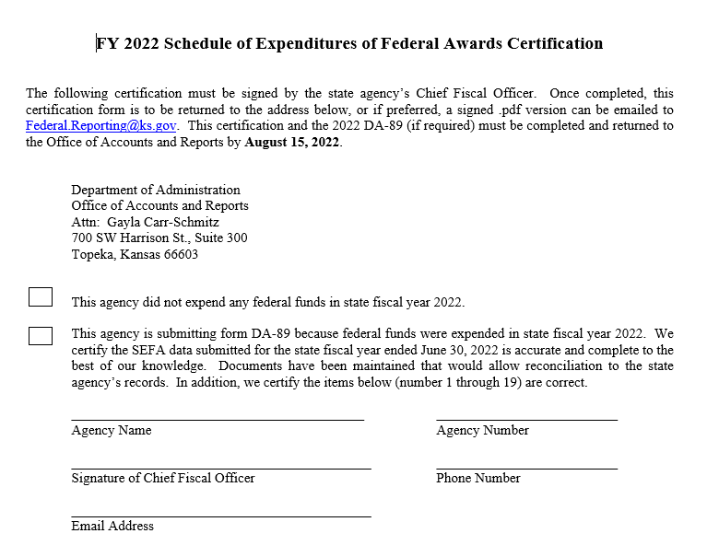

DA89 Form

Contact Information
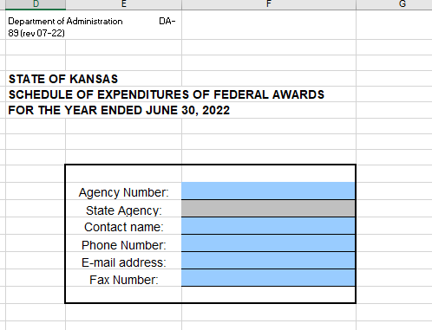
- On the SEFA Data tab, you will find the above blank box that needs to be completed by you.
- The contact information is needed to resolve any issues or answer any questions on what was reported.
- Please make sure to include:
  - Primary contact name for the individual who completed the DA89
  - Agency name and number
  - Phone number of the primary contact
  - Email address of the primary contact

SEFA Data Tab Columns

Column A – ARRA, COVID or Neither
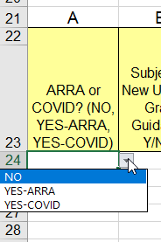

- This column was changed in FY2020 to include COVID-19 (Coronavirus Relief Funds) alongside ARRA (American Recovery and Reinvestment Act)
- Please select one of the options from the drop-down menu either, No, Yes-ARRA, or Yes-COVID, based on the type of funds.
- Select Yes-COVID for any COVID funding/grants expended during FY2022. Please note that ALN/CFDA 21.019 (CRF) and ALN/CFDA 21.027 (ARPA) should always be marked as Yes-COVID.
- Make sure you list ARRA and COVID expenditures separately from non-ARRA or non-COVID expenditures if your ALN/CFDA contains both.
- There is not a separate designation for ARPA funds, so please make sure you do not accidentally select Yes-ARRA for ARPA funds.
- This column should be answered for each Federal award, regardless of funding source.

Column B - Subject to the Uniform Grant Guidance
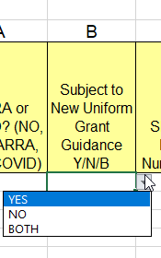

- This column should be answered for each Federal award, regardless of funding source.
- Review grant documentation to determine if the grant is subject to old or new guidance.
- Enter “Y” for Yes, “N” for No or “B” for Both in Column B.
- As a general rule, awards made after December 26, 2014 will be subject to the new Uniform Grant Guidance. Incremental funding of grants in existence prior to December 26, 2014 could be subject to either old or new guidance.
- Please note Part 8 Appendix I of the Compliance Supplement lists out the programs which are excluded from portions of the Uniform Guidance.
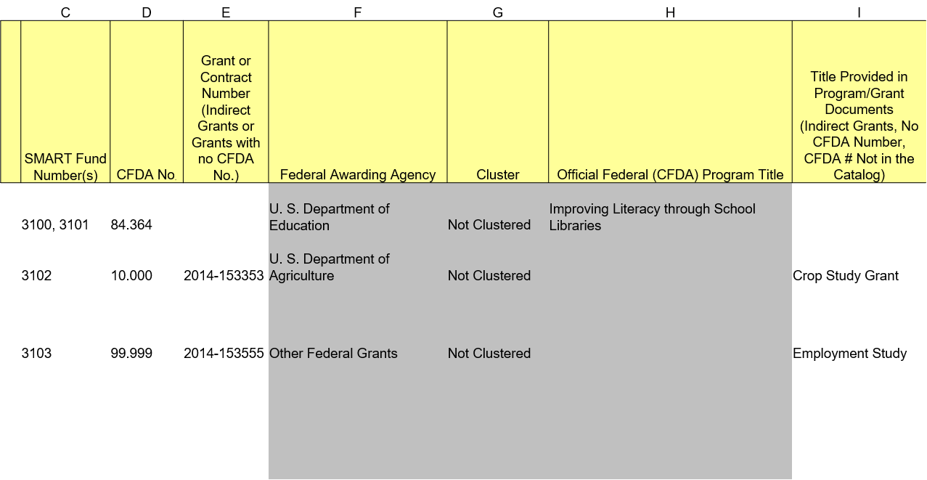
Refer to this example for Columns C through I.

Column C - SMART Fund Number(s)
- In this column you will enter the four-digit SMART fund number
- This field is required for all monetary awards
- If there is more than one SMART fund number, enter each SMART fund associated with the ALN/CFDA number and separate them with a comma and a space.
  - For example:
    - 3155, 3206, 3318

Column D – ALN/CFDA Number
- Enter ALN/CFDA Number in this column.
- If the ALN/CFDA number is in the table, the Federal Awarding Agency, Cluster, and Official Program Title (Columns F, G, and H) fields will automatically populate.
- For generic ALN/CFDA numbers, enter the Federal Awarding Agency number followed by .000 as the ALN/CFDA number (10.000). The Federal Awarding Agency and Cluster (Columns F and G) will populate, but entry for Grant or Contract Numbers and Program Title (Columns E and I) will need to be made.
- If the ALN/CFDA number or Federal Awarding Agency is not known, enter 99.999 as the ALN/CFDA number. Entry will also need to be made in Columns E and I.
- If you need to look up the ALN/CFDA number, please refer to the list of the federal agency numbers at the following website: SAM.gov | Home.

Column E - Grant or Contract Number (Indirect Grants or Grants with a generic ALN/CFDA Number)
- Provide program identifying number as assigned by the non-federal grantor for indirect awards
  - Or the award number
  - Or the contract number if the ALN/CFDA number is not available
- This is a required entry for Indirect awards and awards with Generic ALN/CFDA numbers.
- If the identifying numbers from the non-federal grantor are not provided, the federal government may reject the state’s Schedule of Expenditures of Federal Awards.

Column F - Federal Awarding Agency
- This column will auto populate based on what is entered in Column D, ALN/CFDA Number.
- Federal agency information can be viewed at www.usa.gov.
- Please do not type over the prepopulated data.

Column G - Cluster
- This column will auto populate based on what is entered in Column D, ALN/CFDA Number.
- For more information on clusters, refer to the 2022 Compliance Supplement found at www.whitehouse.gov/omb.
- Please do not type over the prepopulated data.

Column H - Official Federal (ALN/CFDA) Program Title
- This column will auto populate based on what is entered in Column D, ALN/CFDA Number.
- Please do not type over the prepopulated data.
- If data does not prepopulate in column H, use column I to manually enter Program Title.

Column I - Title Provided in Program/Grant Documents (Indirect Grants, generic ALN/CFDA Number, ALN/CFDA Number is not in catalog)
- The title needed here is usually found in the grant award document.
- Do not use abbreviations or acronyms.
- This is a required entry for awards with generic ALN/CFDA numbers and if column F does not pre-populate

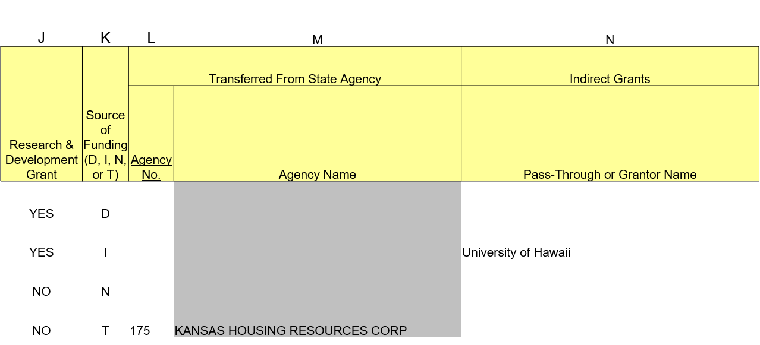
Refer to this example for Columns J through N.

Column J - Research and Development Grants
- Enter either Yes or No, for each award, to record if the award is a Research and Development grant or not.
- Does the grant have both R&D and Operations components?
  - If Yes, then you will need to break it out and list it on two lines.
    - R&D will get its own line for reporting.
    - Operations will get its own line for reporting.
  - If No, then just report it on one line.

Column K – Source of Funding
- Enter one of the following codes to indicate the source of the award in this column:
  - D – Direct- An award received directly from a Federal Agency
    - With a direct grant, you must complete columns A, B, C, D, F (auto populates), G (auto populates), H (auto populates), J, K, O, R, S, and T.
    - Do not complete columns E, I, L, M or N if direct award.
    - Columns P and Q should be used as is appropriate for transfers of funds to subrecipients
  - I – Indirect-An award received from a Non-Federal Agency
      - Non-Profits
      - Local Unit of Government
      - Another State Government
      - University (non-State Agency)
    - With an Indirect Grant, you must complete Columns A, B, C, D, E (Grant or Contract Number), J, K, N (Pass-Through or Grantors Name), O, R, S, and T.
    - If a generic CFDA number is used, please also enter a title in Column I.
    - Do not complete columns L or M if indirect award.
    - Columns P and Q should be used as is appropriate for transfers of funds to subrecipients.
  - N – Non-monetary awards including commodities, property and equipment, food stamps, and vaccines (received directly from a federal agency or from another state agency)
    - For non-monetary awards received directly from a Federal agency, columns A, B, D, F, G, H, J, K, O, R, S, and T must be completed.
    - Do not complete columns C, E, I, L, M, or N if non-monetary award.
    - All federal non-cash assistance should be valued at fair market value at the time of the receipt, or the assessed value provided by the federal agency.
    - Columns P and Q should be used as is appropriate for transfers of non-monetary goods or services to subrecipients.
  - T – Transfer awards received from another state agency (received as a sub-recipient).
    - For transfers from another state agency, where you are not considered a contractor, columns A, B, C, D, F, G, H J, K, L (Agency Number) M (Agency Name), O, R, S, and T must be completed.
    - Select the agency number from the drop-down box in Column L and Column M will populate automatically.
    - Do not complete columns E, I, or N if transfer award.
    - Columns P and Q should be used as is appropriate for transfers of funds to subrecipients.

Column L – Agency Number
- Please select the agency number from the dropdown list from which you received Federal funds.
- For Transfer awards, this is a required field and must be completed.
- For all other funding types, this field is not required.

Column M – Agency Name
- For Transfer awards, this column will auto populate based on what you select in Column L, Agency Number.
- Please do not type over the prepopulated data.
- For all other funding types, this field is not required

Column N – Indirect Grants
- Grantor Name
  - For Indirect awards, the non-federal grantor name will be the name of the organization from which you received Federal funds.
- Enter the full name of the awarding entity.
  - Do not abbreviate, the full name is needed.
- For indirect awards, this is a required field and must be completed.
- This field is not required for direct awards, non-monetary awards, or transfer awards.

Refer to this example for Columns O through T.
O | P | Q | R | S | T
 |  |  | Audit Inquiries
FY 2022 Total Expenditures of Federal Funds (dollar rounded) | Amount Sub-granted to State Agencies | Amount Expended as Pass-through to a Subrecipient* (Non-State Entity). | Was this a New Program for FY 2022? | Any Instances of Fraud Noted by Management Related to This Program? | Any Regulatory or Federal Agency Reviews Performed During FY 2022 for This Program?

Column O – FY Total Expenditures of Federal Funds
- Record the total Federal share of project expenditures, including amounts transferred to other state agencies or amounts passed through to sub-recipients.
- Both old and new guidance provide that expenses are to be offset by:
  - Purchase discounts
  - Rebates or allowances
  - Recoveries or indemnities on losses
  - Insurance refunds or rebates
  - Adjustments of overpayments or erroneous charges.
- Do not include encumbrances.
- All amounts must be rounded to the nearest whole dollar.
  - Do not include cents. This field must be a whole dollar.
- This is a required field.
- Please note: We will reconcile the amount entered in column O to what is reported in SMART. Please verify the amounts reported in this column (by fund number) reconciles to what is in SMART (when applicable). If they do not reconcile, please provide us with an explanation.
  - Reminders:
    - If using Federal funds to pay another state agency for goods or services pursuant to a contractor relationship, report as an expenditure only, not as a transfer out.
    - If receiving Federal funds from another state agency through a contactor (not sub recipient) relationship, do not report these on the SEFA as this would result in an overstatement of expenditures.

Column P – Amounts Transferred to other State Agencies
- Provide the amount of expenditures reported in Column O that represents transfers to other state agencies in a subrecipient relationship.
- Do not include expenditures made pursuant to a contractor (vendor) relationship.

Column Q – Amounts Expended as Pass-Through to Subrecipients
- Provide the amount of expenditures reported in Column O that represents amounts sub-granted to non-State entities. (The State of Kansas uses the 55xxxx account code series for payments to subrecipients. This does not include account codes beginning with 555xxx, which are payments to beneficiaries.)
- Do not include expenditures made pursuant to a contractor (vendor) relationship.
- Do not include payments made to beneficiaries. Beneficiaries are the end users of assistance. Examples include payments to recipients of scholarships, housing/food assistance, medical benefits (including Medical claim/MCO payments). (The State of Kansas uses the 555xxx account code series for payments to beneficiaries.)
- Consult the “Subrecipient, Beneficiary, or Contractor Classification Checklist” for the definitions of subrecipient, beneficiary, and contractor/vendor if there are questions about the classifications. (The checklist can be found here: Subrecipient-Beneficiary-or-Contractor-Checklist-rev.-Feb-2022-1.pdf (ks.gov).)

Additional Tips for Reporting Expenditures

Received federal awards directly from a federal grantor:
- If your agency received federal awards directly from a federal grantor, expenditures may have included payment to sub-recipients who are local or non-profit organizations or may have included transfers to other State agencies.
- Report all of these as expenditures in Column O and provide the “sub-granted” amounts in Column P and Column Q as appropriate.
- Enter a “D” for Direct in the funding source column.

Received federal awards from another State agency:
- If your agency received federal awards from another State agency, report all of these expenditures in Column O and enter a “T” for Transfer in the funding source column.
- If the monies received by your agency are sub-granted to another State agency, report those amounts in Column P.

Received federal awards both directly from the Federal Government and as a Transfer from another State agency
- If your agency received federal awards both directly from the Federal Government and as a Transfer from another state agency, report these expenditures on a separate line for each grantor.

Audit Inquiries Columns

Column R – Was the program new in FY22?
- Select either “Yes” or “No” from the dropdown.
- This is a required field.

Column S – Were any instances of fraud noted by management related to this program?
- Select either “Yes” or “No” from the dropdown.
- This is a required field.

Column T – Were regulatory or Federal agency reviews performed during FY22 for the program?
- Select either “Yes” or “No” from the dropdown.
- This is a required field.
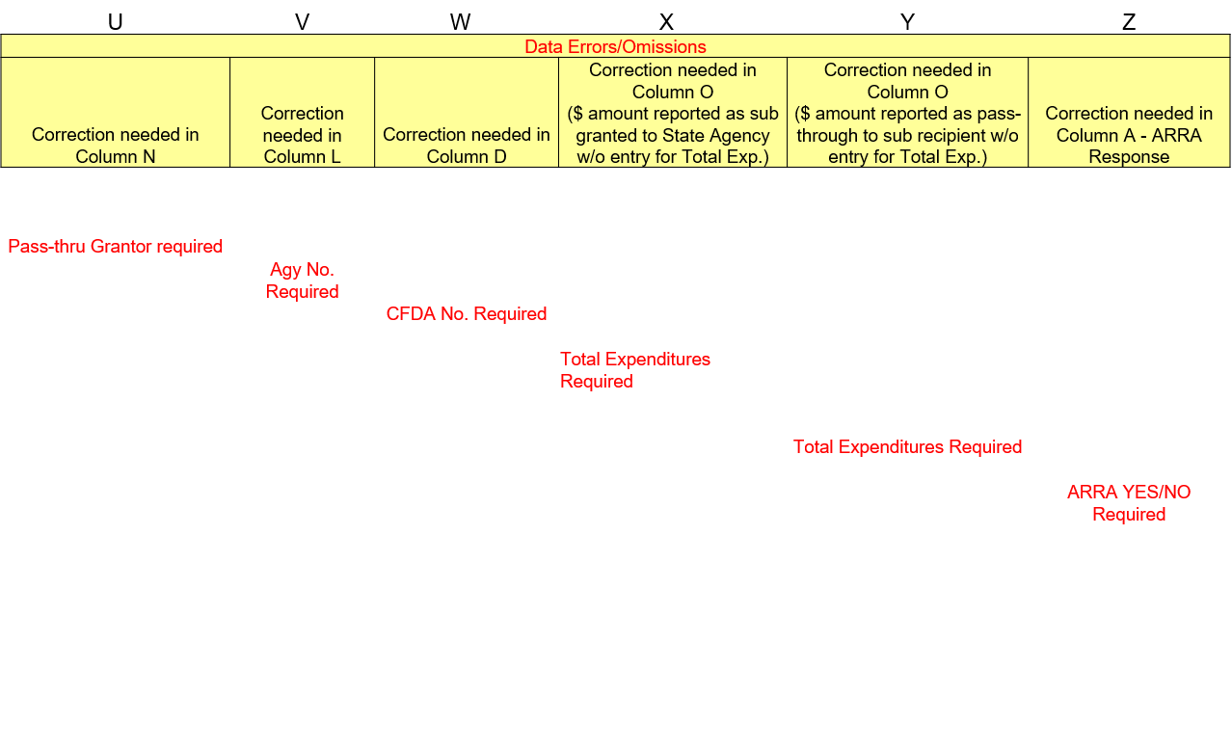
Refer to this example for Columns U through Z.

Column U – Correction needed in Column N
- You will see in red, “Pass-thru Grantor required” if there is an error.
- This happened because the source of funding is coded as I (indirect), but Column N, Pass Through or Grantor name was left blank.
- Please go back and fix Column N by entering the name.
- The column should be blank.

Column V – Correction needed in Column L
- You will see in red, “Agy No. Required” if there is an error.
- This happened because the source of funding is coded as T (transfer), but there is not an entry in Column L (Agency Number).
- Please go back and fix Column L by selecting the Agency Number.
- The column should be blank.

Column W – Correction needed in Column D
- You will see in red, “ALN/CFDA No. Required” if there is an error.
- This happened because Column D, ALN/CFDA No. was left blank.
- Please go back and fix Column D by entering the ALN/CFDA number.
  - If the ALN/CFDA number is not known, but the Federal awarding agency is known, enter the Federal awarding agency number followed by three zeroes.
    - 10.000
  - If both the ALN/CFDA number and Federal awarding agency is not known, enter 99.999 in Column D, ALN/CFDA no.
- The column should be blank.

Column X – Correction needed in Column O
- You will see in red, “Total Expenditures Required” if there is an error.
- This happened because Column P has an amount reported as being sub-granted to another State agency, but there is no entry in Column O, Total Expenditures of Federal Funds.
- Please go back and fix Column O by entering an amount.
- The column should be blank.

Column Y – Correction needed in Column O
- You will see in red, “Total Expenditures Required” if there is an error.
- This happened because Column Q has an amount reported as being sub-granted to a sub-recipient, but there is no entry in Column O, Total Expenditures of Federal Funds.
- Please go back and fix Column O by entering an amount.
- The column should be blank.

Column Z – Correction needed in Column A
- You will see in red, “ARRA YES/NO Required” if there is an error.
- This happened because Column A, ARRA or COVID was left blank and needs to be completed.
- Please go back and fix Column A by select a response from the dropdown in Column A.
- The column should be blank.

Indirect Cost Tab

Indirect Costs
 |  |  |  |  | Yes or No
Did your agency incur any indirect costs for federal grants during FY 2022?
If yes, please complete columns below for each CFDA number with indirect costs.
Note: Indirect cost amounts for each CFDA below should be included in the total expenditures column (O) on the SEFA Data tab.
CFDA Number | SMART Fund Number | Account Number (SMART Transaction Code) | Indirect Cost Amount
93.778 | 3418 | 773200 | 100,000

- This tab was added in FY19 and is to be completed for all agencies.
- Any agency that incurred indirect costs and were reimbursed federal dollars for these costs for FYxx would mark “Yes” and would complete the additional information on the tab. If your agency did not incur any indirect costs for FY2022, then your agency would mark “No” and would not complete the rest of the tab.
- Some agencies are not able to split out the indirect cost amounts by account code due to having a cost allocation plan in place. For these agencies, we are just requesting the CFDA/ALN numbers of those programs which incurred indirect costs for the fiscal year.

Column A – CFDA Number
- Enter the ALN/CFDA number which incurred the indirect costs.

Column B – SMART Fund Number
- Enter the SMART fund number that the indirect costs were paid out of.

Column C – Account Number (SMART Transaction Code)
- Enter the account number used to make the transaction.
- In most cases will be 773200.

Column D – Indirect Cost Amount
- Enter the total Indirect cost amount for the CFDA entered in Column A.

Transfer In Tab

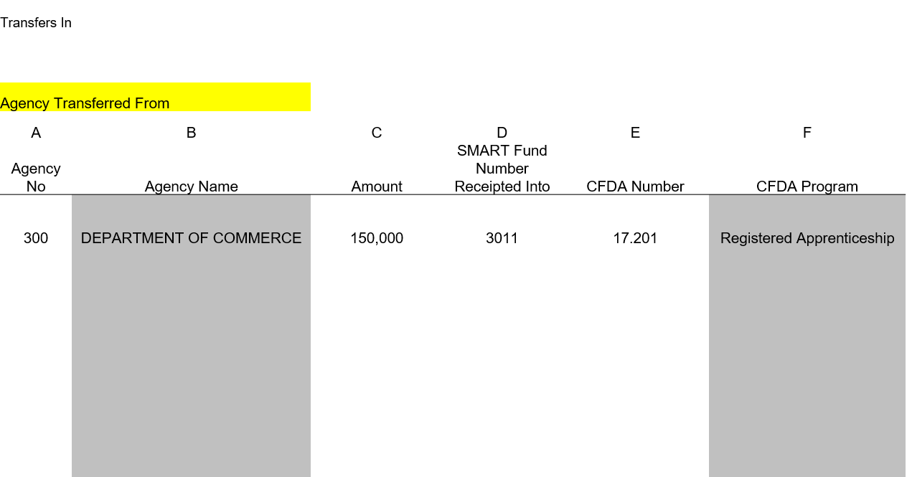
Column A – Agency Number
- Select from the dropdown list the State agency from which the Federal funds are being received.

Column B – Agency Name
- This field will auto populate based on the entry in Column A.
- Please do not type over the prepopulated data.

Column C – Amount
- Enter the total Federal dollars transferred into the fund.
- The amount can be different than the amount recorded on the SEFA Data Tab, which represents Federal awards Expended.

Column D – SMART Fund Number Receipted Into
- Record the SMART fund number in which the transferred monies were deposited.
- If receipted into more than one SMART fund, enter each fund in the field with a comma and space after each number.
  - For example:
    - 3011, 3765

Column E – CFDA Number
- Record the ALN/CFDA number of the Federal award being transferred in.

Column F – CFDA Program Title
- If the ALN/CFDA number recorded in Column E is in the table, the column will auto populate.

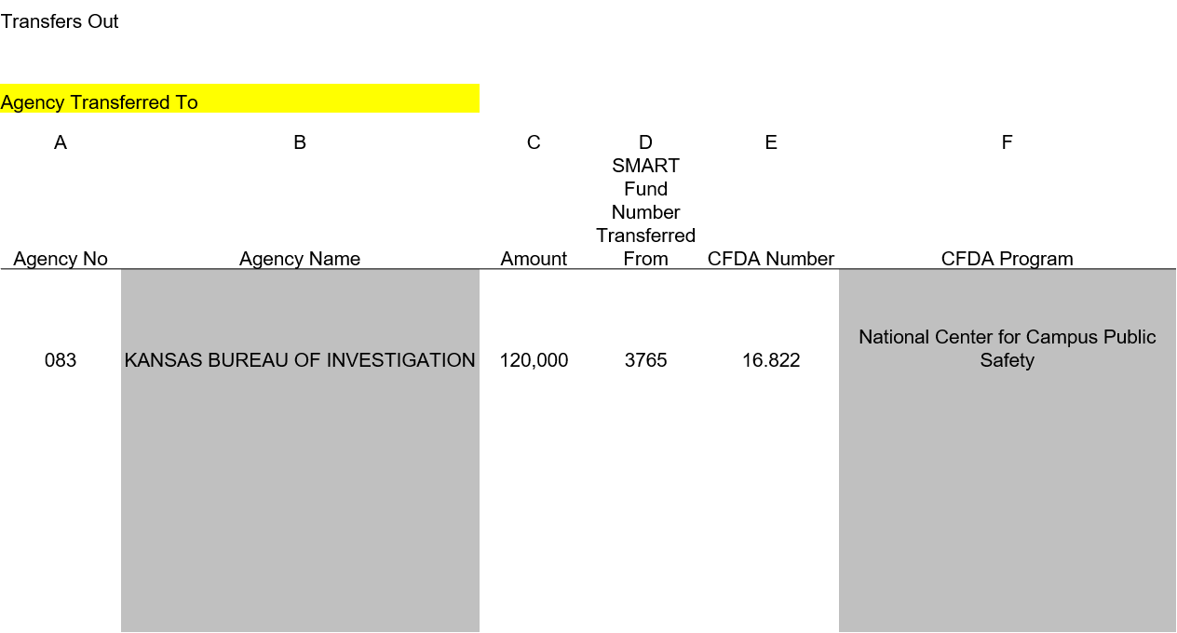
Transfer Out Tab

Column A – Agency Number
- Select from the dropdown list the State agency to which the Federal funds are being transferred to.

Column B – Agency Name
- This field will auto populate based on the entry in Column A.
- Please do not type over the prepopulated data.

Column C – Transfer Amount
- Enter the total Federal dollars transferred out of the fund.

Column D – SMART Fund Number Transferred From
- Record the SMART fund number from which the monies were transferred.

Column E – ALN (Assistance Listing)/CFDA Number
- Record the ALN/CFDA number of the Federal award being transferred to.

Column F – ALN/CFDA Program Title
- If the ALN/CFDA number recorded in Column E is in the table, the column will auto populate.

