State of Kansas
Electronic W2 Consent
Statewide Human Resource and Payroll System

Date Created |  | 1/5/2022
Version |  | 1.0
System |  | Employee Self-Service
Description |  | Completing these steps will allow you to receive your W2, electronically, through Employee Self-Service (ESS). Once consent has been completed, that consent will remain in effect until one of the following events have occurred:  - Consent is Withdrawn  - Retirement  - Termination of Employment  - Death
Navigation |  | https//sharp.sok.ks.gov/sokhrprdess/signon.html
1. | Enter your Employee ID and Password. Select Sign In.  If you do not remember your password, click on the Forgot Your Password? link. | 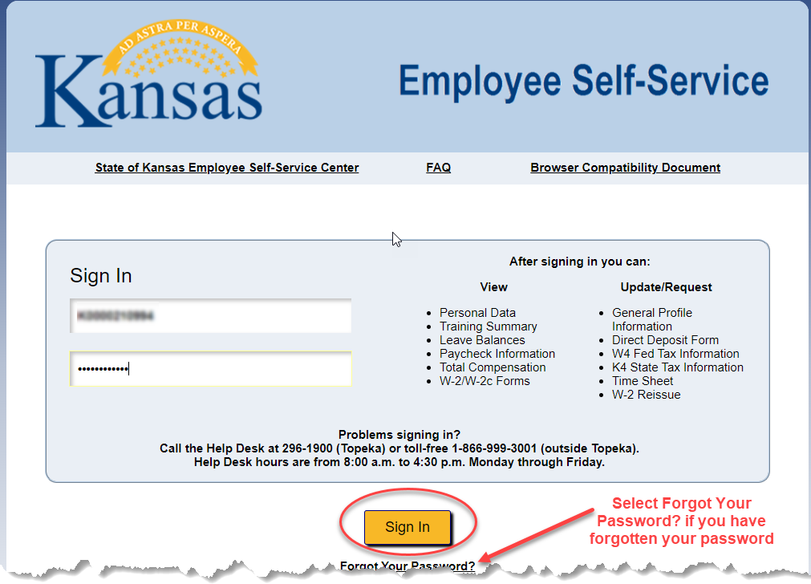
2. | Select the W-2 Consent, Reissue, Forms tile.  (The tile will note the most recent year available.) | 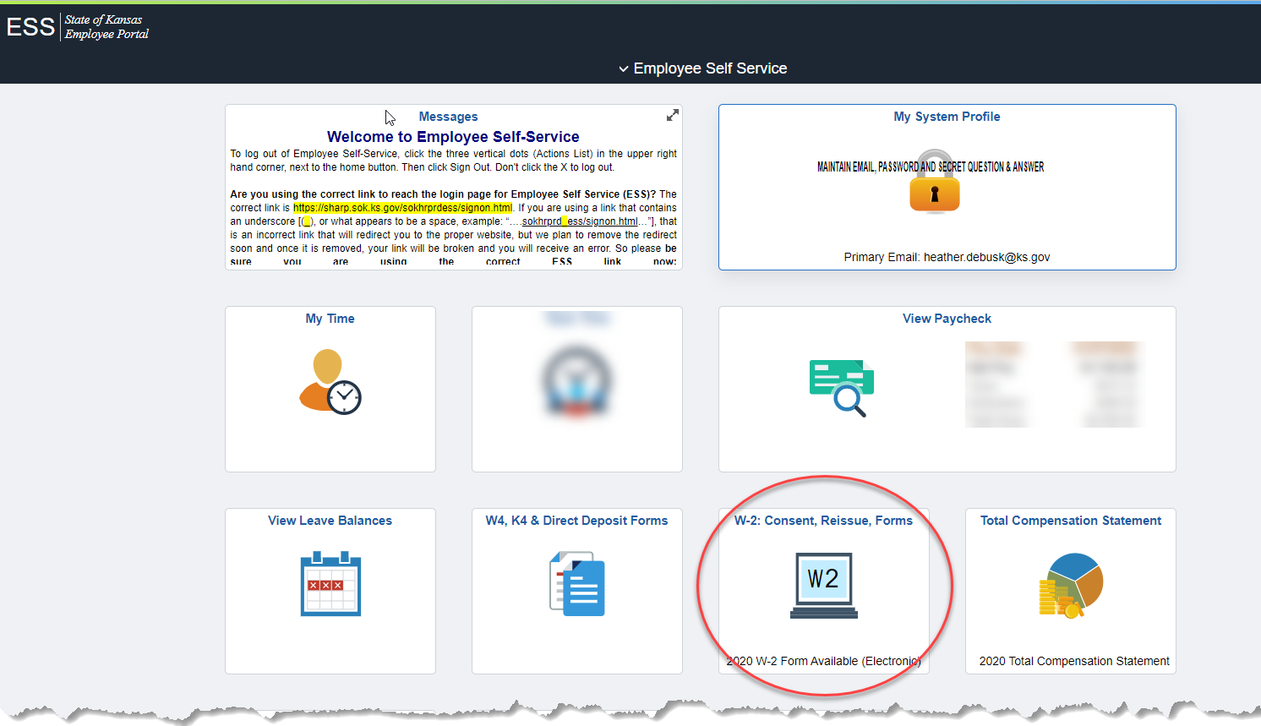
3. | Select the I consent to receive W-2 or W-2c forms electronically box  Select Submit  Enter your Employee ID as the User ID and enter your Password.  Continue | 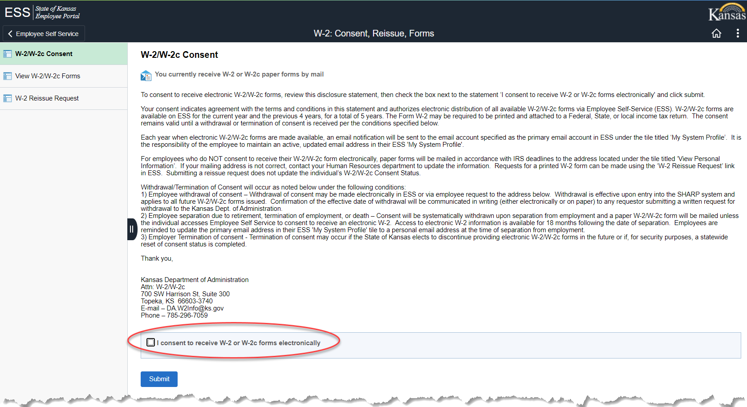  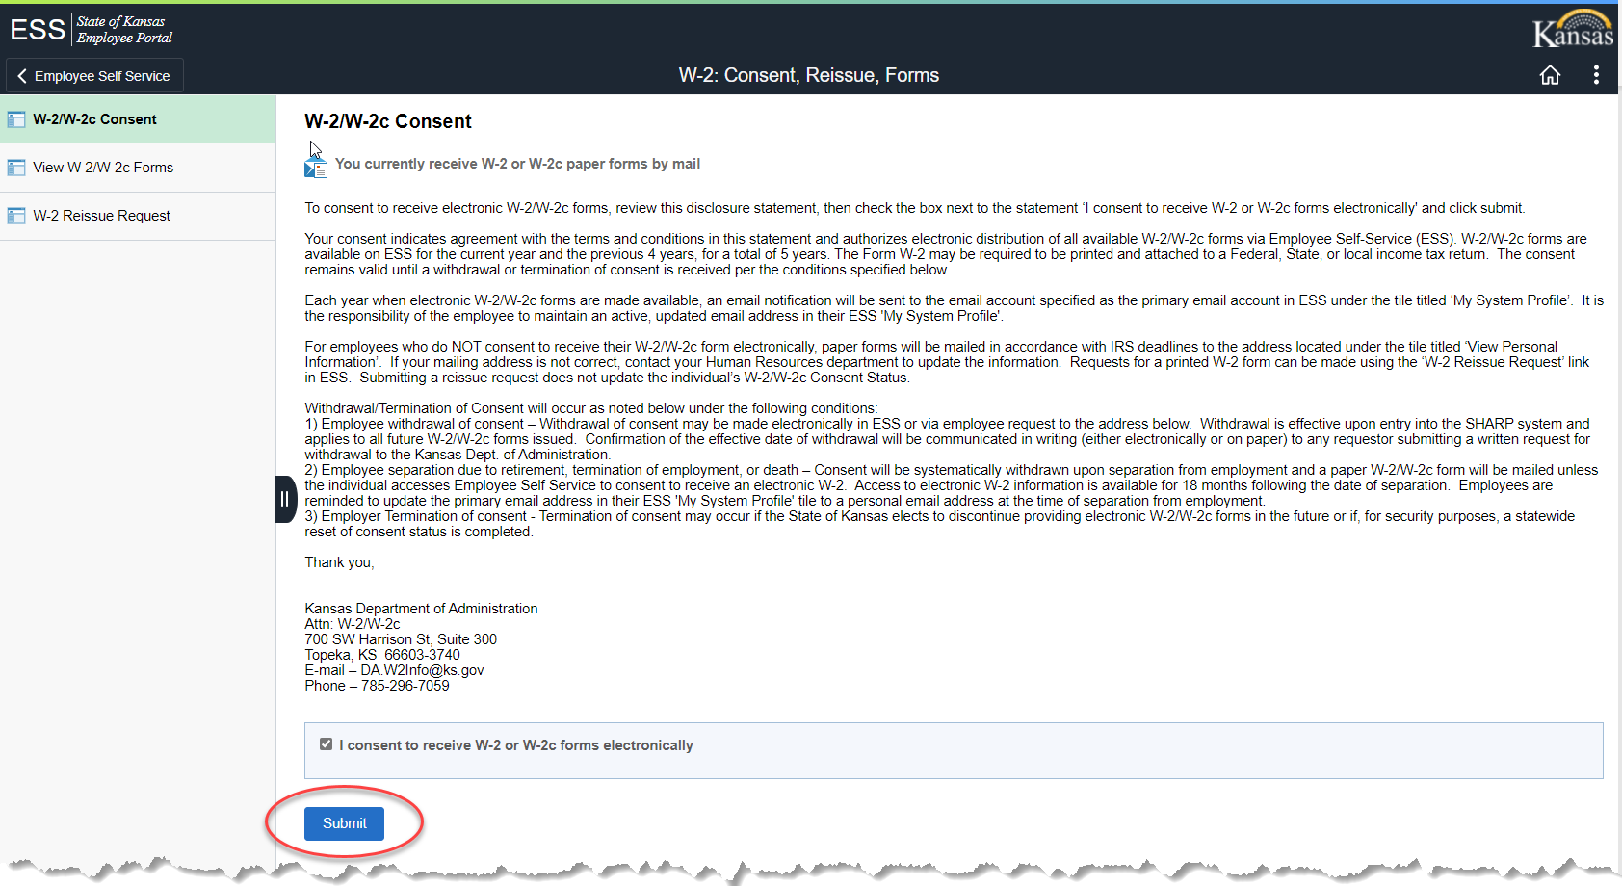  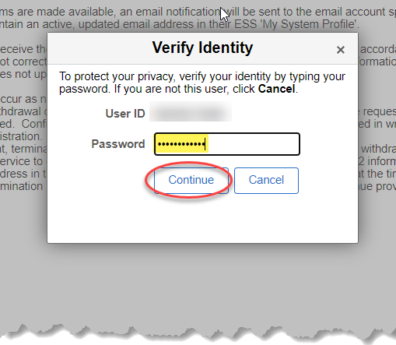
4. | W-2 will be delivered electronically. | 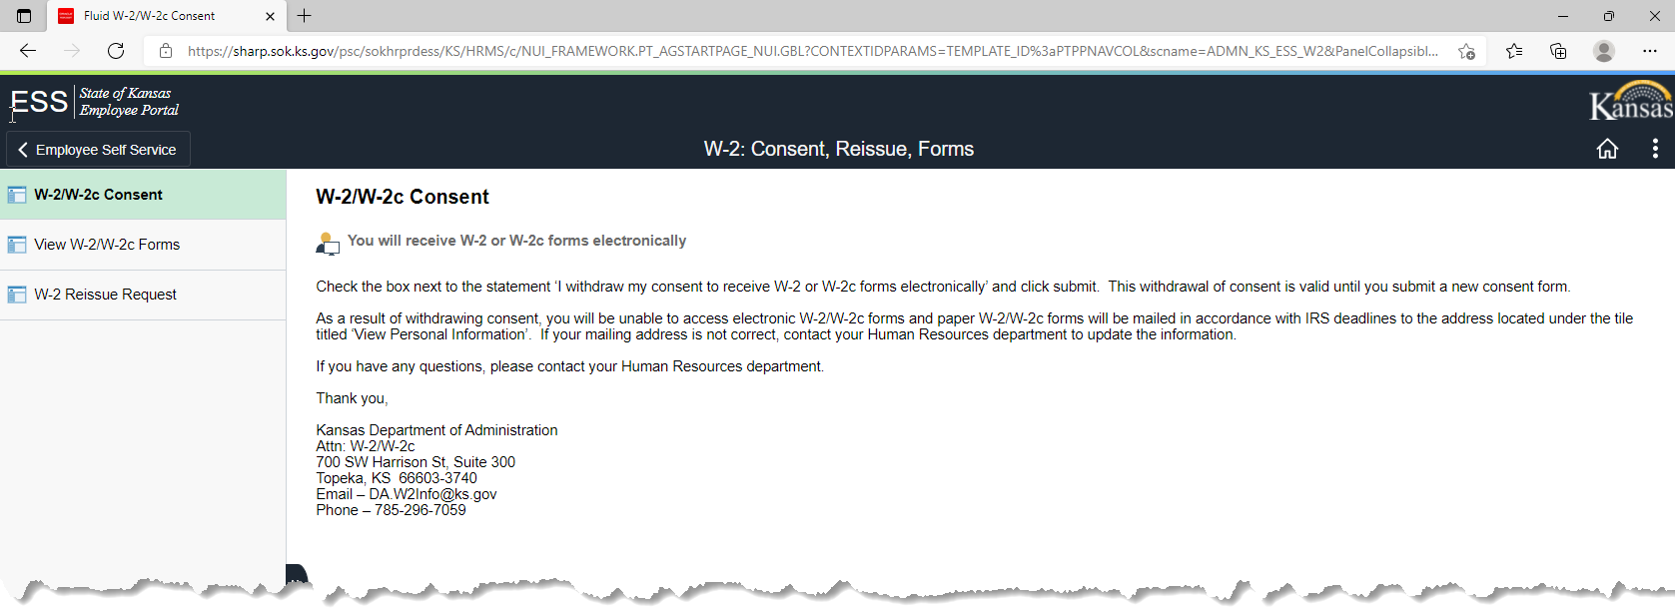
Additional Information |  | Consent can be withdrawn by following the process above. The statement in Step 3 will now show I withdraw my consent  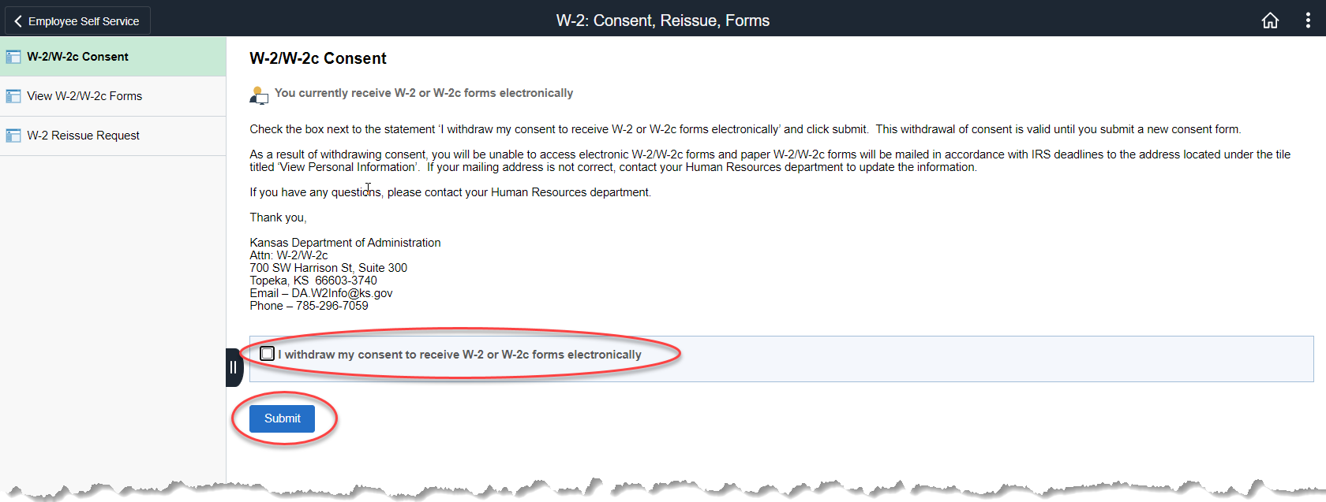  Follow Steps 3 and 4 above to withdraw consent.
 | END OF PROCESS

