Kansas eSupplier Portal
Instructions for Creating a Supplier User Account

Registering a Supplier User Account in the Kansas eSupplier Portal
To register a Supplier User Account, the user must be a Supplier who has received a payment from the State of Kansas within the past 60 months.
A Supplier is defined as an organization who has already done business with, and has been assigned a Supplier ID number by, the State of Kansas.
The Kansas eSupplier Portal is used for category code updates and payment information review only. It is not used to submit responses to bid events. Please continue to contact the Purchasing Agent listed on any bid event in which you would like to participate.
From the Kansas eSupplier Public Portal page, click the ‘User Registration’ tile. | 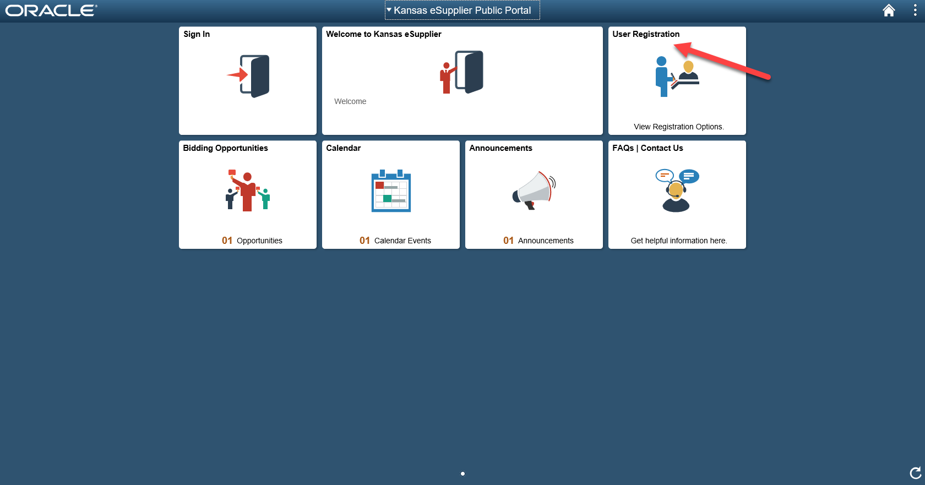
Select the “Register Now” button under the “Register Supplier User Account” section of the next page. | 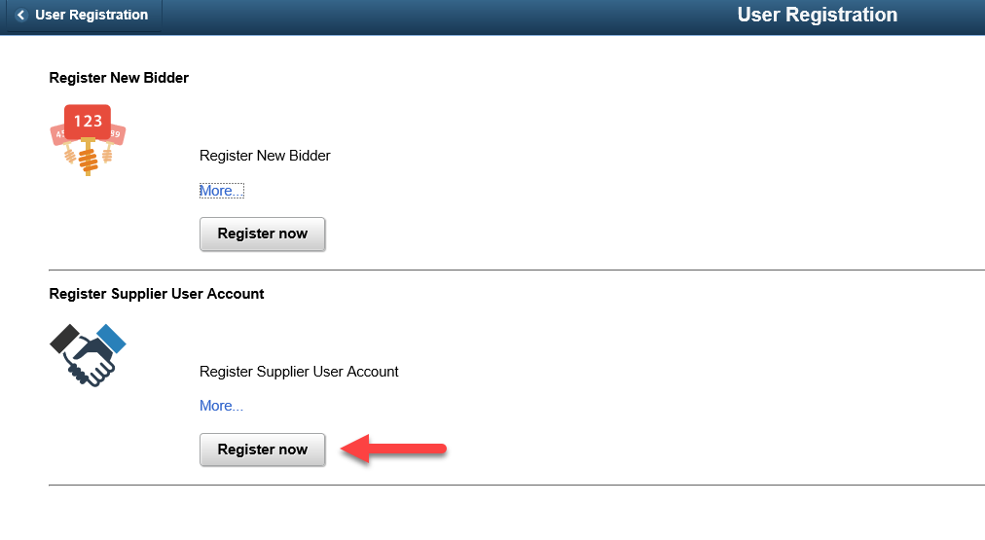

Supplier User Registration – Page 1
IMPORTANT: Users will not be able to search for their Supplier ID on this page.
Users must provide the full and exact 10-character Supplier ID assigned by the State of Kansas.  Once an accurate Supplier ID has been provided, click Search to continue. | 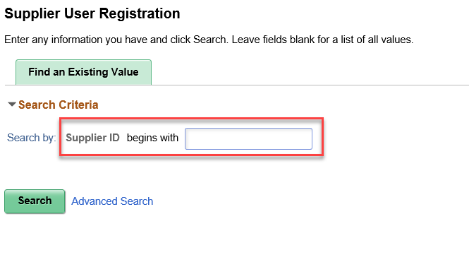
Note: Places to locate the Supplier ID number:
- On payments sent from the State of Kansas:
  - Printed on checks as the ‘Vendor Number’
  - Provided to the recipient’s bank in the addenda information on an Automated Clearing House (ACH) payment as the ‘Application Receivers Code’
- On the contract document, if the organization has a current contract with the State of Kansas (see the Procurement Contract List page: http://da.ks.gov/purch/Contracts/)
- By contacting the state agency from which the entity has received payment

Supplier User Registration – Page 2
IMPORTANT: The user must be able to provide the Tax Identification Number (TIN) and information from a payment received from the State of Kansas within the past 60 months.
Please provide the exact TIN, without punctuation.  The TIN field will only accept 9 numeric digits.  Formatting is #########. | 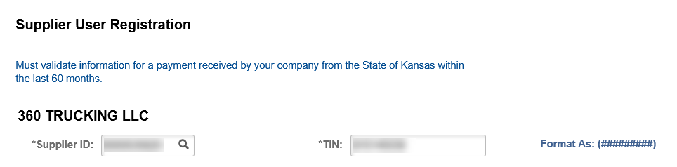

Payment Method:  Select the method of payment being submitted for verification:  - ACH: Automated Clearing House (ACH) is an electronic funds-transfer  or  - Check | 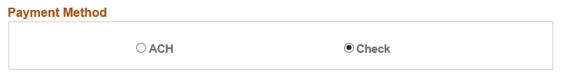

Payment Method ACH
Payment Method ACH:  Enter the requested ACH payment information, if ‘ACH’ was selected in the previous step.  Required fields include:  - Supplier Bank Account Number: exactly as it was provided to the paying state agency on the DA-130 – Authorization for Electronic Deposit of Supplier Payment Form  - Payment Date: formatted as MM/DD/YYYY  - Payment Amount: formatted as ###.##, no dollar sign ($) | 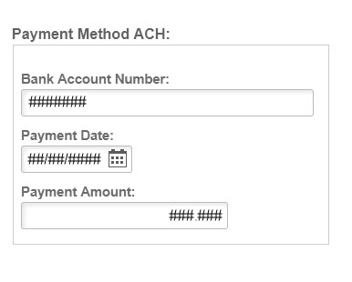

Payment Method Check
Payment Method Check:  Enter the requested check payment information, if ‘Check’ was selected in the previous step.  Required fields include:  - Check Date: formatted as MM/DD/YYYY  - Payment Amount: formatted as ###.##, no dollar sign ($)  - Check Number: the full 10-character check number is required | 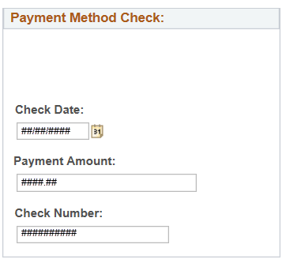
Once the information for a payment received in the last 60 months has been provided, select the Supplier Validation button.  If the information provided matches a payment in the State of Kansas system, a message will display confirming SUCCESS.  Select the Continue button, which appears upon validation. | 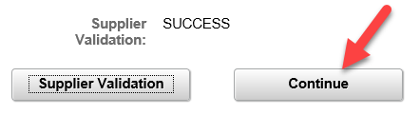
Note: Three failed payment validation attempts will lock a Supplier ID from allowing any NEW Supplier User Accounts from being created. Existing Supplier Users can still access the Kansas eSupplier portal as normal.

Register New Supplier User Accounts
Register New Supplier User Accounts is used to create a new User Account associated to the supplier.  The following information is displayed:  - Supplier Name  - ID Number: TIN  - Supplier ID | 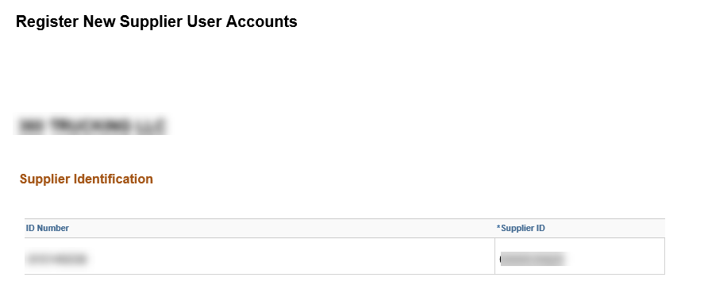
The following information is required:  - Requested User ID: must be in ALL CAPS, beginning with ‘SUP_’ and between 11 and 18 characters, including the required prefix. This field is alpha-numeric. The only special characters that may be used are dashes and underscores.  - Password: must be between 8 and 31 characters, including at least 1 uppercase letter, 1 lowercase letter and 1 number.  - Confirm Password: must match the ‘Password’ field value exactly.  - User First / Last Name:  must be the first and last name of the individual who will have a User Account associated to the supplier (e.g. John Smith).  - Password Secret Question: In the event of a forgotten password, the user will be prompted to provide the answer to the question selected here.  - Response: answer to the selected secret question  - Email: the email used for communication regarding the User Account | 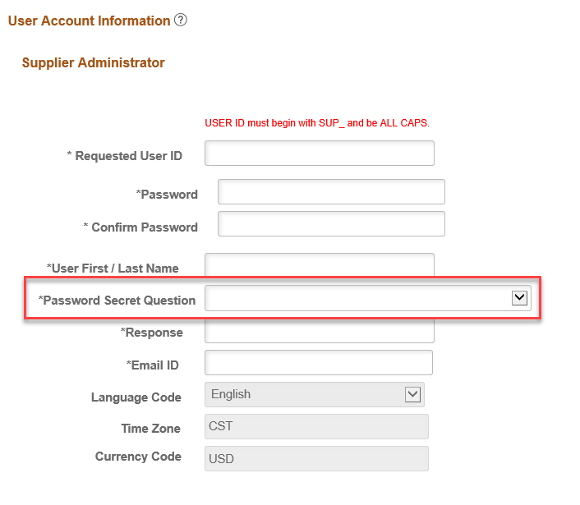  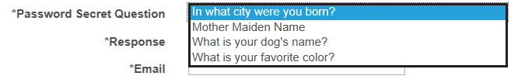
Once all required information has been provided and the box has been checked agreeing to the Terms of Agreement, select Submit.
The option will be provided to create multiple user accounts. | 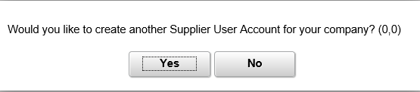
Note: Once complete, the user will immediately be able to login to the Kansas eSupplier Portal with the User ID and Password created.

