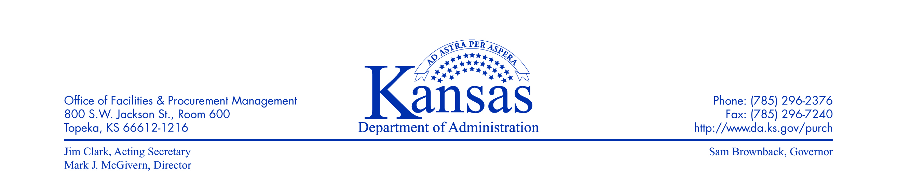
August 19, 2013

PROCUREMENT AND CONTRACTS INFORMATIONAL CIRCULAR 14-01

SUBJECT: Bidding Capital Improvement Projects

- Definition

Capital Improvement Project – A construction project for new construction, building additions, remodeling, demolition of existing structures, or rehabilitation and repair. Rehabilitation and repair is defined as routine, major, or emergency maintenance; restoration; replacement of fixed equipment; energy conservation; request related to Americans with Disabilities Act (ADA); and code compliance projects as needed to meet program requirements.

- Project Number/Data Request Form 935

Prior to submitting specifications for purpose of soliciting competitive bids by Procurement and Contracts for Capital Improvement Projects, agencies must receive a Code Review overview by the Office of Facilities and Procurement Management’s (OFPM) Office of Design, Construction and Compliance (DCC). This process is initiated by first obtaining a project number from DCC by completing Form 935, link follows.

http://www.da.ks.gov/fp/Forms/Executable_Forms/935_Project_Number_Data.xlsx

DCC will determine if a code review is required from the project information provided on Form 935. If insufficient information is provided to make a code review determination additional information will be requested from the agency.

Agencies are strongly encourage to work with their engineer/architect, when applicable, prior to submitting the above documentation. Questions concerning the Code Review overview should be addressed to Diana Hutchison (diana.hutchison@da.ks.gov or 785-296-4728).

- Procurement Process

Procurement Delivery Method will be confirmed by DCC on Form 935. If a code review is required for the project, DCC will initiate and manage the competitive procurement process. If code review is not required, Procurement and Contracts will initiate and manage the competitive procurement process. If the competitive procurement process is handled by Procurement and Contracts, the agency must enter a requisition in SMART to begin the process.
Procurement questions may be directed to Jerry Clements (jerry.clements@da.ks.gov or 785-296-7251) or David Stueve (david.stueve@da.ks.gov or 785-296-0408).

Tracy Diel
Director of Procurement and Contracts

