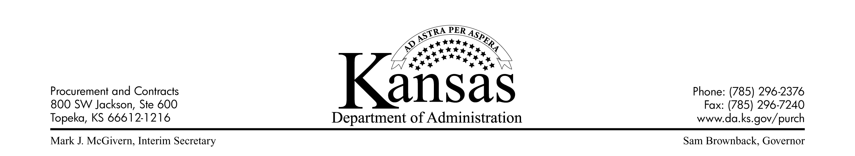
April 30, 2013

PROCUREMENT AND CONTRACTS INFORMATIONAL CIRCULAR 13-02

SUBJECT: Policy for the Use of P-Cards for Travel Expenses

- General Information

Effective immediately, travel expenses for official state travel may be charged to p-cards (plastic) issued in the names of state employees (named p-cards).
- Use of named p-cards for travel expenses is optional, not mandatory. Each agency may determine whether to allow its employees to charge travel expenses to named p-cards, charge to Business Travel Accounts (BTA’s), direct bill for lodging charges or a combination of these options.

- In addition, agencies have the option of limiting the types of travel expenses charged to named p-cards (for example, lodging only cards, etc.)
- Travel Expenses that Are Authorized for Named P-Cards

The following types of travel expenses may be charged to named p-cards:
- Travel Tickets, i.e. airfare, train or bus.

- Lodging

- Vehicle Rentals

- Local Transportation Expenses

- Conference Registration

- Fuel Purchased for State-Owned or Rental Vehicles

- Parking

- Other Miscellaneous Expenses (Supplies, postage, etc.)
- Travel Expenses that Are Not Authorized for Named P-Cards

The following types of expenditures are not authorized travel expenses for named p-cards:
- Meals

- Room service, personal phone calls, movies, laundry and other miscellaneous personal charges

- Any other charge that would not be considered reimbursable under the State Travel Expense guidelines.
- Cardholder Agreements

Cardholders must sign Cardholder Agreements for named p-cards authorized for travel expenses.
- Please refer to the blank Cardholder Agreement available at the Procurement & Contracts Web-Page.

- Until the blank Cardholder Agreement at the Web-Page has been updated to include a category for named p-cards authorized for travel expenses, write a note on the cardholder agreement that the card is authorized for travel expenses.
- Compliance with the Requirements of the State Travel Expense Reimbursement Handbook

Travel expenses charged to named p-cards must be in compliance with the requirements of the State’s Travel Expense Reimbursement Handbook. Special emphasis should be placed on compliance with the following sections of the State Travel Expense Reimbursement Handbook:
- Section 2100 – Travel Authorization

- Section 3300 – Travel by Public Transportation

- Section 3400 – Travel by Charter or Rental of Special Conveyance

- Section 4003 – Travel to High Cost Geographic Areas

- Section 4200 – Lodging Expense Reimbursement

- Section 5000 – Miscellaneous Expenses
- Agencies are responsible for minimizing risks associated with named p-cards authorized for travel expenses:

- Set reasonable transaction and credit limits in the VISA transaction validation system (for example a $1,000 transaction limit for a lodging only card).

UMB has set-up several strategies in the VISA transaction validation system for named p-cards authorized for travel expenses.

- Limit valid merchant types associated with named p-cards (authorized for travel expenses) as much as possible in the VISA transaction validation system. For example, if a card is only authorized by the agency for lodging transactions, valid merchant types in the VISA transaction validation system should be limited to lodging establishments.

- Be selective in issuing named p-cards authorized for travel expenses to agency employees.

- Cancel named p-cards authorized for travel expenses if the cardholder has multiple instances of inappropriate usage (non-compliance with State travel and p-card requirements, no show charges for lodging, personal expenses charged to the card, etc.)

In addition, any personal expenses charged to the card must be immediately reimbursed to the agency by the cardholder.

- Transaction Documentation

Agencies are responsible for adequately documenting transactions charged to named p-cards authorized for travel expenses:
- Obtain detailed, legible receipt documents for all transactions.

- Include written agency out-of-state travel approval documentation with documentation for travel transactions.

- Input a brief ‘purpose/description of travel’ into the ‘Description’ field for all travel transactions when reconciling transactions in SMART.
- How to Rent a Vehicle with a P-Card (Plastic)

- In order to receive the appropriate contract rental rate (Contract 37354; Hertz Corporation), State employees must reference the Corporate Discount Program (CDP) number (not the Applicant number) assigned to their agency, when making rental car reservations with named p-cards (plastic). Contact Hertz Corporation to obtain your agency’s CDP number.

- Send an e-mail to Hertz (sengel@hertz.com or kwantland@hertz.com) to request your agency’s CDP number. Include agency/department information in the e-mail.

- Hertz will then e-mail the assigned CDP number to your agency. CDP numbers should be kept secure.

- Employees are required to present the p-card (plastic) at the rental location, when the vehicle is picked-up.

- The rental will be charged to the p-card (plastic).
IX. Protection from Collision Damage Liability
- VISA provides your agency protection from collision damage liability when renting automobiles, mini-vans and sport utility vehicles with either cardless VISA Business Travel Accounts (BTAs) or regular VISA p-cards (plastic).

- Employees should choose to decline the Loss Damage Responsibility Waiver (LDW) when renting these types of vehicles from the contract vendor (Hertz Corporation)

Note: The Loss Damage Responsibility Waiver (LDW) is referred to elsewhere in the rental car industry as Collision Damage Waiver (CDW).

- Please note that protection from collision damage liability is only provided by VISA when the person driving the vehicle is listed on the rental agreement with the car rental company. If multiple drivers are anticipated, those drivers must be included on the rental agreement in order for your agency to have protection from collision damage liability.

- VISA does not provide protection from collision damage liability when agencies rent large size passenger vans, pickups, or cargo vans with either cardless VISA Business Travel Accounts (BTAs) or regular VISA p-cards (plastic).

However, Collision Damage Waiver (CDW) protection is included in the statewide contracted rates for those vehicles (Contract 37354).

Any questions should be directed to Tim Hund (tim.hund@da.ks.gov or 785-368-6347).

Tracy Diel
Director of Purchases

