Special Provisions
Cropland Production on Perry Wildlife Area

- These contracts are established to obtain agricultural services in the form of crop production activities on approximately 1300 acres located on the Perry Wildlife Area which stretches approximately 5 miles North and South of the city of Valley Falls, KS.

- Crop production acreage for Parcel #1 will be approximately 580 total acres, crop production on Parcel #2 will be approximately 375 total acres, crop production on Parcel #3 will be approximately 200 total acres, and crop production on Parcel #4 will be approximately 100 acres, that will vary each year based on a variety of things. Planned quantities of each crop type are shown below in the Three Year Production Summary. Acreage will vary each year but in most cases will nearly equal the quantities set forth above.

- PRODUCTION LOCATION (See attached maps)
Tracts on each parcel to be farmed include:

Parcel #1: All fields are located West - Northwest of the city of Valley Falls and range from around K16 to as far North as 190th Rd. All fields are located on the West side of the Delaware River.

Parcel #2: All fields are located North – Northeast of the city of Valley Falls and range from just North of K4 to about 190th Rd. All fields are located on the East side of the Delaware River.

Parcel #3: All fields are located South – Southeast of the city of Valley Falls and range from just south of K4 to the intersection of Ferguson and Jackson Rd. All fields are located on the East side of the Delaware River.

Parcel #4: All fields are located South – Southwest of the city of Valley Falls and range from 150th Rd. to around 130th and Edwards Rd. All fields are located on the West side of the Delaware River.

- CONTRACT PERIOD
Date of Award through December 31, 2020

- RENEWAL OPTION
The contract may be renewed under the same terms and conditions by mutual consent of both parties for one (1) additional five (5) year period.

- CONDITIONS OF BIDDING AND PAYMENT
Payment rate will be the same for all acres, regardless of the crop being grown for that year. First half (50%) of the year's payment will be due no later than April 1st of each year. The second half (50%) payment will be due by December 1st. First half payment will always be collected for acres planned to be planted that year. Second half payment will be collected in full for all acres harvested. If acres are too wet to plant or are flooded and insurance is collected by the tenant, the second half payment will be due in full. If no insurance is collected on lost acres then no payment is due for those acres. Documentation proving no insurance was collected will be required if this occurs.

- CONTRACT CONDITIONS
Conditions are covered in two documents (copies attached):

- General contract provisions for crop production for the life of the contract are provided in the attached Agriculture Production Permit.

- The Annual Permit provides more specific detail on agricultural production on an annual basis. Failure to follow annual permit conditions is grounds for contract termination.

- CROPLAND PRODUCTION

- The majority of production will be corn, milo, and soybeans but other crops such as wheat and other small grains, may be included in the rotation.

- An annual ryegrass cover crop is required to be planted on a minimum of 20% of acres planted that given year. Annual ryegrass is to be planted at 12-15 lbs./acre drilled, or 20-25 lbs./acre broadcasted. Preference for cover crop field selection will be soybean fields; however, the manager will determine the location of ryegrass plantings in the annual pre-planting meeting. A minimum of 30 lbs./acre of nitrogen fertilizer is required to be applied in order to achieve adequate growth. Other cover crop methods are allowed and encouraged but only upon approval from the manager.

- Fall tillage is not permitted. Spring field work shall not be permitted before March 1st of the current year. Terrace and drainage work may be permitted with manager’s written approval.

- Permittee shall make every effort to plant designated crops and fields. Deviation from the planned agricultural activity requires the manager’s written approval prior to change.

- Permittee is required to leave designated number of rows standing (unharvested) on all field borders with the exception of soybeans. All soybeans shall be harvested.

- Only herbicides on the approved pesticides list may be used on Department managed lands.

- Permittee is required to control noxious weeds within all fields on contract.

- Wheat shall be cut at the highest header height possible to maximize wheat stubble height. Wheat stubble shall not be tilled or sprayed with herbicide until March 1st of the following crop year.

- On any given year the manager can choose to plant sunflowers in any field within these contracts. This will be treated as a fallow field for the tenant, everything involving production of the sunflowers will be completed by the Department.

- Production Summary

Crop acreages are approximations. Most have no wheat acres, however wheat will be added in future years.

Crop Production – Parcel 1
Crop Type | 2013 | 2014 | 2015
Corn | 215 | 135 | 225
Milo | 76 | 72 | 58
Soybeans | 258 | 356 | 253
Sunflowers | 31 | 15 | 41
Wheat
Totals | 580 | 578 | 577

Crop Production – Parcel 2
Crop Type | 2013 | 2014 | 2015
Corn | 121 | 103 | 152
Milo | 78 | 66 | 29
Soybeans | 140 | 203 | 170
Sunflowers | 23 |  | 23
Wheat
Totals | 362 | 372 | 374

Crop Production – Parcel 3
Crop Type | 2013 | 2014 | 2015
Corn | 60 | 24 | 80
Milo | 14 | 50 | 14
Soybeans | 88 | 108 | 89
Sunflowers | 20 | 15 | 15
Wheat | 20
Totals | 202 | 197 | 198

Crop Production – Parcel 4
Crop Type | 2013 | 2014 | 2015
Corn | 37 | 37 | 37
Milo | 10 | 10 | 10
Soybeans | 53 | 47 | 52
Sunflowers |  | 6
Wheat
Totals | 100 | 100 | 99

- Contractor shall possess applicable liability insurance coverage and present proof upon request.

Contractor Listing

Parcel #1 Contract # 41403

Contractor: Dailey Angus Farms
18004 70th St
McLouth, KS 66054-4110

Vendor ID: 0000057897
FEIN: 481166518
Contact Person: Mike Dailey
E-Mail: mndailey66054@embarqemail.com
Local Telephone: 913-796-6202
Cell Phone Number: 785-865-8489

Parcel #1 #2 & #3 Contract # 41411

Contractor: Thomas M Funk
17305 Marion Rd
Nortonville, KS 66060-4920

Vendor ID: 0000502147
Contact Person: Thomas Funk
E-Mail: farmerfunk73@yahoo.com
Local Telephone: 785-945-4201
Cell Phone Number: 785-640-0536

Parcel #4 Contract # 41402

Contractor: Shawn B Dailey
7027 Wellman Rd
McLouth, KS 66054

Vendor ID: 0000452201
Contact Person: Shawn Dailey
E-Mail: sdailey117@gmail.com
Cell Phone Number: 785-865-8478
PRICE SCHEDULE

Parcel # | Estimated  Number  Of Acres | Annual Payment  To KDWP&T  Per acre | Contractor
1 | 580 | $127.50 | Dailey Angus Farms
2 | 375 | $141.00 | Thomas Funk
3 | 200 | $137.00 | Thomas Funk
4 | 100 | $77.70 | Shawn Dailey

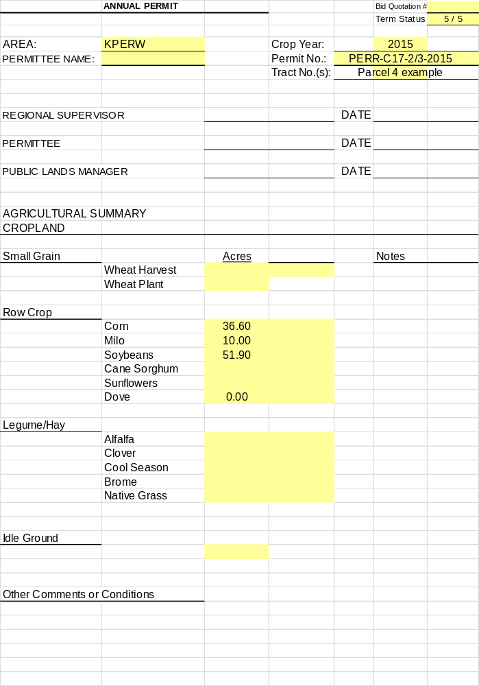
Annual Permit

AREA | Perry Wildlife Area | CROP YEAR | 2015
Permit Number | PERR-17-02-16 | TRACT NO. (S) | Parcel 4 example

Special Conditions:
- The majority of production will be corn, milo, and soybeans but other crops such as wheat and other small grains, may be included in the rotation.
- An annual ryegrass cover crop is required to be planted on a minimum of 20% of acres planted that given year. Annual ryegrass is to be planted at 12-15 lbs./acre drilled, or 20-25 lbs./acre broadcasted. Preference for cover crop field selection will be soybean fields; however, the manager will determine the location of ryegrass plantings in the annual pre-planting meeting. A minimum of 30 lbs./acre of nitrogen fertilizer is required to be applied in order to achieve adequate growth. Other cover crop methods are allowed and encouraged but only upon approval from the manager.
- Fall tillage is not permitted. Spring field work shall not be permitted before March 1st of the current year. Terrace and drainage work may be permitted with manager’s written approval.
- Permittee shall make every effort to plant designated crops and fields. Deviation from the planned agricultural activity requires the manager’s written approval prior to change.
- Permittee is required to leave designated number of rows standing (unharvested) on all field borders with the exception of soybeans. All soybeans shall be harvested.
- Only herbicides on the approved pesticides list may be used on Department managed lands.
- Permittee is required to control noxious weeds within all fields on contract.
- Wheat shall be cut at the highest header height possible to maximize wheat stubble height. Wheat stubble shall not be tilled or sprayed with herbicide until March 1st of the following crop year.
- On any given year the manager can choose to plant sunflowers in any field within these contracts. This will be treated as a fallow field for the tenant, everything involving production of the sunflowers will be completed by the Department.
Bid Quotation # _

STATE LAND FEDERAL LAND X _

KANSAS DEPARTMENT OF WILDLIFE, PARKS & TOURISM
AGRICULTURAL PRODUCTION PERMIT

This permit, number , is made and entered into this day of , 20 between the Kansas Department of Wildlife, Parks & Tourism, hereinafter called the “Department”, and
hereinafter called the “Permittee”, WITNESSETH:

The Kansas Department of Wildlife, Parks & Tourism by virtue of authority conferred by Kansas law, and/or the License, Agreement of Lease of the United States Government, and in consideration of the benefits issuing to the general public from the management of the wildlife resources of Kansas, hereby lets to the Permittee for specified agricultural activities for the term of
beginning , 20 , and ending , 20 , in the following described property situated in the county of , in the state of Kansas:

THIS PERMIT is granted subject to the following provisions and conditions:

- DEPARTMENT COMPENSATION
The Permittee agrees to complete the terms of this permit and to compensate the Department for use of this property as follows:

- AGRICULTURAL ACTIVITIES
  - The agricultural activities for each year will be agreed upon on the Annual Permit which when signed by the permittee, then becomes part of this agreement.
  - It is understood that the Department is using agricultural agreements solely to further wildlife benefits on the project lands and that specified agricultural practices and conditions may differ from those common in the private sector.

- DEPARTMENT
  - The Department agrees to furnish the property previously described only for such agricultural uses as provided in this permit.
  - The Department reserves the right for itself and/or the United States Government, their representative, officers, agents, or employees to enter upon permitted property at any time and for any purpose.
  - The Department and/or the United States shall not be responsible for damages to property or injuries to persons which may arise from or be incident to the use, cultivation, or occupation of the permitted property, nor for damages to the property of the Permittee, nor for injuries to the person of the Permittee or Permittee’s officers, agents, servants, or employees, or others who may be on the permitted property at their invitation or the invitation of any one of them for injury or damage arising from or incident to flooding or state and/or federal activities; and the Permittee shall hold the Department and/or the United States harmless from any and all such claims.
  - The Department reserves the right to take any land out of production that it deems necessary to meet area management objectives.

- PERMITTEE The Permittee agrees to:
  - Furnish all machinery, equipment, materials and labor necessary to achieve the purposes specified in this Agricultural Production Permit and the Annual Permit.
  - Provide all seed (free of noxious weed seed), seed treating materials, and fertilizer necessary to produce crops.
  - Control noxious weeds on leased cropland or rangeland acreage unless otherwise designated on the Annual Permit. Control methods shall be approved by the manager and comply with State Noxious Weed Division guidelines.
  - An annual ryegrass cover crop is required to be planted on a minimum of 20% of acres planted that given year. Annual ryegrass is to be planted at 12-15 lbs./acre drilled, or 20-25 lbs./acre broadcasted. Preference for cover crop field selection will be soybean fields; however, the manager will determine the location of ryegrass plantings in the annual pre-planting meeting. A minimum of 30 lbs./acre of nitrogen fertilizer is required to be applied in order to achieve adequate growth. Other cover crop methods are allowed and encouraged but only upon approval from the manager.
  - Use standard soil testing methods prior to any fertilizer application. Fertilizer must be applied at the same rate to the Department’s and Permittee’s share.
  - Pay all expense of threshing, tilling, harvesting, fencing, hauling, planting, and all other work hired or done by the permittee.
  - Pay an annual cash payment on a per acre basis for acres that will be planted each year. First half payment will always be collected for acres planned to be planted that year. Second half payment will be collected in full for all acres harvested. If acres are too wet to plant or are flooded and insurance is collected by the tenant, the second half payment will be due in full. If no insurance is collected on lost acres then no payment is due for those acres. Documentation proving no insurance was collected will be required if this occurs.
  - Meet planting, harvesting, entry, and removal dates if so specified.
  - Keep Department fences and other improvements in good repair and condition during the term of the agreement (ordinary wear or unavoidable destruction excepted).
  - Obtain prior written permission from the manager on department lands to:
    - damage or remove any vegetation
    - burn, hay, bale, harvest or otherwise remove any crop residue or vegetation
    - plow any land not specified for crop production
    - graze or place any livestock not associated with this permit
    - apply any chemical not on the department’s approved list
    - transfer or assign this permit or sublet said property or any part thereof, or grant any interest, privilege, or license whatsoever in connection with this permit.
  - Maintain certification on all cropland acres with the appropriate Consolidated Farm Service Agency (CFSA) Office.
  - Control soil erosion as completely as possible by strip cropping, contour farming, maintaining waterways, turning rows and terraces, filling small ditches that form and cooperating fully with conservation practices that the Department may direct;
  - Notify the Department of crop harvest or livestock removal on the permitted property at least one week before that harvest or removal and submit the income for the department’s share within 14 days after income is received from the property.
  - Cooperate fully in programs for the enhancement of fish and wildlife and understand the permitted area is open to the public unless otherwise posted by the department.
  - Farm or ranch the land himself or with employees. The Permittee must also be actively engaged in the farming or ranching business as a means of livelihood.
  - Be monetarily liable for any damage or loss caused to permitted property by Permittee’s activities or negligence of activities outlined under this permit and will exercise due diligence in the protection of all resources and/or improvements on or part of such property.
  - Do all in his power to prevent and suppress wild fires on permitted property and immediately report any which he cannot suppress.
  - If it is determined by the Department or the United States that the land covered by this permit or any portion thereof, is needed for any purposes, this permit may be terminated by the United States or the Department upon 30 days written notice to the Permittee.
  - The Permittee shall not do or omit to do, or knowingly suffer, or permit to be done by others, anything by which act or omission, any person may be endangered or injured by the use of the wildlife areas and shall save the United States, and the State of Kansas harmless from any claim on account of any personal injury or property damage by reason of anything done, or knowingly suffered or omitted to be done by the Permittee, in its exercise of the rights and privileges granted by this permit.
  - In the event of the termination of the license, agreement or lease between the United States and the Kansas Department of Wildlife, Parks & Tourism, the United States shall stand in the stead of the Department as grantor for the remainder of the term of this permit; provided, however, in the event of such termination, the United States at any time within 90 days thereafter may terminate this permit by giving to the Permittee 30 days written notice and in such event a period of 30 days after termination of this permit or such longer period as may be determined by the Bureau of Reclamation and/or the Corps of Engineers to be reasonable, improvements which have been constructed on the premises at the sole cost or expense of the Permittee; otherwise after the expiration of such period of time, the title to such improvements shall vest in the United States.
  - Permittee is required to leave designated number of rows standing (unharvested) on all field borders with the exception of soybeans. All soybeans shall be harvested.
  - Fall tillage is not permitted. Spring field work shall not be permitted before March 1st of the current year. Terrace and drainage work may be permitted with manager’s written approval.

- RENEWAL
  - The maximum term length of this permit shall be five (5) years. Competitive bid contracts are renewable for one additional 5 year term, subject to mutual consent between both parties, for a total of 10 years for the life of the contract.
  - Obligations imposed upon permittee are binding and may be enforced by the Department notwithstanding termination of this agreement.

- FORFEITURE OF PERMIT
Failure of the Permittee to comply with the terms and conditions of this permit, or conviction of the Permittee of a wildlife law violation shall be cause for revocation of this permit.

- HEIRS ARE BOUND
This permit shall extend to and be binding upon the heirs, executors and administrators, and agents of the parties of this permit, except as herein provided.

- MODIFICATION
This permit may only be modified by mutual agreement of the parties in writing.

- MISCELLANEOUS
  - The Permittee certifies by placement of signature to this agreement that neither he nor his principals, sub-contractors and suppliers used by him on this project are presently debarred, suspended, proposed for debarment, declared ineligible, or voluntarily excluded from participation in such permit by any State or Federal Department or Agency.
  - The Permittee agrees to comply with all applicable federal, state, and local laws, regulations and ordinances. Further, equal opportunity to participate in and benefit from programs described herein with the Kansas Department of Wildlife, Parks & Tourism is available to all individuals without regard to race, color, national origin or ancestry, religion, sex, age, disability, military or veteran status, political affiliation, sexual orientation or gender identity. Any complaints of discrimination shall be forwarded to the Office of the Secretary, KDWP&T, 1020 S. Kansas Ave, Suite 200, Topeka, KS 66612.
  - The Department reserves the right to withhold payment for incomplete service product or for substandard service work as set forth in the standards above. The Department shall not be responsible for additional work required for bringing the services up to permit standards. Further, the Department reserves the right to terminate the permit at any time based upon the fiscal necessity of the Department and upon written notice effective upon receipt. Breach of any provision of this permit shall be grounds for recession of the permit by the Department, as determined in the sole discretion of the Department.
  - This permit shall not be assigned to any other entity, nor the respective duties thereof. Further, the Department and the Permittee shall act in their individual capacities and not as agents, employees, partners, in joint venture, or as associates of one another. The employees or agents of one party shall not be deemed or construed to be the employees or agents of the other party for any purpose whatsoever.
  - This permit, and its attachments, shall constitute the entire agreement and shall control the relationship between the parties, regardless of any other understanding between the parties. In the event any of the provisions of the permit are deemed to be invalid or unenforceable, the same shall be deemed severable from the remainder of the permit. If such provision shall be deemed invalid due to its scope and breadth, such provision shall be deemed valid to the extent of the scope and breadth permitted by law.
  - The Department’s failure at any time to require strict performance by the Permittee of any provision of this permit shall not waive or diminish the Department’s right thereafter to demand strict compliance therewith or with any provision. Waiver of any default shall not waive any other default.
  - This permit may only be amended by written mutual amendment and attached hereof according to the same formalities required of the original execution of this permit.

IN WITNESS WHEREOF, we have executed this Permit Agreement on , 20 .

BY
Permittee

BY
Manager

BY
Regional Supervisor


