Pricing/Catalog
In place of printed price sheets, O’Reilly Automotive Inc. would like the State of Kansas to use our on-line catalog lookup and ordering system, FirstCall Online. Below you will be provided with a brief set of instructions for the FirstCall Online website.
- Please navigate your browser to www.firstcallonline.com
- In the upper portion of the screen, select “Parts Lookup”.
- The username and password for this proposal will be: un – kansas / pw – stateof
- From this point you can look up parts by application, interchange, etc.
- For any technical assistance please call: 1-800-934-2451.
Kansas’ catalog discount will be list price less 41% or better. The cost column will reflect Kansas’ price with all discounts.

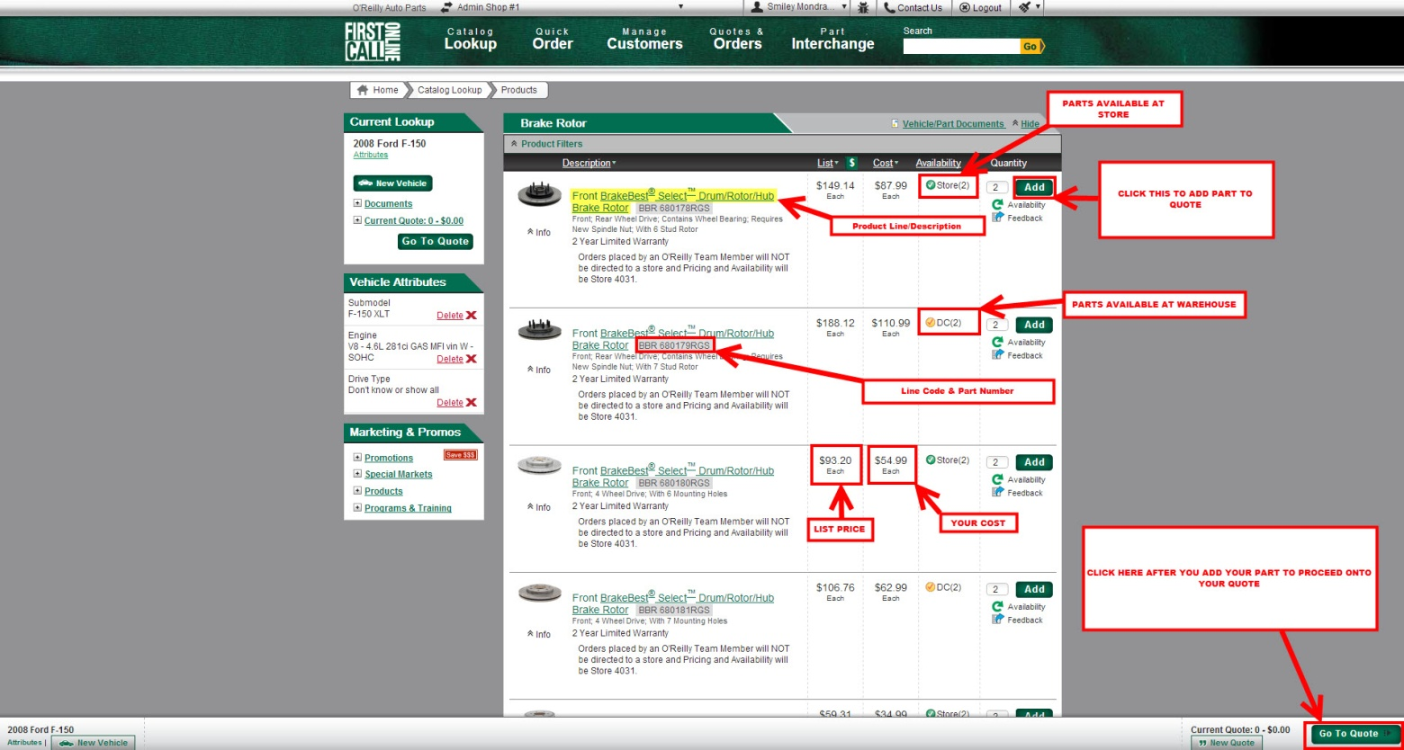

Transportation Terms
Transportation terms shall be FOB Destination, shipped by O’Reilly company vehicle. In cases of factory order items, standard shipping rates will apply.

Distribution
Distribution will be made by a local O’Reilly Store location, by a company delivery truck.
Products
All products O’Reilly carries will be included in this contract. A complete line card has been included for your reference.
Core Charges
Core pick-ups will occur as needed, hourly, daily, or weekly. O’Reilly will tailor the pick-up schedule to the needs of each agency. Cores will be credited on the same day they are received. Any core that is damaged or returned in an otherwise non-rebuildable condition will be billed to the customer at the manufacturer’s listed core price.
Delivery Time
Normal delivery time for stocked items is 1 hour. Non-stocked items are usually delivered the next business day. Emergency items usually follow the same guidelines, but are also handled on a case by case basis. Delivery is available only for locations within 6 miles of an O’Reilly location.
Return Policy
O’Reilly will return any item that was purchased through the contract for full credit that has been purchased in the last thirty days, and in new and resalable condition. All returns will be picked up within seven days of notification, by writing, fax, or email.
Services
Additional value added services O’Reilly provides includes the following:
- Used Battery and Oil Recycling
- Battery Testing
- Custom Hydraulic Hose
- Electrical & Module Testing
- Loaner Tool Program
- Drum, Rotor, and Flywheel Resurfacing
- Machine Shop Services

