Special Provisions
For Aggregates
AIC

1. These contracts are established to provide Aggregate to the Kansas Department of Transportation (KDOT).

2. The contract may be terminated by the Office of Procurement and Contracts if the contractor does not satisfactorily provide aggregate as indicated in the specifications herein. The agency must submit to Procurement and Contracts adequate documentation of unsatisfactory performance, which shall include copies of correspondence to the contractor before a notice of termination will be issued. The notice of termination will be in written form to the contractor with a copy to the agency and be effective seven (7) days after the date of the notice. In addition, the State of Kansas reserves the unilateral right to terminate contracts to prevent unnecessary expense, waste of materials, manpower and facilities. The contract may be terminated in whole or in part when the Contracting Officer deems the termination to be in the best interest of the State of Kansas. A 30 day notice will be given to the contractor prior to such termination.

3. INSURANCE AND LIABILITY: The contractor's interest in all property herein described, if any, or any personal liability to him arising from this agreement to whatever extent shall be considered to be covered by applicable insurance by the contractor to the extent required. Notwithstanding any language to the contrary, no interpretation shall be allowed to find the State of Kansas or any of its agencies responsible for loss or damage to personal property or to hold contractors harmless from any such occurrences. Contractor(s) shall possess Workman's Compensation Insurance in the amount required by law.

4. PRE-PRODUCTION MEETING: Within 15 days after the contract has been awarded, a pre-production meeting may be arranged by the District Engineer with the Contractor to coordinate delivery procedures, arrange for material testing, or other related topics to this contract.

5. CONTRACT PERIOD: September 1, 2015, through August 31, 2016.

6. QUANTITIES: The contract is of the "open-end" type. The contractor will deliver such quantities as may be ordered throughout the contract period. Only those quantities actually required will be ordered.

7. DESTINATIONS: Destinations are indicated in the Schedule of Prices, a part hereof.

8. All aggregate is to be priced by the short ton (2,000 lb.) weight.

- PRICES: Prices are indicated in the Schedule of Prices. All delivered prices are F.O.B. Destination, freight paid by the contractor unless specified plant pick up by KDOT.

10. All pricing shall be guaranteed during the contract period.

11. DELIVERY BY CONTRACTOR: The District Engineer or his designated representative will periodically issue purchase orders for aggregate with the contractor as needs arise. At the time the purchase order is placed, the date, time and location for delivery will be specified and agreed upon. Telephoned purchase orders will be confirmed by Purchase Order.

If the aggregate is not delivered by the date and time agreed, the Contractor may be charged liquidated damages as explained herein.

When the Contractor has started delivery, he will be required to deliver the material at a rate of not less than 250 tons per consecutive working day or the designated quantity to each delivery location specified on the purchase order(s). The contractor may discontinue delivery to any location provided he has notified the District Engineer of his intentions to stop delivery at least 24 hours in advance, and he has agreed to the discontinuance. If the Contractor does not deliver at the rate of 250 tons per working day, he may be charged liquidated damages as explained herein. All deliveries will arrive at the destination within the hours agreed upon the Contractor and District Engineer. The point of delivery will be open for delivery a minimum of eight (8) hours a day if the contractor is delivering that many hours per day. Deliveries will not be accepted during hours other than those hours that have been mutually agreed upon by the contractor and KDOT.

12. STOCKPILE OF MATERIAL: The material is to be stockpiled as directed by the District Engineer. The use of belly-dump trucks will not be permitted without prior approval from the District Engineer.

13. DELIVERY BY STATE EQUIPMENT: The State reserves the right to purchase and haul aggregate by trucks furnished by the State from the supplier's plant. The District Engineer or his representative will telephone or otherwise notify the contractor prior to the departure of the truck.

14. LIQUIDATED DAMAGES:

(a) Liquidated Damages will be treated not as a penalty, but as a fixed, agreed and liquidated damage to the State by reason of interference with business, added cost, administrative and testing expense.

(b) Should the contractor fail to make delivery of 250 tons per working day, or the designated quantity to each destination specified in purchase orders, the State may retain $50.00 for each possible working day that at least 250 tons were not delivered. A working day as defined herein (Para. 17). Liquidated Damages will be deducted from the purchase authority prior to being processed for payment. The State reserves the right to waive all or any part of such liquidated damages.

(c) Should the contractor fail to complete delivery by the date specified, the State may retain ten cents ($.10) per ton per calendar day on the undelivered portion of the order, beginning the day following the delivery date and continuing until the delivery is completed.

(d) Example of Liquidated Damages: A location has placed a purchase order for 1,000 tons of material. The Contractor had delivered only 850 tons at the end of the date specified the material was to be delivered, leaving 150 tons yet to be delivered. 150 ton multiplied by $.10 per ton equals $15.00. The State will retain $15.00 per calendar day and continuing until the delivery is completed.

15. DEFAULT OF DELIVERY: In the event a contractor fails to make delivery as specified herein, or consistently fails to deliver at the rate of 250 tons per working day, the State reserves the right to cancel any such unfilled orders and to purchase such material from the nearest available source in the manner as stipulated herein OR demand of the contractor's surety that the surety proceed in place of the contractor to complete the delivery of the material on the contract is in accordance with the terms and provisions. The contractor in such case, gives his full consent that the completion of the contract shall be undertaken and performed by the surety and the surety will complete said contract, whichever is deemed to be in the best interest of the State. Any additional cost to the State may be collected from the contractor. The contractor will not be held liable for failure to ship within the stipulated time when his inability to ship is caused by an Act of God, State or Federal Government Order or Regulation, War, Insurrection, Riot, Fire, Strike, or any other cause beyond the reasonable control of such party, provided notice of such condition is given to the Department of Transportation with reasonable promptness.

16. A working day shall be any day upon which the contractor can physically and legally prosecute the work and shall be counted as provided in Section 108 of the Standard Specifications for State Road and Bridge Construction, current edition.

17. PLANT PRICES: The unit price per ton for material loaded into trucks furnished by the State, F.O.B. the supplier's plant, shall be shown in the space provided. The State reserves the right to accept or reject the price for use as outlined below:

(a) If the material is to be hauled by trucks furnished by the State to a destination where a truck delivered contract price has been established, it shall be purchased from the contractor for that destination and at the rate per ton established as the plant price.

(b) If the material is to be hauled by trucks furnished by the State to a destination where a delivered contract price has been established for railroad cars, it shall be purchased from the contractor for that destination at the plant price.

(c) If the material is to be hauled by trucks furnished by the State to a destination not under contract, unlisted in the Schedule of Prices, it shall be purchased from the supplier nearest to the unlisted destination, at the plant price quoted. An unlisted destination is defined as a point or an area five (5) miles or more from a listed destination.

(d) If the material is to be hauled by the contractor to a destination not specifically stated on the contract, the delivery price will be nearest plant price per ton plus a cost per mile fee. This will replace the calculation used in the past, but should be easier to calculate for those infrequent needs for delivery to an unlisted location.

18. SPECIFICATIONS:

Aggregate for Ice Control shall be in accordance with Specification TS 65.14, dated 8-6-04, and the required modifications for each District as shown on the specification sheet.

19. METHOD OF MEASUREMENT: Method of measurement will be in accordance with Section 109, of the Kansas Department of Transportation Standard Specifications for State Road and Bridge Construction, 2007 Edition, with the following exceptions:

(a) All aggregate is to be delivered by weight, unless by volume is approved by the District Engineer. When aggregate is measured by volume, the hauling vehicle shall be approved and measured at the point of delivery. The Engineer may require loads to be leveled at the point of delivery.

(b) Deduction for moisture content above amounts listed below will be made when delivery is by weight:

AIC—No deduction will be made for moisture

20. LEASED PITS: The State reserves the right to continue to produce and haul aggregates with its own equipment from pit locations leased by the Department of Transportation for that purpose when the District Engineer deems it necessary and advantageous to do so.

21. PAYMENT: Payment will be made within 30 days of delivery acceptance or receipt of invoice, whichever is later. The invoice shall be submitted to the address as instructed on the Purchase Order. KDOT Purchase Order number must be referenced on the invoice.

22. Price Adjustment: Aggregate Pricing will be adjusted weekly based on the Average Retail On-Highway Diesel pricing for the Midwest region posted on the Energy Information Administration Website:
http://tonto.eia.doe.gov/oog/info/wohdp/diesel.asp

If the price of fuel increases or decreases $ 0.10 per gallon, the price of aggregate will increase or decrease $ 0.05 per ton accordingly. Adjustments will be made in $ 0.05 increments.

The starting point is $2.561 per gallon.

Fuel adjustment allowances must be reflected as a separate line item on each invoice.

The order date, not the delivery date, will be the basis for the adjustment.

Contractors
Vendor
No. Name Plant Price

01. Contract ID: 40761
Pennys Aggregate, Inc. AIC-A $ 12.85 Ton
23400 W. 82nd Street 3584 Tennessee Road, Ottawa, KS
Shawnee, KS 66227
Toll Free Telephone: 800-322-9710 AIC-B $ 12.85 Ton
Telephone: 913-667-6505 1752 N. 1500 Road, Lawrence, KS
Cellular Telephone: 913-915-2869
Fax: 913-441-1830 Delivery cost to non-specified locations:
Contact Person: Melanie Lorsenzo $ .16 per mile per ton
E-Mail: mlorenzo@pennysconcrete.com
Vendor ID: 0000321388

02. Contract ID: 40772
Alsop Sand Company, Inc. AIC-B $ 7.20 Ton
105 Industrial Road Scandia, Concordia, Abilene
Concordia, KS 66901
Telephone: 785-243-4249 Delivery cost to non-specified locations:
Fax: 785-243-4255 $ .25 per mile per ton
Contact Person: Dane Barclay
E-Mail: alsop@nckdirect.com
Vendor ID: 0000048997

03. Contract ID: 40762
Huber Sand, Inc. AIC - B $ 3.00 Ton
2935 Prairie Ave , PO Box 1359 Pit #4 – South on Barton Road, Syracuse, KS
Garden City, KS 67846
Telephone: 620-275-7601 AIC-B $ 2.00 Ton
Cellular Telephone: 620-640-2838 Pit #2 – 2 miles S. E. of Hwy 50, Garden City, KS
Fax: 620-275-7542
Contact Person: Robin Huber Delivery cost to non-specified locations:
E-Mail: Hubersand@yahoo.com $ .12 per mile per ton
Vendor ID: 0000161348

04. Contract ID: 40766
Cornejo & Sons, LLC AIC-B $ 5.30 Ton
2060 E. Tulsa 3500 N. West St., Wichita, KS
Wichita, KS 67216
Telephone: 316-522-5100 1438 S. 122nd Street, Oxford, KS
Cellular Telephone: 316-655-8858
Fax: 316-522-8187
Contact Person: Chris Blasdel
E-Mail: chris.blasdel@cornejomaterials.com
Vendor ID: 0000052279

05. Contract ID: 40779
Nelson Quarries, Inc.
P. O. Box 100
Gas, KS 66742-0100
Telephone: 620-365-5300
Fax: 620-365-5310
Contact Person: Patrick Clift
E-Mail: patrickclift@gmail.com
Vendor ID: 0000048743
Vendor
No. Name Plant Price

06. Contract ID: 40775
Heft & Sons LLC
14081 I Street AIC-B $ 6.00 Ton
Greensburg, KS 67054 6 miles East & 4 ½ South of Greensburg
Telephone: 620-723-2495
Cellular Telephone: 620-546-3275 Deliver cost to non-specified locations:
Fax: 620-723-2215 $6.00 per mile per truckload
Contact Person: Steve Heft
E-Mail: sheft.heftandsons@att.net
Vendor ID: 00000035608

07. Contract ID: 40764
APAC - Kansas, Inc. AIC-B $ 7.40 Ton
Shears Division 3401 E. Avenue G, Hutchinson, KS
PO Box 1605
1600 North Lorraine, Suite 1
Hutchinson, KS 67504-1605
Telephone: 620-662-3307 ext. 132
Fax: 620-662-3181
Contact Person: Rod Jerrick
E-Mail: rjjerrick@apac.com
Vendor ID: 0000154586

08. Contract ID: 40769
B & B Readimix, Inc. AIC-B $ 21.00 Ton
1873 1st St.
Phillipsburg, KS 67661-8701 Delivery cost to non-specified locations:
Telephone: 785-543-5133 $ 4.00 per mile per truckload
Cellular Telephone: 785-543-8508
Fax: 785-543-5215
Contact Person: Delores Mongeau
E-Mail bbredimix@kans.com
Vendor ID: 0000049575

09. Contract ID: 40763
Eakin Enterprises Inc. AIC-B $ 5.70 Ton
111 Main St.
Larned, KS 67550-3917 Delivery cost to non-specified locations:
Telephone: 620-285-2097 $ 4.00 per mile per truckload
Cellular Telephone: 620-793-2809
Fax: 620-285-2764
Contact Person: Chad Eakin
E-Mail: chad@eakinenterprises.com
Vendor ID: 0000159622

10. Contract ID: 40776
Midwest Concrete Materials AIC-B $ 6.50 Ton
701 S. 4th St. Kaw Sand Plant. Riley County Plant
Manhattan, KS 66502 Wabaunsee County Plant,
Toll Free Telephone: 800-813-5195 Geary Sand Plant
Telephone: 785-776-8811
Cellular Telephone: 785-218-7451 Delivery cost to non-specified locations:
Fax: 785-776-1816 $ .18 per mile per ton
Contact Person: Chris Eichman
E-Mail: chris.eichmann@4mcm.com A1C-B $ 7.00 ton
Vendor ID: 0000047170 Jefferson County Plant

Vendor
No. Name Plant Price

11. Contract ID: 40777
Hall Brothers, Inc. AIC-B $ 5.40 Ton
1196 E. POnoy Express Hwy. 2 miles West of Blue Rapids on K-9
PO Box 166
Marysville, KS 66508 Delivery cost to non-specified locations
Telephone: 785-562-2386: $ .16 per mile per ton
Fax: 785-562-5543
Contact Person: Rob Roudybush
E-Mail: roudybush@hallbros.net
Vendor ID: 0000047203

12. Contract ID: 40767
Wade Agricultural Products, Inc. AIC-A $ 9.80
Dba Wade Quarries Greeley Quarry
PO Box 38 LaCygne Quarry
23202 E. 2400 Rd. Cadmus Quarry
LaCygne, KS 66040
Telephone: 913-757-4457
Cellular Telephone: 913-645-2548
Fax: 913-575-2255
Contact Person: Gwen Gooding
E-Mail: ggooding@peoplestelecom.net
Vendor ID: 0000049584

13. Contract ID: 40765
Midwest Products L.L.C. AIC-B $6.95 Ton
Box 396 South Plant
Hanover, KS 66945
Toll Free Telephone: 800-371-2252 Delivery cost to non-specified locations:
Local Telephone: 785-337-2252 $ 4.75 per mile per truckload
Cellular Telephone: 785-541-0036
Fax: 785-337-2253
Contact Person: Jay Holle
E-Mail: midwestproductsllc@yahoo.com
Vendor ID: 0000060551

14. Contract ID: 40760
Hartford Sand & Gravel, LLC AIC-B $ 6.00 Ton
PO Box 1615 1019 McDowell Creek Rd., Manhattan, KS
Manhattan, KS 66505
Telephone: 785-477-9801
Cellular Telephone: 785-456-4977
Fax: 785-456-2518
Contact Person: Robert Davies
E-Mail: hartfordsand@hotmail.com
Vendor ID: 0000060692

Vendor
No. Name Plant Price

15. Contract ID: 40778
Midwest Minerals Inc.
PO Box 412
709 Locust St.
Pittsburg, KS 66762-0412
Telephone: 620-231-8120
Cellular Telephone: 650-235-3915
Fax: 620-235-0840
Contact Person: Steve Sloan
E-Mail: ssloan@midwestminerals.com
Vendor ID: 0000048177

16. Contract ID: 40773
Double D, Inc.
dba Dale Brothers
PO Box 12541
Kansas City, KS 66112-0541
Telephone: 913-334-1075
Cellular Telephone: 913-957-4526
Fax: 913-210-2028
Contact Person: Thomas Irish
E-Mail: ti@dalekc.com
Vendor ID: 0000011753

17. Contract ID: 40771
Sporer Land Development, Inc.
PO Box 246
431 US Hwy 83
Oakley, KS 67748
Telephone: 785-672-4319
Fax: 785-672-3409
Contact Person: Jay Sporer
E-Mail: jay@sporerland.com
Vendor ID: 0000049134

DISTRICT ONE
AGGREGATE FOR ICE CONTROL (AIC)
(Types A, B, or D)

COUNTY | STOCKPILE LOCATION | ITEM NO. | EST. TONS | PRICE  PER TON | CONTRACTOR
Atchison | 1 mi. N. Jct. US-59/K-4 on US-59 | 1133 | 400 | $14.00 | 10
 | KDOT Yard, at Atchison, KS | 1110 | 600 | $14.30 | 10
Brown | 1 mile W of US-36/US-73 | 1113 | 400 | $19.00 | 10
 | 1.5 mile E of Horton, KS on US-73 | 1102 | 1000 | $16.65 | 10
Doniphan | KDOT Storage Yard, US-36, Wathena, KS | 1145 | 600 | $18.50 | 10
 | 3.5 mi. E of Jct. US-36/K-120 on US-36 | 1144 | 600 | $18.30 | 10
 | KDOT Yard, at Troy, KS | 1120 | 800 | $17.80 | 10
Douglas | Jct US-56/US-59 (315 E 1250 Rd) | 1441 | 1000 | $11.30 | 10
 | 4.5 mi. E of Jct. US-59/K-10 on K-10 | 1442 | 2000 | $11.30 | 10
 | KDOT Yard, at Lawrence. KS | 1444 | 1500 | $11.00 | 10
Jackson | KDOT Storage Yard, at Netawaka, KS | 1116 | 300 | $17.50 | 10
 | KDOT Yard, at Holton, KS | 1150 | 1500 | $14.50 | 10
Jefferson | West of Valley Falls, KS on K-16 | 1341 | 500 | $12.85 | 10
 | KDOT Yard, at Oskaloosa, KS | 1340 | 1500 | $12.00 | 10
Johnson | KDOT Yard, Overland Park, KS, 167th &  US-69 Hwy. | 1220 | 1500 | $16.00 | 16
 | E Jct. K-7 & Shawnee Mission Parkway,  Shawnee, KS | 1240 | 1500 | $13.25 | 16
 | KDOT Yard, Gardner, KS on US-56 | 1210 | 1500 | $15.00 | 10
Leavenworth | US-73 at Leavenworth/Atchison Co. Line | 1334 | 500 | $14.80 | 10
 | KDOT Yard, at Leavenworth, KS | 1330 | 1000 | $13.80 | 10
 | 18893 McLouth Rd, Tonganoxie | 1336 | 1000 | $10.75 | 10
Lyon | KDOT Yard, at Emporia, KS – KTA Yard | 9101 | 2000 | $13.92 | 7
 | 1 mi. S. Jct. US-56/K-99 on K-99 | 1451 | 1500 | $14.00 | 10
Marshall | 0.5 mi. N. Jct. US-36 & US-77, NW of Marysville, KS on US-77 | 1544 | 1500 | $8.85 | 11
Nemaha | KDOT Storage Area, 0.5 mi. W of W  Jct. US-36/US-75, on US-36 | 1135 | 500 | $13.65 | 11
 | KDOT Yard, Seneca, KS | 1130 | 500 | $11.70 | 11
Osage | 0.2 mi. West of Jct. US-56 & US-75 on  US-56 | 1432 | 1000 | $13.25 | 10
 | 1.5 mi NW Osage City, KS on US-56 | 1433 | 2000 | $15.75 | 10

DISTRICT ONE

AGGREGATE FOR ICE CONTROL (AIC) (Cont’d.)
(Types A, B, or D)

COUNTY | STOCKPILE LOCATION | ITEM NO. | EST. TONS | PRICE  PER TON | CONTRACTOR
Pottawatomie | KDOT Yard, Wamego, KS | 1510 | 1800 | $9.00 | 10
 | 0.5 mi. W. Jct. K-16/K-99, on K-16,  Blaine, KS | 1530 | 1600 | $10.40 | 11
Riley | 0.25 mile S of Marshall C/L on US-77 | 1523 | 200 | $8.15 | 11
 | KDOT Yard, 0.5 mi. W. Jct. K-13/  US-24 on US-24, Manhattan, KS | 1520 | 1800 | $9.35 | 14
Shawnee | KDOT Yard, 101 Gage, Topeka, KS | 1420 | 3500 | $11.75 | 10
 | K-4/Seward Interchange, NW Ramp Loop | 1413 | 1500 | $11.65 | 10
Wabaunsee | KDOT Yard, 0.25 mi. East I-70/K-30, Maple Hill, KS | 1421 | 750 | $11.25 | 10
 | KDOT Yard, Eskridge, KS | 1560 | 1500 | $12.85 | 10
 | 9 mi. S of Alma, KS at Jct. K-4/K-99 | 1566 | 1000 | $11.80 | 10
 | KDOT Yard, 0.5 mi. N. Jct. I-70/K-99 on K–99 | 1550 | 2500 | $9.75 | 10
Wyandotte | KDOT Yard, 9548 Woodend Rd. | 1310 | 1000 | $13.65 | 10
 | KDOT Yard, Jct. US-24 and US-73 | 1332 | 1000 | $12.65 | 10
 | KDOT Yard, I-35 & Lamar, Kansas City, KS | 1230 | 1500 | $15.00 | 16
 | 5110 Speaker Rd., Kansas City, KS | 1330 | 1000 | $14.10 | 10

DISTRICT TWO

AGGREGATE FOR ICE CONTROL (AIC)
(Types A, B, or D)

COUNTY | STOCKPILE LOCATION | ITEM NO. | EST. TONS | PRICE  PER TON | CONTRACTOR
Clay | KDOT Yard, Clay Center, 731 W Crawford | 2107 | 400 | $11.87 | 2
Cloud | 2 mi. W of Jct. US-81/US-24 on US-24 | 2218 | 500 | $13.67 | 2
Dickinson | Jct. K-4/K-15, Elmo, KS | 2121 | 100 | $13.77 | 2
 | KDOT Yard Abilene, KS, Jct. K-15/I-70 | 2120 | 500 | $9.86 | 2
Geary | KDOT Yard, Junction City, KS | 2137 | 700 | $9.20 | 10
McPherson | 2.5 mi. S of McPherson on US-81 | 2339 | 400 | $8.02 | 7
Republic | 3.5 mi. W. of Jct. US-81/US-36 on US-36 | 2263 | 500 | $13.77 | 2
Washington | 1.5 mi. E. Washington, KS on US-36 | 2155 | 400 | $13.30 | 13

DISTRICT THREE
AGGREGATE FOR ICE CONTROL (AIC)
(Types A, B, or D)

COUNTY | STOCKPILE LOCATION | ITEM  NO. | EST. TONS | PRICE  PER TON | CONTRACTOR
Cheyenne | KDOT Yard, St. Francis, KS | 3210 | 100 | $15.00 | 17
Decatur | US-83 S. City Limits, Oberlin, KS | 3228 | 200 | $20.75 | 17
Ellis | KDOT Yard, NW Quadrant I-70/US-183A | 3306 | 500 | $13.84 | 9
Gove | KDOT Yard, Grainfield, KS | 3431 | 300 | $14.59 | 7
Graham | KDOT Yard, Hill City, KS | 3310 | 100 | $23.45 | 7
Logan | KDOT Yard, Winona | 3403 | 100 | $15.70 | 7
Norton | US-36, 1 mi. W Norton, KS | 3120 | 400 | $25.50 | 17
Osborne | US-24, East edge of Downs, KS | 3130 | 100 | $19.74 | 9
 | US-281, 2 mi N Osborne, KS | 3133 | 400 | $19.49 | 9
Phillips | KDOT Yard, Phillipsburg, KS | 3108 | 400 | $21.00 | 8
Rawlins | KDOT Yard, Atwood, KS | 3202 | 200 | $18.70 | 17
Rooks | KDOT Yard,2 mi. N Stockton on US-281 | 3152 | 200 | $18.55 | 7
 | KDOT Yard, Plainville, KS | 3151 | 200 | $16.66 | 7
Russell | KDOT Yard, Luray, KS | 3340 | 100 | $16.84 | 9
 | KDOT Yard, Russell, KS | 3341 | 100 | $12.12 | 9
Sherman | KDOT Yard, Goodland, KS, ECL | 3244 | 500 | $13.71 | 7
Sheridan | KDOT Yard, Hoxie, KS | 3440 | 300 | $17.94 | 7
 | KDOT Yard, Selden, KS | 3441 | 100 | $17.54 | 7
Smith | KDOT Storage Area, E Smith Center, KS | 3145 | 400 | $20.87 | 2
Thomas | KDOT Yard, Colby, KS | 3250 | 1000 | $14.45 | 17
 | KDOT Yard, 0.5 mi. N Oakley on US-83 | 3410 | 300 | $11.05 | 3
Trego | KDOT Yard, Wakeeney, KS | 3350 | 500 | $18.10 | 7
Wallace | 1 mi. N of Sharon Springs, KS on K-27 | 3465 | 300 | $12.97 | 3

DISTRICT FOUR
AGGREGATE FOR ICE CONTROL (AIC)
Types A or D only Per Specification TS 65.14

COUNTY | STOCKPILE LOCATION | ITEM  NO. | EST. TONS | PRICE  PER TON | CONTRACTOR
Allen | KDOT Strip, Moran, KS, Jct. of US-54/US-59 Types A or D only | 4131 | 500 | $14.00 | 5
 | KDOT Yard, Iola, KS Type A or D only | 4110 | 1500 | $14.00 | 5
Anderson | KDOT Strip, Garnett, KS 1 mi W of N Jct US-59 on K-31. Type A only | 4213 | 1000 | $15.95 | 1
Bourbon | KDOT Yard, Fort Scott, KS Type A or D only | 4126 | 1500 | $15.00 | 5
Chautauqua | KDOT Strip Sedan, KS 1 mi. N of Jct. US-166 Bus/K-99 Type A or D only | 4331 | 750 | — | —
Cherokee | KDOT Yard, Columbus, KS Type A or D only | 4421 | 500 | $18.90 | 15
Coffey | KDOT Strip, 3 mi. E of Waverly on K-31  Type A only | 4252 | 1200 | $17.12 | 7
Crawford | KDOT Yard, Pittsburg, KS 2 mi W of US-69 on  K-126 Type A or D only | 4410 | 500 | $16.95 | 15
Elk | KDOT Moline Strip, 1 mi S of Jct. US-160/K-99 Type A or D only | 4333 | 300 | — | —
Franklin | KDOT Yard, 1 mi. E of I-35 on K-68, Ottawa Type A only | 4241 | 1200 | $12.85 | 1
Greenwood | KDOT Yard, Eureka, KS Type A or D only | 4111 | 1500 | $17.30 | 5
Labette | KDOT Altamont Strip, 3 mi W of Altamont on US-160 Type A or D only | 4414 | 500 | $20.20 | 15

DISTRICT FOUR
AGGREGATE FOR ICE CONTROL (AIC)
Types A or D only Per Specification TS 65.14

COUNTY | STOCKPILE LOCATION | ITEM  NO. | EST. TONS | PRICE  PER TON | CONTRACTOR
Linn | KDOT Strip, 1 mi. N of Mound City, KS on K-7 Type A only | 4233 | 700 | $15.80 | 12
 | KDOT LaCygne Strip, 3 mi W Jct K-152/US-69 on K-152. Type A only | 4232 | 500 | $14.05 | 12
Miami | KDOT Yard, 3 mi. W of US-69 on  K-68, Louisburg, KS Type A only | 4221 | 1200 | $14.80 | 1
Montgomery | KDOT Yard, Independence, KS  Type A or D only | 4324 | 1100 | $16.10 | 15
 | KDOT Cherryvale Strip. 1 mi S Jct US-400/US-169 on US-169. Type A or D only | 4321 | 500 | $16.60 | 15
 | KDOT Havana Strip, 1 mi W of N Jct.  US-75/US-166 on US-166. Type A or D only | 4322 | 500 | $19.20 | 15
 | KDOT Strip, Coffeyville, KS, 0.75 mi E of N Jct. US-169/US-166 on US-166. Type A or D only | 4323 | 750 | $17.90 | 15
Neosho | KDOT Yard, Erie, KS Type A or D only | 4431 | 500 | $16.50 | 5
Wilson | KDOT Yard, Altoona, KS Type A or D only | 4311 | 1000 | $14.90 | 15
Woodson | KDOT Yard, Yates Center, KS  Type A or D only | 4141 | 1500 | $14.50 | 5

DISTRICT FIVE
AGGREGATE FOR ICE CONTROL (AIC)
(Types A, B, or D)

COUNTY | STOCKPILE LOCATION | ITEM  NO. | EST. TONS | PRICE  PER TON | CONTRACTOR
Barber | 4 mi. E of Medicine Lodge, KS on US-160 | 5143 | 800 | $14.25 | 6
Barton | KDOT Yard, ECL Great Bend, KS | 5410 | 500 | $8.50 | 9
Butler | KDOT Area Yard, El Dorado, KS | 5201 | 1500 | $8.01 | 7
 | KDOT Sub-Area, K-196/K-254 | 5210 | 2000 | $7.85 | 7
Comanche | KDOT Sub-Area, .5 mi E US160/US183, Coldwater, KS | 5160 | 800 | $14.80 | 6
Cowley | 2 mi. E. Udall, KS on K-15 | 5314 | 500 | $7.57 | 7
 | 1 mi. S Dexter, KS on K-15 | 5313 | 500 | $9.79 | 7
 | 3 mi. E Cambridge, KS on US-160 | 5312 | 500 | $9.79 | 7
 | 6 mi. W Arkansas City, KS on US-166 | 5311 | 500 | $9.28 | 4
 | Winfield, KS 7093 US-160 | 5310 | 1000 | $8.41 | 4
Edwards | 1.5 mi. W. of Kinsley on US-50 | 5122 | 500 | $12.00 | 9
Harvey | KDOT Mixing Strip, K-15/I-135 | 5221 | 2000 | $8.12 | 7
Harper | 0.5 mi. W. of Anthony on US-160 | 5332 | 1000 | $12.81 | 7
 | 1 mi E Harper on US-160 | 5333 | 500 | $11.22 | 7
Kingman | 2.5 mi S Kingman on K-14 | 5151 | 100 | $10.97 | 7
Kiowa | 2 mi. E Jct. US-54/US-183, Greensburg, KS | 5131 | 800 | $10.75 | 6
Pawnee | 1.5 mi. South of Larned, KS on K-19 | 5441 | 500 | $8.25 | 9
Pratt | 2 mi. W of Pratt, KS on US-54 | 5111 | 100 | $10.75 | 6
Reno | KDOT Yard, 1018 S Halstead, Hutchinson, KS | 5230 | 2000 | $8.97 | 7
Rice | 0.5 mi. E of Lyons, KS on US-56 | 5422 | 500 | $8.95 | 9
Rush | 0.5 mi. N Lacrosse, KS on US-183 | 5431 | 500 | $10.70 | 9
Sedgwick | KDOT Yard, 45th Street N (Hillside) Wichita, KS | 5510 | 2000 | $6.09 | 4
 | KDOT Yard, Jct. K-96/US-54, Wichita, KS | 5530 | 2000 | $6.99 | 4
 | KDOT Yard, K-42 & I-235 Wichita, KS | 5520 | 2000 | $6.59 | 4
Stafford | Jct. US-50/US-281 | 5114 | 100 | $9.99 | 9
Sumner | 1 mi. E of E Jct. K-49/US-160 on US-160 | 5324 | 500 | $9.30 | 7
 | 1 mi. W. Wellington, KS on US-160 | 5322 | 1000 | $8.63 | 7

DISTRICT SIX

AGGREGATE FOR ICE CONTROL (AIC)
(Types A, B, or D)

COUNTY | STOCKPILE LOCATION | ITEM NO. | EST. TONS | PRICE  PER TON | CONTRACTOR
Clark | 1 mi. S of US-54 on US-283 | 6344 | 300 | $10.40 | 3
 | W. Jct. US-160/US-183 | 6334 | 250 | $14.00 | 6
 | KDOT Yard, Ashland, KS | 6330 | 500 | $14.00 | 6
Finney | E Jct. K-23/K-156 | 6354 | 250 | $5.77 | 3
 | KDOT Sub-Area, Garden City, KS | 6130 | 500 | $4.25 | 3
Ford | KDOT Yard, Dodge City, KS | 6300 | 500 | $7.75 | 3
 | KDOT Yard, E edge Bucklin, KS | 6340 | 500 | $9.99 | 6
Grant | 2 mi. N Jct. US-160 on K-25 | 6213 | 500 | $7.75 | 3
Gray | 1 mi. E of Jct. K-23/US-56 on US-56 | 6324 | 250 | $7.52 | 3
 | KDOT Yard, Cimarron, KS | 6320 | 500 | $6.18 | 3
Greeley | 1 mi. W of K-27 on K-96 | 6163 | 500 | $10.42 | 3
Hamilton | KDOT Yard, Syracuse, KS | 6100 | 500 | $5.35 | 3
Haskell | 1 mi W of Satanta on US-56 | 6234 | 500 | $7.04 | 3
 | 0.5 mi N US-56 on US-83 | 6263 | 500 | $6.08 | 3
Hodgeman | KDOT Yard, Jetmore, KS | 6350 | 500 | $8.72 | 3
Kearny | 1 mi. N Lakin, KS on K-25 | 6120 | 500 | $4.74 | 3
Lane | KDOT Yard, 1 mi. W Dighton, KS on K-96 | 6143 | 500 | $8.60 | 3
Meade | 1 mi E Plains, Jct. US-160/US-54 | 6244 | 500 | $9.92 | 3
 | 1 mi. W of Meade K-23 & US-54 | 6253 | 500 | $11.36 | 3
Morton | 0.4 mi N Richfield on K-27 | 6224 | 500 | $7.64 | 3
 | W Jct. US-56 & K-51 | 6223 | 500 | $9.08 | 3
Ness | 0.5 mi. W of US-283 on K-4 | 6364 | 250 | $14.00 | 3
 | KDOT Yard, Ness City, KS | 6360 | 500 | $11.60 | 3
Scott | KDOT Yard, Scott City, KS | 6150 | 500 | $6.92 | 3
Seward | 1 mi W Liberal, KS on US-54 | 6243 | 500 | $9.80 | 3
Stanton | .25 mi W of K-27 on US-160 | 6114 | 500 | $7.36 | 3
Stevens | KDOT Yard, Hugoton, KS | 6230 | 500 | $13.36 | 3
Wichita | 2 mi S Jct. K-96 on K-25 | 6124 | 300 | $8.75 | 3
.

Page 1 of 4
Revised: July, 2000
KDOT District
Specifications for Aggregate

DISTRICT ONE

- Aggregate for Ice Control shall be Type A, B, or D, and shall be in accordance with Specification No. TS 65.14, dated 8-6-04.

DISTRICT TWO

- Aggregate for Ice Control shall be Type A, B, or D, and shall be in accordance with Specification No. TS 65.14, dated 8-6-04.

DISTRICT THREE

- Aggregate for Ice Control shall be Type A, B, or D, and shall be in accordance with Specification No. TS 65.14, dated 8-6-04.

DISTRICT FOUR

1. Aggregate for Ice Control shall be Type A or D, as specified on the pricing page by location, and shall be in accordance with Specification No. TS 65.14, dated 8-6-04.

2. Aggregate Certification. The producer shall provide certification as to the product meeting the specifications. This certification shall be as shown in the following two (2) pages. The gradation shall be noted and shall be provided as the material is first being delivered. Certifications shall be at the onset of delivery and be required for each 500 ton increment and shall include any portion thereof. KDOT reserves the right to perform random testing.

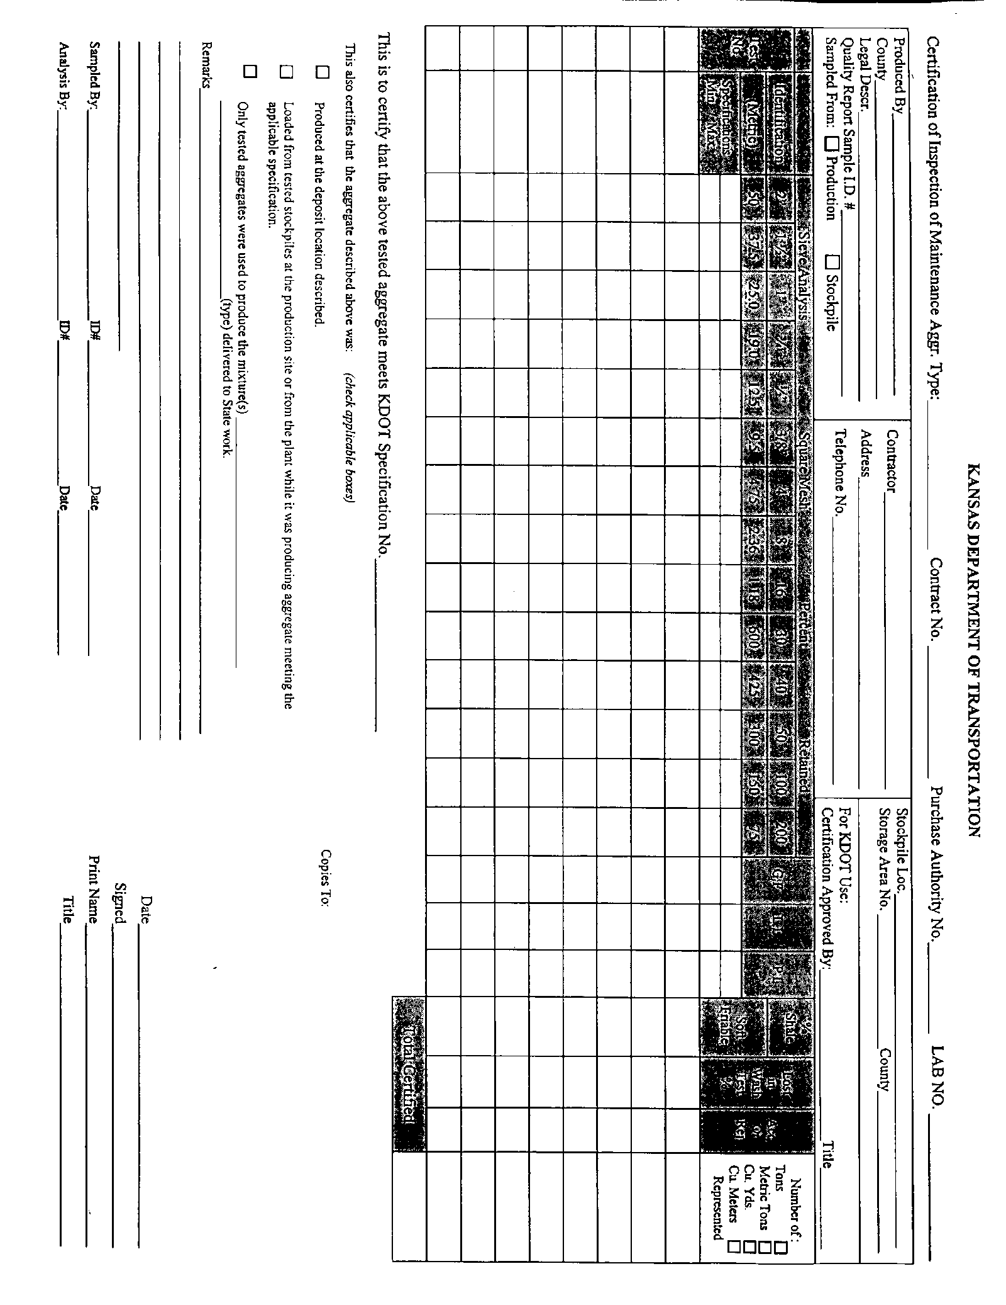
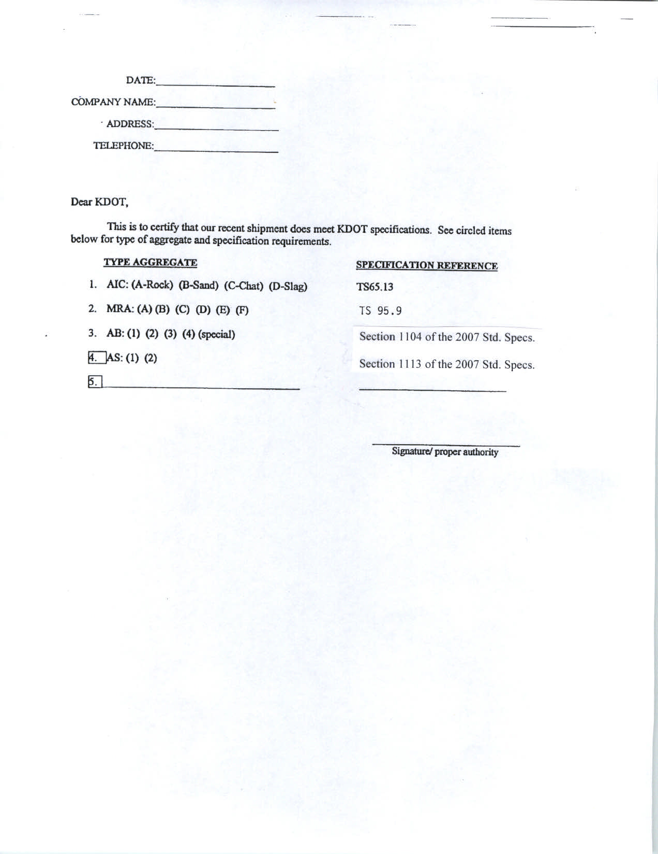
KDOT District
Specifications for Aggregate

DISTRICT FIVE

1. Aggregate for Ice Control shall be Type A, B, or D, and shall be in accordance with Specification No. TS 65.14, dated 8-6-04.

DISTRICT SIX

- Aggregate for Ice Control shall be Type A, B, or D, and shall be in accordance with Specification No. TS 65.14, dated 8-6-04.
Spec: TS 65.14
08-06-04
Page 1 of 2

STATE OF KANSAS

SPECIFICATIONS
FOR
AGGREGATE FOR ICE CONTROL

The following specifications shall apply to purchases of AGGREGATE FOR ICE CONTROL for the Kansas Department of Transportation. The State reserves the right to waive minor technicalities under this Specification.

1.0 DESCRIPTION:

1.1 Type A (Rock): Rock aggregate for ice control shall consist of crushed limestone or sandstone conforming to the gradation requirements in Table 1.

1.2 Type B (Sand): Sand aggregate for ice control shall be either a natural sand resulting from the disintegration of siliceous and/or calcareous rocks or sand manufactured from naturally occurring sands and gravels, or a combination of the two. It shall conform to the gradation requirements in Table 1.

1.3 Type C (Chat): Chat aggregate for ice control . (Deleted; not an option)

1.4 Type D (Slag): Slag aggregate shall be a boiler slag (ceramic aggregate) produced by burning coal in "wet bottom" boilers. The slag shall be a hard, glass-like material, meeting the approval of the Engineer and conform to the gradation requirements in Table 1.
Spec.: TS 65.14
08-06-04
Page 2 of 2

TABLE 1

GRADATION REQUIREMENTS FOR AGGREGATE FOR ICE CONTROL
Percent Retained on Square Mesh Sieve*

Maximum
Pass
Number
200
TYPE\COMPOSITION 1/2" 3/8" 4 8 16 30 50 100 Wash

A\Rock 0 0-2 5-35 55-98 95-100 3

B\Sand 0 0-15 10-50 50+ 95-100 2

C\Chat (Deleted; not an option)

D\Slag 0 0-2 0-15 50+ 95-100 2

* After removal of minus Number 200 material.

2.0 METHODS OF TEST:

2.1 Sampling KT-1

2.2 Sieve Analysis KT-2

2.3 Material passing Number 200 Sieve by Wash KT-3

2.4 Unit Weight KT-5

08-06-04 (M&R) (REK)
District Four

Contacts for information and to set up delivery schedules are:

Area One ----- Iola Contact Person:
(For Allen, Bourbon, Greenwood and Woodson Counties)
Kansas Dept. of Transportation Darrin Petrowsky, P.E.
1720 N. State St. Area Engineer
Iola, Kansas 66749
Gary Ward
Phone: 620-365-2161 Area Maintenance Supt.
FAX: 620-365-2402

Area Two ----- Garnett Contact Person:
(For Anderson, Coffey, Franklin, Linn and Miami Counties)
Kansas Dept. of Transportation Hugh Bogle, P.E.
507 N. Maple Area Engineer
Garnett, Kansas 66032-1081
Kevin Ryan
Phone: 785-448-5446 Area Maintenance Supt.
FAX: 785-448-2486

Area Three ----- Independence Contact Person:
(For Chautauqua, Elk, Montgomery and Wilson Counties)
Kansas Dept. of Transportation Wayne Gudmonson
P.O. Box 884 Area Engineer
Independence, Kansas 67301-0884

Marcus Leck
Phone: 620-331-3760 Area Maintenance Supt.
FAX: 620-331-7017

Area Four ----- Pittsburg Contact Person:
(For Cherokee, Crawford, Labette and Neosho Counties)
Kansas Dept. of Transportation George Dockery, P.E.
P.O. Box 104 Area Engineer
Pittsburg, Kansas 66762-0104
Wayne Nelson
Phone: 620-231-7560 Area Maintenance Supt.
FAX: 620-231-1149

