This brochure is meant as a reference guide to basic travel questions. It assumes the user is familiar with the "Employee Travel Expense Reimbursement Handbook" which can be found in its entirety at the following Internet site:
http://www.admin.ks.gov/offices/chief-financial-officer/travel-information-for-state-employees

Terms, policies and procedures have been shortened in order to fit within this guide.

Out-of-state and international travel requires approval as prescribed by the agency head in accordance with agency policy and PM 3,817.

TRANSPORTATION EXPENSES

Maximum Mileage Reimbursement Allowable
Automobiles | $ .54/mile
Motorcycles | $ .51/mile
Planes | $1.17/mile
Moving | $ .19 /mile
Mileage allowed within Kansas for motorcycles and automobiles is based on the most direct route as listed on the Kansas Department of Transportation distance chart. Travel by privately owned airplane should use air mile distances (as the crow flies). An acceptable site for verifying the air mileage is http://www.indo.com/distance/

Airfare

Airline tickets for travel within the United States may be purchased using the agency’s appropriate cardless Procurement Card (cardless P-Card) and in accordance with the agency travel policy. Airfare can also be charged to an employee’s personal credit card however, the traveler will NOT be reimbursed for that airfare prior to the completion of the related travel. As travelers are making reservations through ticket outlets other than the State Travel Center, they need to be aware that air carriers have varying policies regarding the presentation of the actual credit card used to purchase airfare at the airport. When a traveler is combining personal travel and business travel, the employee must pay for the airline tickets and be reimbursed for the business portion of the trip. For example, when buying two for one tickets, (where one ticket is for personal use) the state will reimburse the traveler for half the price of the ticket. Reimbursement requires the passenger copy of the airline ticket or a copy of the booked itinerary from the Internet.

Car Rental
Car rental reservations should be made in accordance with the agency’s travel policy. Reservations for in-state car rental should be made with Hertz and charged to the agency’s appropriate cardless P-Card. Employees renting cars out-of-state are reimbursed by submitting the official receipt for the rental or charter with the travel claim form. Personal accident insurance (PAI), personal effects insurance (PEI), and other supplemental liability insurance are considered personal expenses and are not reimbursable.

Information on insurance can be found under Insurance at http://www.admin.ks.gov/offices/ofpm/state-agency-vehicle-usage.

Information on accident reporting can be found under ACCIDENTS at http://www.admin.ks.gov/offices/ofpm/state-agency-vehicle-usage.

SUBSISTENCE EXPENSE

Subsistence rates will consist of a standard subsistence rate and non-standard area subsistence rates. The standard rate (or “other” location rate) is used except when the travel location is specified as a non-standard area, in which case the subsistence rate for that non-standard area is used. See “SOURCE OF SUBSISTENCE RATES” in this travel reimbursement summary for more information on subsistence rates.

Meals & Incidental Expense (M&IE) Reimbursement
On the day of departure and the day in which the employee returns to the official station or domicile, M&IE allowance is reimbursed as follows:

% of M&IE
Day of Day of
Time of departure Quarter Day Departure Return
12:00 AM - 5:59 AM Quarter 1 100% 25%
6:00 AM - 11:59 AM Quarter 2 75% 50%
12:00 PM - 5:59 PM Quarter 3 50% 75%
6:00 PM - 11:59 PM Quarter 4 25% 100%

M&IE Allowance Rate (includes charges for meals, taxes, and all fees and tips to waiters, hotel porters, bellhops, doormen, maids and dining room stewards):

Standard M&IE Allowance | $ 51.00

International M&IE Allowance rates are obtained from the U.S. Dept. of State website at: https://aoprals.state.gov/web920/per_diem.asp

The agency shall reduce the M&IE Allowance for meals provided at no cost to the employee. See Section 4301 of the Travel Handbook for detailed guidelines.

A single meal reimbursement for same-day travel may be authorized by the agency in limited situations at the meal allowance rates above. See Section 4100(D) of the Travel Handbook for detailed guidelines.

Lodging
Maximum lodging allowed (traveler is reimbursed for single occupancy only). No allowance for any tips is included within this rate. Taxes associated with lodging shall be reimbursed in addition to the established maximum allowance:

Standard Lodging Rate | $ 89.00
Conference Lodging qualified  under K.A.R. 1-16-18a* | Actual
International | Actual

The daily lodging expense limitations above may be exceeded by the lesser of either: (1) An additional 50% of the applicable lodging expense limitation; or (2) the actual lodging expense incurred. Either of these must be approved by the agency head or designee in accordance with agency policy and PM 3,817.

*Actual conference lodging may be paid without limit if approved by the appropriate agency official per PM 3,817.

State agencies may pay lodging expenses directly to lodging establishments via a check, ACH, or an appropriate cardless P-Card.

SOURCE OF SUBSISTENCE RATES

SMART contains the official subsistence rates for CONUS and OCONUS travel locations and will be updated each October 1 and April 1. International subsistence rates are not loaded into SMART. Employees will obtain M&IE rates for international travel locations directly from the U.S. Dept. of State (DOS) website listed below. See Section 4005 of the Travel Handbook for the following information regarding the source of subsistence rates.
Contiguous United States (CONUS)-
- The U.S. General Services Administration (GSA) maintains the M&IE rates and lodging rates for travel locations in the contiguous United States -
  - U.S. General Services Administration website: http://www.gsa.gov/portal/content/104877
Outside Contiguous United States (OCONUS):
(Alaska, Hawaii, and U.S. Territories/Possessions) -
- The U.S. Department of Defense (DOD) maintains the M&IE rates and lodging rates for travel locations within Alaska, Hawaii and U.S. Territories/Possessions -
  - U.S. Department of Defense website: http://www.defensetravel.dod.mil/site/perdiemCalc.cfm
International Locations -
- The U.S. Department of State (DOS) is the source for M&IE rates only for international travel locations-
  - U.S. Department of State website: https://aoprals.state.gov/web920/per_diem.asp
- For international travel, payment for actual lodging expense is allowed.
Note for using federal websites:
For CONUS and OCONUS travel, if SMART is not accessible, employees may access subsistence rates through the federal websites. However interim federal website updates may occur subsequent to the semi-annual SMART updates each October 1 and April 1. CONUS rates are published on an annual basis but the annual file is updated periodically throughout the year with no interim files published. OCONUS and international rates are updated and published on a monthly basis. Be aware that any interim updates for CONUS or OCONUS locations are not valid until reflected in SMART. For international travel, only the October 1 and April 1 subsistence files should be used to locate the M&IE rates.

If employees utilize the federal websites to find M&IE and lodging rates, those rates should be used as follows:

- Rates published October 1 - for travel occurring between October 1 and March 31 of each year.
- Rates published April 1 - for travel occurring between April 1 and September 30 of each year.

A query “KS_EX_CONUS_RATES” is available in SMART 9.2 which provides the effective CONUS and OCONUS travel locations and subsistence rates. SMART will be updated semi-annually with the October 1 and April 1 subsistence rates.

MISCELLANEOUS
Receipts are not required (except as required by the paying agency) for taxi fare, shuttles, turnpike receipts, and unattended parking meters

Note: Specific questions regarding travel should be directed to your agency's business office.

STATE OF KANSAS

Department of Administration

Office of the Chief Financial Officer

EMPLOYEE TRAVEL EXPENSE
REIMBURSEMENT SUMMARY

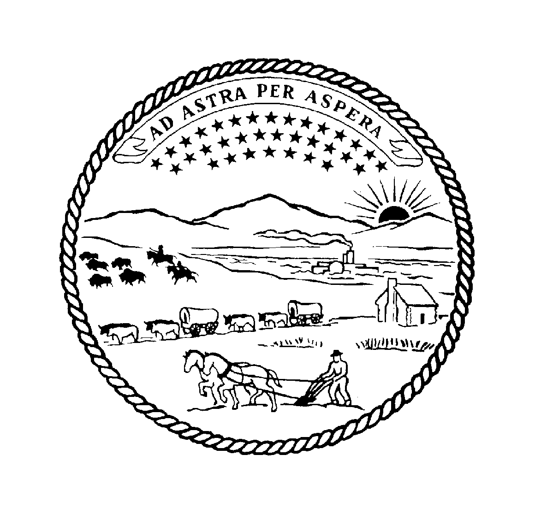

Revised January 1, 2016

SAM BROWNBACK
Governor

SARAH SHIPMAN
Acting Secretary of Administration

DeAnn Hill, CPA, CGMA, PFS
Chief Financial Officer

