SPECIFICATIONS

- These contracts are established to obtain Stationary Impact Attenuators and Repair Parts to the Kansas Department of Transportation (KDOT).

- Contract Period: January 1, 2017 through December 31, 2021 unless prematurely terminated as provided for below.

- Termination: Either party may terminate the contract, without cause, on the anniversary date, December 31, with sixty (60) Days written prior notice, to the Procurement Officer.

- Attenuators shall reasonably comply with the attached specification PR 111611 dated 11/18/2011.

- Shipping and F.O.B. Point: Prices are F.O.B. DESTINATION TO ANY LOCATION IN KANSAS, PREPAID AND ALLOWED (included in the contract price), which means delivered to a state agency's receiving dock or other designated point without additional charge. Shipments shall be made in order to arrive at the destination at a satisfactory time for unloading during regular working hours between 8:00 a.m. and 4:30 p.m., Monday through Friday, except holidays.

- Industry Standards: If not otherwise provided, materials or work called for in this contract shall be furnished and performed in accordance with best established practice and standards recognized by the contracted industry and comply with all codes and regulations which shall apply.

- Indefinite Quantity Contract: This is an open-ended contract between a vendor and the State to furnish an undetermined quantity of a good or service in a given period of time.

- Prices: Prices shall remain firm for the entire contract period. Prices shall be net delivered, including all trade, quantity and cash discounts. Any price reductions available during the contract period shall be offered to the State of Kansas. Failure to provide available price reductions may result in termination of the contract.

- Warranty: Standard Manufacturer's Warranty, for all equipment bid, is to be considered a part of these conditions. All defective items shall be replaced free of charge.

Contractor shall provide a ONE (1) year PARTS AND LABOR warranty on all devices and/or labor provided.

The contractor will be the sole point of contact on any problems with the equipment or systems during the warranty period.

The contractor shall be responsible for all work put in under these specifications. The contractor shall make good, repair and replace, at the contractor's own expense, as may be necessary, any defective work, material acceptance, if in the opinion of agency and/or Division of Purchases said defect is due to imperfection in material, design, or workmanship for the warranty period specified.

- Certification of Materials Submitted: The response to this IFB, together with the specifications set forth herein and all data submitted by the contractor to support the response including brochures, manuals, and descriptions covering the operating characteristics of the item(s) proposed, shall become a part of any contract between the successful bidder and the State of Kansas. Any written representation covering such matters as reliability of the item(s), the experience of other users, or warranties of performance shall be incorporated by reference into the contract.

STATE OF KANSAS
KANSAS DEPARTMENT OF TRANSPORTATION

SPECIFICATIONS
FOR
STATIONARY ATTENUATOR
(CRASH CUSHIONS) and/or REPAIR PARTS

The following specifications shall apply to purchases of STATIONARY ATTENUATOR (CRASH CUSHIONS) and/or REPAIR PARTS for the Kansas Department of Transportation. The State reserves the right to waive minor technicalities under this specification. Federal and State laws supersede any conflicting part of this specification.

The unit shall be a current model, new and unused, under standard production by the manufacturer. Parts shall be available for older models which are still in service. All parts utilized on the unit shall be new and unused. Parts need to be delivered within 10 business days. Provide a list of parts that will exceed 10 business days delivery.

The bidder agrees, if his proposal is accepted, to guarantee the design, material and workmanship of the unit bid according to the standard factory warranty, or for one year, whichever is greater. A copy of the warranty shall accompany the bid. Warranty coverage shall include costs of transporting the unit to and from dealer's shop, when outside a 150 mile radius of the delivery point.

Complete specifications and literature and repair parts list on the unit bid shall accompany the bid. Any exceptions to these specifications shall be indicated on the bid or on a separate attachment to the bid, labeled as such.

Any “equal” or “equivalent” items for brand specified components shall be listed with the bid package. Complete description and literature on the “equal”/“equivalent” components shall be supplied for consideration by the KDOT. The burden of proof regarding “equal”/“equivalent” items shall be upon the vendor.

TECHNICAL SERVICE: The services of a competent technician, thoroughly trained in the installation, operation and servicing of the unit, shall be furnished for a minimum period of one working day for each delivery point. The technician shall instruct the KDOT personnel in the proper installation, safety, operation and preventive maintenance of the unit and to test the unit for satisfactory performance. This training would be by request per Area Crew. There are 26 Area Crews located across the state such as Kansas City and Wichita. This instruction shall be performed on a date to be agreed upon by the District Superintendent.

PRINTED MANUALS: One shop manual, and parts manual shall be supplied with each unit. The manuals shall fully and clearly cover all components of the unit.
STATIONARY ATTENUATOR
(CRASH CUSHIONS) and/or REPAIR PARTS

SHOW MFG. & MODEL OFFERED _________________________________________

EXCEPTIONS TO
MFG. CODE SPECIFICATION SPECIFICATIONS

GENERAL:

_____________ _____________ This specification describes a Multi Award Contract to supply the Stationary Attenuator Repair Parts and/or Stationary Attenuator (Crash Cushion) System for permanent installation or temporary work zones.

_____________ _____________ KDOT has several different models of Stationary Attenuators in service. KDOT needs to be able to purchase repair parts for these proprietary systems.

_____________ _____________ This system shall provide impact protection to the motorists from the exposed ends of concrete barriers, fixed objects, or other obstacles.

_____________ _____________ The Stationary Attenuator Repair Parts and /or Stationary Attenuator (Crash Cushion) System shall have successfully passed, both the required and optional tests that fall under the guidelines of NCHRP Report 350 Test Level 3, and/or MASH 350.

_____________ _____________ Certified test results and associated test reports and films produced in compliance with NCHRP report 350 and /or MASH 350 report not listed on KDOT prequalified list shall be submitted with bid

PRODUCT MODELS

_____________ _____________ KDOT has the following Attenuators (Crash Cushions) and Barrel systems in service:
G-R-E-A-T (Trinity)
TRACC (Trinity)
CAT – 350 (Trinity)
TREND (Energy Absorption)
REACT (Energy Absorption)
Quad Guard (Energy Absorption)
Quad Guard II (Energy Absorption)
ACZ-350 (Energy Absorption)
ABSORB 350 (Highway Safety Corp.)
TAU-II (Highway Safety Corp.)
SCI (SMART CUSHSION)
(Work Area Protection Corp.)

GALVANIZING:

_____________ _____________ All exposed steel surfaces on the Attenuators shall be galvanized. Galvanizing shall be applied after the proper preparation of all steel components. The metal preparation shall include cleaning, degreasing the metal surface.
STRIPING:

_____________ _____________ The surface of the Impact Frame facing oncoming traffic, shall display a black on yellow inverted “V” chevron pattern. Color bands are recommended to be (4 in.) wide.

EXCEPTIONS TO
MFG. CODE SPECIFICATION SPECIFICATIONS

DESTINATIONS:

_____________ _____________ Deliveries are to be made to the Kansas Department of Transportation location noted on each Purchase Order.

_____________ _____________ A complete list of the vendors repair parts and pricing for their models shall be provided.

_____________ _____________ A complete list of the vendors Attenuator system units and pricing shall be provided.

Contract #42559

Contractor: Trinity Industries, Inc.
dba Trinity Highway Products, LLC
2525 North Stemmons Freeway
Dallax, TX 75207-2401
Vendor ID: 0000162105
FEIN: 42-1642965
Contact Person: Tom J. Aslin
E-Mail tommy.aslin@trin.net
Toll Free Telephone: 800-527-6050
Local Telephone: 214-631-4220
Fax: 214-559-8423

PRICE SCHEDULE

COMPLETE ATTENUATORS (PURCHASE)

MFG MODEL UNIT PRICE

Trinity Highway Products CAT-350 $3,335.00

Trinity Highway Products TRACC $14,430.00

Trinity Highway Products SHORTRACC $10,500.00

Trinity Highway Products FASTRACC $17,510.00

ATTENUATOR REPAIR PARTS

Trinity Highway Products CAT-350

Trinity Highway Products TRACC

Trinity Highway Products SHORTRACC

Trinity Highway Products FASTRACC

Click here for pricing

Exceptions

Regarding Page 3 of KDOT’s contract document, #EVT0004716, Trinity Highway Products, LLC (“THP”) notes the following exception(s):

4th Specification: “The Stationary attenuator Repair Parts and/or Stationary Attenuator (Crash Cushion) System shall have successfully passed, both the required and optional tests that fall under the guidelines of NCHRP Report 350 Test Level 3, and/or MASH 350.”

Exceptions:
1) The reference to “MASH 350” should be corrected to read “MASH,” as NCHRP Report 350 and MASH represent separate testing guidelines/criteria.

2) THP currently sells the TRACC and CAT systems to KDOT under this contract. Please note that these systems were each tested to and successfully passed the applicable tests per NCHRP 350, as listed below. However, consistent with NCHRP Report 350 guidance, as set forth in Section 3.1, THP did not conduct optional tests with a 700C vehicle. Other tests listed in the applicable NCHRP Report 350 test matrix may have been waived because prior NCHRP Report 230 tests that were conducted on substantially similar versions of these systems provided sufficient data.

TRACC: In FHWA Letter CC-54, FHWA states that “…we conclude that the TRACC, as designed and tested, meets the evaluation criteria for an NCHRP Report 350 TL-3 attenuator and may be used on the National Highway System (NHS) as a permanent or temporary crash cushion.” Subsequent responses extended eligibility to TL-2 versions of this system as well.

Tests:
3-30 Conducted
3-31 Conducted
3-32 Conducted
3-33 Conducted
3-37 Conducted
3-38 Conducted
3-39 Conducted

CAT: FHWA Letter CC-33 states, in part, that “This review indicated that the CAT has successfully passed all required tests and is acceptable for use on the National Highway System (NHS) when such use is proposed by a highway agency.” Based on the following tests, FHWA has deemed the CAT system eligible for federal-aid reimbursement as an NCHRP Report 350 TL-3 crash cushion.

Tests:
3-31 Conducted
3-32 Conducted
3-33 Conducted
3-34 Conducted
3-37 Conducted
3-39 Conducted

Contract #42556

Contractor: Roadsafe Traffic Systems, Inc.
805 N. Haverhill Rd.
El Dorado, KS 67042
Vendor ID: 0000048288
FEIN: 26-1084418
Contact Person: Adam Brenton
E-Mail abrenton@roadsafetraffic.com
Local Telephone: 316-322-3070
Cell Phone Number: 316-253-4990
Fax: 316-321-1267

PRICE SCHEDULE

COMPLETE ATTENUATORS (PURCHASE)

MFG MODEL UNIT PRICE

Work Area IL-3 with concrete anchor $20,150.00

Smart Cushion IL-3 with asphalt anchor $20,500.00

IL-2 with concrete anchor $15,825.00

IL-2 with asphalt anchor $16,175.00

ATTENUATOR REPAIR PARTS

See following price list

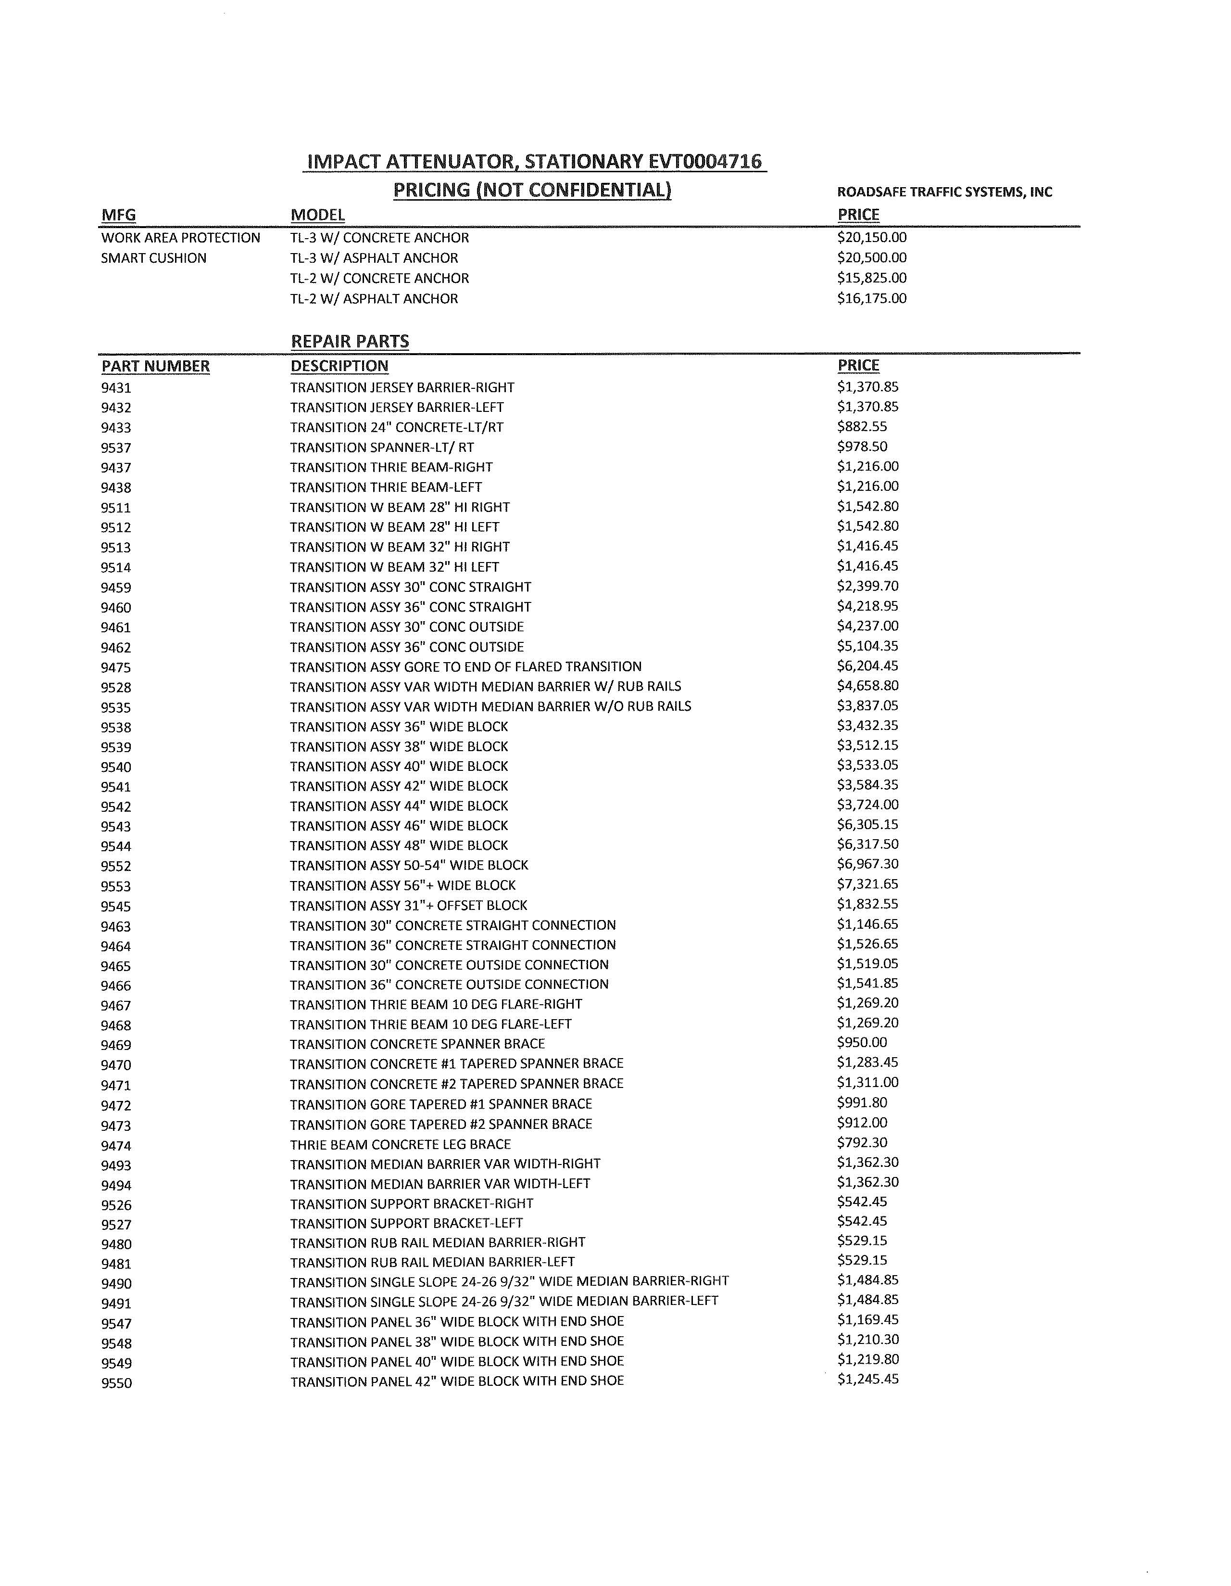

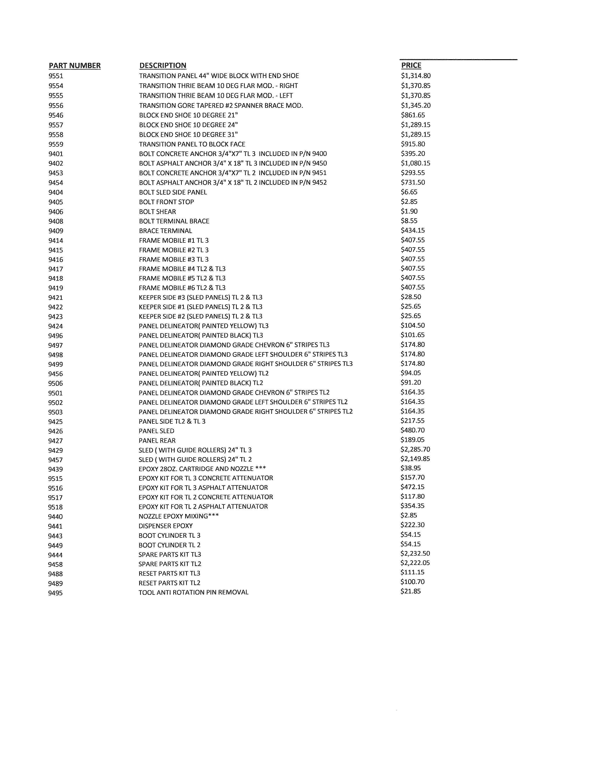

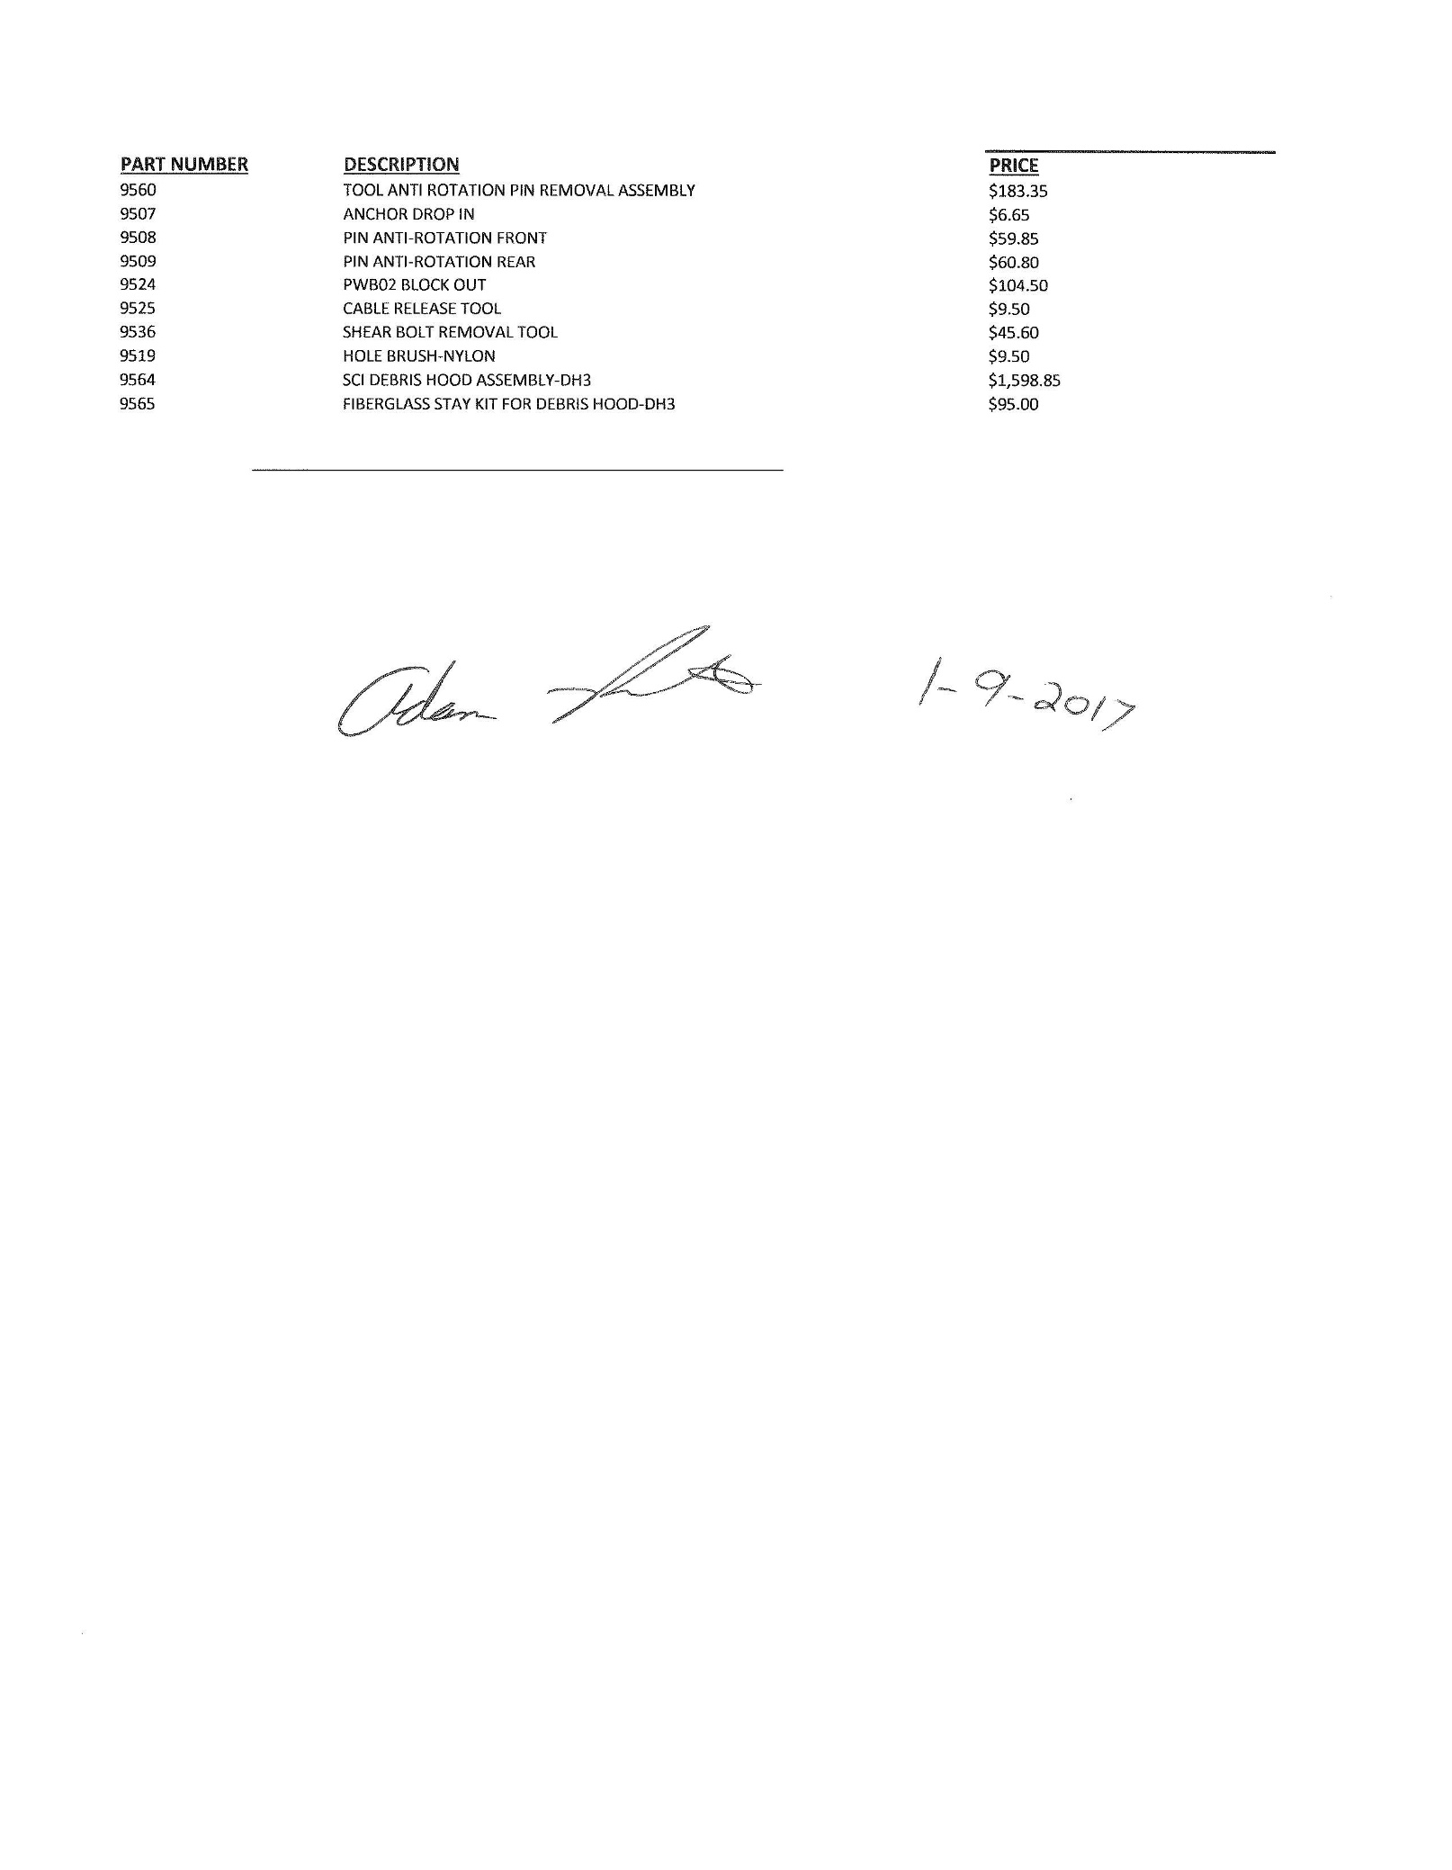

Contract #42557

Contractor: John Thomas, Inc.
1560 Lovett Dr.
Dixon, IL 61021-9623
Vendor ID: 0000026314
FEIN: 34-1857196
Contact Person: Anne Bruousil
E-Mail abrousil@jtitraffic.com
Toll Free Telephone: 888-447-7263
Local Telephone: 815-288-2343
Fax: 815-288-3432

PRICE SCHEDULE

Click here for pricing on complete attenuators and repair parts

