**ADDENDUM**

February 14, 2018

Addendum Number: 1

RFP: Atchison-DCF Office

Closing Date: March 2, 2018; 2:00 p.m. (C.S.T.)

Contact Person: Brent Whitten

Telephone: (785) 368-6360

E-Mail Address: [Brent.Whitten@ks.gov](mailto:Brent.Whitten@ks.gov)

Item: Leased Space-Atchison, KS

Agency: KS Department for Children and Families

Conditions: Reception & Interview Room Security Windows Details

Atchison DCF RFP - Reception & Interview Room Security Windows Details

Re:  Page 9 A.  Public Area and 2. Client Secured Interview Stations:

Details on the “Windows with staggered glass designed with two rows of CR Laurence narrow insert framed window with surround sound.”  Installation of Security Windows with “Fixed Floating Glass” for openings (Reception and Interview Windows).

**Window Details:**   The design of each of the Security Windows will be as follows:

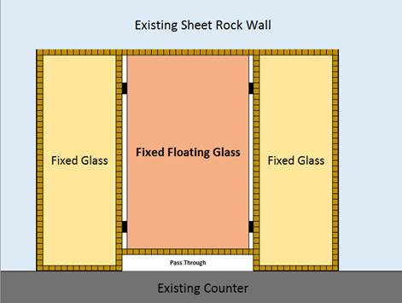

All opening shall be completely enclosed with the use of aluminum Framed tempered glass.

All glass is ¼ “ thick tempered glass. Each Opening will have a “22” wide fixed floating glass” as follows:

* The fixed floating tempered glass window part shall be 22” in width.
* The 22” wide fixed floating tempered glass window part shall be the height of the opening, minus 3 ½” at the bottom to provide for a pass through transaction counter.
* The 22” wide fixed floating tempered glass window shall be framed in brown or bronze 5/16”gauge aluminum framing.
* The 22” wide fixed floating tempered glass window shall be supported on the sides by a hard rubber support gaskets approximately 2” in length by the 1 ½” width and  placed at 15” apart. ( please see the picture below)
* The bottom support portion of the 22” wide fixed floating tempered glass window shall be the 3 ½” aluminum frame serving as a spacer and support.
* The fixed floating glass will be centered between the fixed glass – the size of the fixed glass will vary window to window depending on the size of the opening.
* The remainder of the window opening shall be fixed glass (on each side of the fixed floating glass)  framed with the same bronze or brown colored 5/16” gauge aluminum frame, ¼” tempered glass that will be from top to bottom of the opening  (no pass through area)
* All caulking shall be of a matching color to the window frame.

The “floating glass” design plan is Illustrated in the following photos

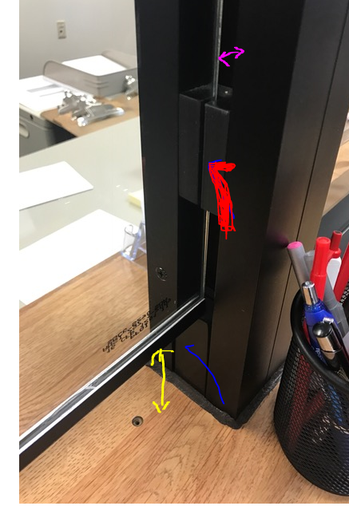– marked as follows:

* The purple arrow = ½” side space for passive sound transfer
* The red check = hard rubber gasket side mountings assisting with

the vibratory transfer of sound.

* The blue check = bottom of the fixed floating tempered glass area

spacer support for transaction counter opening 3 ½”

* The yellow = Bottom of window trim and the 3 ½” transaction

window  pass through.

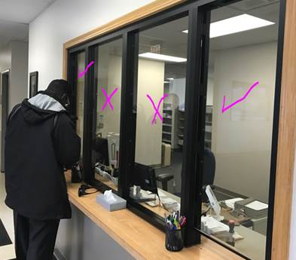                  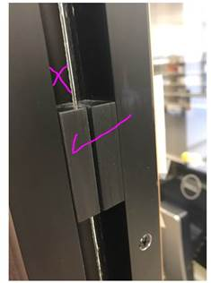

This pictures above are of a “double window Reception Area.  All of our windows will be “Single Windows”

The “x” = ½” side passive sound transfer space

The checks = Fixed floating glass                                  The check = the hard rubber side support gasket

The “x” = Fixed glass

I (We) have read and understand this addendum and agree it is a part of my (our) bid response.

NAME OF COMPANY OR FIRM:

SIGNED BY:

TITLE: DATE:

**It shall be the vendor's responsibility to monitor this website on a regular basis for any changes/addenda**.

[**https://admin.ks.gov/offices/ofpm/real-estate-leasing/bid-solicitations-for-leased-space**](https://admin.ks.gov/offices/ofpm/real-estate-leasing/bid-solicitations-for-leased-space)